|  |
| --- |
| **A. Y. DADABHAI TECHNICAL INSTITUTE,**  **KOSAMBA (R.S.)** |

**3rd Aug, 2015**

***A REPORT***

***On***

***WELCOME AND ORIENTATION PROGRAM OF GTU’S 1ST SEMESTER STUDENTS”***

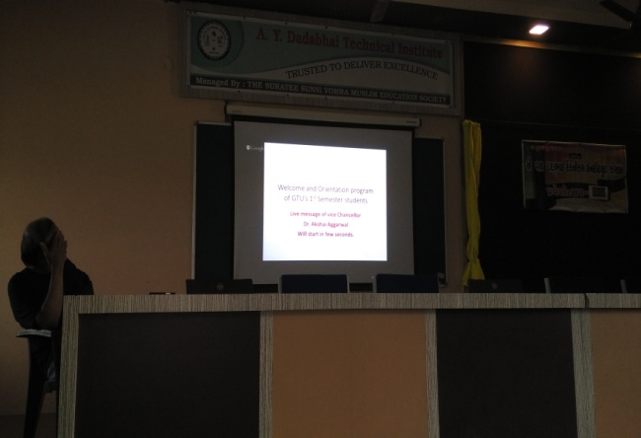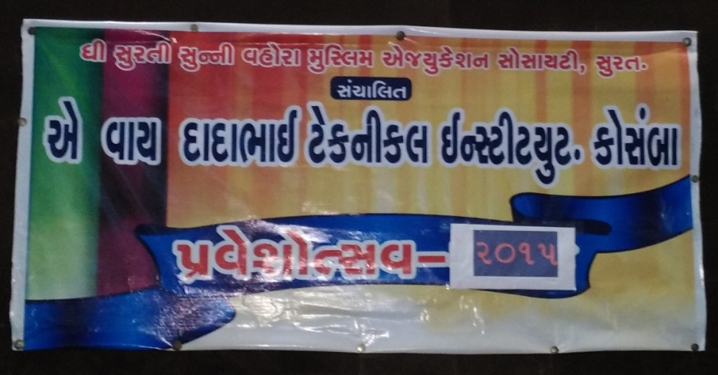

According to the GTU’s guidline A. Y. Dadabhai technical Institute has organized ***PRAVESHOTSAV-2015*** entitle as **“Welcome and Orientation Program of GTU’s 1st Semester Students”** by GTU.

The function was started at 11:00 am in the morning with introduction of Praveshotsa-2015 which is followed by a very inspirational video clip related to the passion and interest of the student, in their respective field. The clip was gave a very nice massage with the help a story of five friend among them who get success and who was passionate about their work and also gave an idea about the thing , better for the student and how to plan for future.

**PHOTO OF RUNNING VIDEO CLIP:**

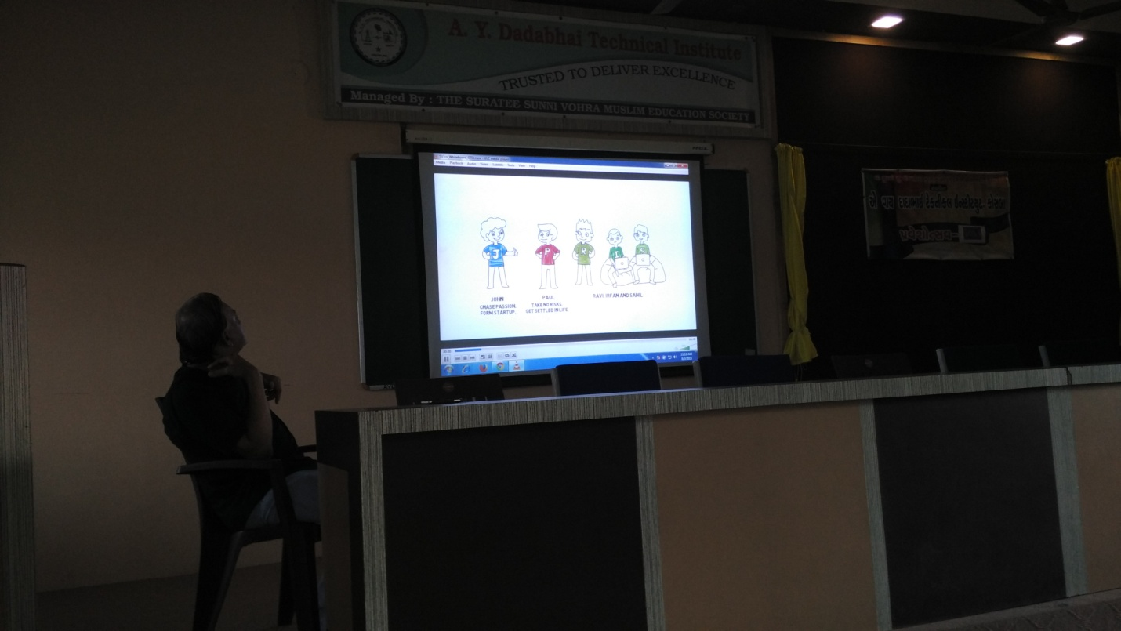

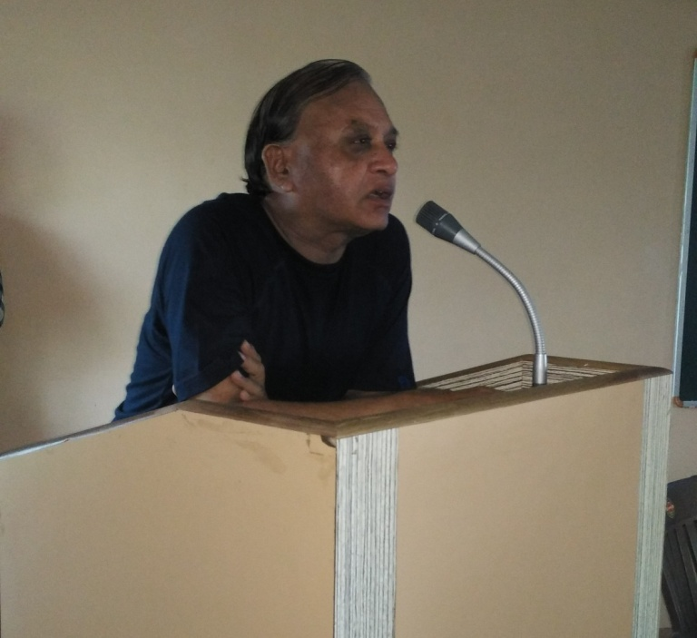Latter on Principal **Mr. H. I. Patel** gave some useful information about the institute and education which may beneficial for the student. They also told that how co-curricular activity is useful along with the study.

Then after honorable VC of GTU, **Dr. Akshai Aggarwal** has given live speech to students and welcome to all new comer students. He also gave some introduction of Gujarat Technological University as well as told about Nation and how the engineer can help in development of Nation under the Indian government scheme “MAKE IN INDIA”.

They told that how to achieved goal in the future and they also placed some weight on CPD, so that every students can speak fluently without any fear and can develop their personality throughout the diploma.

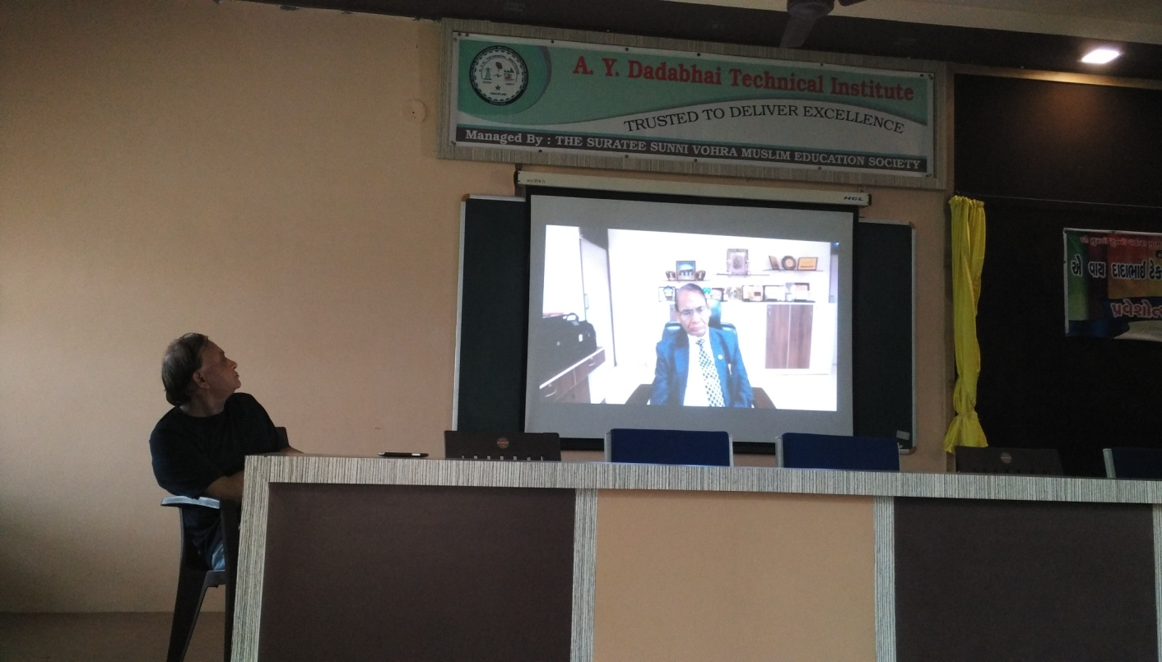At last, **Dr. Akshai Aggarwal** concluded the function by congratulate to all students and gave good wishes for their future.

**LEVE WELCOME SPEECH BY Dr. Akshai Aggarwal:**

**MOMENTS OF THE FUNTION:**

|  |  |
| --- | --- |
| **E:\SABIR\AYD\Gtu orientation Aug 2015\IMG_20150803_111703.jpg** |  |
| **E:\SABIR\AYD\Gtu orientation Aug 2015\IMG_20150803_110928.jpg** | **E:\SABIR\AYD\Gtu orientation Aug 2015\IMG_20150803_111140.jpg** |