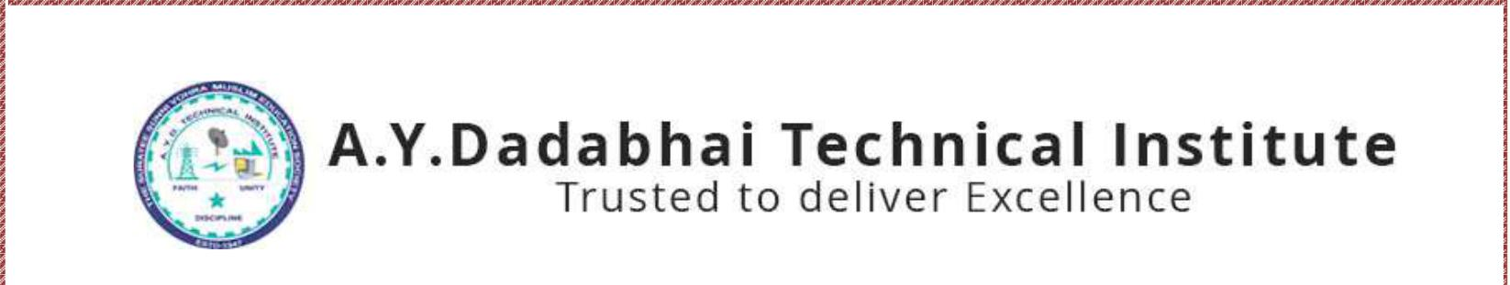

**Report on**

*Welcome Ceremony for the 1st Semester Students*

*14th October, 2019*

**Under**

**“UDAAN - WOMAN IN DEVELOPMENT CELL”**

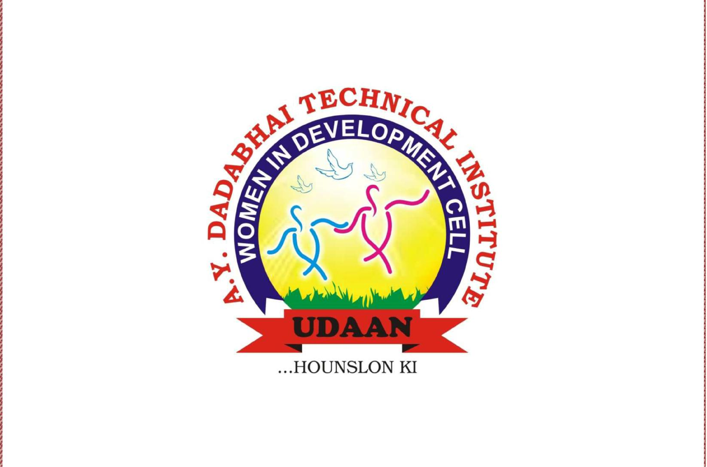

A.Y. DADABHAI TECHNICAL INSTITUTE Kosamba-Mahuvej Road, At post : Kosamba,  
 Dist :Surat, Gujarat-3964120

Udaan - WID Cell organized a Welcome programme on 14th October at A.Y.Dadabhai Technical Institute, A-wing Seminar Hall at 11.00 am. All girl students are invited for this programme.

First year students are welcomed by WID members. Main aim of this programme is to aware new comers with “Udaan-WID” activities, college activities, discipline, attitude, various skill development programme. And to encourage them for involving in all these type of activities.

In the beginning of ceremony started with welcome speech by Mrs. Sneha More. After that, Mr. P. J. Surti, Lecturer of Mechanical Engg. Department gave his speech about discipline and then Mr. M. M. Dalchawal, Director gave inspirational speech to the girls students. Mrs. S. S. Multani gave brief introduction of WID activities and all rules and regulations. We take students suggestion and views also. The programme concludes with our national anthem.

Jai Hind

