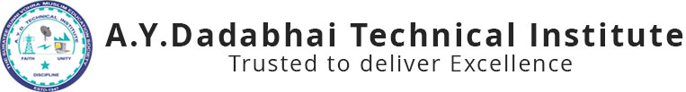

**Report on**

***“Expert lecture on Kotlin”***

***5th OCT, 2019***

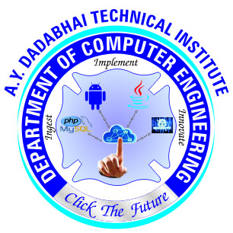

A.Y. DADABHAI TECHNICAL INSTITUTE, KOSAMBA

Kosamba-Mahuvej Road, At post : Kosamba,

Dist :Surat, Gujarat-3964120

Computer Engineering Department of A.Y.Dadabhai Technical Institute, Kosamba has arranged an expert lecture on **Kotlin for 3rd and 5th semester** students on **5th October 2019**. As per the Curriculum of 6th Semester Diploma in Computer Engineering , students have to study Androind. A.Y. Dadabhai Technical Institute is very much concerned about the Professional Development of each Student. Computer Engineering Department also takes regular steps to fulfill the Institute’s vision and as well as Department’s own vision. To pursue this vision Computer engineering Department organizes various Quiz Competition and Expert Lecture for Computer engineering Students. **Mr. Ankit Sodha**  from **Tops Technologies** has shared his Experience on Kotlin technology. He shared his experience around 2 hours to students.

Nowadays Android technology is widely used in Mobile phones. Kotlin technology is latest technology used to develop android application. Kotlin is easy to understand and user friendly syntax. So, Developer can easily design android application with Kotlin.

The Expert Lecture was very helpful to the Students. As they were able to know the things to which they were unknown till date. Students had also asked some queries at the end of expert lecture and exaggerate their gratitude for the Expert Lecture planned by the Computer Department of the Institute.

Glimpse of Expert Lecture

