**A.Y.DADABHAI TECHNICAL INSTITUTE, KOSAMBA**

**WOMEN IN DEVLPMENT CELL (WID)**

**“Udaan …. Hosulon ki..”**

**One day “Riffle Training” programme on 3rd AUG-2015**

WID (Woman in development cell) of A.Y.D.T is always seeking to promote development like internal growth, strength of social and educational development etc, for girl students and ladies staff members.

WID has arranged one day training programme of Riffle, Horse Ridding, and Lecture related health and Cyber safety with the co-ordination of Kosamba Police Department. Around 500 Girl students and 25 Ladies staff of different institutes, schools, college students and staffs participated in this training. Among of these **23Girl students and 02 ladies staffs Ms.Tejal C. Patel & Ms.Niharika D. Lad** are our Institute. The Entire Training organized at “GHALUDI, Gramya Vadu Mathak” of Gramya Police Station.

The training started at 9:00 AM with Yoga session by ladies police trainer. In yoga session ladies police trainer had given a speech on yoga with practical. She had done different yoga like “Surya Namaskar, Chakarashan, Savasan, Prayam” etc with girls.

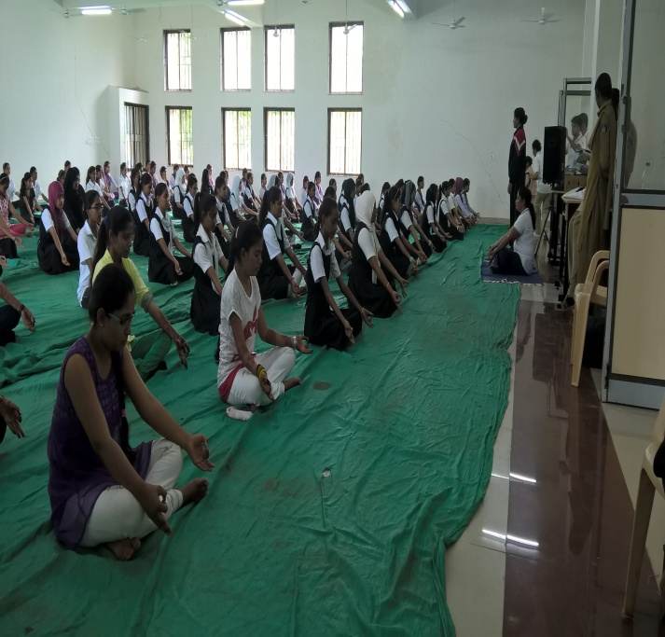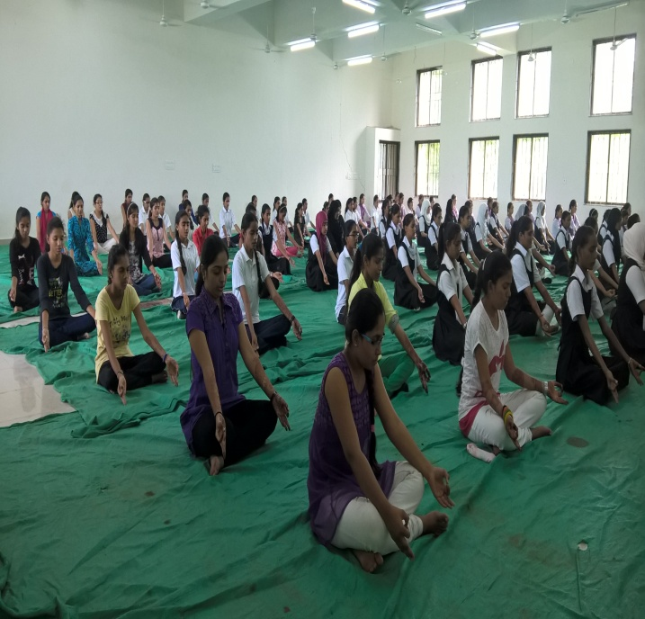

After the completion of Yoga session, at 10:30 AM, there was an arrangement of one hour Medical lecture has given usefull advices related health and also focused on “BETI PATHAO, BETI VADHAVO”. A Banner prepared with signature of all the present participants of the event.

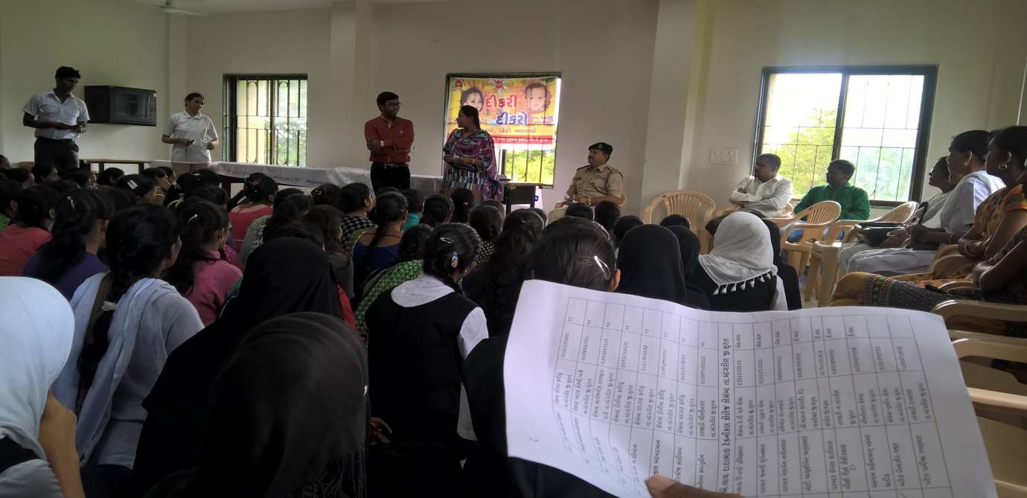

After this session at 11:30 AM, there was an arrangement of breakfast for all

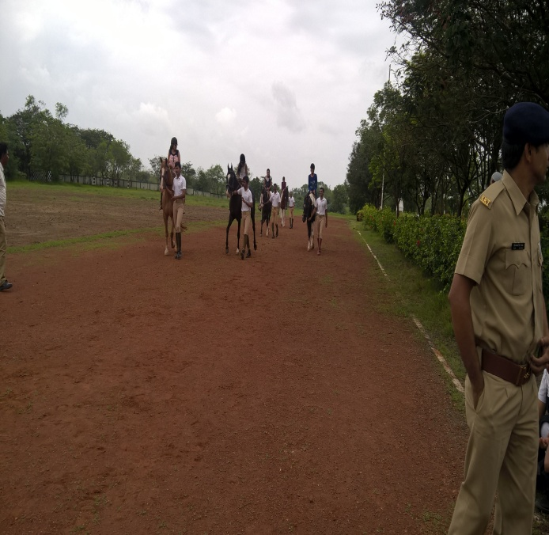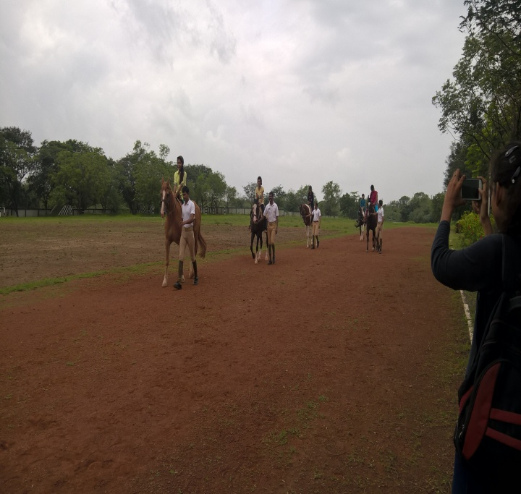 At 12:30, Horse Ridding training is also given to all Girl students and ladies staff members.

At 01:30 PM there is an arrangement of expert lecture of Cyber Safety & Cyber Crime organized by Surat City Police & Vision of Tomorrow Charitable Trust .They take an Initiative to Fight Against cyber Crimes. They given different tips and advices related to cyber safety like Camera, Mobile, Social applications use, etc. In this Session Half and hours for question -answer by girl student’s related cyber or social applications uses.

This session was completed at 02:00 PM; there was an arrangement of Lunch for all.

After the completion this all session the main session “Riffle Shutting” was started at 3:00 PM on Firing Ground with all safety. There are many Police officers present to give Riffle training. Every girls has taken **20 round** of **0.2Riffle** with Command, under observation of trainer. It was amazing experience to all girls and staff members.

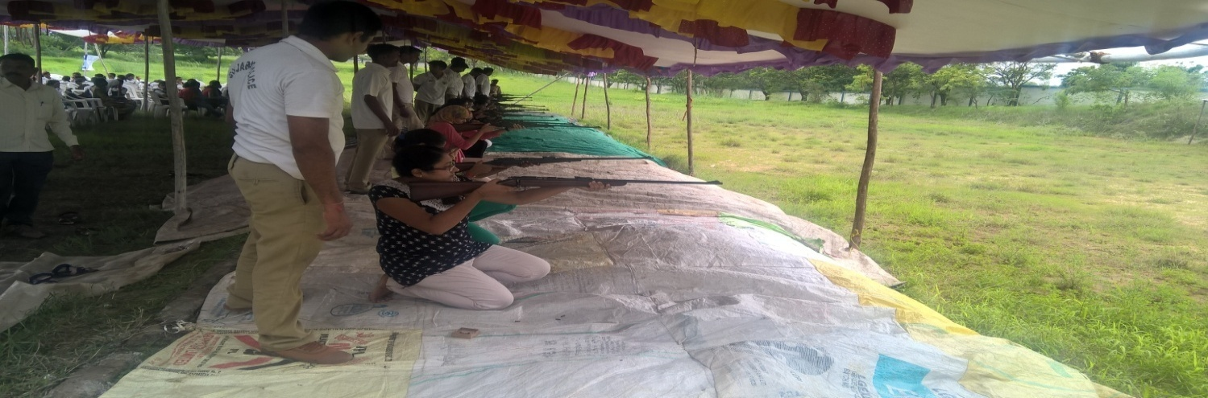

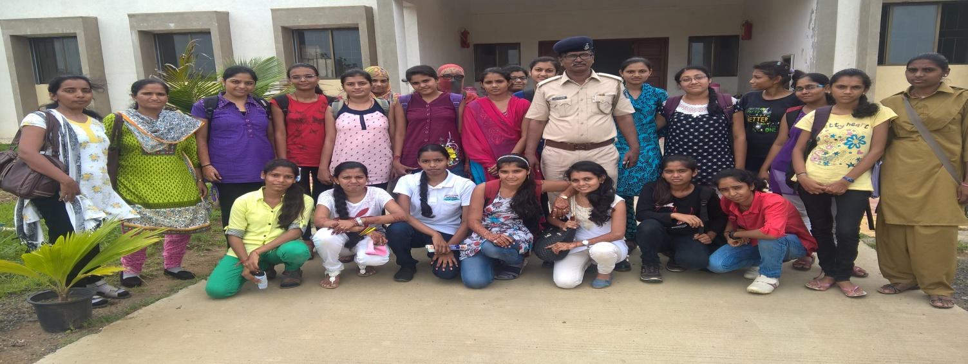 A Programme was completed at 4:00 PM.

*****