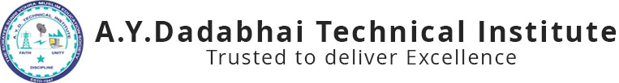

**Report on**

**Industrial Visit at**

**“SOPAN INFOTECH”**

**20th FEB 2020**

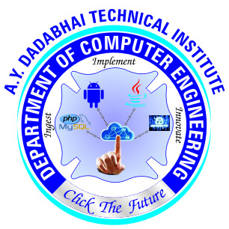

A.Y. DADABHAI TECHNICAL INSTITUTE, KOSAMBA

Kosamba-Mahuvej Road, At post : Kosamba,

Dist :Surat, Gujarat-3964120

A.Y. Dadabhai Technical Institute, Kosamba focuses on the overall growth of the students. Computer Department arranges many activity during the semester to improve the Students performance in every category like Elocution Competition, Quiz Competition and also Fun activities. Students must be familiar with the practical terms which are covered in their curriculum. So the Industrial Visit can make them understand how the theories work actually in the real world.



Total 38 students of 6th semester and 2 staff members went for visit. First we reached at SOPAN INFOTECH by 11:00AM. MR.Abhijit Rakshit(IT –Design Head) had conducted the session and given brief overview of software Development, focuses on PHP, Website Development also on current trends in Software Field. He had also demonstrated his own developed Python based application like ALEXA, JARVIS…which works on voice based commands.



.

After this session we visited a studio which is used by different government programs like Chief Minister speech, conference, live lectures etc. GTU also use this studio for recording video lectures. We also visited control room from where all the controlling of videos are handled technically.



Students enjoyed this visit and also they learned many things related to space technology and studio management. All the information given to the students was very helpful in their further studies.

Glimpse of Expert Lecture

