**A.Y.DADABHAI TECHNICALINSTITUTE, KOSAMBA**

**ORGANISED**

**ANNUAL SPORTS EVENT**

**RANBHUMI-2017**

A.Y.Dadabhai Technical Institute, Kosamba has Organized 5th Annual Sports event **RANBHUMI-2017** during **17th Jan- 2017 to 21st Jan- 2017.**

**RANBHUMI-2017** was held at Campus of A. Y. Dadabhai Technical Institute, Kosamba under the Leadership of **Mr. P. A. Patel** (In charge of Sports committee) and also the co-operation of sports committee members under the guidance of **Mr. M. M. Dalchawal** director of our Institute**.**

In **RANBHUMI-2017** around 300 students were participated in different games/events like **Cricket, Volleyball, Kho-Kho, Badminton, Chess, Carrom, Table- tennis, Tug of war.** All the games are organized for both boys and girls. The whole event was successfully completed by co-ordination of sport committee members, Women in Development committee Members, discipline committee members, canteen committee members and other staff members of institute.

On **21st Jan-2017** Staff event are also organized for different games. Prize distribution program and closing ceremony of RANBHUMI-2017 is arranged on **20th January-2017 at 12:00pm.**

In this programme ***Mr. Sushil R. Gaur (AGM of Piramal Glass Limited, Kosamba) and Mr. Sanjay Gandhi*** was present for distribution of award to the winners of RANBHUMI-2017.

**LIST OF PARTICIPANTS AND WINNER FOR DIFFERENT EVENT OF RANBHUMI-2017**

|  |  |  |
| --- | --- | --- |
| **GAME** | **TOTAL PARTICIPANTS** | **WINNER** |
| **CRICKET**  **(BOYS)** | **15 Teams** | **Mechanical Engineering Department**  **(6th semester)** |
| **CRICKET**  **(GIRLS)** | **03 Teams** | **Civil Engineering Department** |
| **VOLLEYBALL**  **(BOYS)** | **15 Teams** | **Civil Engineering Department**  **(2nd semester)** |
| **VOLLEYBALL**  **(GIRLS)** | **03 Teams** | **Computer engineering Department**  **(2nd semester)** |
| **KHO-KHO**  **(BOYS)** | **10 Teams** | **Civil Engineering Department**  **(6TH semester)** |
| **KHO-KHO**  **(GIRLS)** | **04 Teams** | **Civil Engineering Department** |
| **TUG OF WAR**  **(BOYS)** | **12 Teams** | **Electrical Engineering Department**  **(6th Semester)** |
| **TUG OF WAR**  **(GIRLS)** | **5 Teams** | **Computer engineering Department**  **(4th semester)** |
| **BADMINTAN**  **(BOYS)** | **100** | **KAZI FARHAN**  **Computer Engineering Department**  **(4thsemester)** |
| **BADMINTAN**  **(GIRLS)** | **34** | **CHAUHAN DIPALI K.**  **Computer Engineering Department**  **(6TH Semester)** |
| **CARROM**  **(BOYS)** | **52 Pairs** | **VASAVA MANISH - VASAVA ROHAN**  **Mechanical Engineering Department**  **(6TH Semester)** |
| **CARROM**  **(GIRLS)** | **16 Pairs** | **VASAVA DHRUVI V.- LAD HEMANGINI M.**  **Computer Engineering Department**  **(4th semester)** |
| **CHESS**  **(BOYS)** | **30** | **PATEL MO.UZAIR**  **Civil Engineering Department**  **(2ndsemester)** |
| **CHESS**  **(GIRLS)** | **04** | **CHAUHAN DIPALI K.**  **Computer Engineering Department**  **(6TH Semester)** |
| **TABLE- TENNIS**  **(BOYS)** | **20** | **KAZI FARHAN**  **Computer Engineering Department**  **(4thsemester)** |

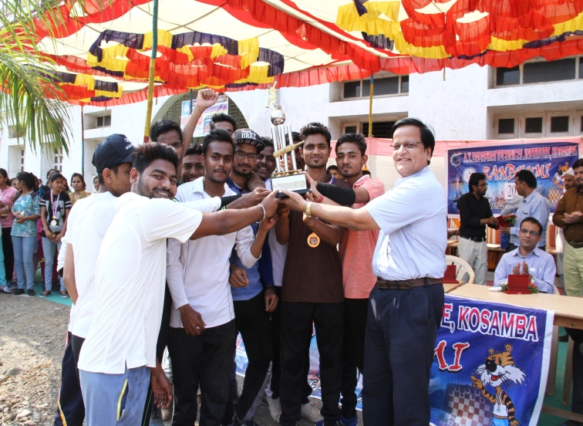

**WINNER OF CRICKET (BOYS)**

**Mechanical Engineering Department**

**(6th semester)**

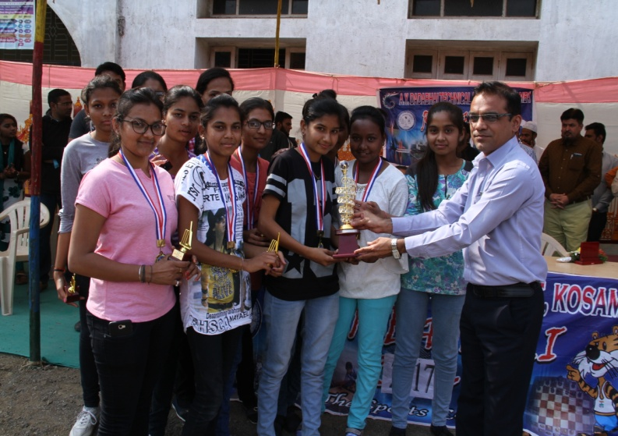

**WINNER OF CRICKET (GIRLS)**

**Civil Engineering Department**

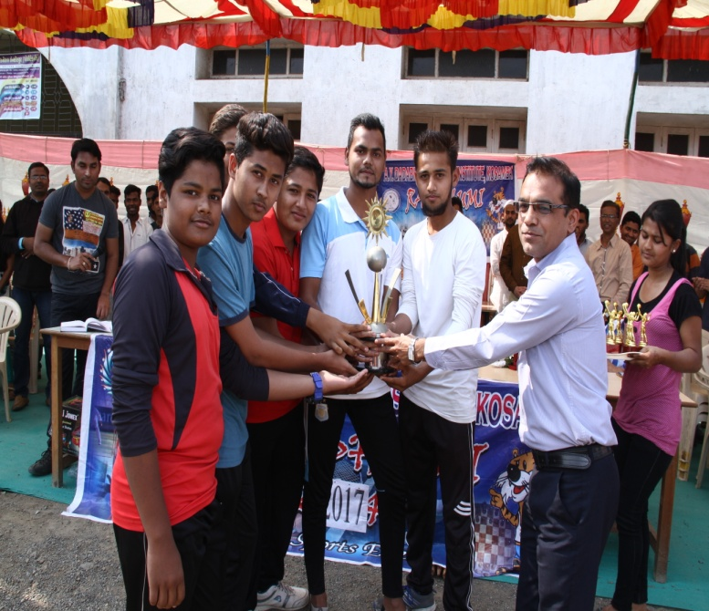

**WINNER OF VOLLEYBALL (BOYS)**

**Civil Engineering Department**

**(2nd semester)**

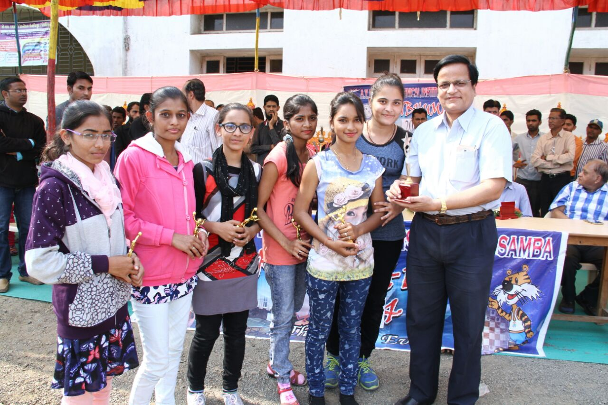

**WINNER OF VOLLEYBALL(GIRLS)**

**Computer Engineering Department**

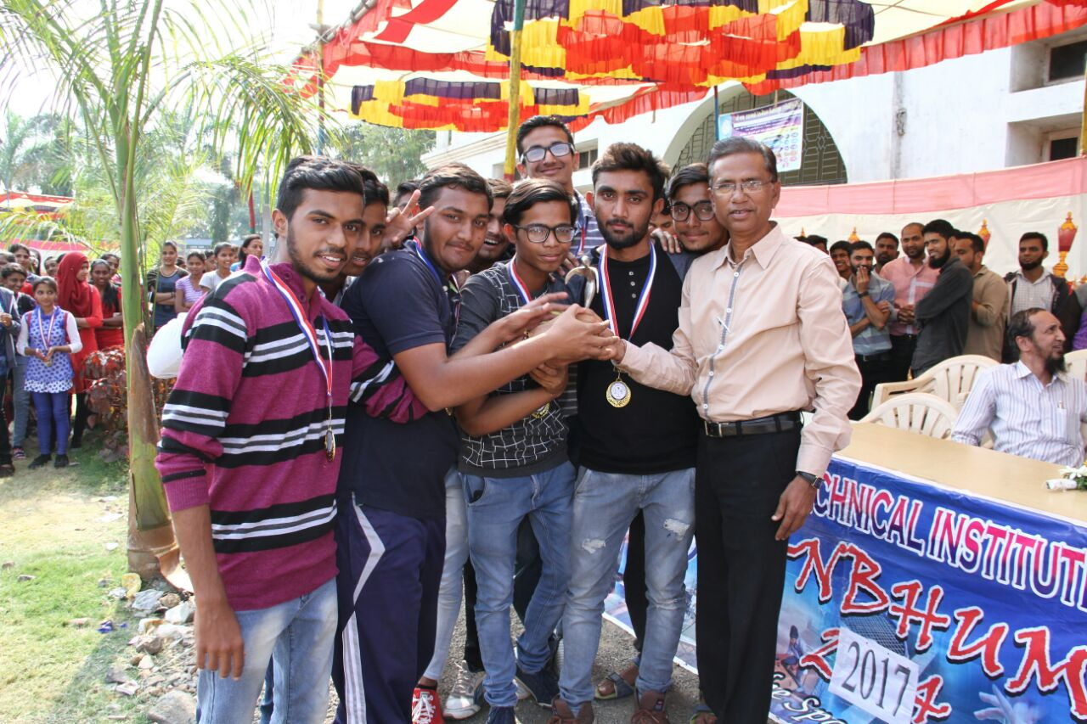

**WINNER OF KHO-KHO (BOYS)**

**Civil Engineering Department**

**(6th semester)**

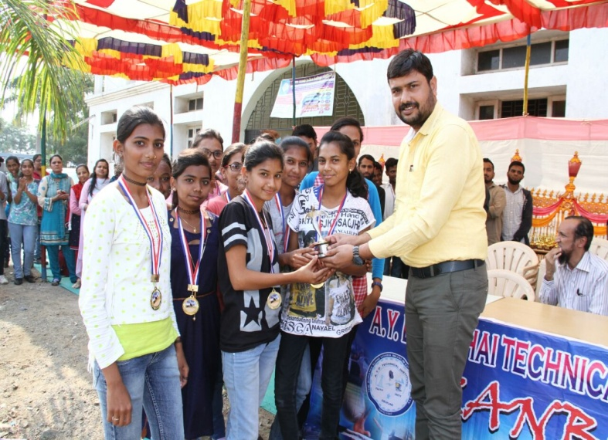

**WINNER OF KHO-KHO (GIRLS)**

**Civil Engineering Department**

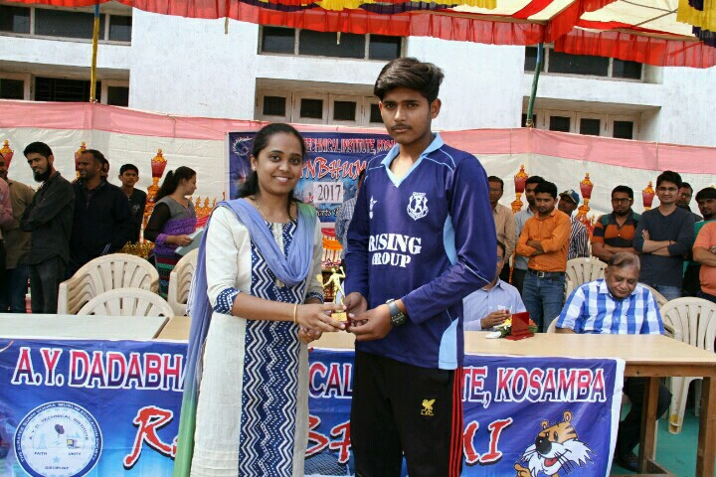

**WINNER OF BADMINTAN(BOYS)**

**KAZI FARHAN**

**Computer Engineering Department**

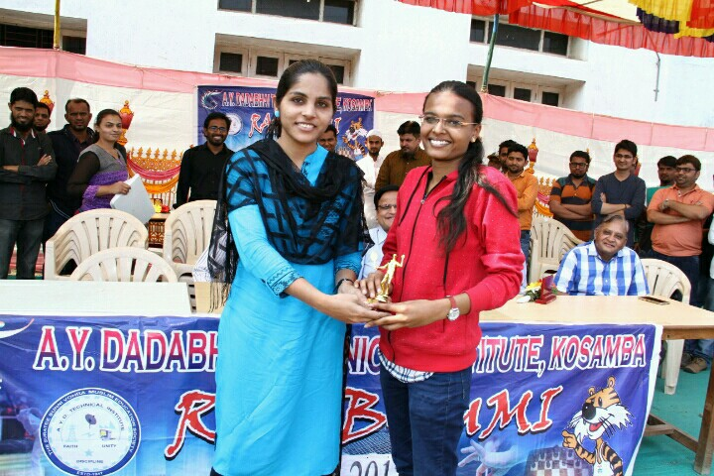**(4th Semester)**

**WINNER OF BADMINTAN (GIRLS)**

**CHAUHAN DIPALI K.**

**Computer Engineering Department**

**(6TH Semester)**

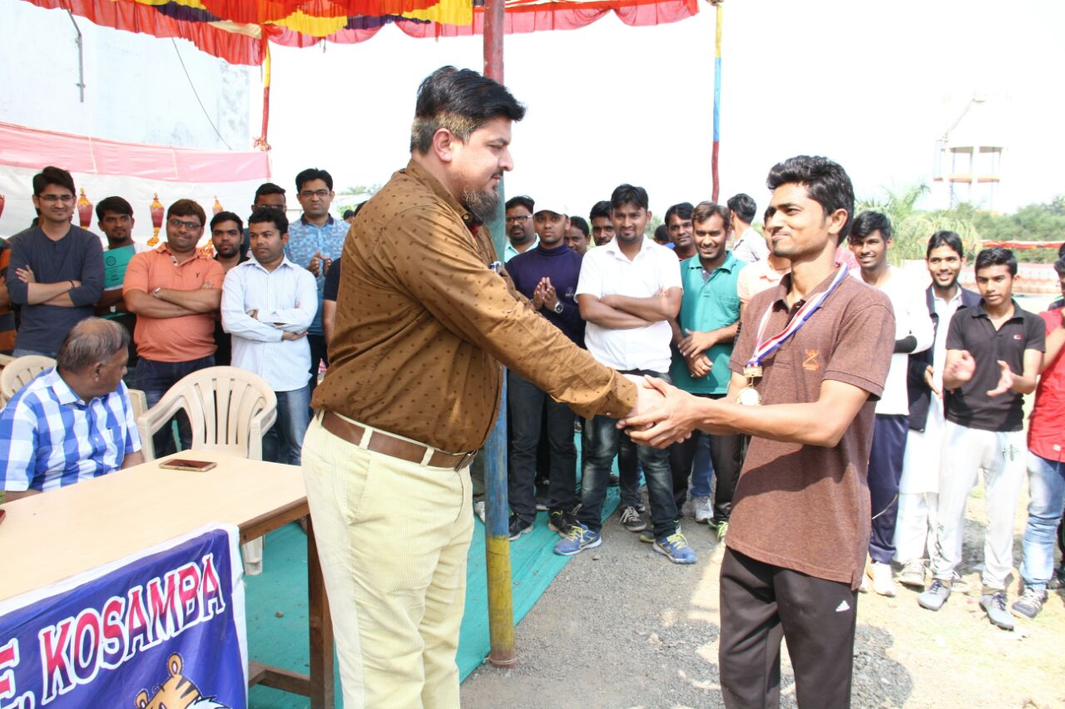

**WINNER OF CARROM (BOYS)**

**(VASAVA MANISH – VASAVA ROHAN)**

**(Mechanical Engineering Department)**

**(6TH Semester)**

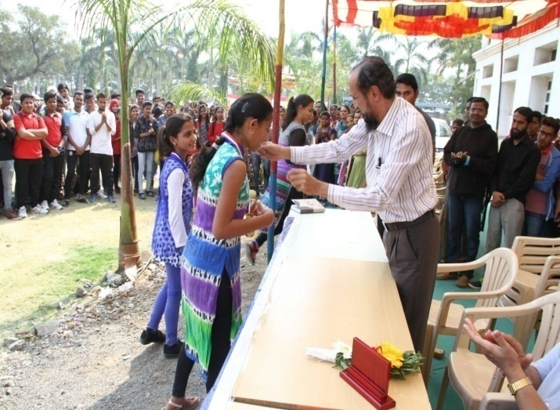

**WINNER OF CARROM(GIRLS)**

**(VASAVA DHRUVI – LAD HEMANGINI)**

**(Computer Engineering Department)**

**(4th semester)**

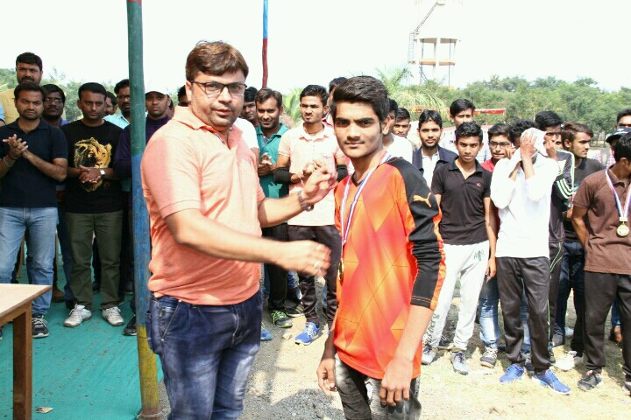

**WINNER OF CHESS (BOYS)**

**PATEL MOHAMMED UZAIR**

**(Civil Engineering Department)**

**(2nd Semester)**

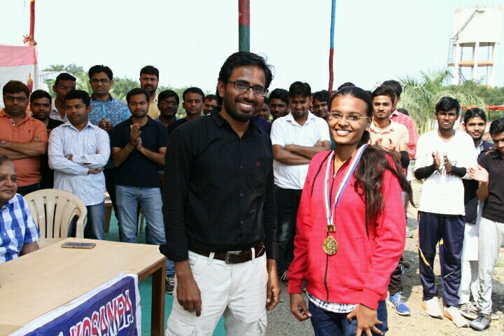

**WINNER OF CHESS (GIRLS)**

**CHAUHAN DIPALI K.**

**(Computer Engineering Department)**

**(6TH Semester)**

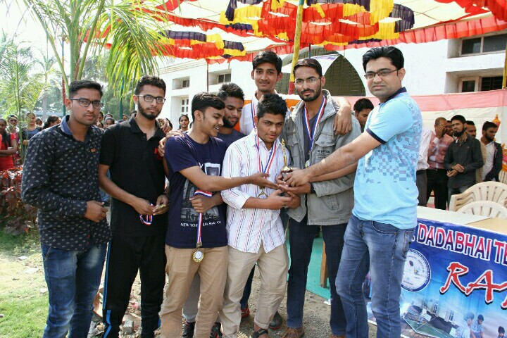

**WINNER OF TUG OF WAR (BOYS)**

**Electrical Engineering Department**

**(6th Semester)**

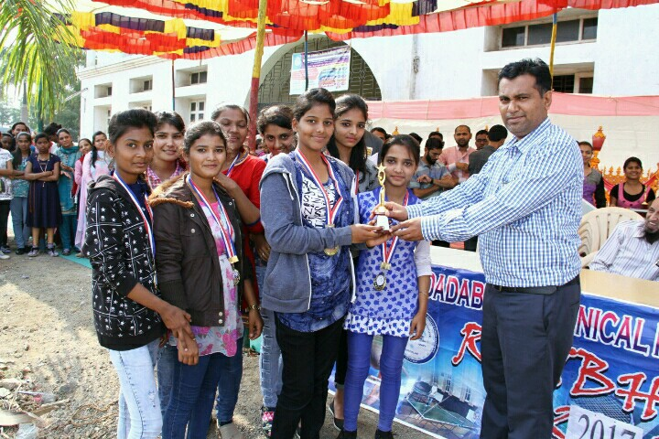

**WINNER OF TUG OF WAR (GIRLS)**

**Computer Engineering Department**

**(4th Semester)**

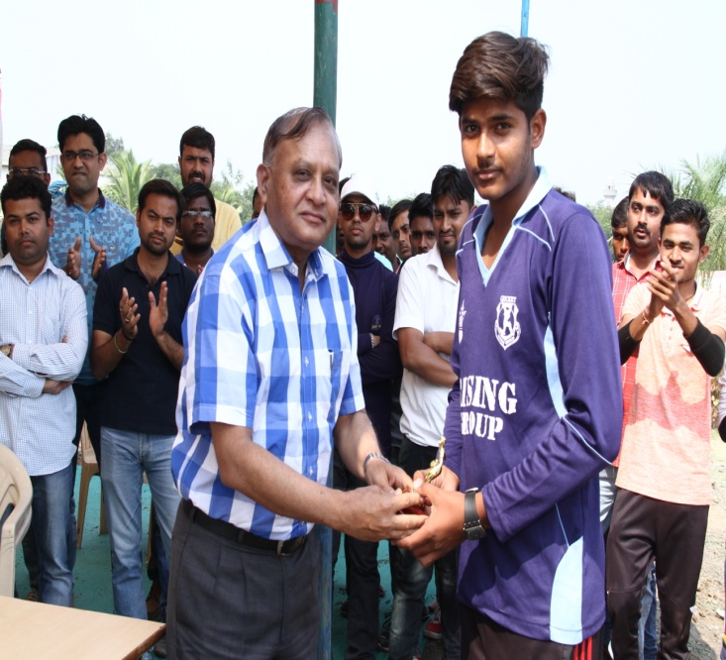

**WINNER OF TABLE TENNIS (BOYS)**

**KAZI FARHAN**

**Computer Engineering Department**

**(4th Semester)**

**MOMENTS OF RANBHUMI- 2017**

