**A.Y.DADABHAI TECHNICAL INSTITUTE, KOSAMBA**

**ELECTRONICS AND COMMUNICATION ENGINEERING DEPARTMENT**

**REPORT ON INDUSTRIAL VISIT AT BSNL, SURAT**

**DATE: 25/08/2015**

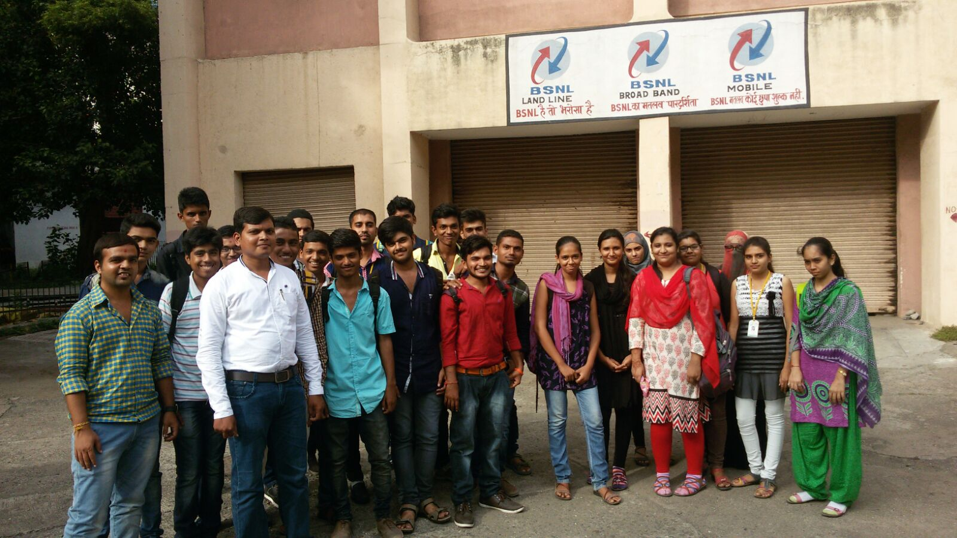

We have organized the Industrial visit of semester 5th students at BSNL market telephone exchange at Surat. Total 31 students and two staff members are participated in this visit. All students and faculty members reach at exchange at 10:30 am on the 25th august 2015. The security and other terms and conditions are agreement by students.

The students are divided in to two groups. The Deputy engineer G. S. Patel and their technical staff members have given detail working of various sections like NIB, GSM-MSC, TRANSMISSION OFC Room, Power plant and battery room etc. The students understands the how the landline and mobile networks are works. The each team of students has spent more than an hour in the every section. Finally students visited the power plant and battery sections and understand the process of power management in case of power failed. In every section, students have asked various questions and got the detail answers by the technical staff.

The visit was finished at 4:30 pm.