|  |
| --- |
| **A. Y. DADABHAI TECHNICAL INSTITUTE,**  **KOSAMBA (R.S.)** |

**22nd APRIL, 2015**

***A REPORT***

***On***

***5th Annual Function cum Farewell and 3rd Alumni Meet “SANKALAN”***

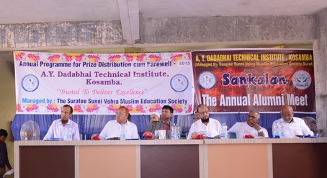

A. Y. Dadabhai Technical Institute, Kosamba (R. S.) organized its 5th annual function cum Farewell and 3rd Alumni Meet *“SANKALAN”* on Wednesday 22nd April, 2015. Function was attended by more than 500 students along with alumni members. Function was graced with the presence of chief guest **Dr. Shivendra Gupta**, Management Educational Professional and Technical Advisor of GTU.

Annual function was started at 10:00 am in the morning, with inaugural prayer presented by a group of girls and a student as per our Indian tradition. It was followed by flower felicitation and welcome of our chief guest Dr. Shivendra Gupta along with President of the trust “The Surati Sunni Vohra Muslim Education Society”, Mr Salimbhai Patel, Secretary Mr. Bhana Patel and other respected trustees.

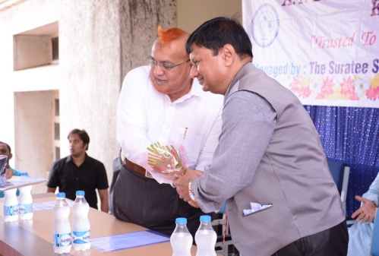**Flower Felicitation And Welcome**

*Secretary of Trust Mr. Bhanabhai Patel felicitating Dr. Shivendra Gupta*

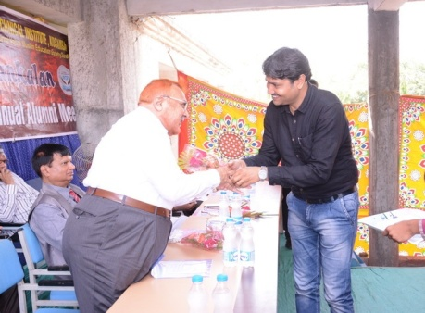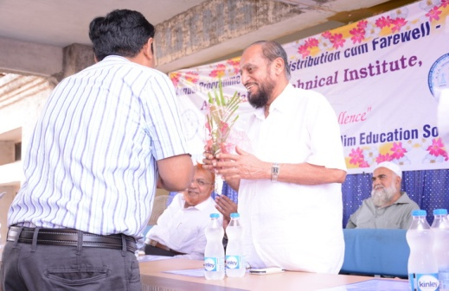

Then after one of the WID Cell member Ms Niharika Lad briefed every one about the two important schemes i.e. **Tejashwini** for girl child, recently launched on **14th March, 2015** in the presence of some well known personality like Mr. Lavjibhai Dalia (Social Worker), Mrs Trupti Almora (I/C Director, Narmada College of Management) and Mr. Rakesh Khopker (GM, Piramal Glass Ltd) based on the theme “BETI BACHAO, BETI PADHAO” by our honorable Prime Minister Shree Narendra Modi.

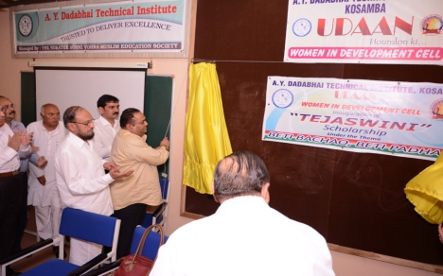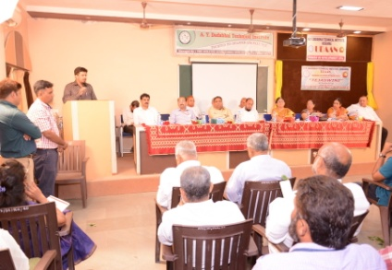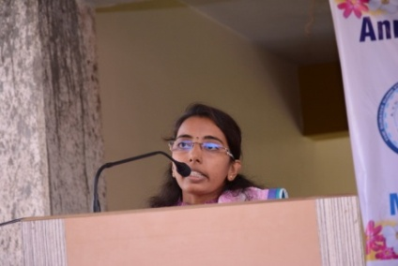**Tejashwini**

Another scheme **“SETU – ek kadi”**, to help under privilege people in rural area with clothes and other basic requirements, which was appreciated with an award under **iSCALE** during award function held by **GTU Innovation Council** on 14th February, 2015.

**“SETU – ek kadi”**

 

Subsequent to the introduction of two schemes, **3rd edition** of Institute’s Annual Magazine **“RAHEIN-path to glory”** was launched by all the dignitaries and praised by the Chief Guest.

**Launching moment of Rahein**a

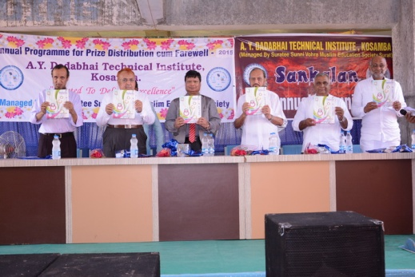

College has achieved many milestones in the academic field as well as in other co-curricular activity through students, which was appreciated with prize distribution.

In the academic section, total of 16 silver medals was distributed to 1st, 2nd and 3rd ranker. Not only academic scholar were appreciated but also sports event **“RANBHUMI-2015”** winners in different games like Cricket, Volleyball, Kho-Kho, Badminton, Table Tennis etc as well as **“PRAKALP-2015”** (Project Competition for 6th Semester Students and Quiz Competition for 2nd & 4th Semester Students) winners were awarded with certificate and reward by the Chief Guest and other dignitaries.

**Medal distribution**

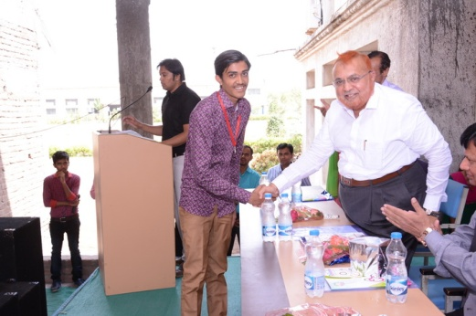 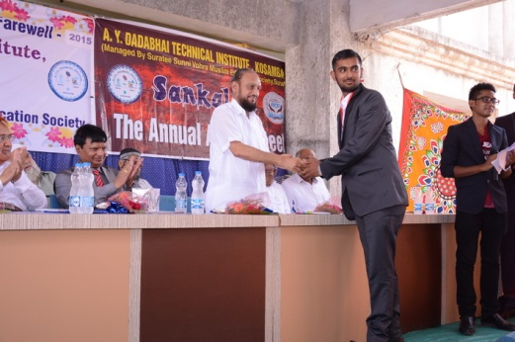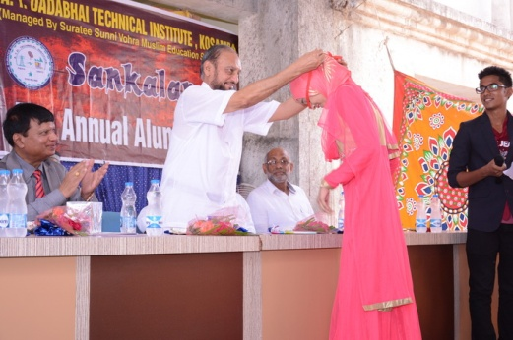 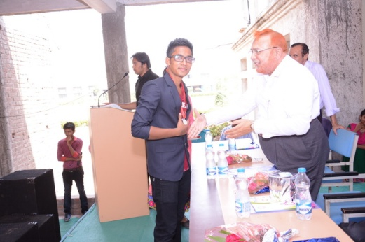

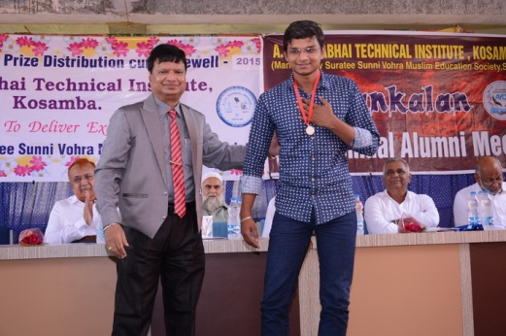 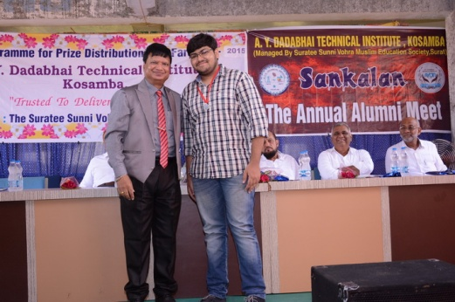

**Ranbhumi Prize distribution**

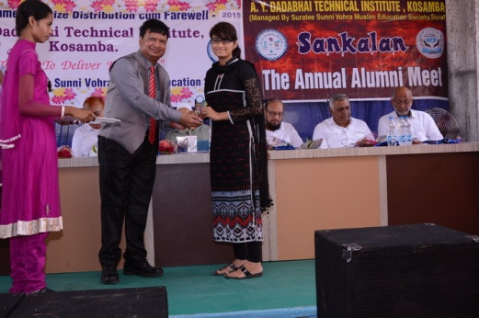 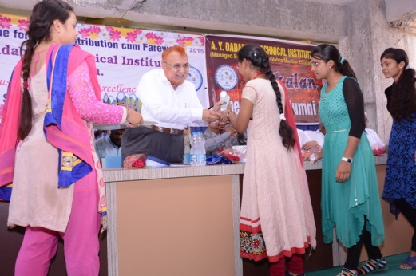

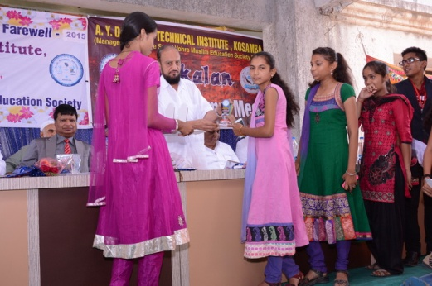 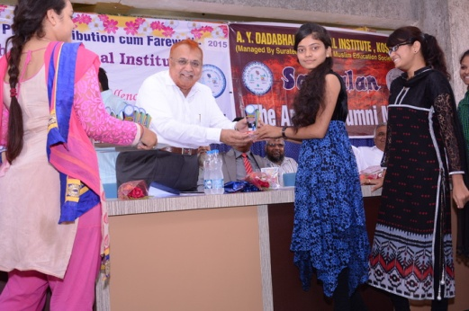

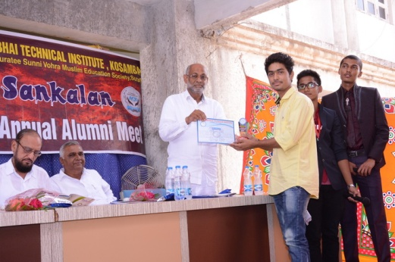 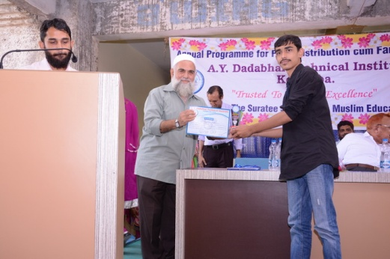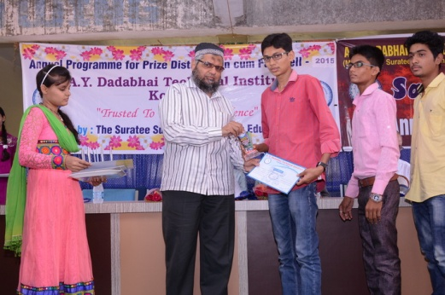 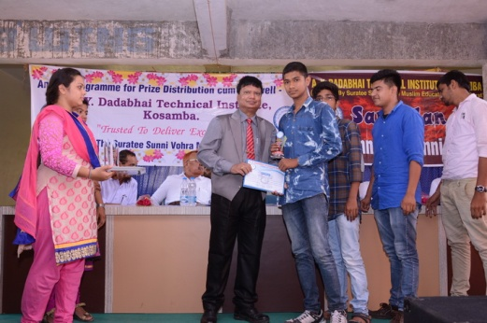

**Prakalp (Project Prize distribution)**

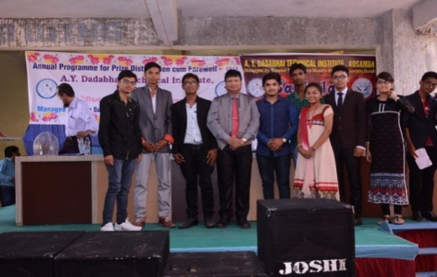 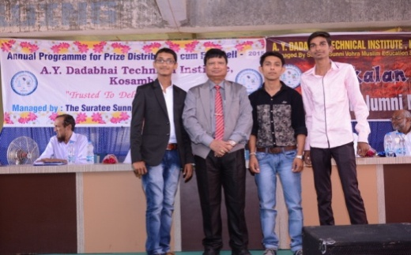

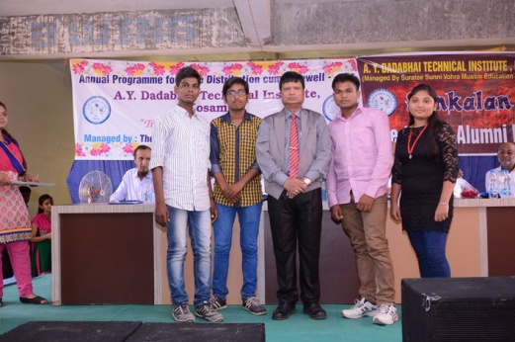 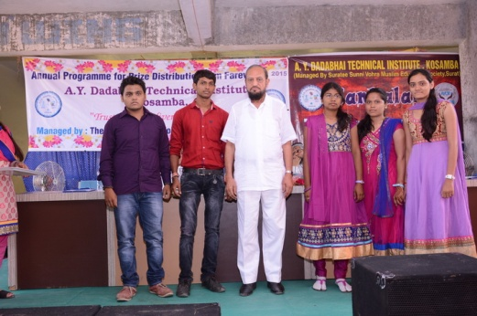

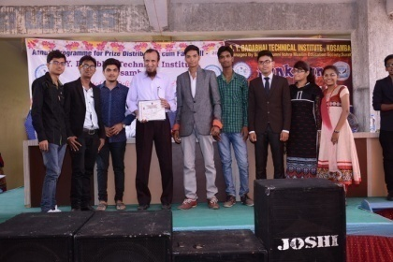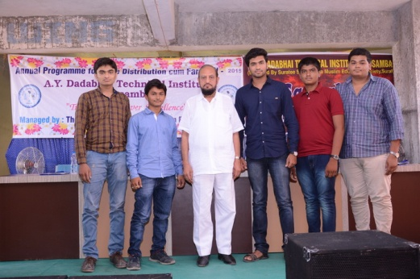

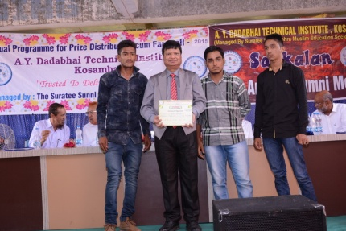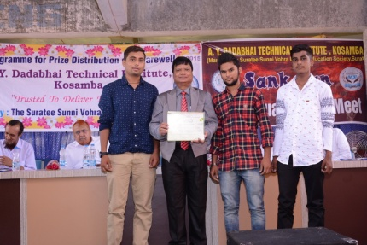

Prize distribution followed by Inspiring and motivational speech by chief guest Dr. Shivendra Gupta regarding the practical life and the condition which will going to be faced by final year students in their upcoming life. He communicated so nicely about the positive attitude that all staff members, students and alumni students were filled by positive energy. It was concluded on high note with great cheer from students with motivational “Urdu” sayari.

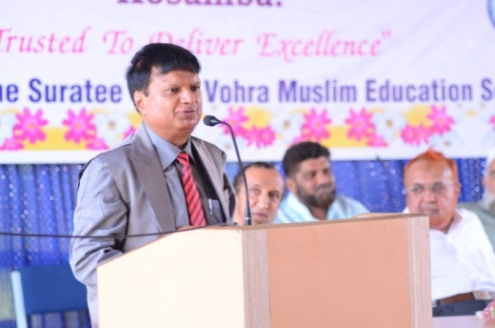 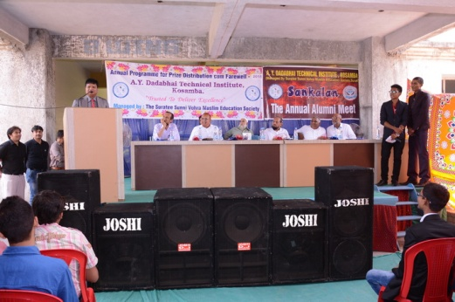

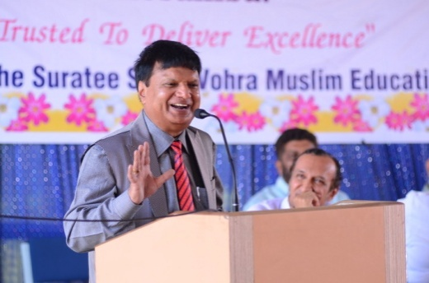 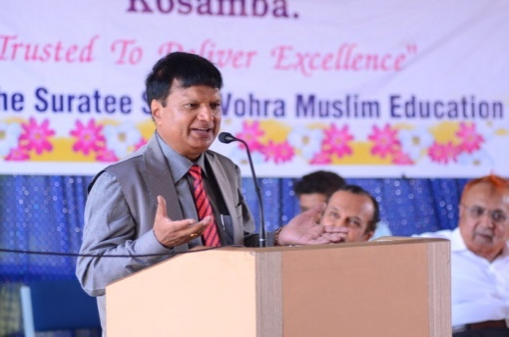

After a while, it was concluded with vote of thanks by Mr. Denish Maisuriya especially to our chief guest, who spared their valuable time with us and all the trust members for their inexorable support.

Latter, the function was followed by light and joyful events, specially arranged for the alumni members as well as the final year student, who will be the alumni very soon. This session contained variety of entertaining items like one minute games, singing performance, solo music playback, drama etc.

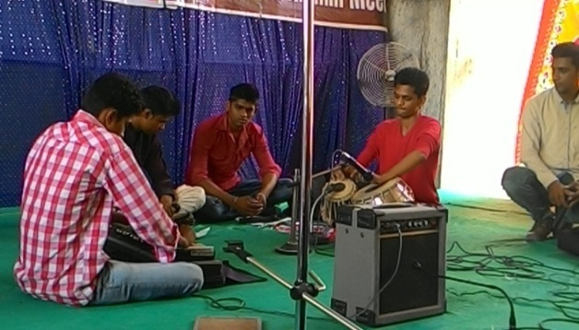 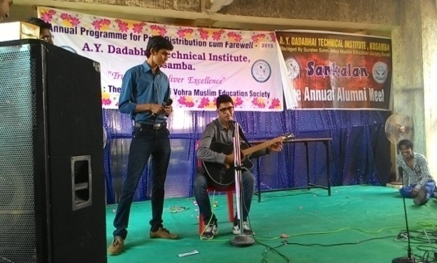

**Singing Performance by Students**

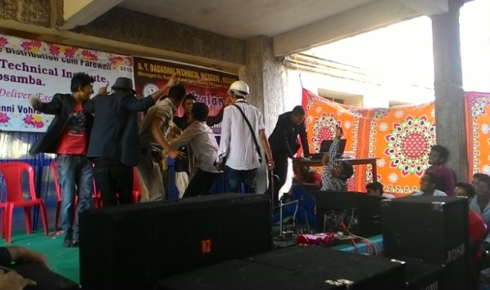 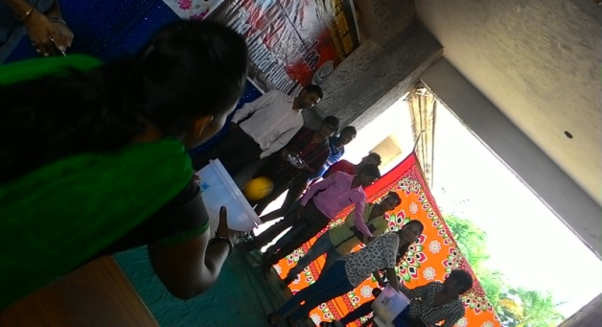

**Comedy Drama played by Students Girl Students with One Minute Game**

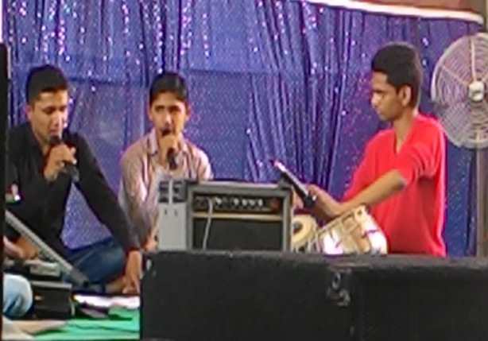 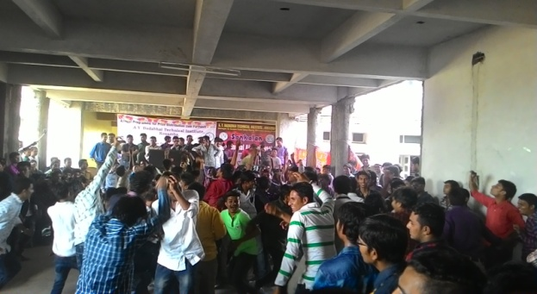

Singing Gazal & Dancing with DJ

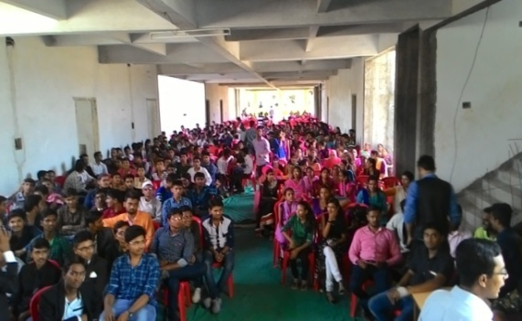 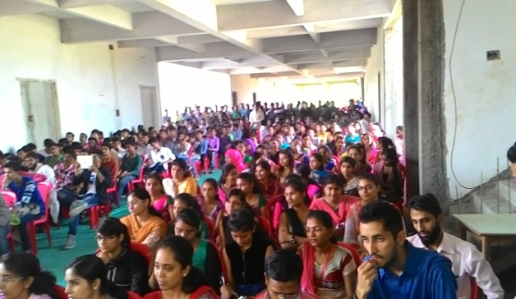

Students & Staff Members Enjoying Performances