**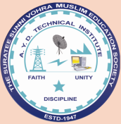**

***A REPORT***

***On***

Celebration of ***“68th Republic day”***

Proud to celebrate republic day of our nation when the government of common public exist by strong effort of Dr. Bhimrao Ambedkar. From 26th Jan, 1950, our country become self ruled, we Indians now free to elect our leader who might brought our nation in the race of developing country. After all of these success, we should not forget our freedom fighter without whom existence of this day may not possible. In order to continue our respect toward our nation, A. Y. Dadabhai Technical Institute, Kosamba (R.S.), have celebrated 68th republic day with lots of proud and respect for our freedom fighter.

***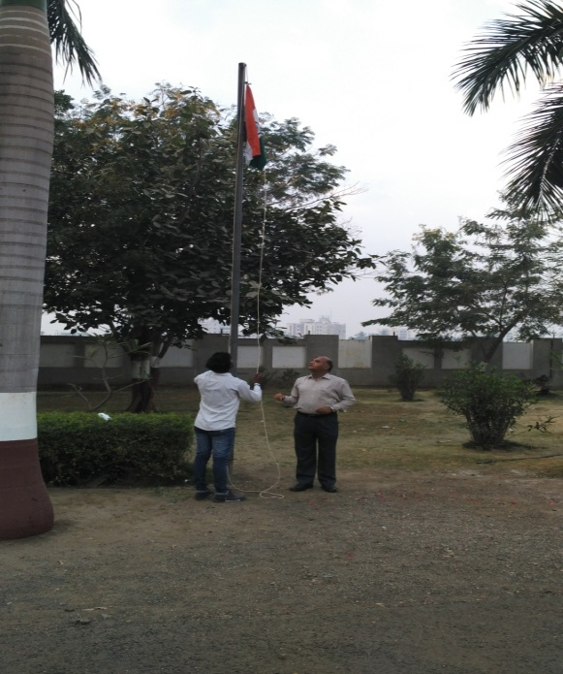 Flag Hosting***

As the trend early in the morning at about 7:45 am, principal Mr. H. I. Patel has hosted the flag which was followed by national anthem and national song.

Student have also participated in this ceremony with their views, some of them have shared that with us. Miss Fatem from Computer Engg. Department have told about the current situation and early situation and also thrown some light on comparision between these two situation.

***Staff Members***

|  |  |
| --- | --- |
| E:\1. SABIR\AYD\CULTURAL REPORT\19 67 republic day - Copy - Copy\26th jan\IMG_20170126_074305.jpg | E:\1. SABIR\AYD\CULTURAL REPORT\19 67 republic day - Copy - Copy\26th jan\IMG_20170126_074648.jpg |

***Students delivering speeches***

|  |  |
| --- | --- |
| E:\1. SABIR\AYD\CULTURAL REPORT\19 67 republic day - Copy - Copy\26th jan\IMG_20170126_074656.jpg | E:\1. SABIR\AYD\CULTURAL REPORT\19 67 republic day - Copy - Copy\26th jan\IMG_20170126_075002.jpg |

Mr. Chintan Makwana from Civil Engg. Department has told about the inspirational story about to set high goal, he also spoke about to bring our nation in front line with applying maximum effrot toghter.

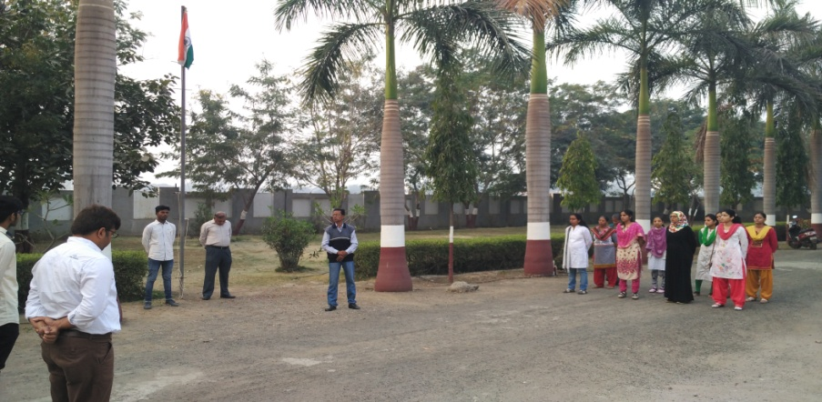Mr. N. J. Patel, faculty member from Civil Engg. Department has told about the brief history of Indian constitution and how it come in the action and which difficulties raised at that time. They also gave us ideas that why our constitution come in action on 26th Jan only. They gave three reason behind it.

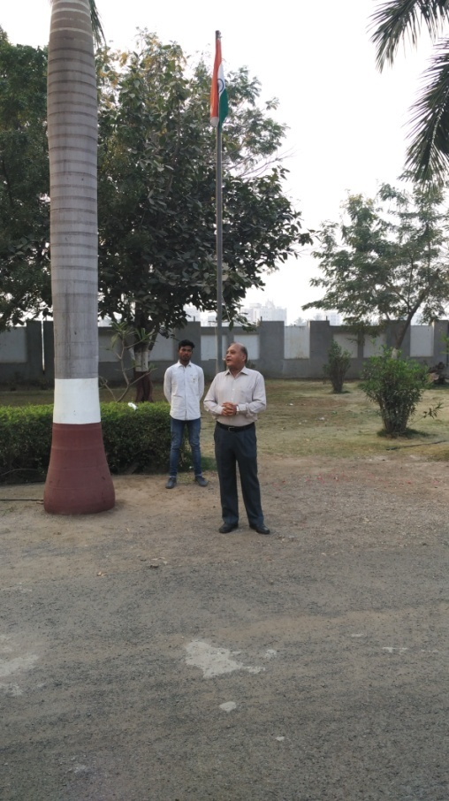Finally our chief guest Mr. H. I Patel sir have told about the current issues like demonetization, corruption, poverty and youth. They told about late honorable prime minister Shree Lal Bahadur Shastri, who had faced so many problem during their study. He also memorized us that Lal Bahadur Shastri had given a slogan “Jay Javan, Jay Kishan” but still situation very worst for JAVAN and KISHAN in nation is not good after 68 years of Republican.

The function was dismissed with some oath to take our nation ahead and bring some equality within us, and memories of freedom fighter.

***Moments of event***

|  |  |  |  |
| --- | --- | --- | --- |
| E:\1. SABIR\AYD\CULTURAL REPORT\19 67 republic day - Copy - Copy\26th jan\IMG_20170126_075736.jpg | | E:\1. SABIR\AYD\CULTURAL REPORT\19 67 republic day - Copy - Copy\26th jan\IMG_20170126_075946.jpg | |
|  |  | |  |
| E:\1. SABIR\AYD\CULTURAL REPORT\19 67 republic day - Copy - Copy\26th jan\IMG_20170126_074702.jpg | E:\1. SABIR\AYD\CULTURAL REPORT\19 67 republic day - Copy - Copy\26th jan\IMG_20170126_075008.jpg | | E:\1. SABIR\AYD\CULTURAL REPORT\19 67 republic day - Copy - Copy\26th jan\IMG_20170126_075329.jpg |