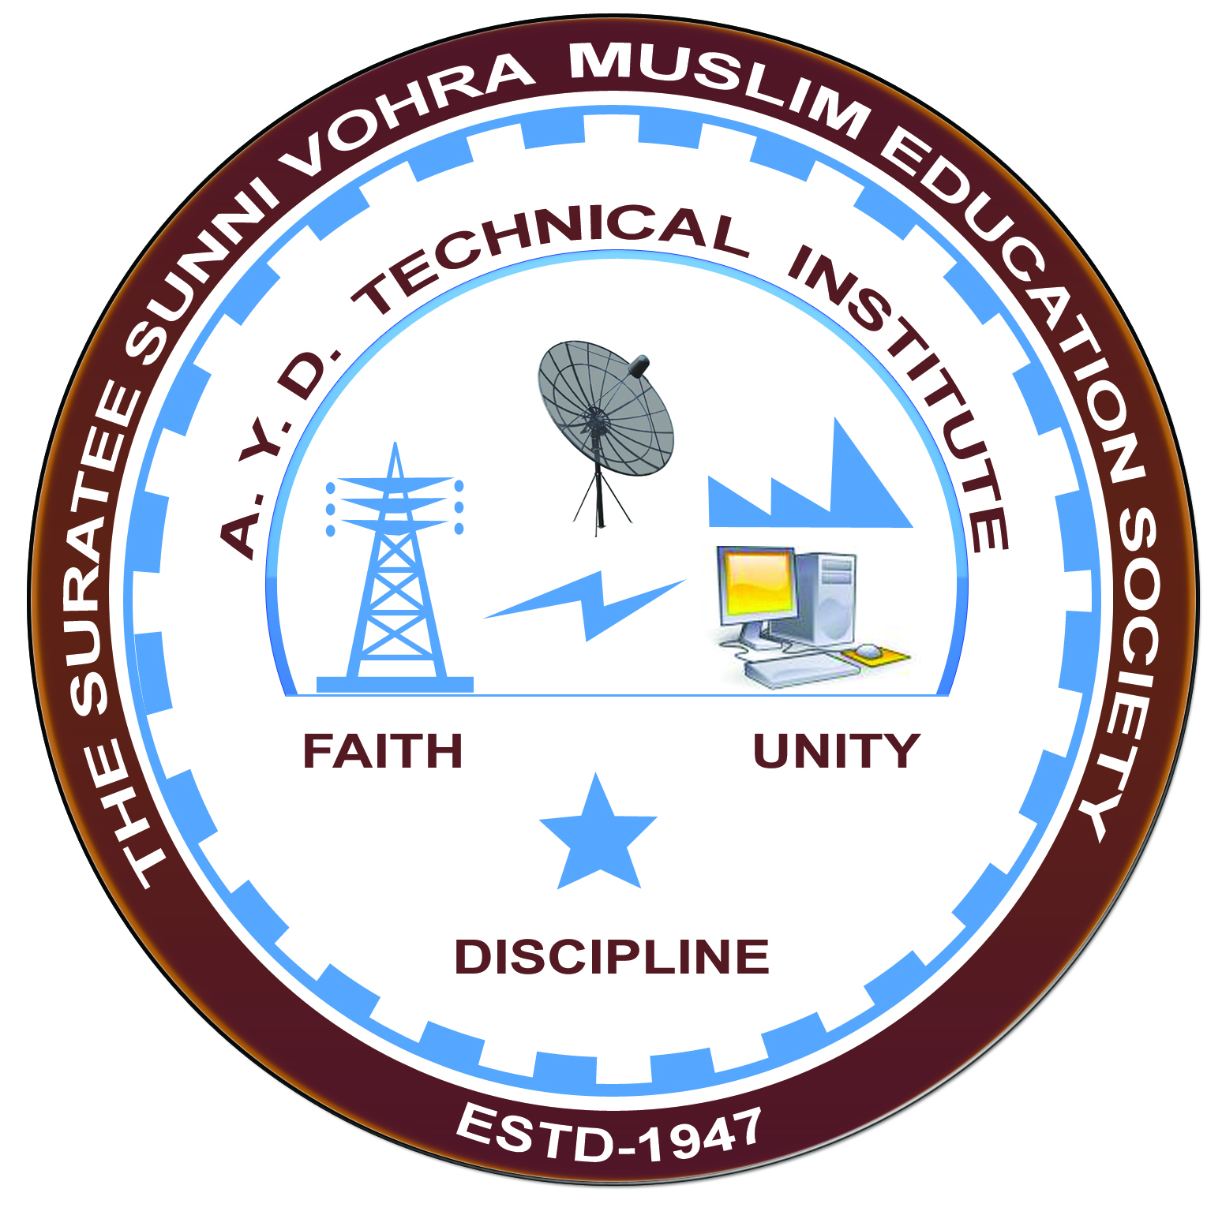

**PLC AND SCADA**

**Arranged by**

**Electrical Engineering Department,**

**A.Y.DADABHAI TECHNICAL INSTITUTE, KOSAMBA**

**REPORT ON EXPERT LECTURE**

**DATE:-** 25TH FEBRUARY 2023

**DEPARTMENT:-** Electrical Engineering

**SEM**:-6TH SEM

**FACULTY: -** (1) Mr. M S Dinath

(2)Mr. M H Darsot

(3) SNEHA MANIK

(4) Mr.M A Shiekh

(5) Mr. M Y Patel

(6) RAVI SINGH

(7) MAMTA VANSIYA

**NO OF STUDENTS: - 45**

|  |  |  |
| --- | --- | --- |
| **Name Of Expert** | **Designation** | **Organization Of Expert** |
| Mr ADARSH MISHRA  MISS BHAVI DESAI | TRAINNER | ALPHATECH AUTOMATIONS,VADODARA |

**Topic Of Expert Lecture:-PLC ,SCADA AND INDUSTRIAL AUTOMATIONS**

**Brief about Expert Lecture:-**

Our electrical engineering department of A. Y. Dadabhai Technical Institute, Kosamba Had organized expert lecture on**:-“DC MACHINES PLC AND SCADA SYSTEM”**on the date of25TH FEBRUARY2023.The session was very interactive and students participated enthusiastically. The workshop was divided into two sessions. The first were held before lunch. First session was conducted by Miss Bhavi Desai. She introduced a key concept of PLC AND SCADA. Shealso covered the role of home automations and industrial automations in modern era. In the second she session saw some practical thing.

Both the sessions also included multimedia resources to better elucidate key concepts.

The students showed keen interest in the workshop and gave gained hands on experience in the topics of PLC AND SCADA. As per the feedback received from the students it was very good learning experience, the lecture helped them in understanding the concepts of PLC and SCADA.

**PHOTO’S OF EXPERT LECTURE**

