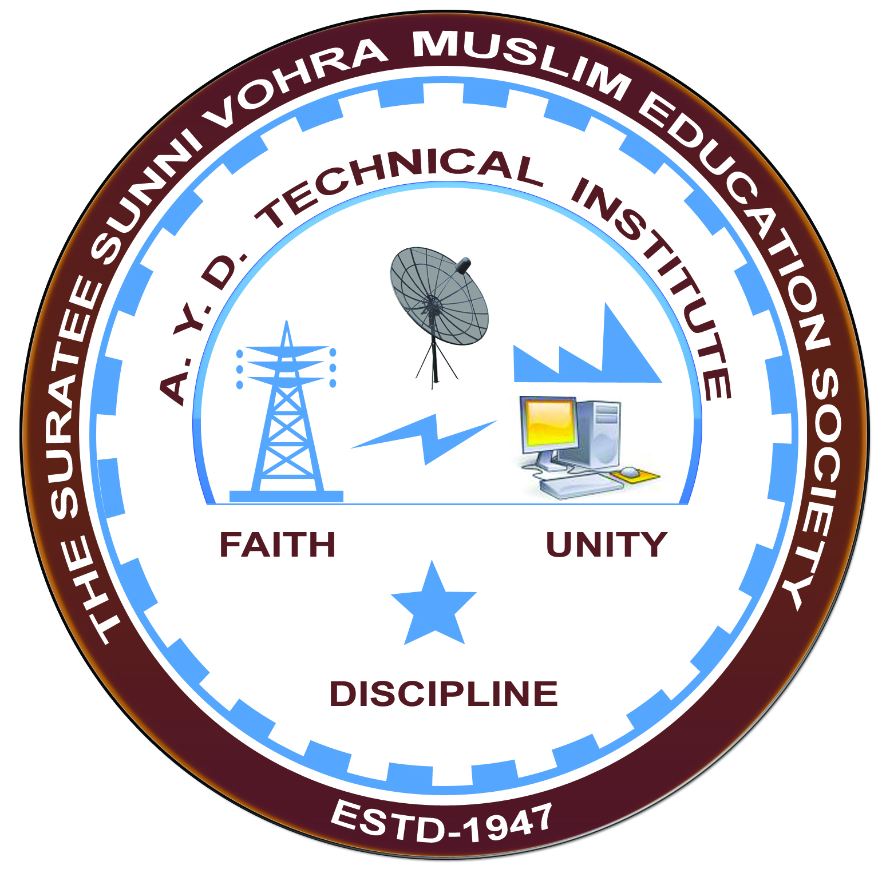

**MOTIVATIONAL SPEECH & CARRIER GUIDANCE**

**Arranged by**

**Electrical Engineering Department,**

**A.Y.DADABHAI TECHNICAL INSTITUTE, KOSAMBA**

**REPORT ON EXPERT LECTURE**

Date:- 9/9/2019

Department:- Electrical Engineering

Sem:- 1st Semester

Faculty:- (1) Mr. M. Y. Patel

(2) Mr. M. A. Sheikh

No Of Students:-73

|  |  |  |
| --- | --- | --- |
| **Name Of Expert** | **Designation** | **Organization Of Expert** |
| Mr. Javid Karodiya | Teacher | MOTA VARACHHA HIGH SCHOOL |
| Mr. Iqbal Mulla | Teacher |

**Topic:- Motivational Speech & Carrier Guidance**

Brief About Expert Lecture:

Our electrical engineering department of A. Y. Dadabhai Technical Institute, Kosamba Had organized expert lecture of Electrical Power Generation & transmission on the date of 30 August 2019

MR.JAVID KARODIYA had given motivational speech to students. They told the students not to give up. He also said that you are good enough and the perfect job is out there for you.Also he said that you need a little encouragement and push in right direction. MR.IQBAL MULLA had given carrier guidance.

**PHOTO GALLERY:**

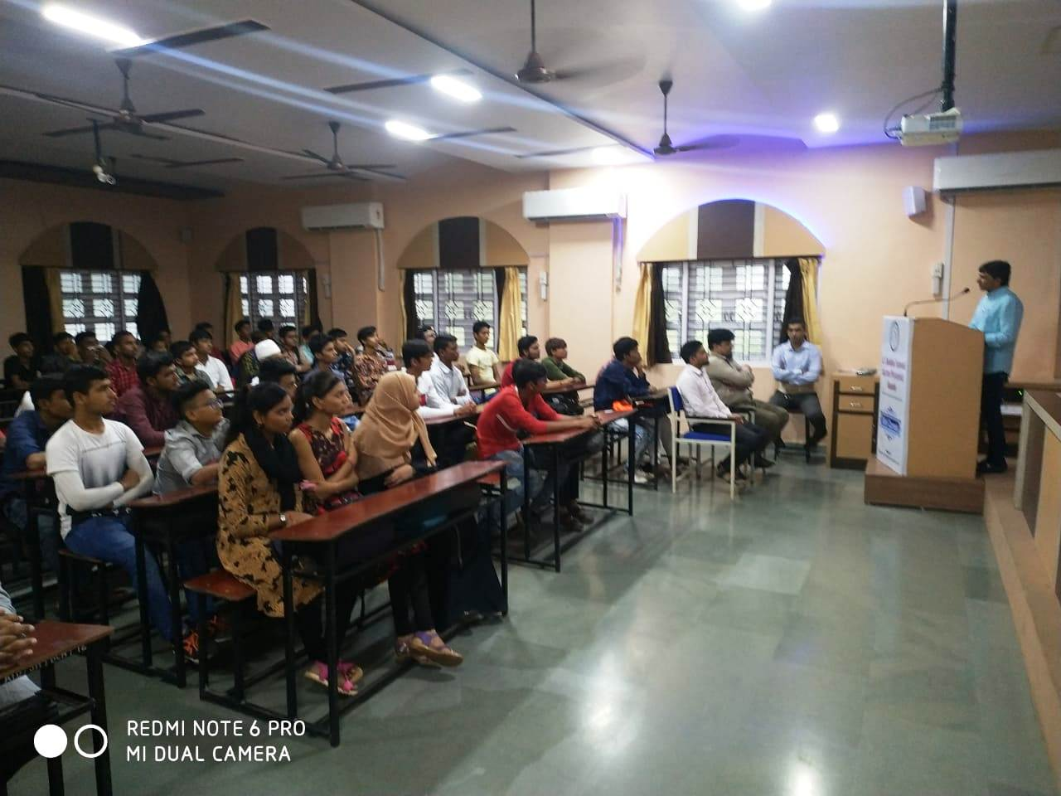

**EXPERT SPEECH**

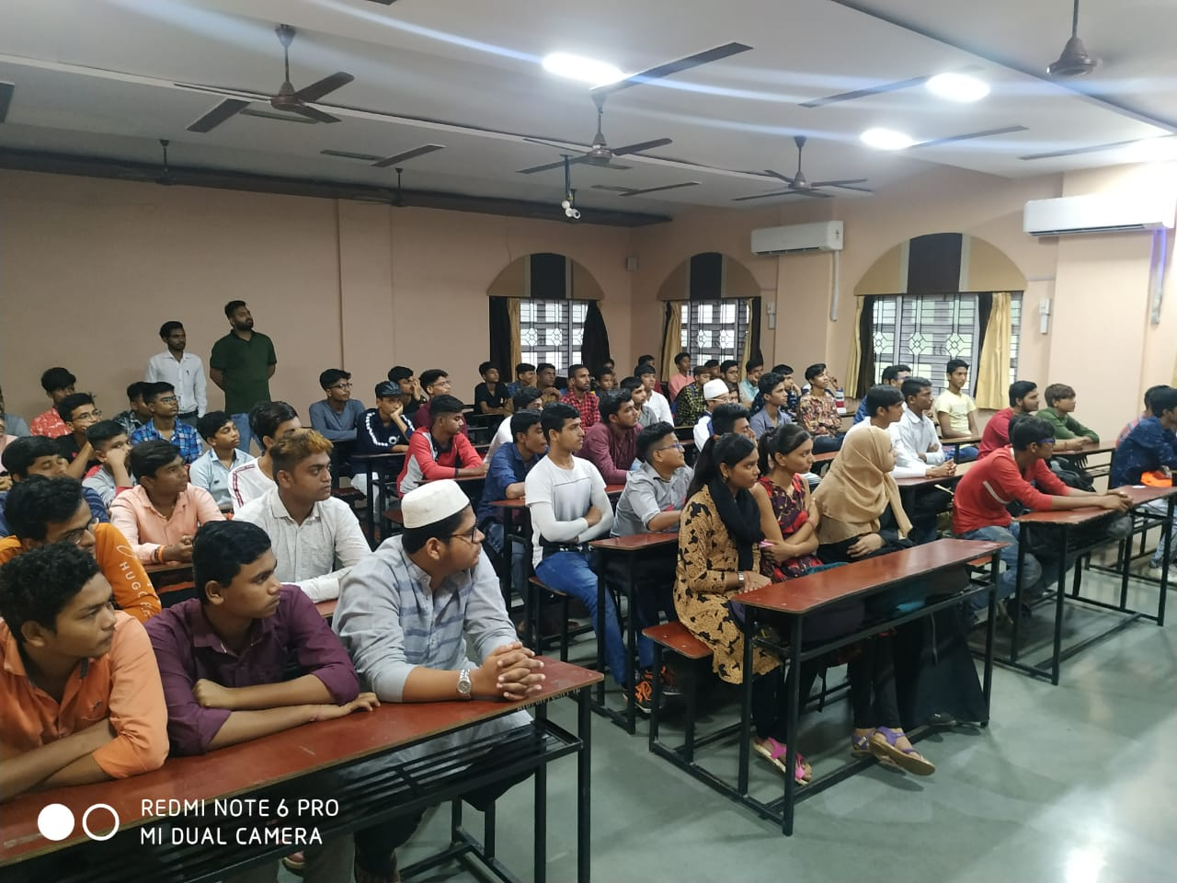

**STUDENTS PARTICIPATED**

