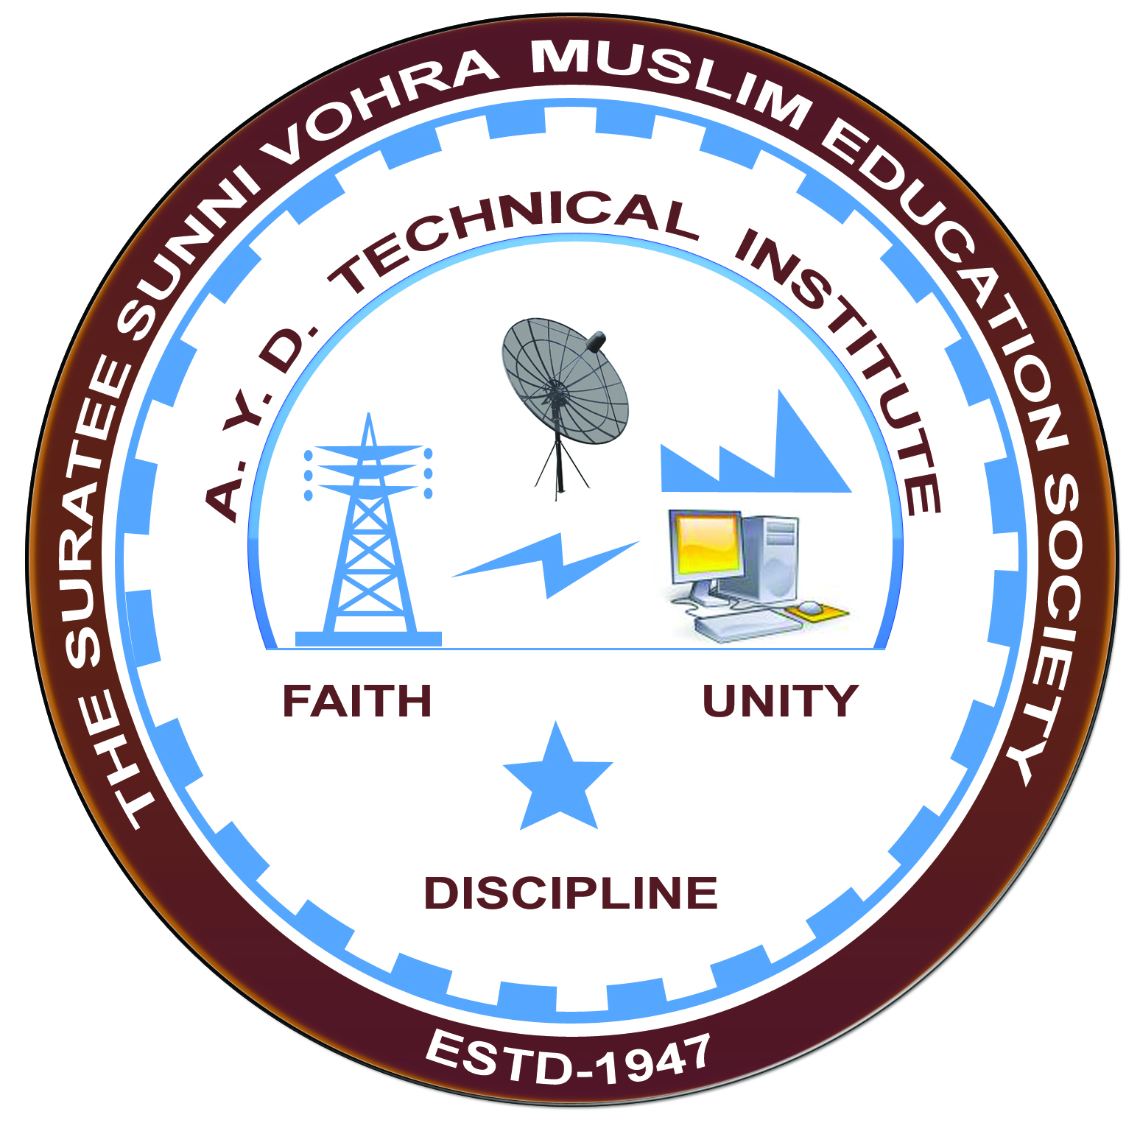

**APTITUDE TEST & SKILLS FOR INTERVIEW**

**Arranged by**

**Electrical Engineering Department,**

**A. Y. DADABHAI TECHNICAL INSTITUTE, KOSAMBA**

**REPORT ON EXPERT LECTURE**

**Date:-** 11-02-2023

**Department:-** Electrical Engineering

**Sem:-** 6th Semester

**Faculty: -** (1) Mr. M. S. Dinath

(2) Mr. R. J. Singh

**No of Students: -** 41

|  |  |  |
| --- | --- | --- |
| **Name Of Expert** | **Designation** | **Organization Of Expert** |
| MR HITESH S JARIWALA | T & P OFFICER | S.N.PATEL INSTITUTE OF TECHNOLOGY AND RESEARCH,UMRAKH,BARDOLI |
| MR JANAK B PATEL | ASSISTANT PROFESSOR | S.N.PATEL INSTITUTE OF TECHNOLOGY AND RESEARCH,UMRAKH,BARDOLI |

**Topic Of Expert Lecture:-** APTITUDE TEST AND SKILLS FOR INTERVIEW

**Brief about Expert Lecture:-**

Our electrical engineering department of A. Y. Dadabhai Technical Institute, Kosamba had organized expert lecture on aptitude test and skills for interview on the date of **11 February 2023**. **Mr. Hitesh S Jariwala** (T&P Officer) And **Mr. Janak Kumar B Patel** (Assistant Professor) from S.N.Patel Institute Of Technology And Research, Umrakh, Bardoli.

This Expert lecture is divided into two session one is aptitude test skills and the other is session is about skill for interview

First session is taken by Mr. Hitesh S Jariwala sir he give the knowledge about which types of aptitude question asked in different exam and he also show the some exam of latest questions asked in different aptitude exam of companies this year and student gets idea which types of questions asked in exam and prepare for which types of questions. Students gain so much of knowledge from this session and also enjoy the session.

Second session is taken by Mr. Janak B Patel sir has delivered an excellent lecture about which types of electrical question asked in interview and give example of some question asked in interview.

Both the session was highly motivating and insightful, and lead the way for students on Why and How they need to change their mind sets and how they can be industry they discussed the current industry requirements and the importance of technical support jobs in the industry. They shared the technologies which are required to be prepared by students to get technical support jobs. The session was very interactive and the students were very pleased after the session.

**Expert Lecture photo**

