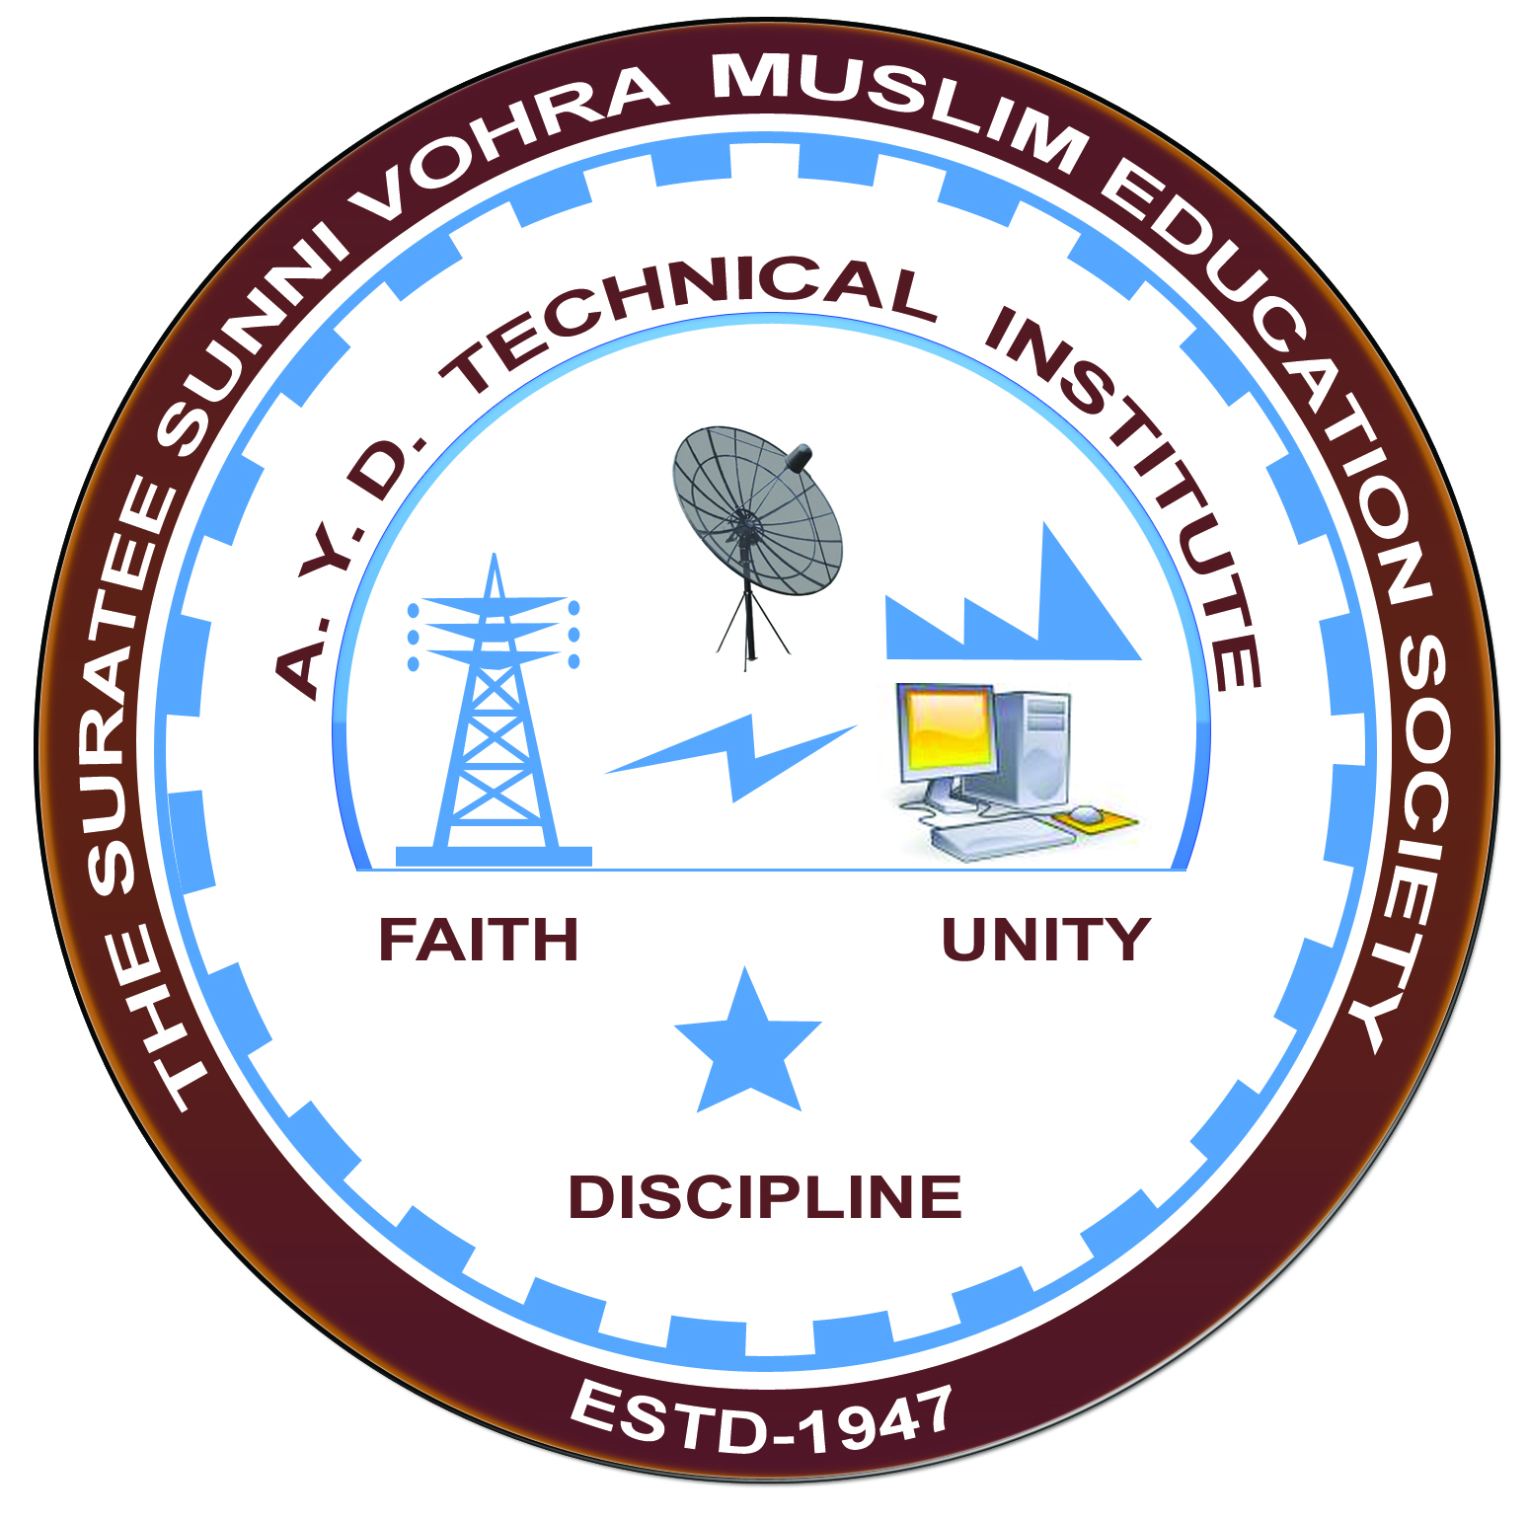

**Report on Expert Lecture**

**ELECTRIC TRACTION & CONTROL**

**Arranged by**

**Electrical Engineering Department,**

**A.Y.DADABHAI TECHNICAL INSTITUTE, KOSAMBA**

**EXPERT LECTURE**

**Date:-** 26/08/2019

**Department:-** Electrical Engineering

**Sem:-** 5th Semester

**Faculty: -** (1) Mr. M. Y. Patel

(2) Mr. M. R. Vansiya

**No of Students: -** 40

|  |  |  |
| --- | --- | --- |
| **Name Of Expert** | **Designation** | **Organization Of Expert** |
| Mr. C.J. Bhaidasna | Retired Section Engineer | Railway  (Electric Locoshade Valsad) |

**Topic Of Expert Lecture:-** Electric traction & control

**Brief about Expert Lecture:-**

Our electrical engineering department of A. Y. Dadabhai Technical Institute, Kosamba Had organized expert lecture on Electric traction & control system on the date of 26 August 2019

Mr. C. J. Bhaidasna started with basic of electric traction system & covers the topic of

* Different types of traction system
* Electrification of traction
* Traction substation
* Different types of traction motors
* Controlling of motors & different types of braking method used in traction system.
* Coach electrification

Finally Students discuss their query & technical problems with experts.

**PHOTO GALLERY:**

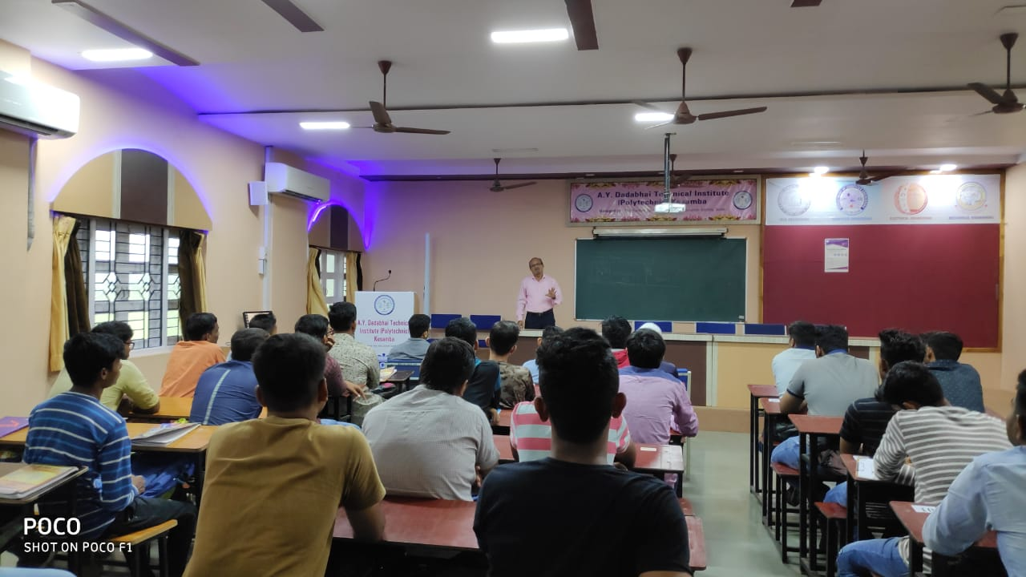

**MR.C.J.BHAIDASNA DELIVERING LECTURE**

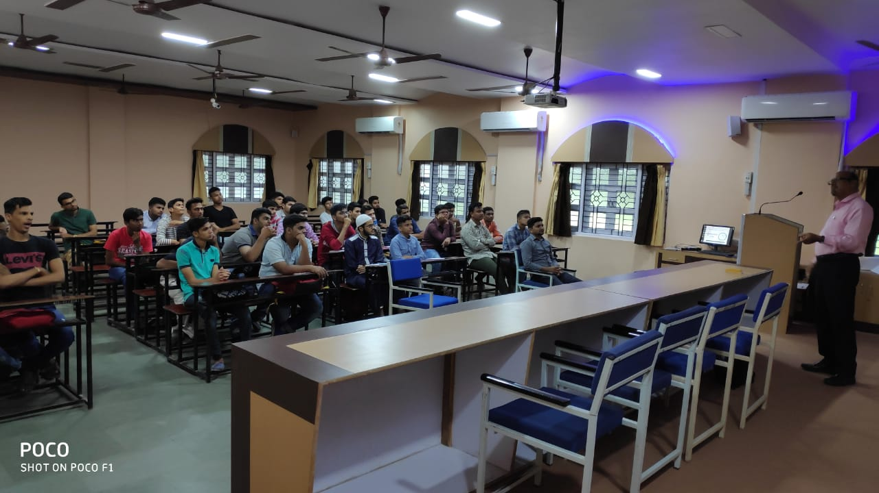

**STUDENTS PARTICIPATED**