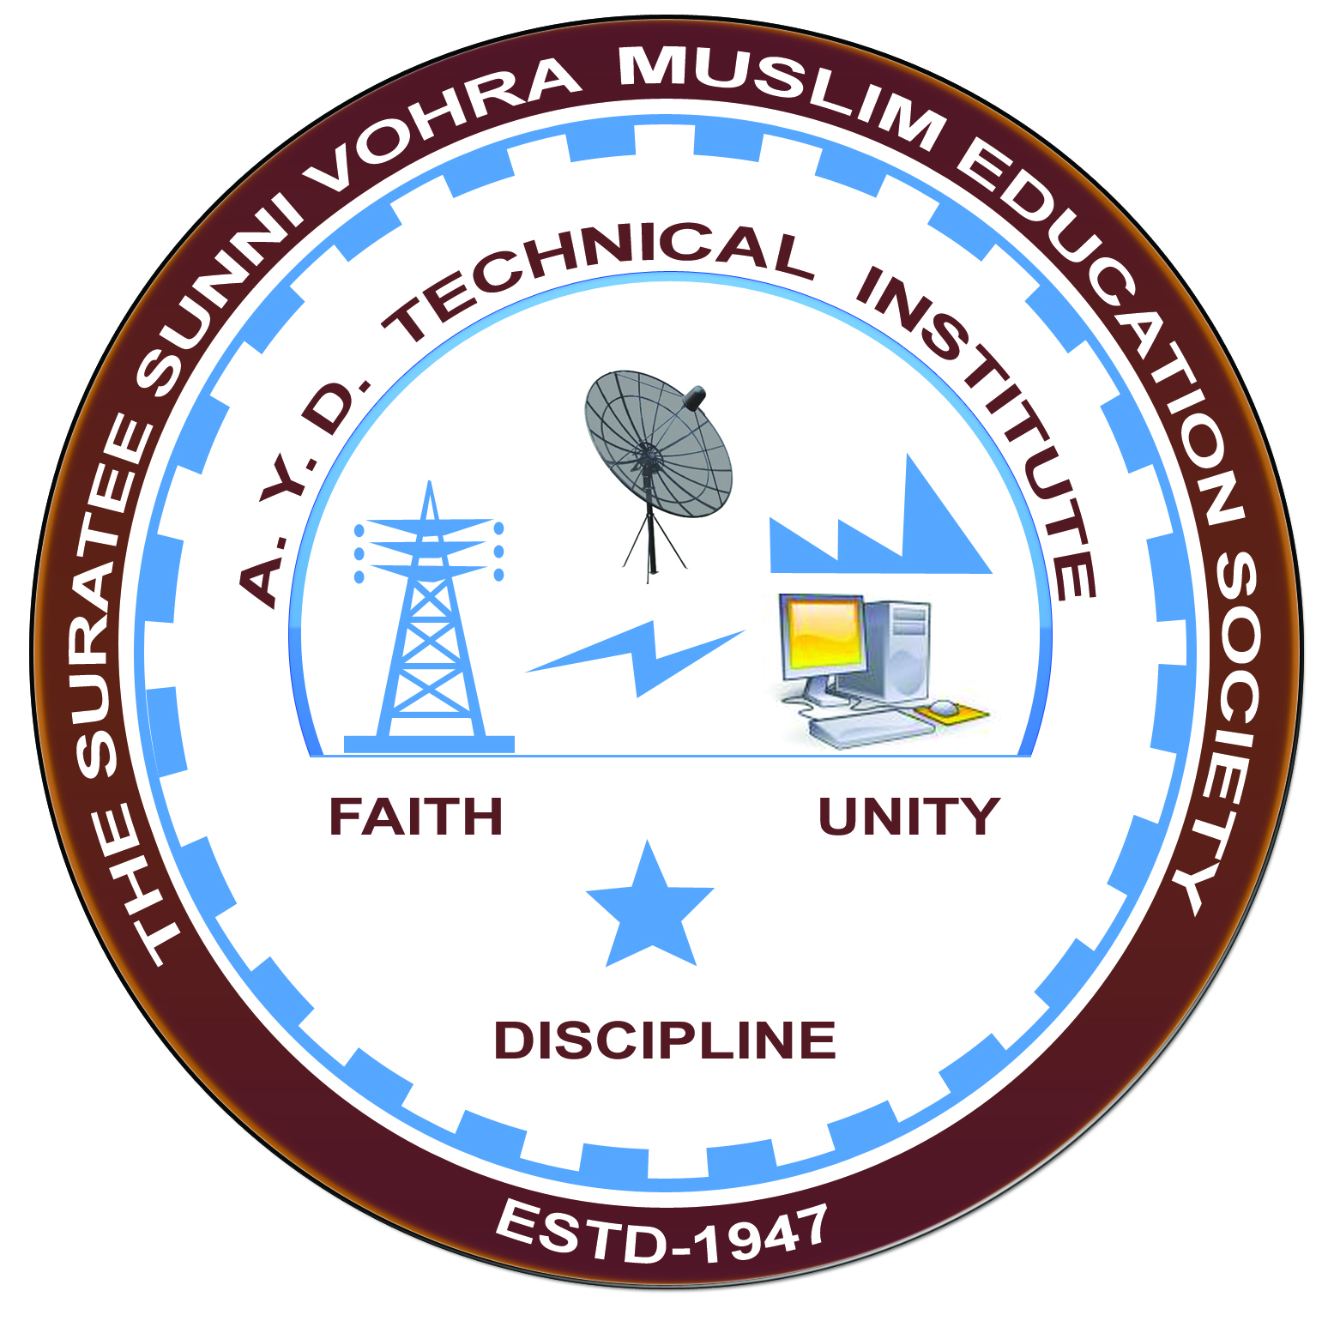

**Economy of power plant and Tariffs**

**Arranged by**

**Electrical Engineering Department,**

**A. Y. DADABHAI TECHNICAL INSTITUTE, KOSAMBA**

**REPORT ON EXPERT LECTURE**

**Date:-** 01-OCTOBER ,2022

**Department:-** Electrical Engineering

**Sem:-** 5TH SEM

**Faculty:** 3

1. M A SHIEKH
2. M Y PATEL
3. R J SINGH

**No of Students: -** 25

|  |  |  |
| --- | --- | --- |
| **Name Of Expert** | **Designation** | **Organization Of Expert** |
| Dinanath Akela | Energy Consultant | Hazira Industries |

**Topic Of Expert Lecture:- Economy of power plant and Tariffs.**

**Brief about Expert Lecture:-**

Our electrical engineering department of A. Y. Dadabhai Technical Institute, Kosamba Had organized expert lecture on **Economy of power plant and Tariffs.**

On the date of **1 OCTOBER 2022** his session was very interactive and students participated enthusiastically. The speaker gave information about various technical aspects and concepts where energy can be conserve and he also explain that which aspects to be kept in mind for conserving energy.

Student not only learns about how to conserve electrical energy but also how to conserve mechanical, chemical energy etc.

As per the feedback received from the students it was very good learning experience, the lecture helped them in their understanding the concept of Energy Conservation & Audit.

**PHOTOS OF EXPERT LECTURE**

