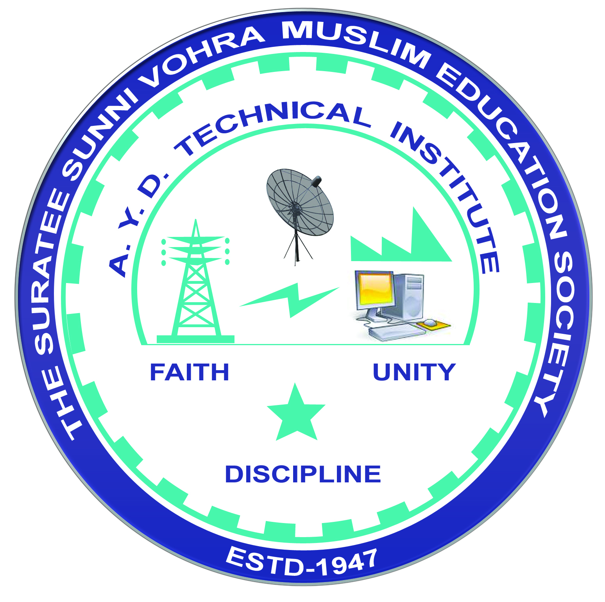 | A.Y. DADABHAI TECHNICAL INSTITUTE, KOSAMBA | 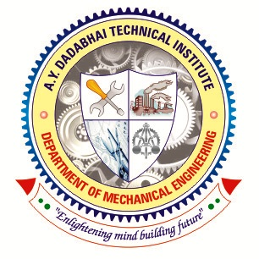

DEPARTMENT OF MECHANICAL ENGINEERING

Report

Name of Expert: Mr. Dharmin
Designation: Senior Application Engineer
Address: Sopan Institute of Engineering and Design, Surat
Date of Lecture Conduct: 06-07-2022
Semester: 2ND
No. of Students: 50
Subject (Course) Related to Expert Lecture: Computer Aided Design
Topic Covered: Draft sight Webinar on “2D Drafting Software”.
Venue: Online Webinar link at A.Y. Dadabhai Technical Inst. Kosamba
Time: 10:30 am to 11.30 am
Photograph :
