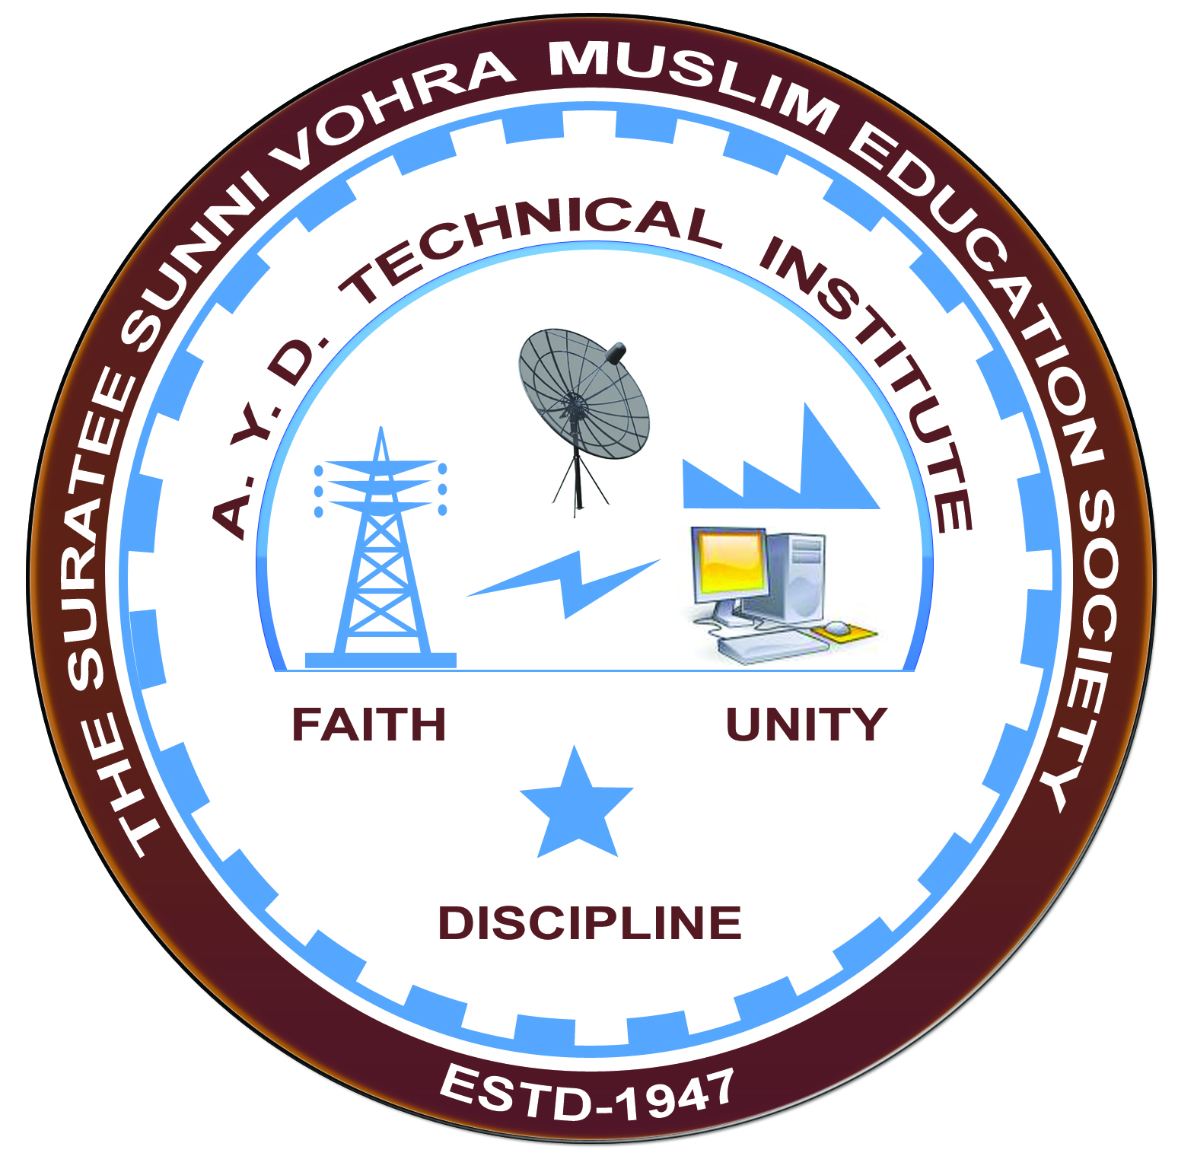

**Rayzon Green Energies, Karanj**

**Arranged by**

**Electrical Engineering Department,**

**A. Y. DADABHAI TECHNICAL INSTITUTE, KOSAMBA**

**VISIT REPORT**

**Date:-** 24/02/2022

**Department: -** Electrical Engineering

**Semester: -** 6TH SEM

**Subject: -** Introduction to solar industry

**No of Students: - 48**

**Name of Faculty:-**

1. Mr. M.H.DARSOT (LECTURER)
2. Mrs. S R MANIK (LECTURER)
3. MR. R. J. SINGH (LECTURER)
4. Mr. H. N. DESAI (Lab Technician)

**Name of Place/Company Visited: -** Rayzon Green Energies,Karanj

**About Visit**

On the 24th February 2022 our electrical Department has arranged an industrial visit for our 6th semester students. Total 50 students & 5 faculty members had visited the solar industry in karanj.

On receiving the permission letter from Rayzon Green Energies, 48 students with 4 faculties went on industrial visit to this Solar Company. We all assembled at the college at 10 a.m. We reached the solar industry at 10.45 a.m. An engineer in charge received us at the entrance and gives the brief introduction about their company. He first of all gives us the brief introduction of the company. Rayzon Solar is a young, dynamic, and experienced solar photovoltaic module manufacturer having 300MW state of the art facility in Vibrant state Gujarat, India. They had drawn a vision in 2014 in believing that our customers, partners, and communities should use sun-rays in a simplified way to make their future more vibrant and sustainable. To cope with this essential, Rayzon Solar, established in 2016, has ventured on a strategic plan to build its business in solar energy. Since the inception, the company has delivered the trust by making highly reliable photovoltaic modules for various domestic, commercial, and industrial applications.

Afterward they also show us the manufacturing process of making solar module and the different testing process of solar module.

**Visit Photograph**



