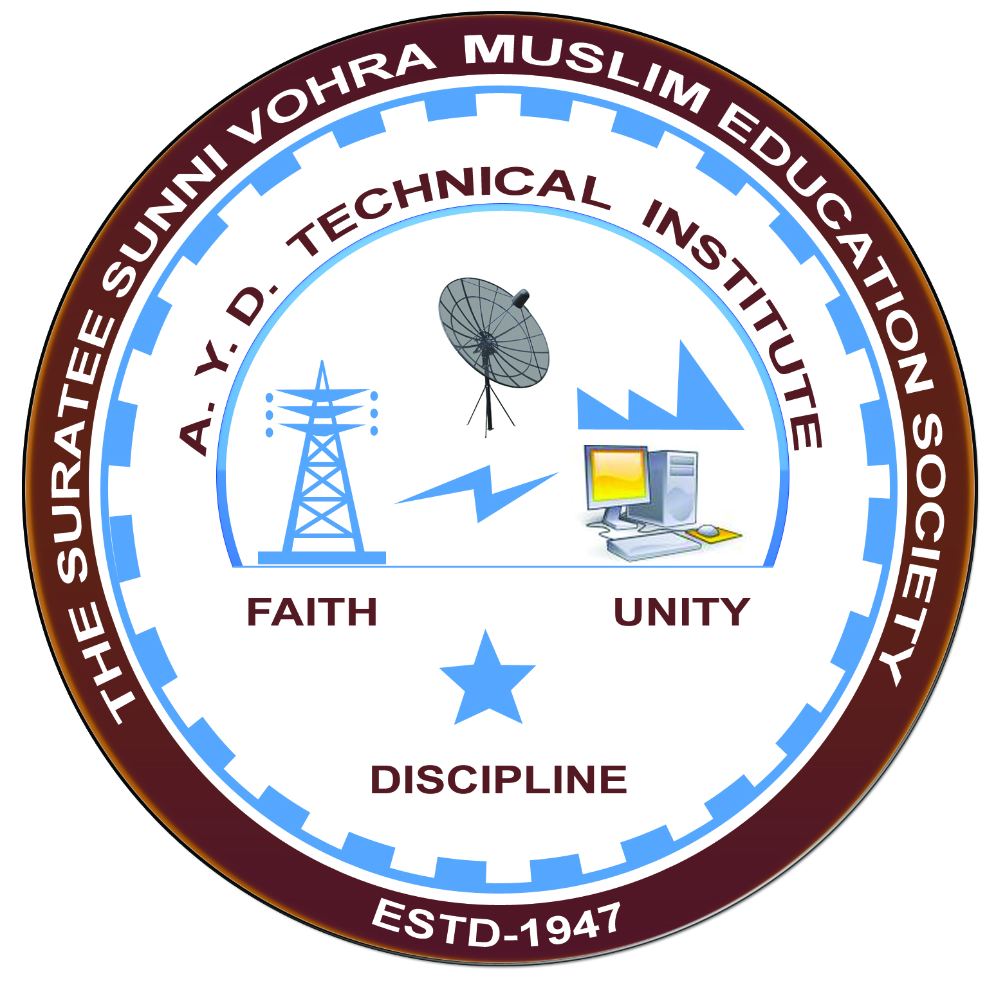

**PRAGATI GLASS PVT LTD, KOSAMBA**

**Arranged by**

**Electrical Engineering Department,**

**A.Y.DADABHAI TECHNICAL INSTITUTE, KOSAMBA**

**VISIT REPORT**

**Date:-**12/03/2022

**Department:-** Electrical Engineering

**Semester:-**4TH SEM

**Subject:-**Introduction To Glass Industry

**No Of Students: - 50**

**Name Of Faculty:-**

1. Mr. M.H.DARSOT (LECTURER)
2. MR. M.Y.PATEL (LECTURER)
3. MR.R.J.SINGH (LECTURER)
4. MAMTA VANSIYA (LECTURER)
5. Mr. H. N. DESAI (Lab Technician)

**Name Of Place/Company Visited:-**PRAGATI GLASS PVT LTD,KOSAMBA

**About Visit**

On the 12thmarch 2022 our electrical Department has arranged an industrial visit for our4th SEM students. Total 50students& 5 faculty members had visited the glass industry in Kosamba

On receiving the permission letter from PRAGATI GLASS PVT, LTD, KOSAMBA 50 students with 5 faculties went on industrial visit to glass industry. We all assembled at the college at 9 a.m. We reached the glass industry at 9.45 a.m. An engineer in charge received us at the entrance and gives the brief introduction about the GLASS industry. He explained us that the PRAGATI GLASS PVT LTD was founded in year 1982 and it has earned enduring international fame in the industry of manufacturing clear glass bottles and tumblers. In Kosamba plant they have two furnaces of 80tons and 70 tons each, with a daily production capacity of 170 tons per day. Theyalso have IS machines of single gob and double gob semi-automatic and fully automatic machines, which can produce approximately 1 million bottles every day.The visit comes to an end around 2 p.m. It was an informative, interesting and successful visit.

**Visit Photograph**

