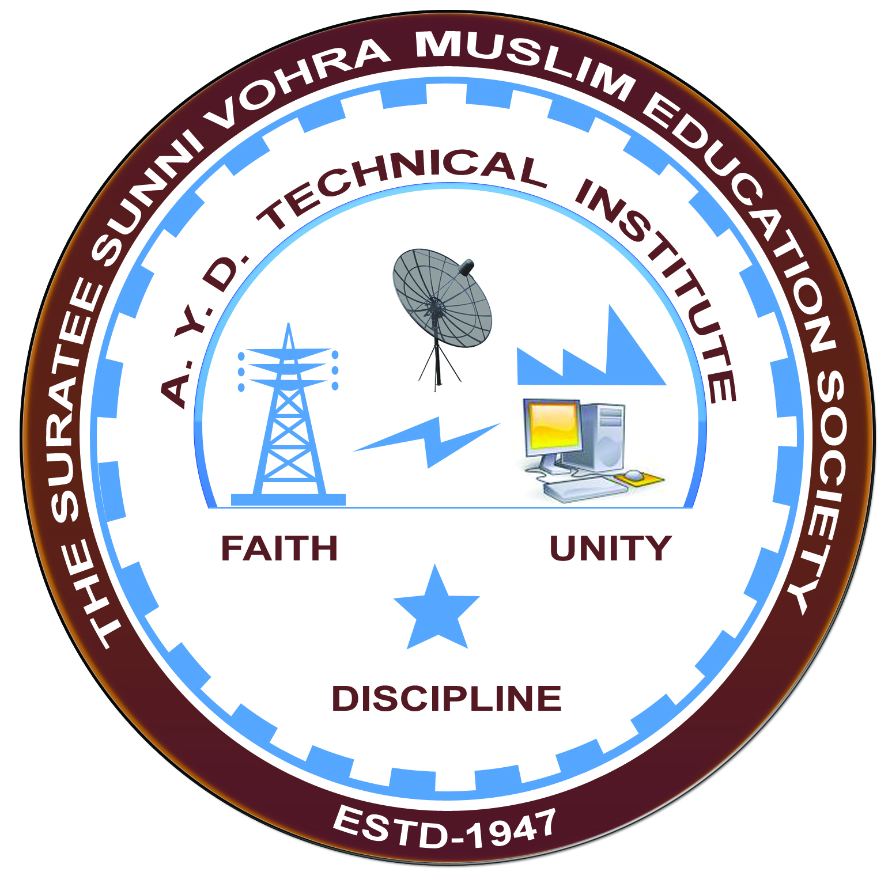

**MICROPROCESSOR AND MICROCONTROLLER APPLICATIONS**

**Arranged by**

**Electrical Engineering Department,**

**A. Y. DADABHAI TECHNICAL INSTITUTE, KOSAMBA**

**REPORT ON EXPERT LECTURE**

**Date:-** 08/09/2022 to 28/09/2022

**Department: -** Electrical Engineering

**Sem:-** 5TH SEM

**Faculty: -** (1) Mr M.S.DINATH

(2) SNEHA MANIK

(3) MAMTA VANSIYA

**No of Students: -** 55

|  |  |  |
| --- | --- | --- |
| **Name Of Expert** | **Designation** | **Organization Of Expert** |
| HANIF KAGDI | EX.SENIOR ENGINEER IN PATNI COMPUTERS | SURAT |

**Topic Of Expert Lecture:-** MICROPROCESSORS AND CONTROLLER APPLICATIONS

**Brief about Expert Lecture:-**

Our electrical engineering department of A. Y. Dadabhai Technical Institute, Kosamba Had organized expert lectureon **MICROPROCESSOR AND MICROCONTROLLER APPLICATIONS** on the date of 08 September 2022. TO 28 September 2022. All the students of fifth semester students had attended the talk and interacted with the resource person. The speaker highlighted the basic concept of microprocessor 8085 and microcontroller 8051.He had covered microprocessor design issues, memories, system logic chips. The speakers emphasized on right mix of knowledge, attitude and additional skills for a successful career.

The speaker had included the fundamental concept

