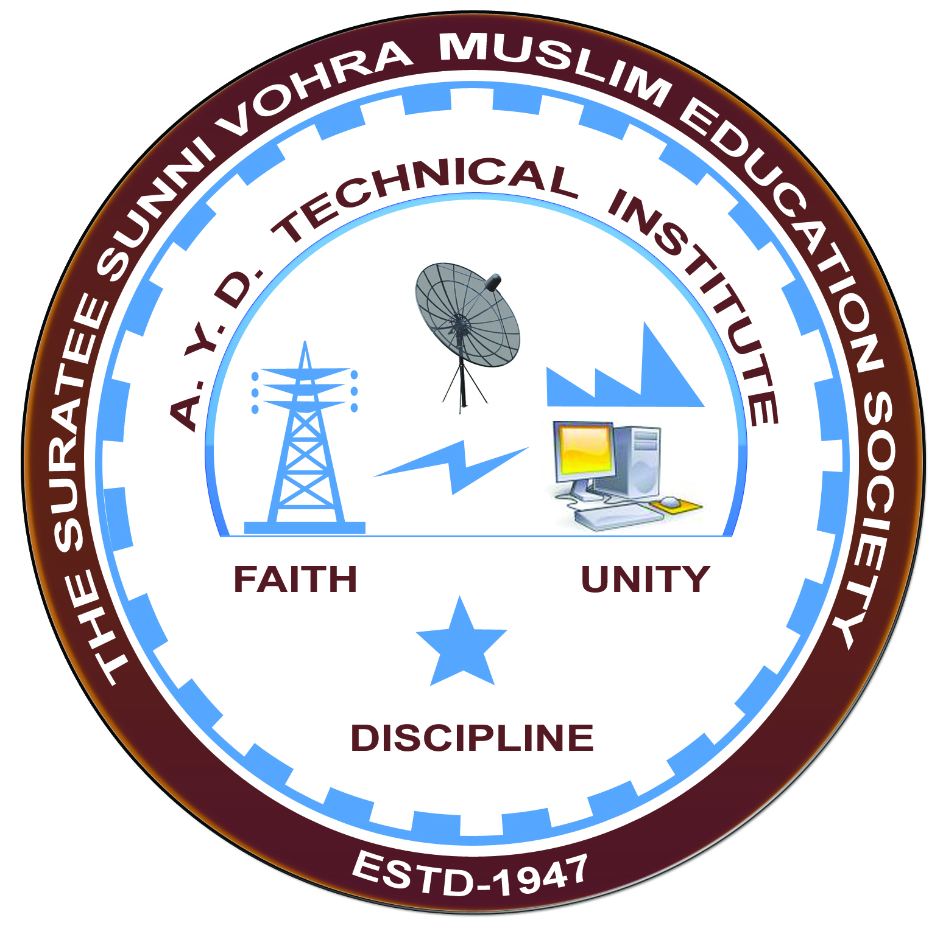

**AMUL DAIRY AND AMUL CHOCOLATE PLANT,ANAND**

**Arranged by**

**Electrical Engineering Department,**

**A.Y.DADABHAI TECHNICAL INSTITUTE, KOSAMBA**

**VISIT REPORT**

**Date:-**17/05/2022

**Department: -** Electrical Engineering

**Semester: -** 4TH SEM

**No Of Students: -** 55

**Name Of Faculty:-**

1. Mrs. S. R MANIK (LECTURER)
2. Mr. M. A. SHEIKH (LECTURER)
3. Mr. M. Y. PATEL (LECTURER)
4. Mr. H. N. DESAI (Lab Technician)
5. Mr. P. J. Patel (Lab Assistant)

**Name of Place/Company Visited: -** AMUL DAIRY AND AMUL CHOCOLATE PLANT.

**About Visit**

On the 17thmay 2022 our electrical Department has arranged an industrial visit for our4th SEM students. Total 55 students& 5 faculty members had visited the AMUL DAIRY AND AMUL CHOCOLATE PLANT, ANAND.

On receiving the permission letter from AMUL DAIRY AND AMUL CHOCOLATE PLANT, ANAND 55 students with 5 faculties went on industrial visit to amul dairy. We all assembled at the college at 6a.m. We reached the amul dairy at 11.00 a.m. An engineer in charge received us at the entrance and gives the brief introduction about the amul dairy. He explained us how milk is collected, how milk quality is tested in the laboratory, what are the process through which the milk undergoes before packing in pouches, how it is soured before dispatching in the market . He also explained how AMUL has spurred the white revolution in India and world’s largest producer of milk. Then they show us the various AMUL PRODUCTS like Amul Butter, Amul Ghee, Amul Cheese, Amul ice cream and some delicious Amul chocolates in the chocolate plant.

**Visit Photograph**



