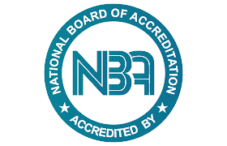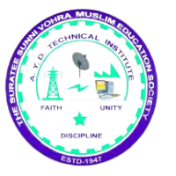

A.Y.DADABHAI TECHNICAL INSTITUTE,KOSAMBA

Workshop on Resume Building and Interviewing Skills

**Report on Online Workshop on Resume Building and Interviewing Skills**

**Organized by: A.Y. Dadabhai Technical Institute, Kosamba**

**Date**: 13th July 2024  
**Mode**: Online  
**Number of Participants**: 133

On 13th July 2024, A.Y. Dadabhai Technical Institute, Kosamba, organized an online workshop titled "Resume Building and Interviewing Skills" for final-year students. The objective of the workshop was to equip students with essential skills for crafting effective resumes and excelling in job interviews, thereby enhancing their employability. The session attracted a robust participation of 133 students, all eager to gain valuable insights into preparing for their professional careers.

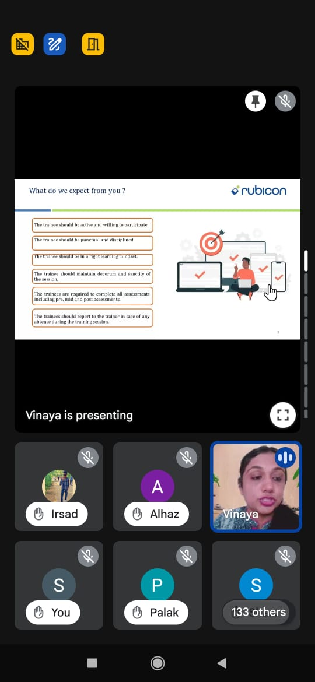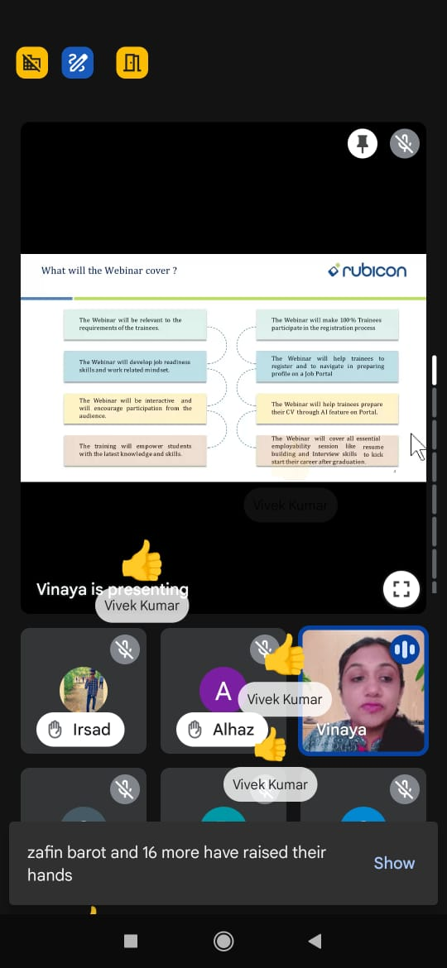

Expert delivering lecture

The workshop was led by Ms. Priya Atul Bagul, a skilled expert from Rubicon Skill Development, who shared her extensive knowledge and experience in the field. Ms. Bagul's presentation was interactive and practical, focusing on core aspects of resume-building and interviewing that are essential for final-year students preparing to enter the job market.

**Workshop Overview**: The 2-hour workshop covered several critical topics, including:

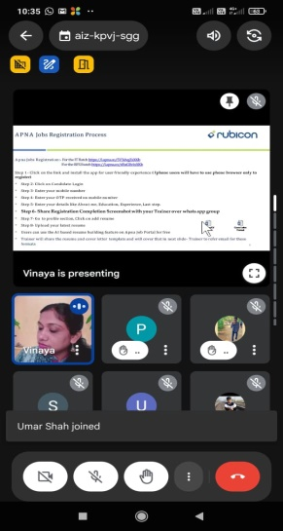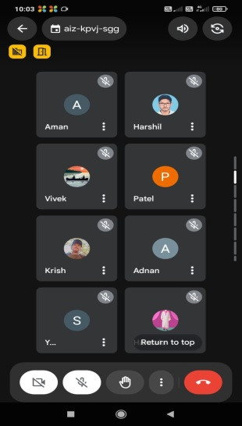

Expert with participants.

* **Resume-Building Techniques**: Ms. Bagul explained the structure and key components of an effective resume, highlighting the importance of clarity, relevance, and precision. She provided tips on how to showcase skills, achievements, and experiences in a way that appeals to recruiters.
* **Interviewing Skills**: The session addressed common interview questions and provided strategies for answering them confidently. Students learned how to effectively communicate their strengths and aspirations during interviews.

A unique aspect of this workshop was the integration of **AI tools** for resume optimization. Ms. Bagul demonstrated how AI-powered platforms can help students create polished and tailored resumes, optimize keywords, and increase their chances of passing initial screenings in today’s competitive job market.

Additionally, the workshop was conducted in collaboration with the **Apna Job Portal**, a renowned job platform known for its extensive job listings and career resources. Students were encouraged to register on Apna for access to a wider array of job opportunities and tailored resources to support their career journey.

**Outcome and Benefits**: The workshop provided students with actionable insights and practical skills to improve their resume-building and interviewing techniques. By utilizing the tools and resources introduced, students gained confidence in their job search efforts and acquired the knowledge needed to create impactful applications.

Through this collaboration with Rubicon Skill Development and Apna Job Portal, A.Y. Dadabhai Technical Institute aims to empower students with the tools necessary for a successful transition into the professional world. The workshop was highly beneficial, and the participants expressed appreciation for the valuable guidance provided.

**Conclusion**: The Resume Building and Interviewing Skills workshop was a successful initiative, helping final-year students of A.Y. Dadabhai Technical Institute prepare for their career paths. The integration of AI tools and partnership with a leading job portal further enhanced the workshop’s value, leaving students equipped with both knowledge and resources for their future endeavors.

The institute extends its gratitude to Ms. Priya Atul Bagul for her insightful session and looks forward to organizing more such collaborative efforts in the future to support students’ professional development.

Bottom of Form