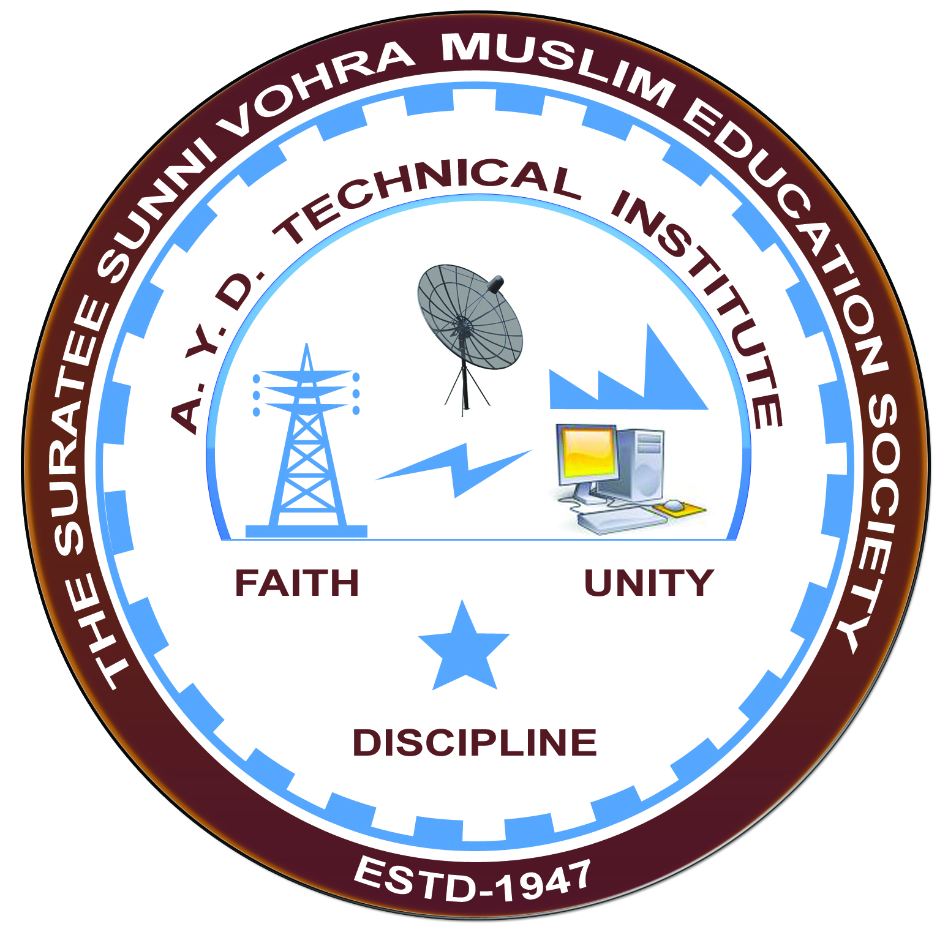

**EMPLOYABILITY SKILL ENHANCEMENT**

**Arranged by**

**Electrical Engineering Department,**

**A. Y. DADABHAI TECHNICAL INSTITUTE, KOSAMBA**

**REPORT ON EXPERT LECTURE**

**Date:-** 29-01-2020

**Department:-** Electrical Engineering

**Sem:-** 6th Semester

**Faculty: -** (1) Mr. M. A. Sheikh

(2) Mr. R. J. Singh

**No of Students: -** 38

|  |  |  |
| --- | --- | --- |
| **Name Of Expert** | **Designation** | **Organization Of Expert** |
| Mr. Shailesh Thakkar | Soft Skill Trainer | Vadodra |

**Topic Of Expert Lecture:-** Employability Skill Enhancement

**Brief about Expert Lecture:-**

Our electrical engineering department of A. Y. Dadabhai Technical Institute, Kosamba Had organized expert lecture on Employability Skill Enhancement system on the date of 29 January 2020

**Program Photograph:-**

(Felicitation Of Expert)

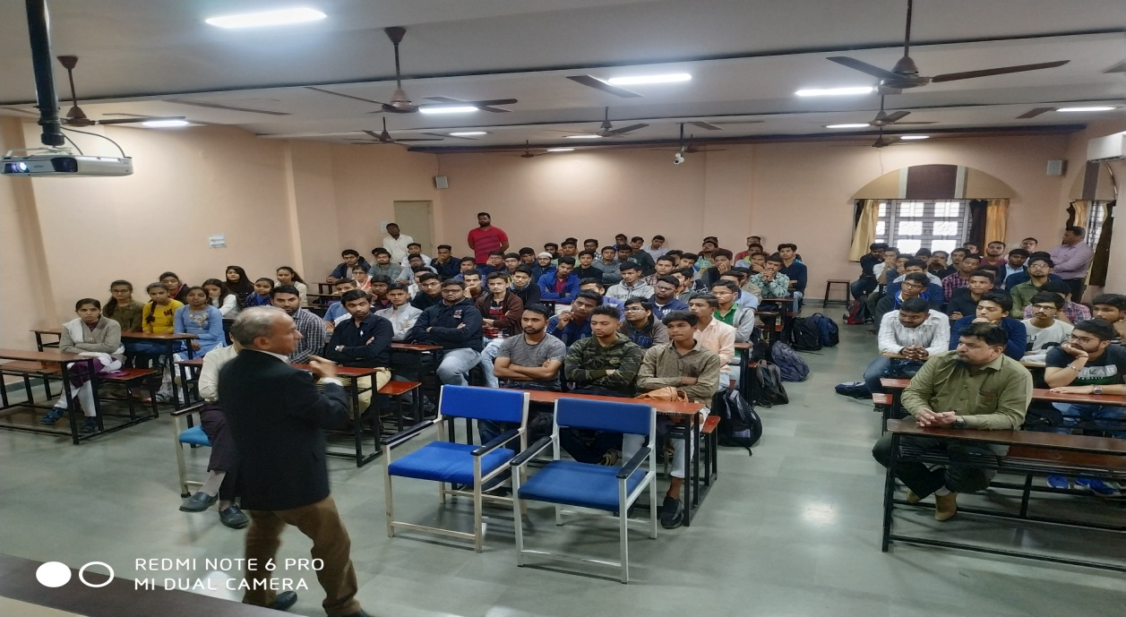

(Expert Delivering Lecture)

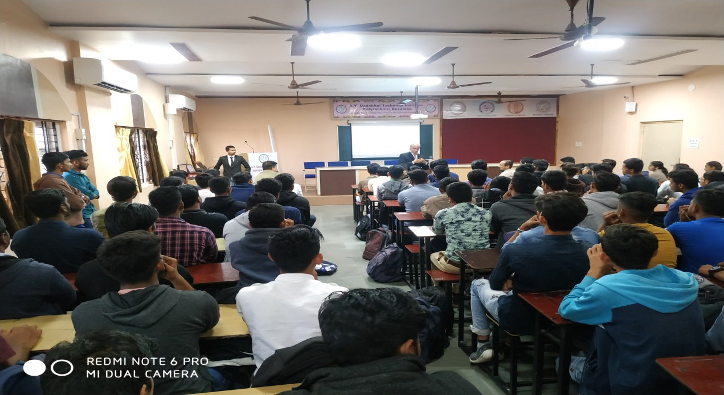

(Participations Of Students)

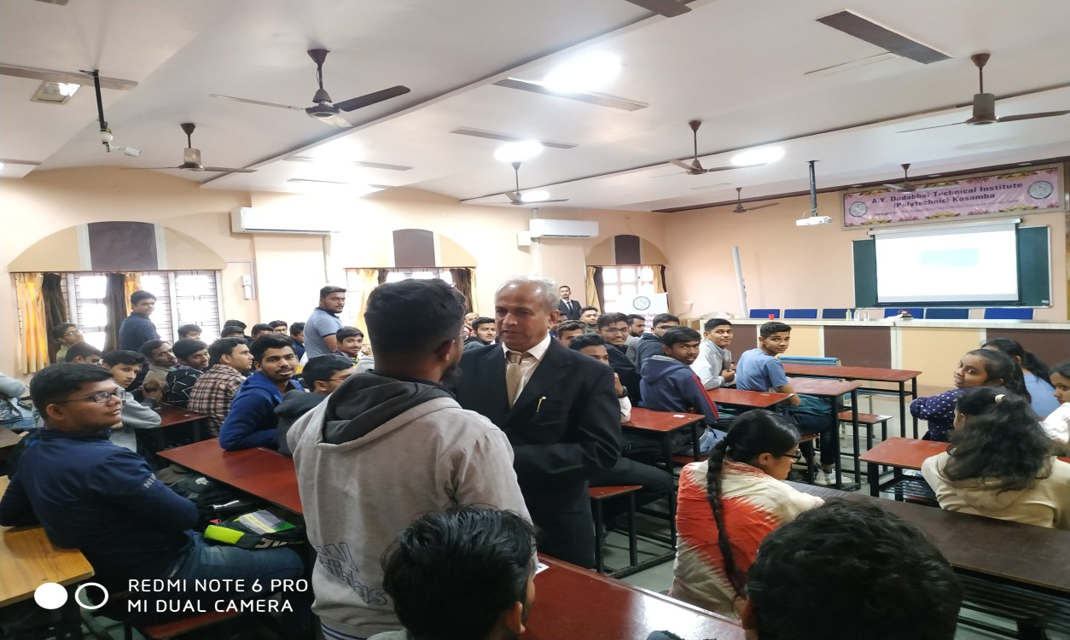

(Moment Of Lecture)