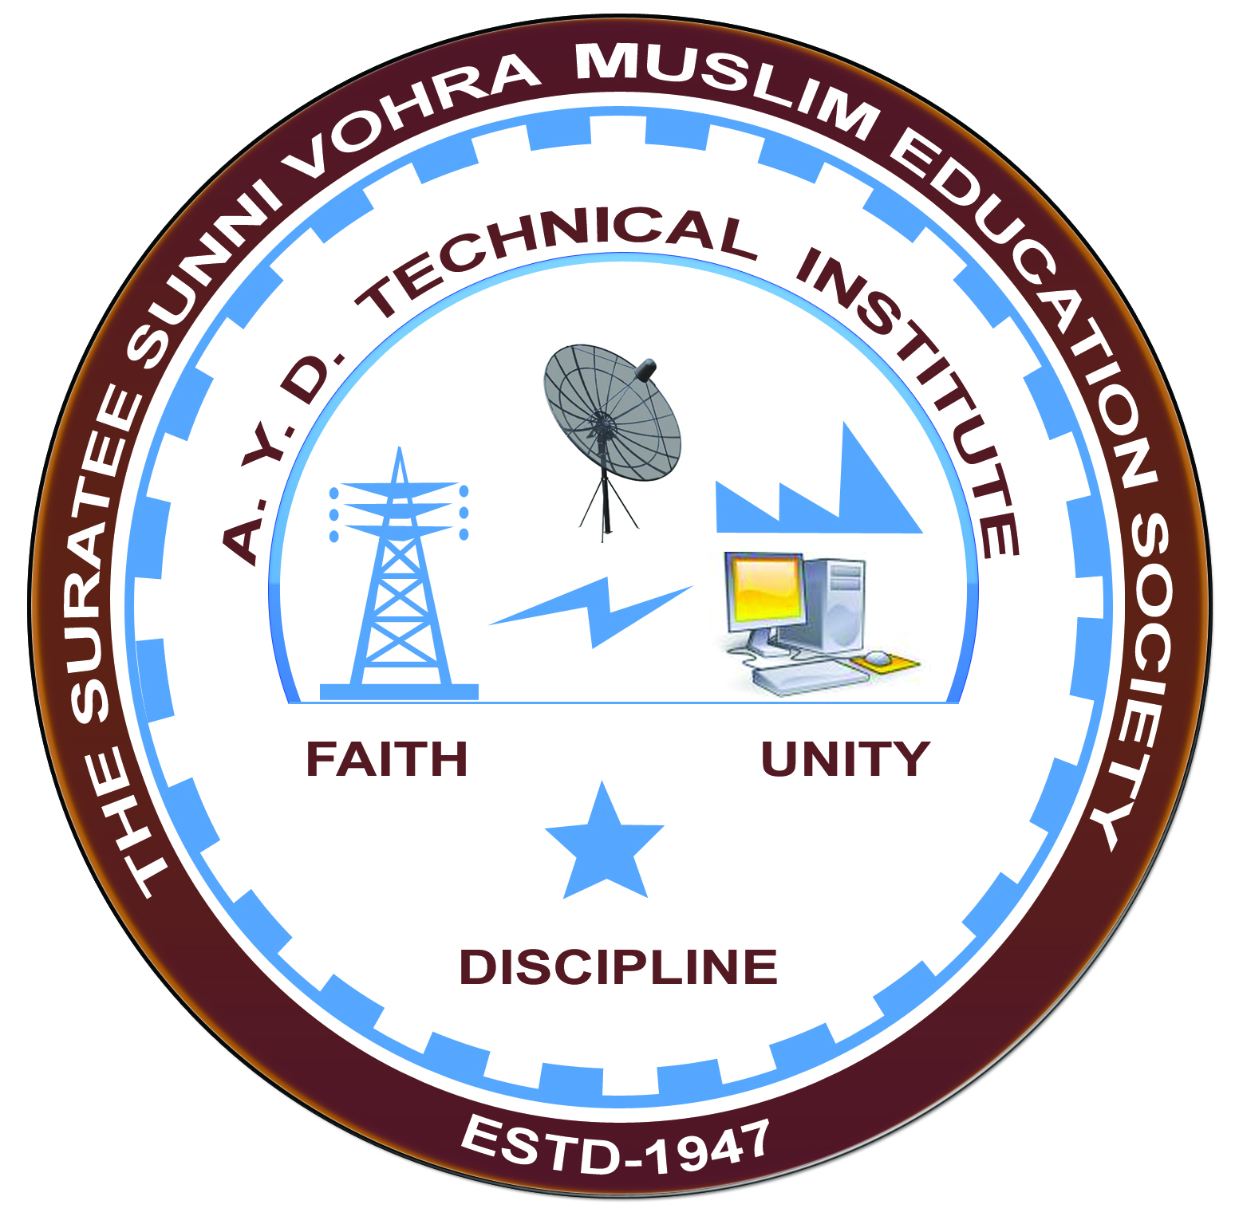

**Selection & Testing of LV Switchgear**

**Arranged by**

**Electrical Engineering Department,**

**A. Y. DADABHAI TECHNICAL INSTITUTE, KOSAMBA**

**REPORT ON EXPERT LECTURE**

**Date:-** 6 APRIL 2023

**Department:-** Electrical Engineering

**Sem:-** 6TH SEM

**Faculty:** 3

(1) SNEHA MANIK

(2) R.J.SINGH

(3) Miss M .R. VANSIYA

**No of Students: -** 42

|  |  |  |
| --- | --- | --- |
| **Name Of Expert** | **Designation** | **Organization Of Expert** |
| Mr. Jay Patel | Assistant Professor | UKA Tarsadia, Maliba University, Bardoli |

**Topic Of Expert Lecture:-**

**Brief about Expert Lecture:-** Selection & Testing of LV Switchgear

Our electrical engineering department of A. Y. Dadabhai Technical Institute, Kosamba Had organized expert lecture on **Selection & Testing of LV Switchgear**on the date of **6 APRIL 2023** The session was very interactive and students participated enthusiastically. In the beginning the expert gave introduction about various technical aspects and concepts of different protective system and circuit interrupting devices.

After the lecture student able to understand where which switchgear device is used and also understand how the testing of HV switchgear is done

As per the feedback received from the students it was very good learning experience, the lecture helped them in their understanding the concept of switchgear and protection

**PHOTOS OF EXPERT LECTURES**

