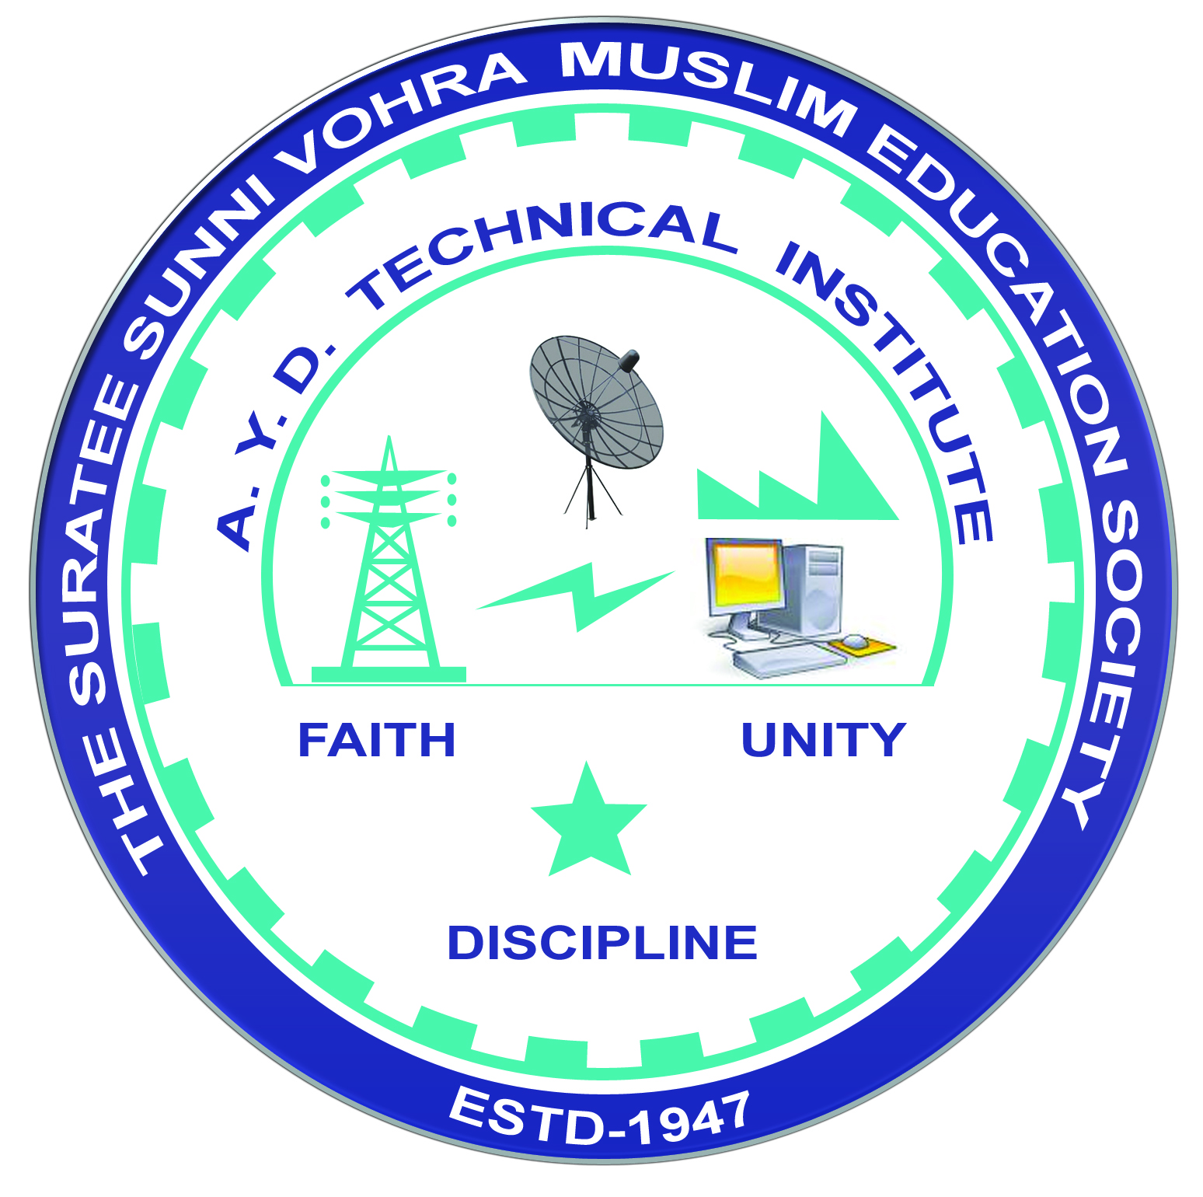 | A.Y. DADABHAI TECHNICAL INSTITUTE, KOSAMBA | 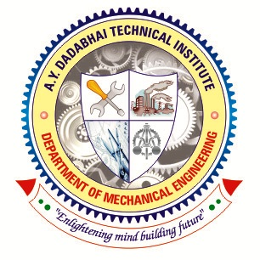

DEPARTMENT OF MECHANICAL ENGINEERING

One Day Educational Visit of Industry

Name of Industry: Shahjanand Technologist Pvt Ltd.

Address: G.I.D.C., Sachin, Di-Surat.
Date of Visit: 21-12-2019
No. of Students Visited: 69
No. of Faculty Visited: 04
Subject (Course) Related to Industry:
C.A.M. (3361901) & Manufacturing System (3361904)
Contact person of Industry: HR - Mr. Jayeshbhai Chorawala
Contact No: 8238754191
Get Approval by: e-mail contact@stpl.com
Product of Industry: Machines for Diamond Planning, Cutting & Security.
Name of departments visited in Industry:
Fabrication, Manufacturing, Quality Control & Assembly.
Prepared brief report: Yes No

Attachment:
- List of students.
- List of faculties.
- Consent letter from parents.
- Faculty order letter.
- Letter of Thanks (Outward No).
- Brief report.

