 | A.Y. DADABHAI TECHNICAL INSTITUTE, KOSAMBA | 

DEPARTMENT OF MECHANICAL ENGINEERING

Industrial Visit Report

Name of Industry: Steel Peckers
Address: Plot no-2925-2929,3031-3042,3127-3132/2,Road no-3, Phase-3, G.I.D.C. Panoli, Ta-Ankleshwar, Dist-Bharuch-394116
Date of Visit: 10-05-2023
Semester: 6th
No. of Students Visited: 61
No. of Faculty Visited: 04
Subject (Course) Related to Industry: FABRICATION TECHNOLOGY
Contact person of Industry: Mr. Moshinkhan A. Pathan
Contact No: 8200750035

Product of Industry: Fabricated Beams,Channels,Pressure Vessels
Name of departments visited in Industry:Fabrication ,Inspection, Colour Coating, Sand blasting.
Photographs:
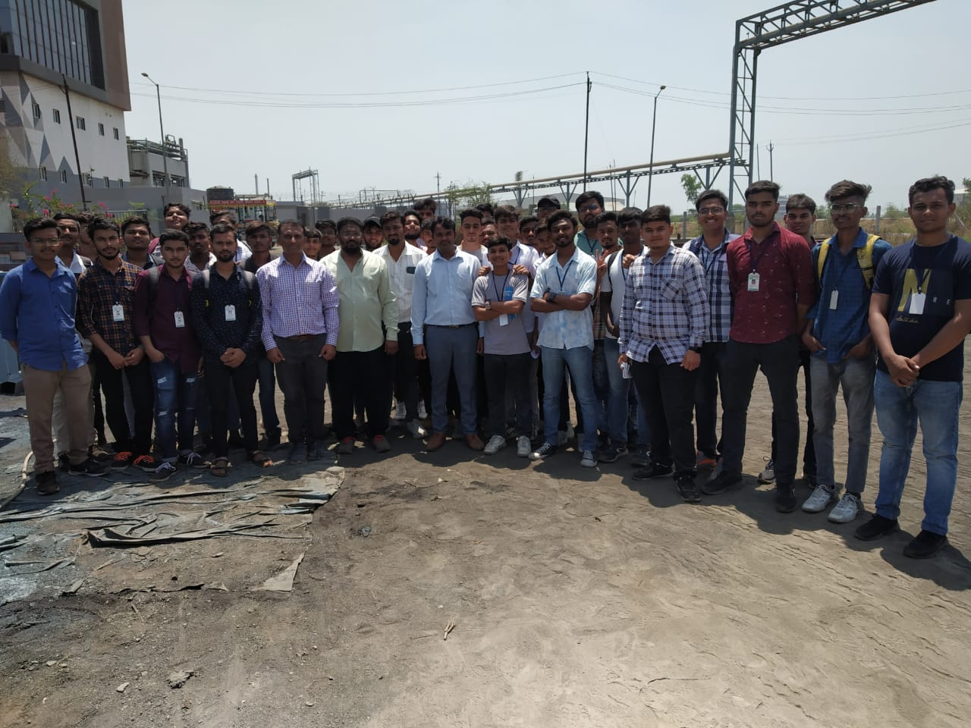 | 