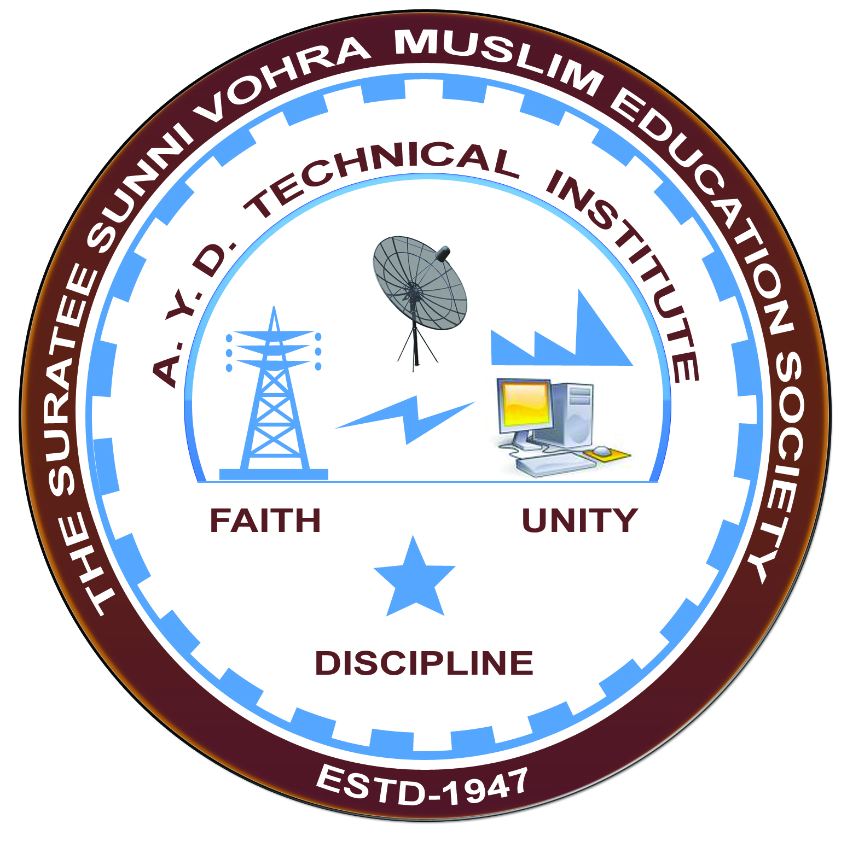

**EFFECTIVE USE OF EDUCATIONAL SIMULATOR MOBILE APP**

**Arranged by**

**Electrical Engineering Department,**

**A. Y. DADABHAI TECHNICAL INSTITUTE, KOSAMBA**

**REPORT ON EXPERT LECTURE**

**Date:-** 08-02-2020

**Department:-** Electrical Engineering

**Sem:-** 6th & 4th Semester

**Faculty: -** (1) Miss. S. V. More

(2) Miss. M. R. Vansiya

(3) Mr. R. J. Singh

**No of Students: -** 79

|  |  |  |
| --- | --- | --- |
| **Name Of Expert** | **Designation** | **Organization Of Expert** |
| Dr. S. N. SAMPAT | Head Of E C dept. | G P Surat |

**Topic Of Expert Lecture:-** Effective use of educational simulator mobile app

**Brief about Expert Lecture:-**

Today on 08/02/2020, saturday the Department of Electrical Engineering of A Y Dadabhai Polytechnic. Kosamba has successfully arranged a Workshop for our ELECTRICAL Branch Students and Staff members.

The workshop title " Introduction and effective use of educational simulator mobile app-electric circuit studio " for academics

In workshop following simulations will be explained for analog and digital circuits.

Transient analysis  
Dc circuit analysis  
Ac circuit analysis

There would be about 15 simulation exercise after the explanation of the circuits would be done by our students and staff members

**Program Photograph:-**

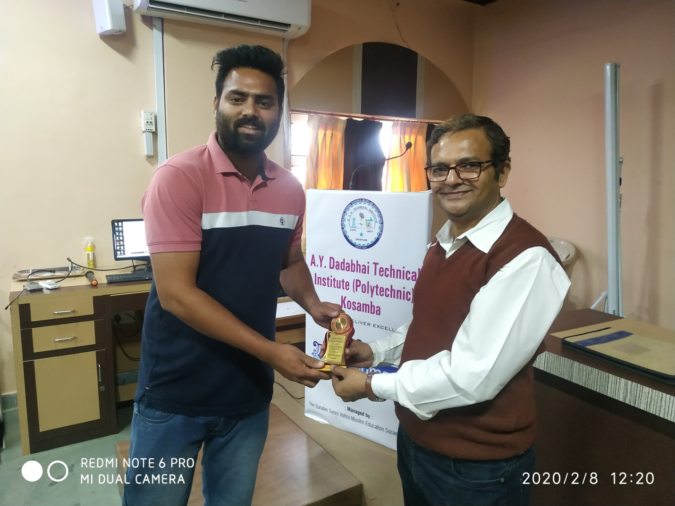

(Felicitation Of Expert)

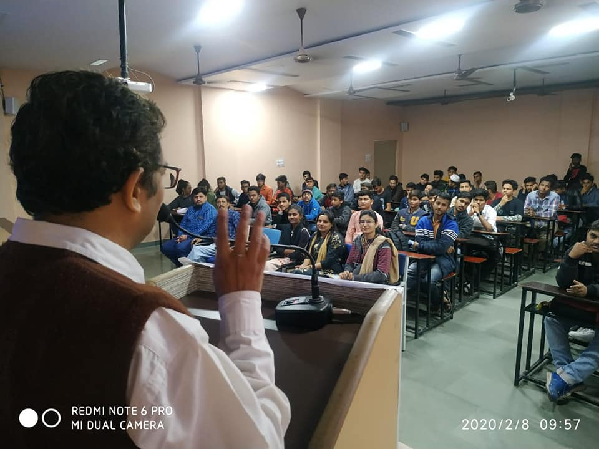

(Expert Delivering Lecture)

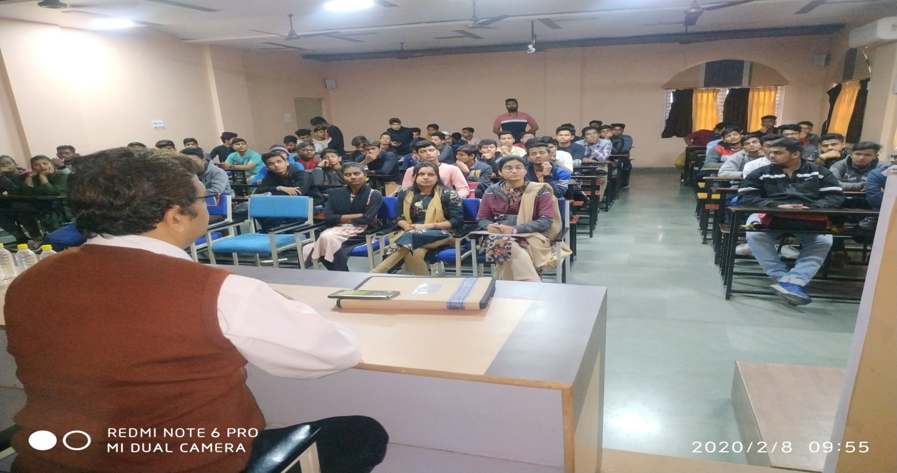

(Participations Of Students)

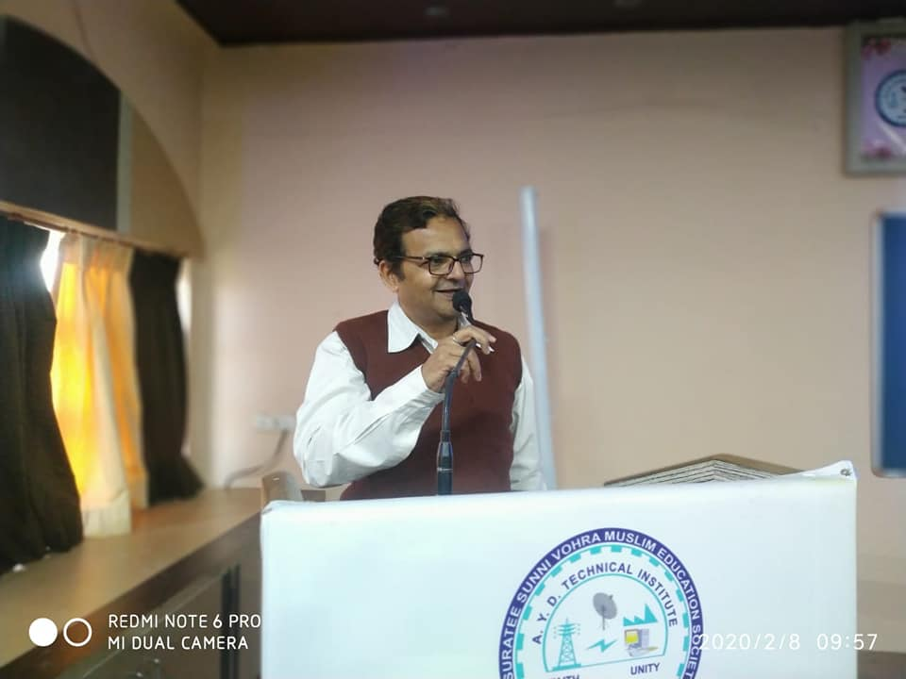

(Moment Of Lecture)