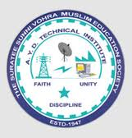 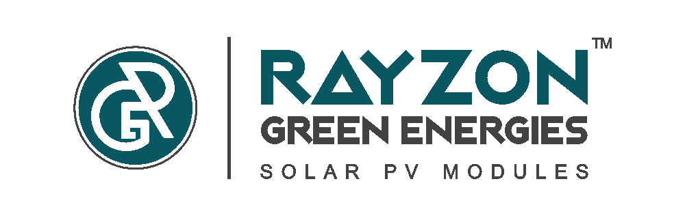

***A REPORT ON***

***CAMPUS INTERVIEW***

***At***

**A.Y.DADABHAI TECHNICAL INSTITUTE, KOSAMBA**

***On***

***2nd March, 2020***

**By**

**RAYZON Green Energies, Kim**

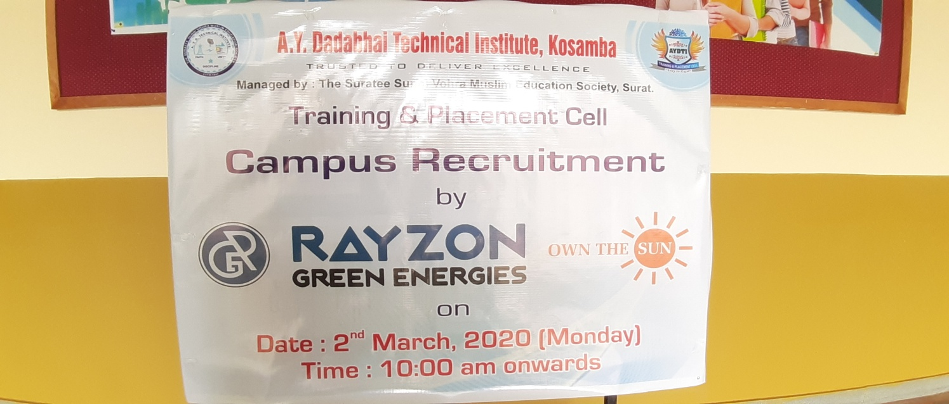

**SUMMARY OF CAMPUS INTERVIEW**

We have organized campus interview for Final year students of Electrical Engineering and Mechanical Engineering Department on 2nd March, 2020 at Meeting Room of A.Y. Dadabhai technical institute, kosamba. Total 39 students appeared in this campus interview process.

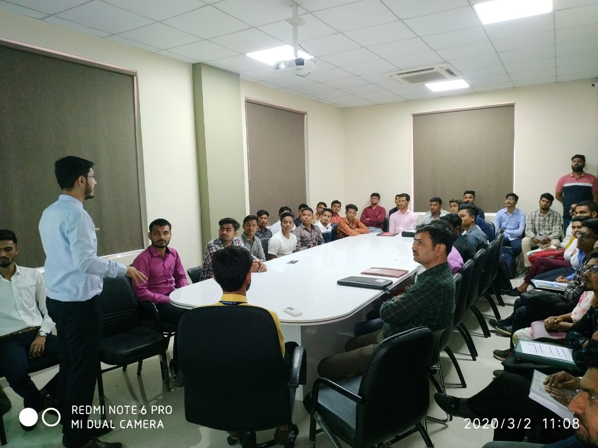 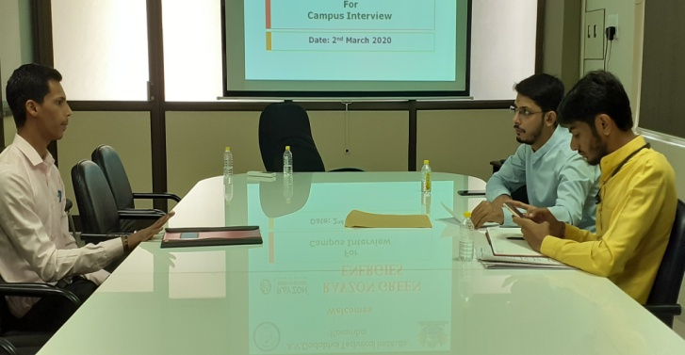

The company **Head-Procurement, Mr. Kamlesh Gohil** gave brief introduction about the company to the students. he also discusses the recruitment process.

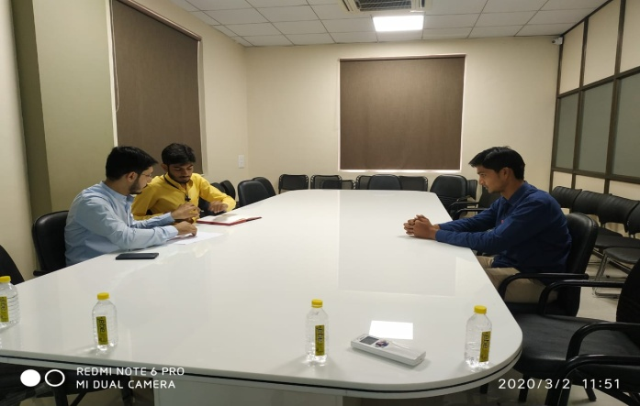 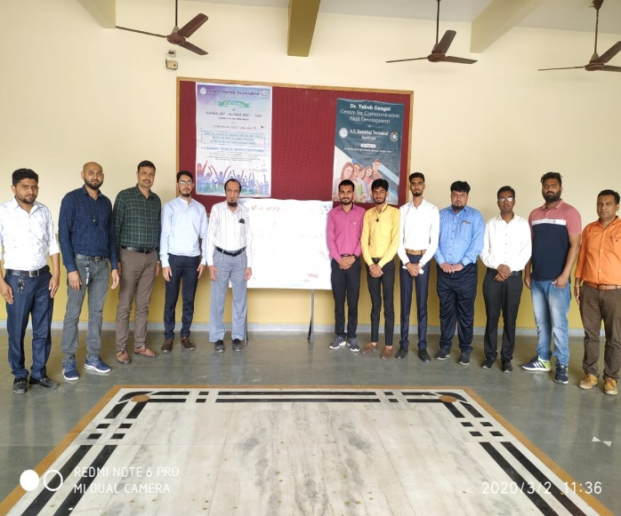

Prepared by: Mr. Dilip Kalathia