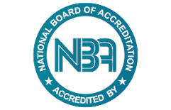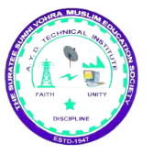

***A.Y.DADABHAI TECHNICAL INSTITUTE***

***KOSAMBA,SURAT***

***REPORT***

**Report on Career Guidance Program for Study Abroad**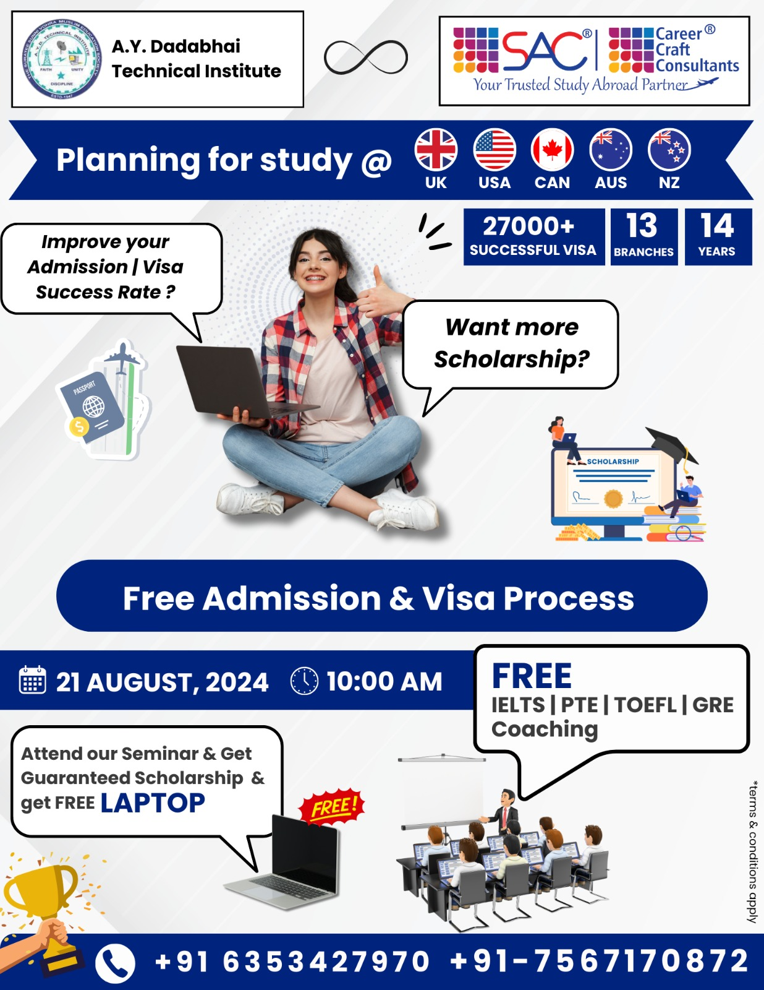

**Organized by: A.Y. Dadabhai Technical Institute, Kosamba**

On 21-08-2024, A.Y. Dadabhai Technical Institute, Kosamba, organized a Career Guidance Program for students aspiring to study abroad. The event saw the participation of 70 students from various departments, all keen to explore international educational opportunities.

The program commenced with a welcome address by Mr. M.A. Sheikh, the Training and Placement Officer (TPO) of the institute. Mr. Sheikh introduced the event and highlighted the importance of global education in today’s competitive world. He emphasized the potential benefits of studying abroad, such as exposure to diverse cultures, advanced academic resources, and enhanced career opportunities.

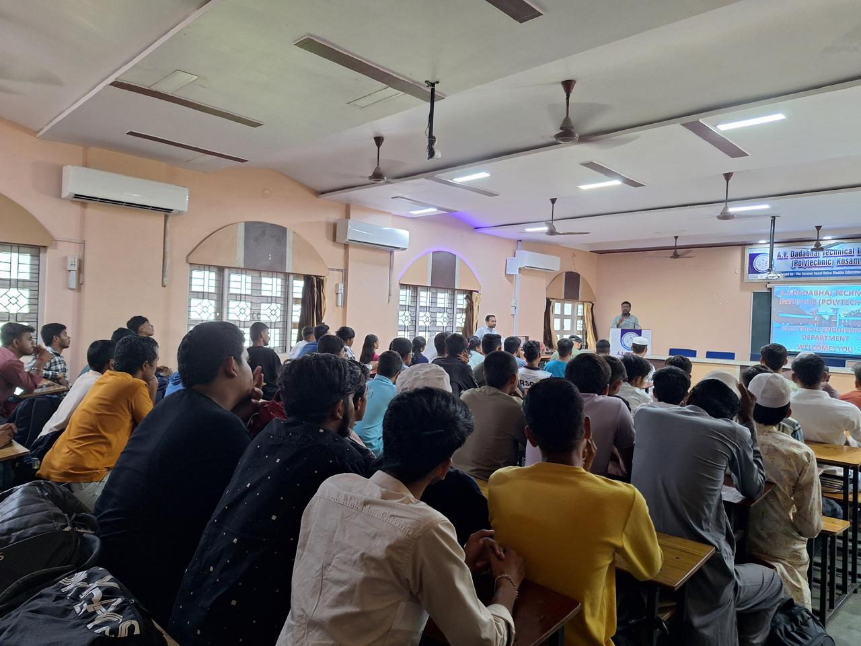

Mr. M.A. Sheikh delivering welcome address

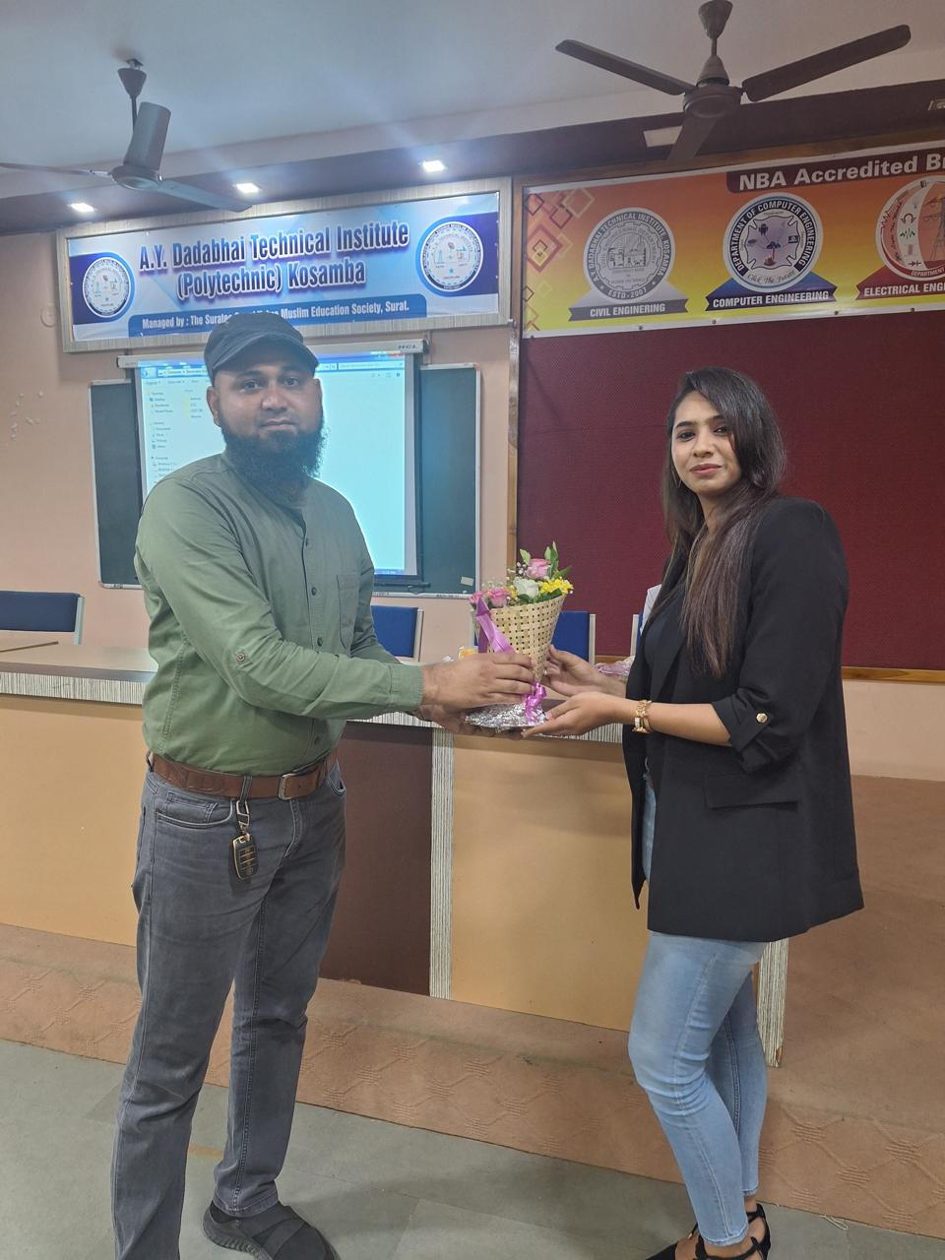The key speaker for the event was Ms. Nazmin Malkani, the Marketing Head at Career Craft Consultants. She was warmly welcomed and felicitated with flowers by Mr. M.H.DARSOT, a faculty member of the ELECTRICAL Engineering Department.

MR. M.H Darsot welcomes Ms. Nazmin Malkani

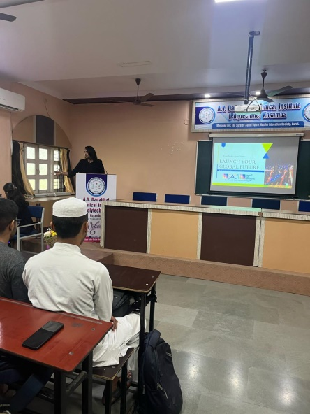Ms. Nazmin Malkani provided an in-depth overview of Career Craft Consultants, a consultancy firm with over 14 years of experience in guiding students towards prestigious institutions abroad. With 13 branches worldwide and a record of over 27,000 successful visa applications, the organization has been a trusted partner for students pursuing higher education in countries like the UK, USA, Canada, Australia, New Zealand, and France.

Ms. Nazmin Malkani delivering to speech

During her presentation, Ms. Nazmin covered several key services offered by Career Craft Consultants, including:

1. Assistance with university and course selection across various fields.
2. A free admission and visa process to simplify the application procedure.
3. Specialized guidance on scholarships to help students manage the financial aspects of their education.
4. Additional support services, such as free English improvement classes, airport pickup, and accommodation arrangements.
5. Comprehensive support for university enrollment and job assistance during the Post-Study Work (PSW) period.

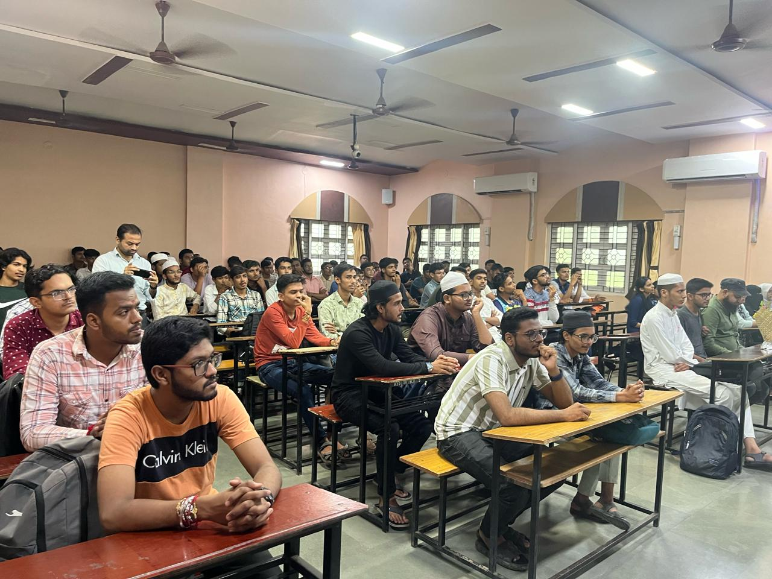

The students were also informed about a promotional offer, where eligible students could receive a free laptop (terms and conditions applied). Ms. Nazmin concluded her talk by encouraging students to take advantage of the QR code provided for easy registration and further inquiries.

The session was interactive, with students asking questions about the application process, scholarship opportunities, and the benefits of studying in different countries. The event concluded with a vote of thanks, leaving the students better informed and motivated to pursue international education.

The Career Guidance Program was a successful initiative by A.Y. Dadabhai Technical Institute, providing valuable insights and assistance to students aiming to enhance their academic and career prospects through international education.

