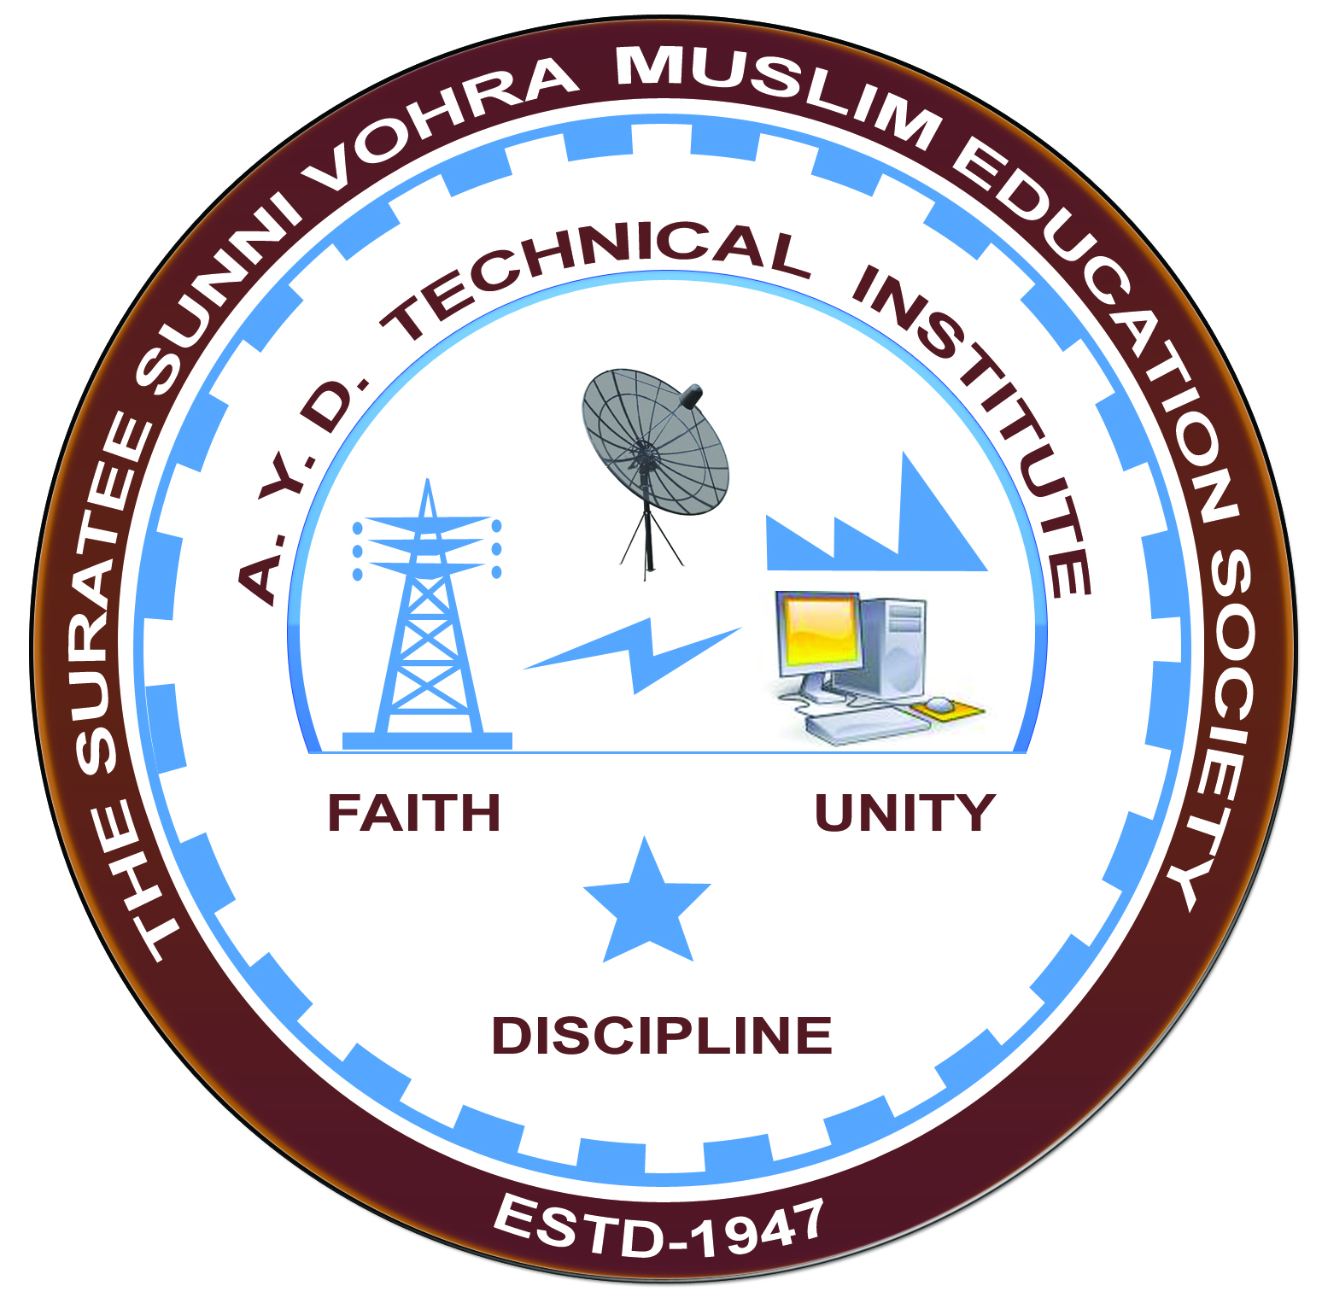

**Central Height Building (Panoli GIDC)**

**Arranged by**

**Electrical Engineering Department,**

**A. Y. DADABHAI TECHNICAL INSTITUTE, KOSAMBA**

**VISIT REPORT**

**Date:-** 28/01/2020

**Department:-** Electrical Engineering

**Semester:-** 6th SEM

**Subject:-** Electrification Of Buildings & Complexes

**No Of Students:- 39**

**Name Of Faculty:-**

1. Mr. M. H. DARSOT (LECTURER)
2. MR. M. Y. PATEL (LECTURER)
3. MR.R. J. SINGH (LECTURER)
4. Mr. H. N. DESAI (Lab Technician)

**Name Of Place/Company Visited:-** Central Height Building (Panoli GIDC)

**About Visit**

On the 28th January 2020 our electrical Department has arranged an industrial visit for our 5TH SEM students. Total 39 students & four faculty members had visited Central Height Building (Panoli GIDC).

**Visit Photograph**

