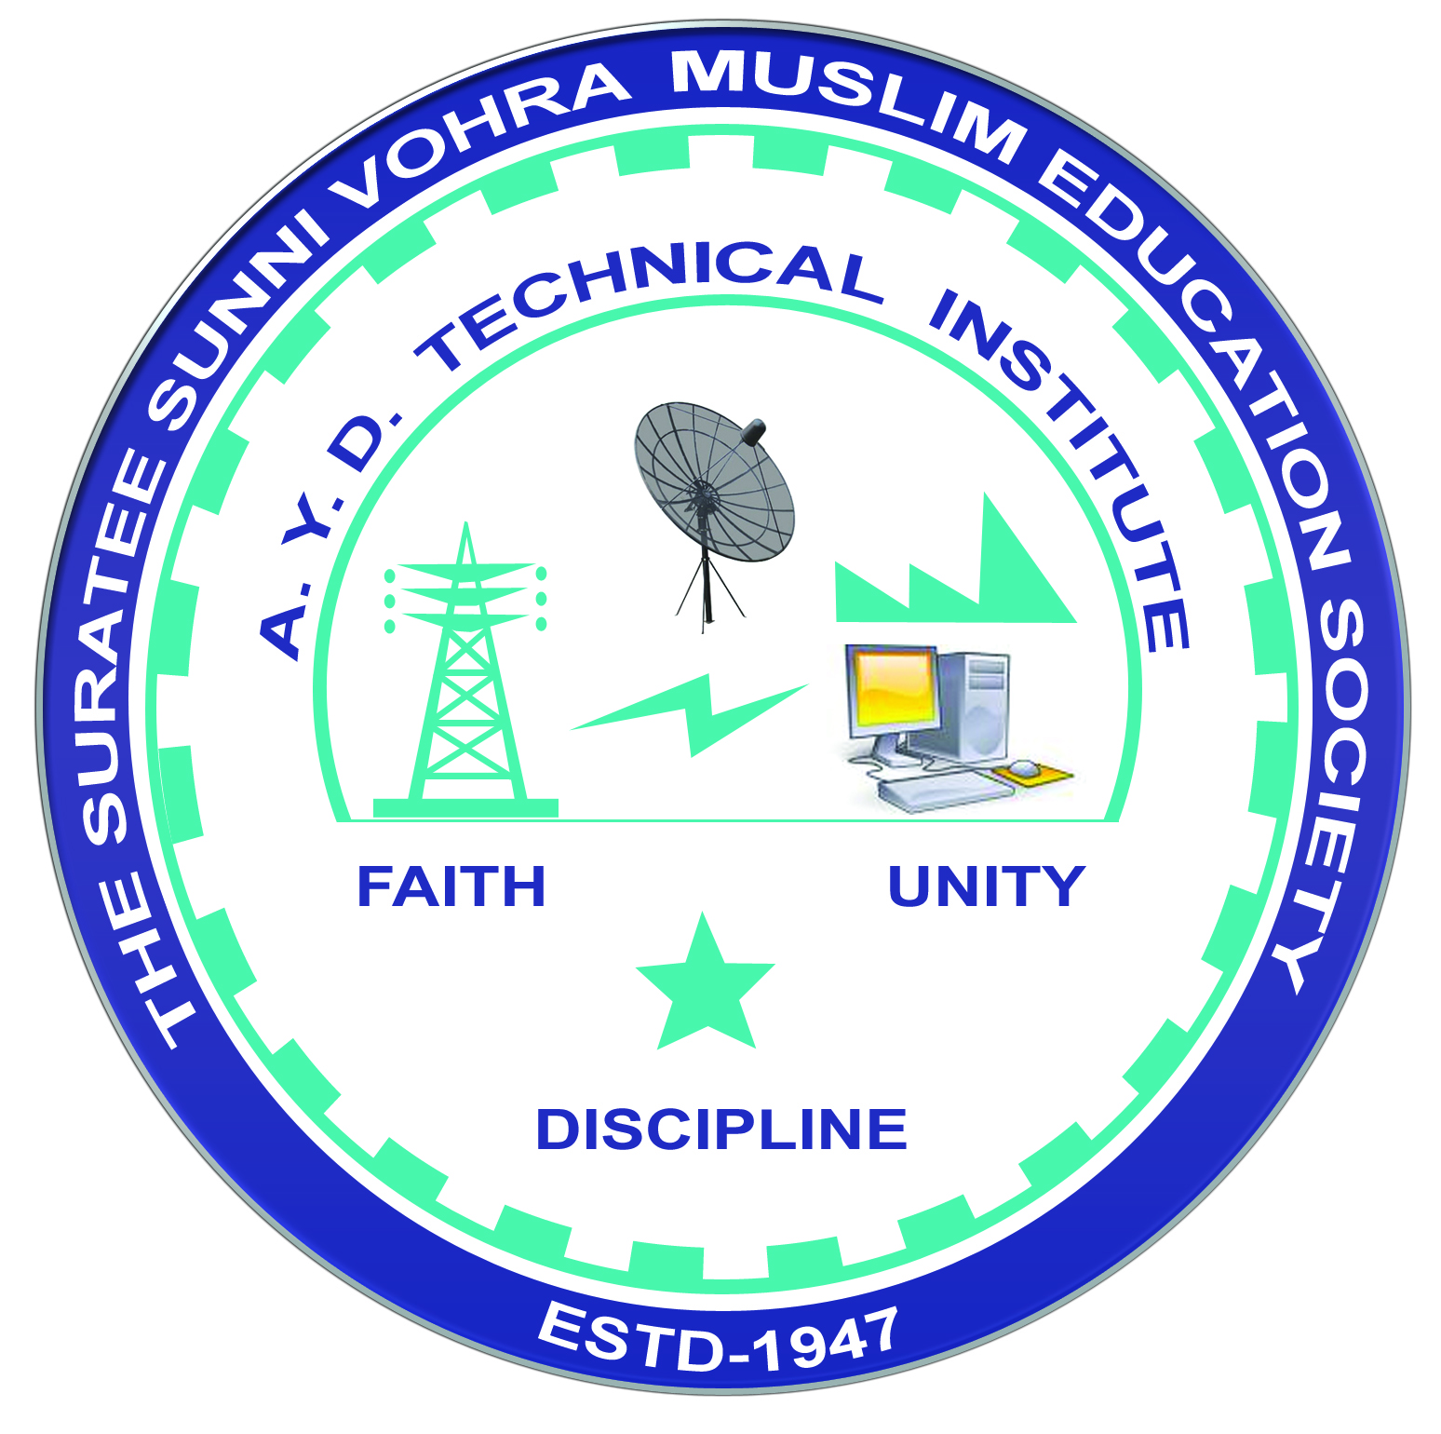 | A.Y. DADABHAI TECHNICAL INSTITUTE, KOSAMBA | 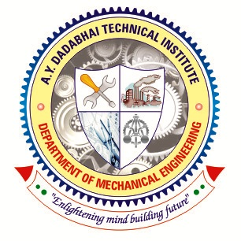

DEPARTMENT OF MECHANICAL ENGINEERING

One Day Workshop Report

Name of Institute : R.N.G.Patel Institute of Technology, Tajpor- Bardoli
Address: Bardoli – Navsari Road, Isroli, Afwa, Bardoli, Surat-394620.
Date of Visit: 29-03-2022
Semester: 6th
No. of Students Visited: 63
No. of Faculty Visited: 04
Subject (Course) Related to Industry: Computer Aided Manufacturing & Fabrication Technology
Contact person of Industry: Dr. Vratraj K Joshi
Contact No: 9537460034
Name of departments visited : CAM Lab & Workshop
Photographs:
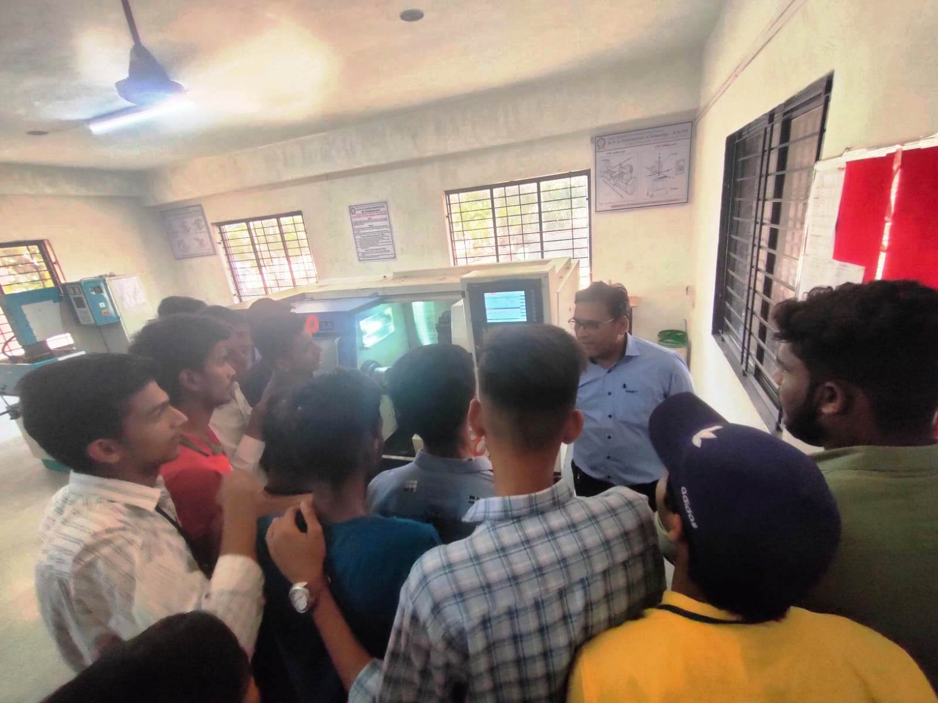 | 