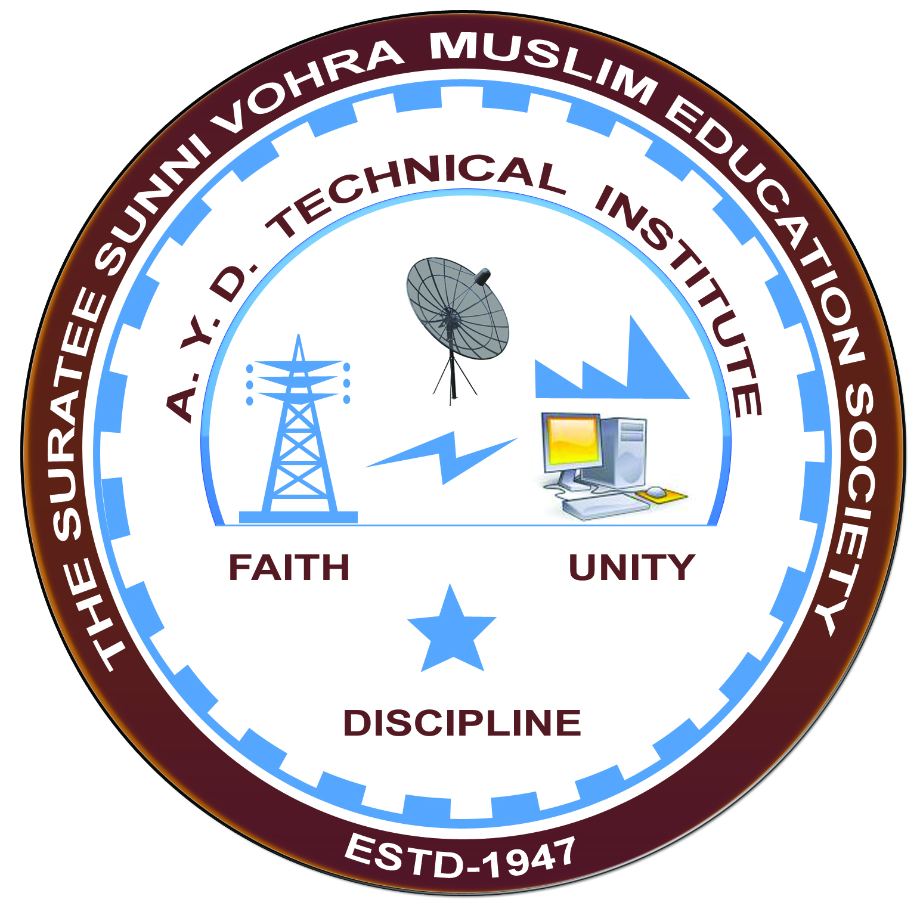

**Report on Expert Lecture**

**SOLAR POWER GENERATION TECHNOLOGY**

**Arranged by**

**Electrical Engineering Department,**

**A.Y.DADABHAI TECHNICAL INSTITUTE, KOSAMBA**

**EXPERT LECTURE**

**Date:-** 03/09/2019

**Department:-** Electrical Engineering

**Sem:-** 3rd Semester

**Faculty:-** (1) Mr. M. A. Sheikh

(2) Mr. M. R. Vansiya

**No of Students: -** 55

|  |  |  |
| --- | --- | --- |
| **Name Of Expert** | **Designation** | **Organization Of Expert** |
| MR. MIHIR RANA | ASST.ENGINEER | K.P SOLARISM  VI: SUDI DI: BHARUCH |

**Topic Of Expert Lecture:-** Solar Power Generation Technology

**Brief about Expert Lecture:-**

Our electrical engineering department of A. Y. Dadabhai Technical Institute, Kosamba Had organized expert lecture of SOLAR POWER GENERATION on the date of 28 & 29 August 2019

MR.MIHIR Started with basic block diagram of Solar Power Generation & then Covered the following Topics.

* Different Elements & Equipments Of Solar Panel Generation
* How Solar Panel Works
* What is PV Cell & how It Works
* Which Factors Affect the Solar Power Generation?

Finally Students discuss their query & technical problems with experts.

**PHOTO GALLERY:**

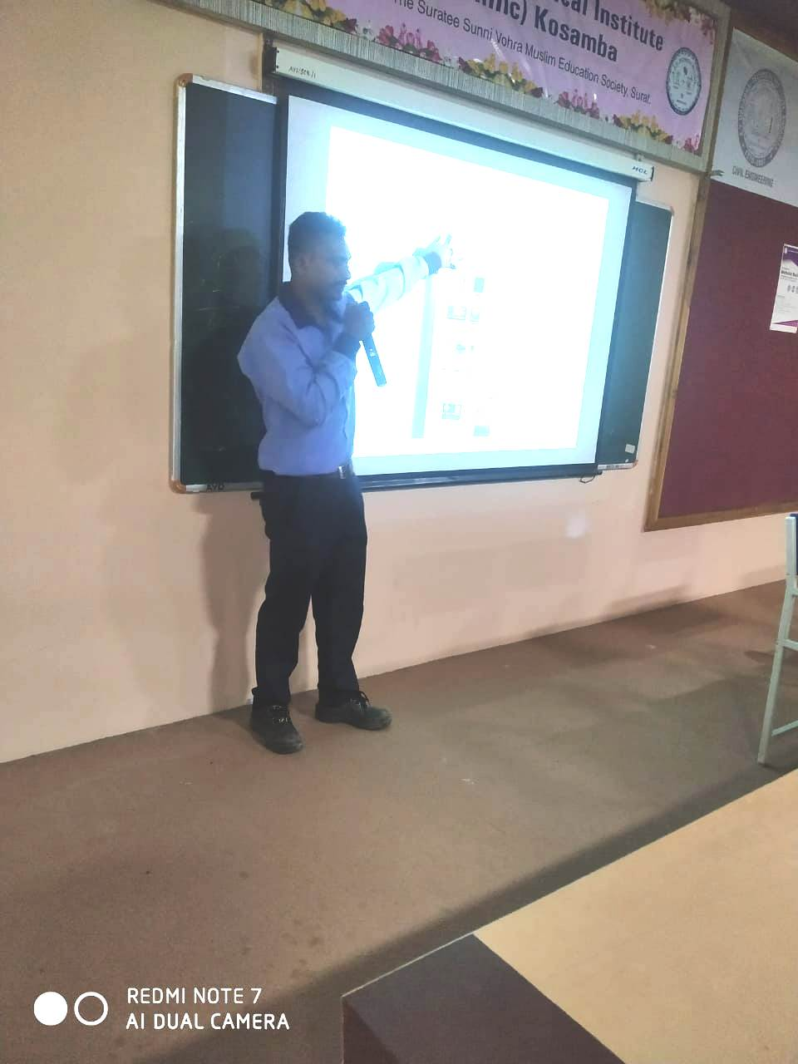

**EXPERT DELIVERING SPEECH**

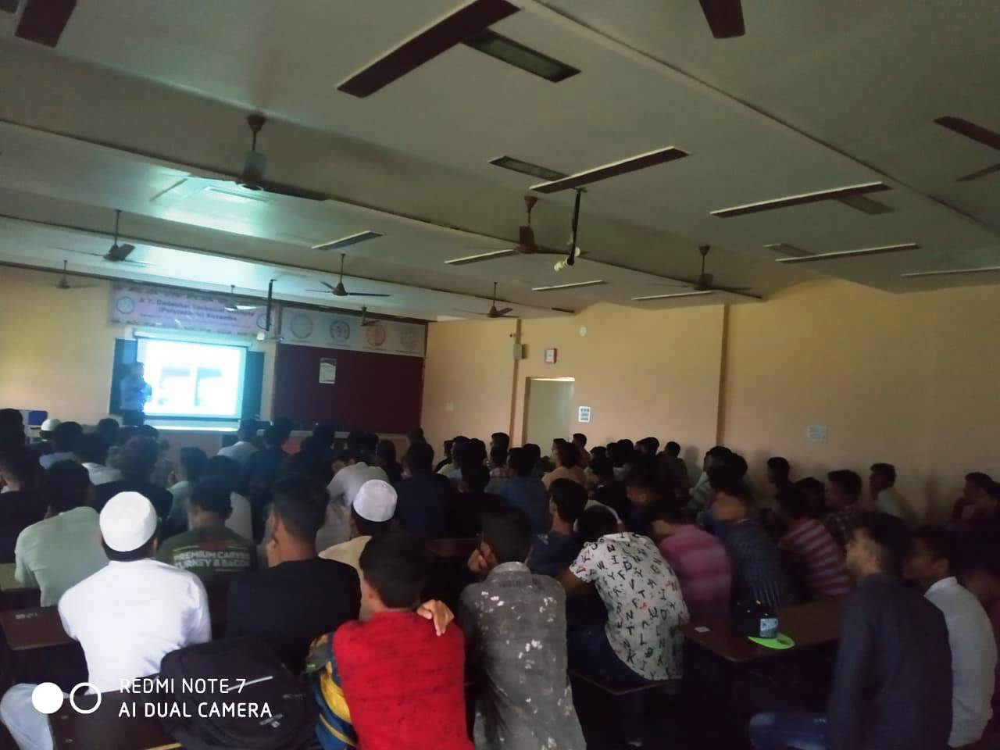

**STUDENTS PARTICIPATED**