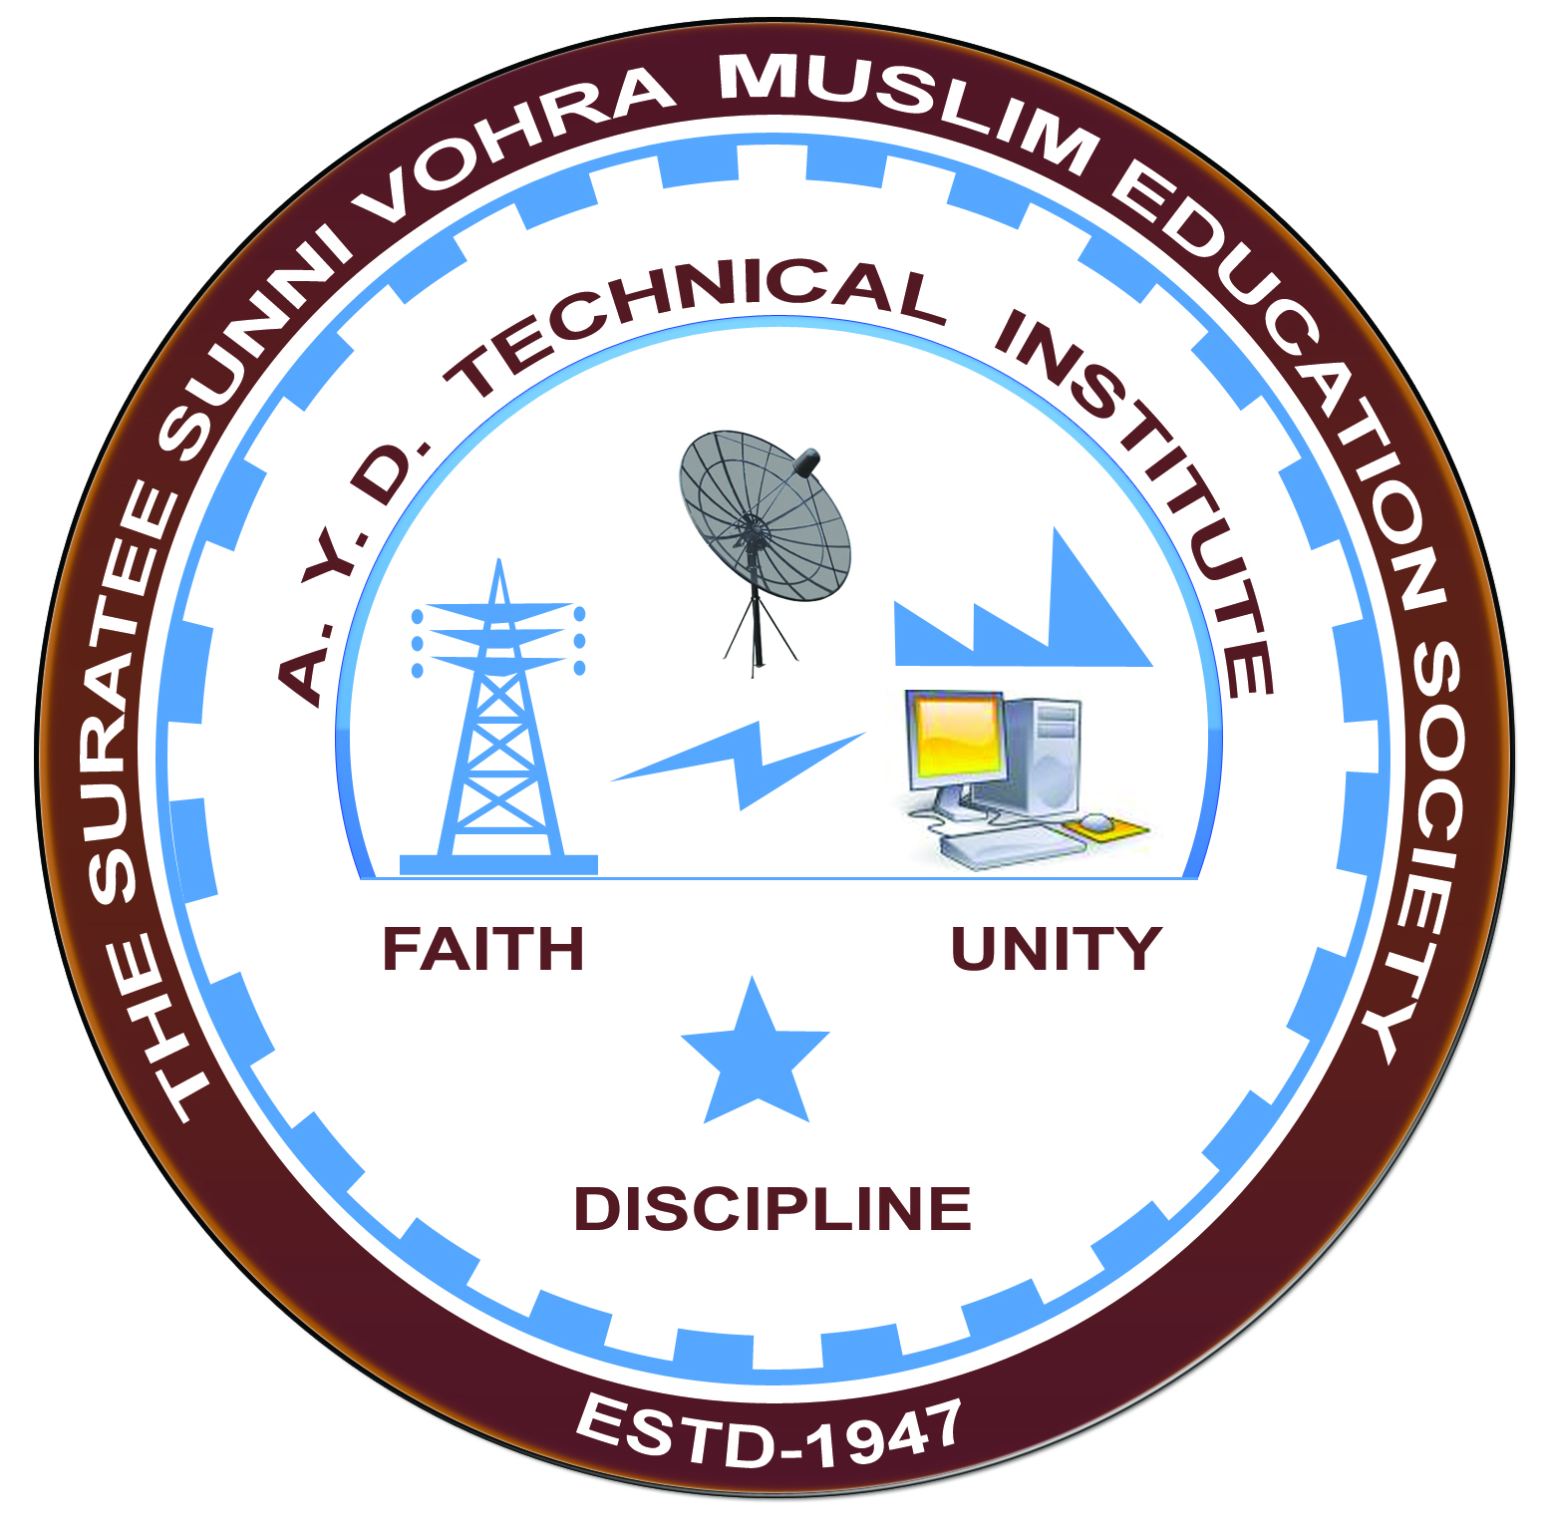

**TRANSMISSION & DISTRIBUTION**

**Arranged by**

**Electrical Engineering Department,**

**A. Y. DADABHAI TECHNICAL INSTITUTE, KOSAMBA**

**REPORT ON EXPERT LECTURE**

**Date:-** 25-01-2020

**Department:-** Electrical Engineering

**Sem:-** 4th Semester

**Faculty: -** (1) Mr. M. A. Sheikh

(2) Mr. R. J. Singh

(3) Miss. M. R. Vansiya

**No of Students: -** 52

|  |  |  |
| --- | --- | --- |
| **Name Of Expert** | **Designation** | **Organization Of Expert** |
| Mr. H. M. Mansuri | Deputy Engineer | GSECL (Vadodra) |

**Topic Of Expert Lecture:-** Electrical Transmission & Substation’s Operation & Maintenance

**Brief about Expert Lecture:-**

Today on 25 th January Saturday , 2020 an expert lecture arranged on Electrical Transmission and Substation at Electrical Engineering Department of Our A Y Dadabhai polytechnic, kosamba.

Mr. H M Mansuri ( Deputy Engineer of GSECL, vadodra) has given an impressive speech and focusing on current scenario on this topic.

**Program Photograph:-**

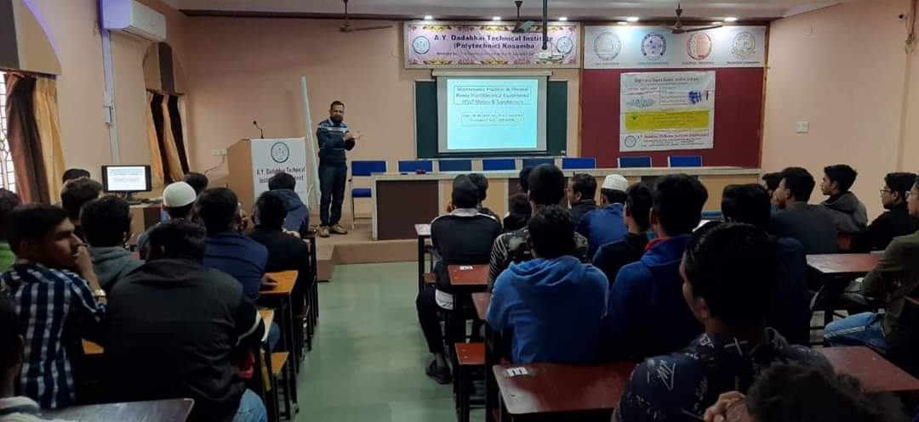

(Expert Delivering Lecture)

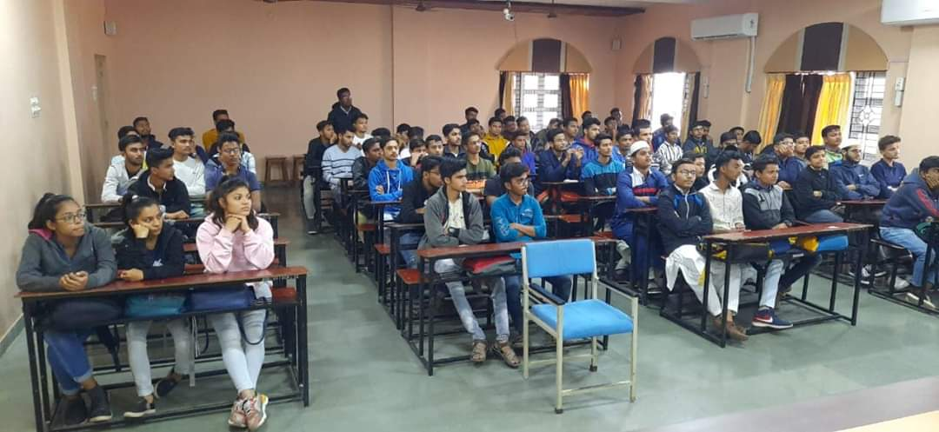

(Participations Of Students)

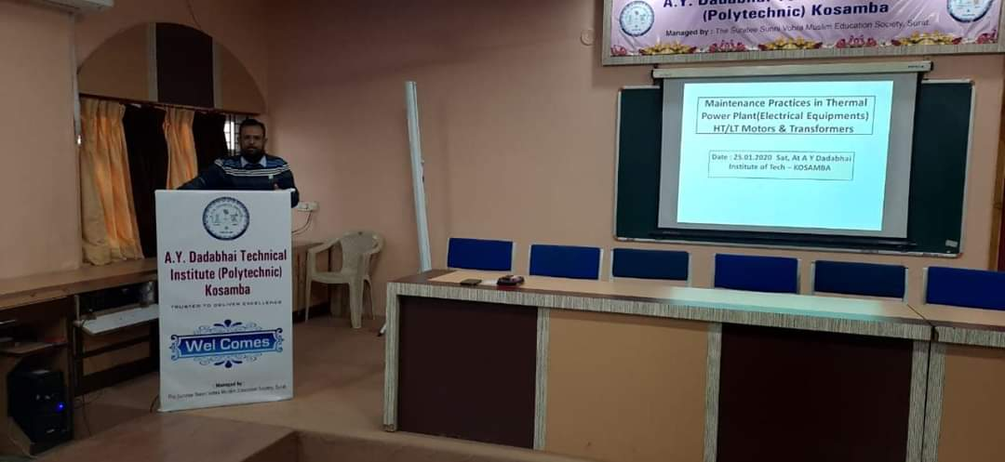

(Moment Of Lecture)