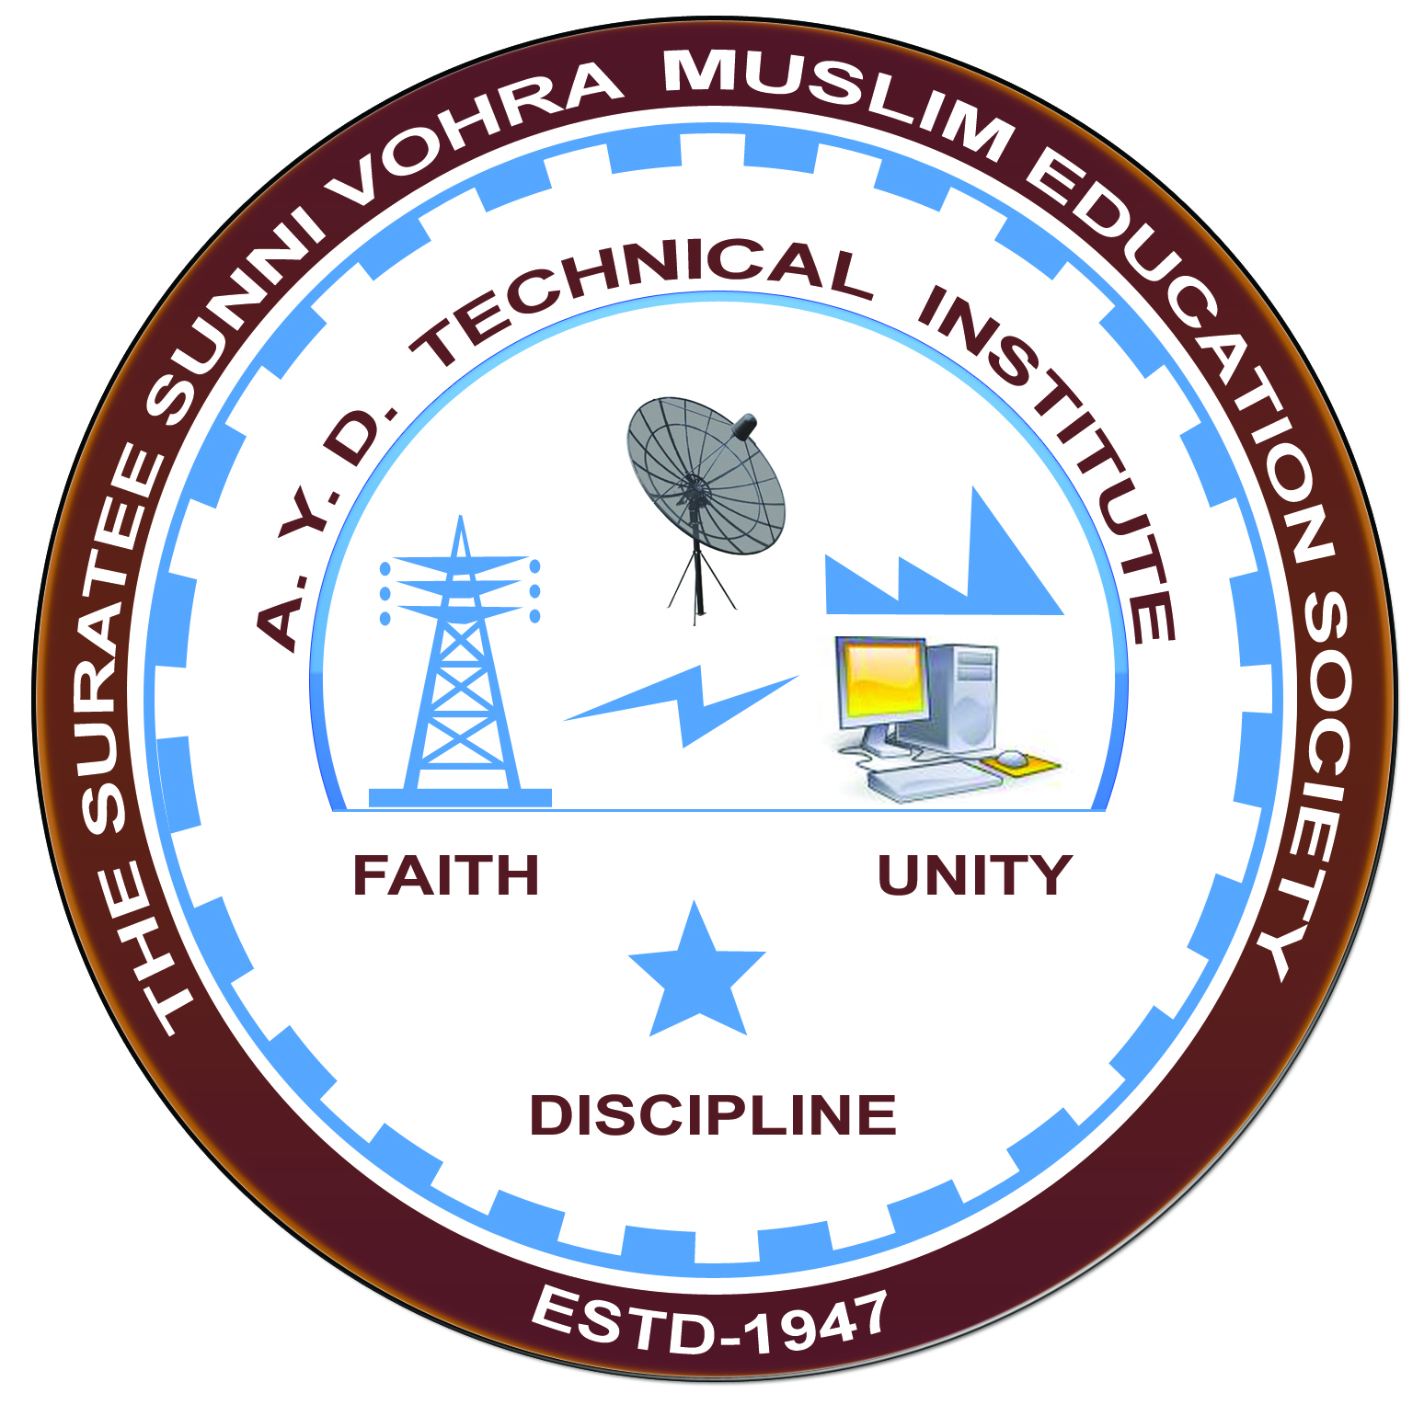

**SWITCHGEAR AND PROTECTION**

**Arranged by**

**Electrical Engineering Department,**

**A. Y. DADABHAI TECHNICAL INSTITUTE, KOSAMBA**

**REPORT ON EXPERT LECTURE**

**Date:-** 12 FEBRUARY 2022

**Department:-** Electrical Engineering

**Sem:-** 6TH SEM

**Faculty:** 2

(1) SNEHA MANIK

(2) R.J.SINGH

**No of Students: -** 52

|  |  |  |
| --- | --- | --- |
| **Name Of Expert** | **Designation** | **Organization Of Expert** |
| Mr VIKAS YADAV | PROPRIETOR | OHM ELECTRO ENGINEERS,ANKLESHWAR |

**Topic Of Expert Lecture:-SWITCHGEAR AND PROTECTION**

**Brief about Expert Lecture:-**

Our electrical engineering department of A. Y. Dadabhai Technical Institute, Kosamba Had organized expert lecture on **SWITCHGEAR AND PROTECTION**  on the date of **12 FEBRUARY 2022** The session was very interactive and students participated enthusiastically. in the beginning the speaker gave introduction about various technical aspects and concepts of different relays and circuit interrupting devices.

As per the feedback received from the students it was very good learning experience, the lecture helped them in their understanding the concept of switchgear and protection.

**PHOTOS OF EXPERT LECTURES**

