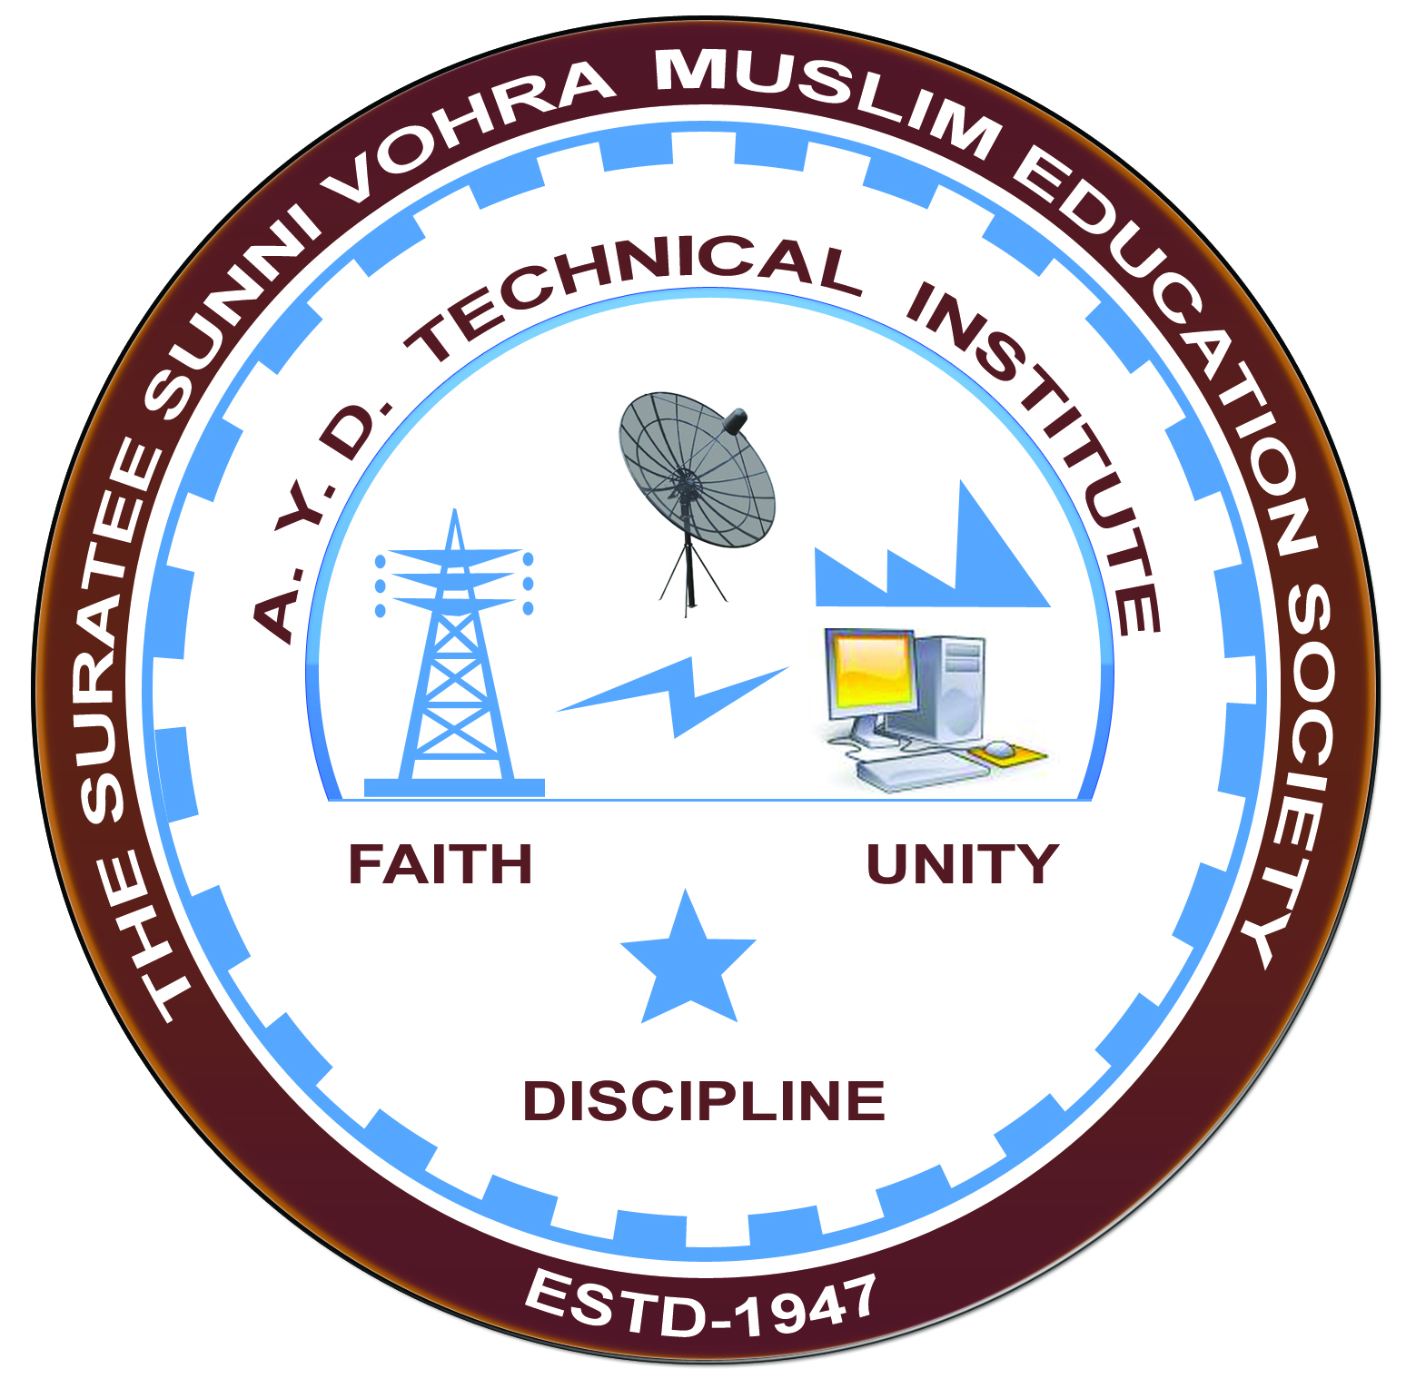

**ENERGY CONSERVATION & AUDIT**

**Arranged by**

**Electrical Engineering Department,**

**A. Y. DADABHAI TECHNICAL INSTITUTE, KOSAMBA**

**REPORT ON EXPERT LECTURE**

**Date:-** 1 SEPTEMBER 2022

**Department:-** Electrical Engineering

**Sem:-** 5TH SEM

**Faculty:** 44

1. S R MANIK
2. M Y PATEL
3. R J SINGH

**No of Students: -** 44

|  |  |  |
| --- | --- | --- |
| **Name Of Expert** | **Designation** | **Organization Of Expert** |
| Mr S K NAYAK | DIRECTOR | 3S Energy core & Consulting Services |

**Topic Of Expert Lecture:- ENERGY CONSERVATION & AUDIT.**

**Brief about Expert Lecture:-**

Our electrical engineering department of A. Y. Dadabhai Technical Institute, Kosamba Had organized expert lecture on **ENERGY CONSERVATION & AUDIT.**

On the date of **1 SEPTEMBER 2022** The session was very interactive and students participated enthusiastically. The speaker gave information about various technical aspects and concepts where energy can be conserve.

As per the feedback received from the students it was very good learning experience, the lecture helped them in their understanding the concept of Energy Conservation & Audit.

**PHOTOS OF EXPERT LECTURE**

