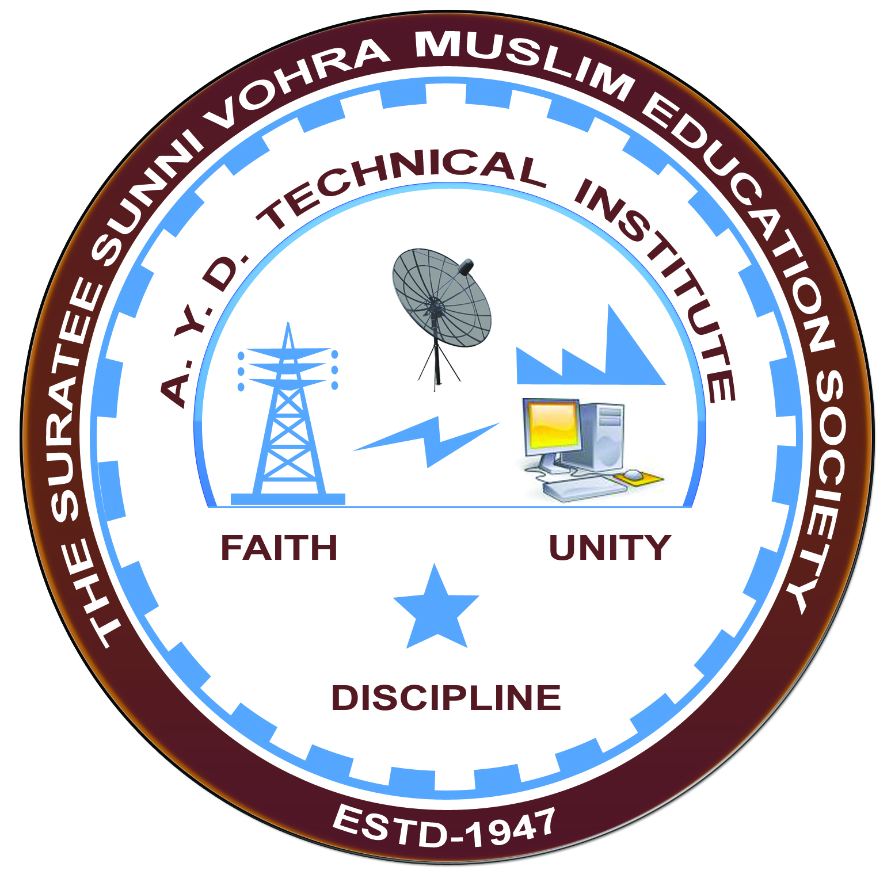

**SOLAR INSTALLATION AND METERING SYSTEM**

**Arranged by**

**Electrical Engineering Department,**

**A.Y.DADABHAI TECHNICAL INSTITUTE, KOSAMBA**

**REPORT ON EXPERT LECTURE**

**Date:-** 07-02-2022

**Department:-** Electrical Engineering

**Sem:-** 6thSemester

**Faculty: -** (1) Mr. M. S. Dinath

(2) Mr. R. J. Singh

**No of Students: -**60

|  |  |  |
| --- | --- | --- |
| **Name Of Expert** | **Designation** | **Organization Of Expert** |
| MR. CHIRAG PATEL | CONSULTANT | AHA SOLAR PVT LTD |

**Topic Of Expert Lecture:-** Solar Installation & Metering System

**Brief about Expert Lecture:-**

Our electrical engineering department of A. Y. Dadabhai Technical Institute, Kosamba Had organized expert lecture onSolar Installation and Metering Systemon the date of 7 February 2022

MR. CHIRAG PATEL (CONSULTANT AHA SOLAR PVT LTD) has delivered an excellent lecture to our Final year Electrical students at (online mode) on Solar Installation and Metering System. By this our student gets knowledge about important of installation of solar power plant and about calculation of capacity of plant require. There should be good questions and answer session between students and the Expert.