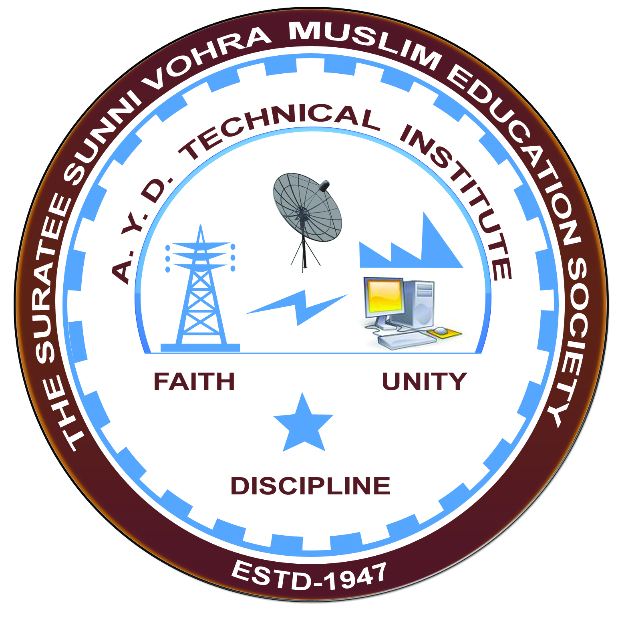

**POWER PLANT MAINTENANCE**

**Arranged by**

**Electrical Engineering Department,**

**A. Y. DADABHAI TECHNICAL INSTITUTE, KOSAMBA**

**REPORT ON EXPERT LECTURE**

**Date:-** 07-01-2020

**Department:-** Electrical Engineering

**Sem:-** 6th & 4th Semester

**Faculty: -** (1) Mr. M. S. Dinath

(2) Mr. M. H. Darsot

(3) Mr. M. A. Sheikh

**No of Students: -** 87

|  |  |  |
| --- | --- | --- |
| **Name Of Expert** | **Designation** | **Organization Of Expert** |
| Mr. Kartik Engineer | Maintenance Engineer | RAS Girtas Power Company, QATAR |

**Topic Of Expert Lecture:-** Power plant maintenance

**Brief about Expert Lecture:-**

Our electrical engineering department of A. Y. Dadabhai Technical Institute, Kosamba Had organized expert lecture on Power plant maintenance system on the date of 25 January 2020

Mr. Kartik Engineer (Senior Maintenance Engineer of RAS GIRTAS POWER COMPANY a giant power company of QATAR country) has delivered an excellent lecture to our Final year Electrical students at our college. There should be good questions and answer session between students and the Expert.

**Program Photograph:-**

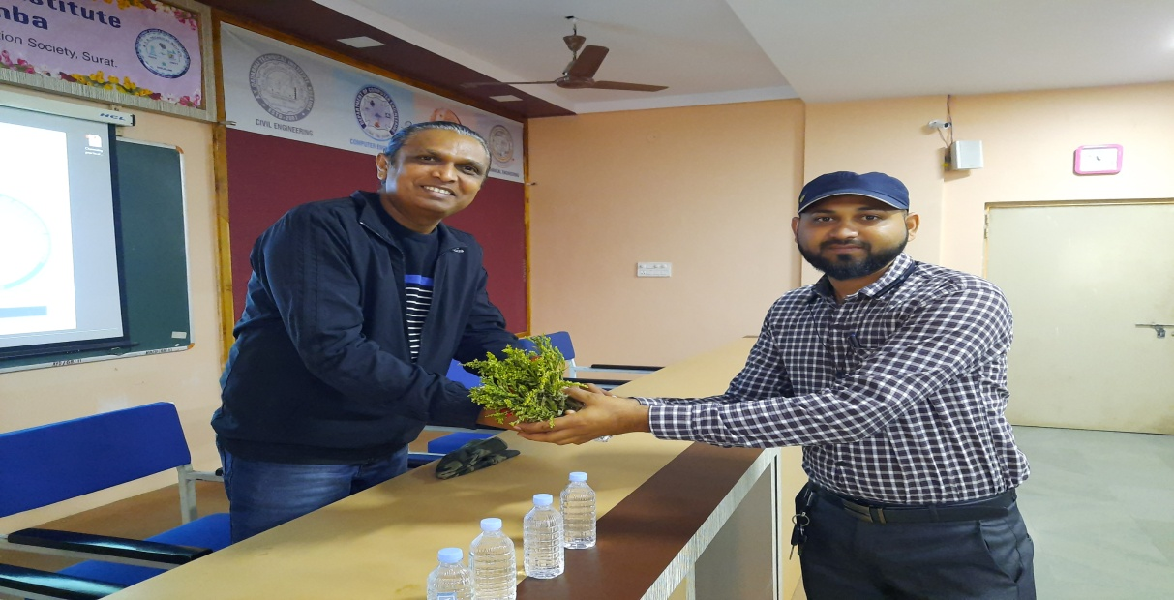

(Felicitation Of Expert)

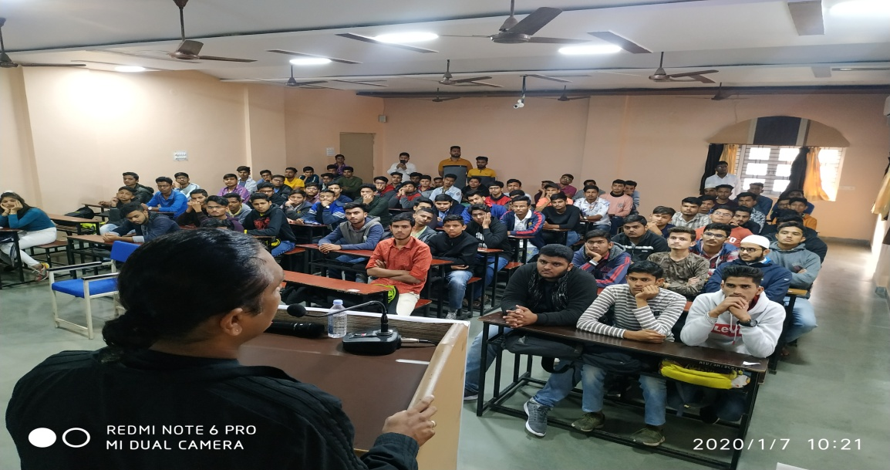

(Expert Delivering Lecture)

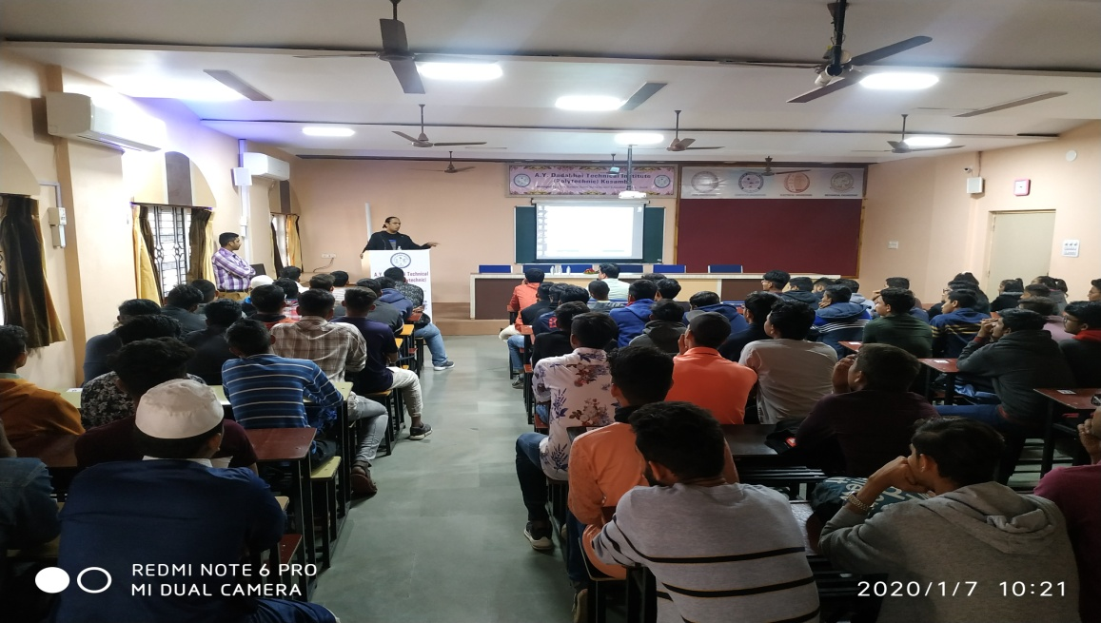

(Participations Of Students)

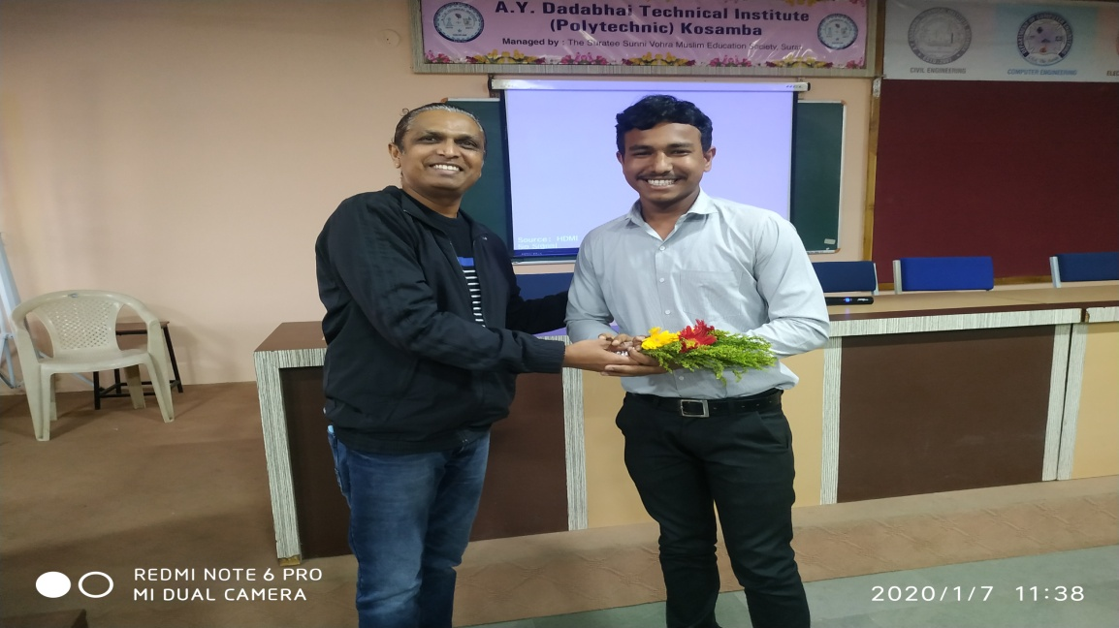

(Moment Of Lecture)