|  |  |  |
| --- | --- | --- |
| D:\broucher, banner, logo & profile\Logo\AYDTI, Kosamba - Copy.jpg | **A Y DADABHAI TECHNICAL INSTITUTE, KOSAMBA** | D:\broucher, banner, logo & profile\Logo\logo_t&p - Copy.jpg |

**Training & Placement Cell**

* A Seminar on Immigration & Foreign Opportunities

Date: 27th December, 2018

Time: 10:30 am to 12:00 pm

No. of Participants: 100 Final Year Students and 10 faculty

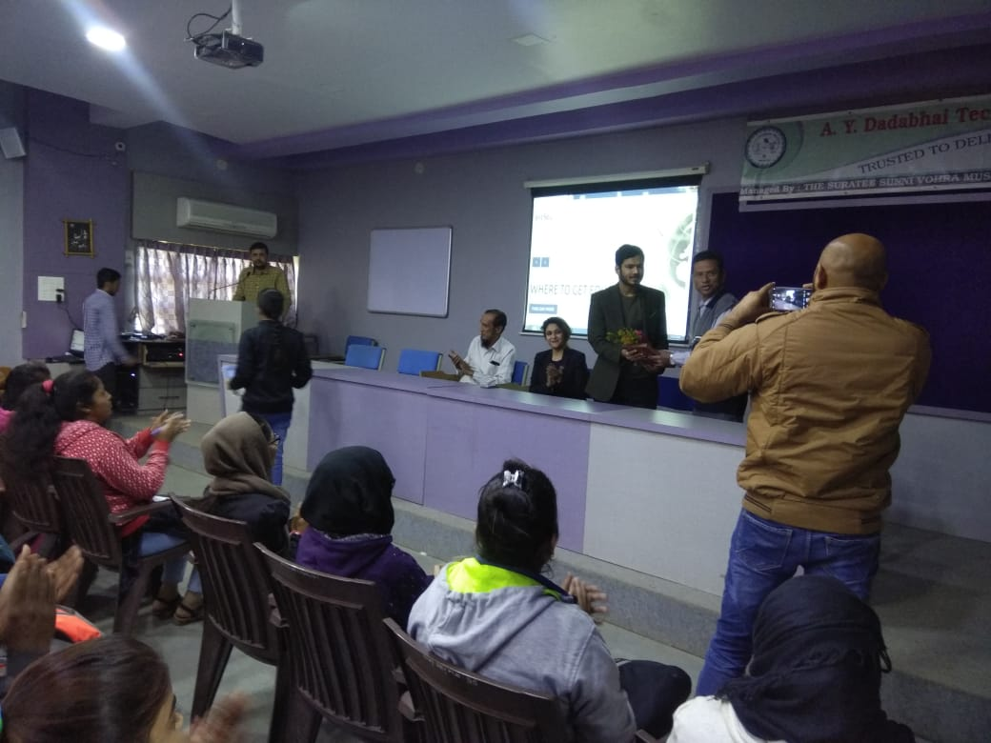 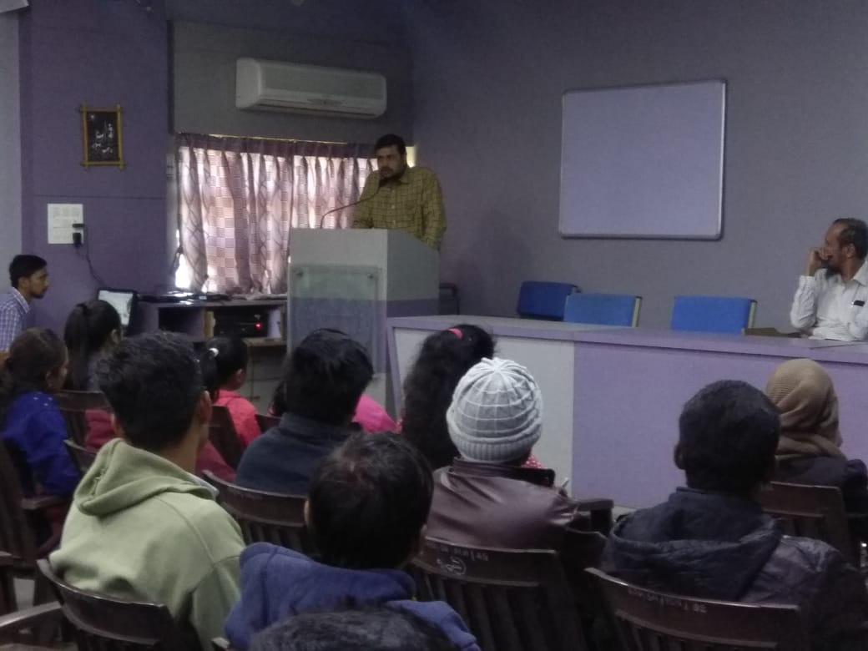

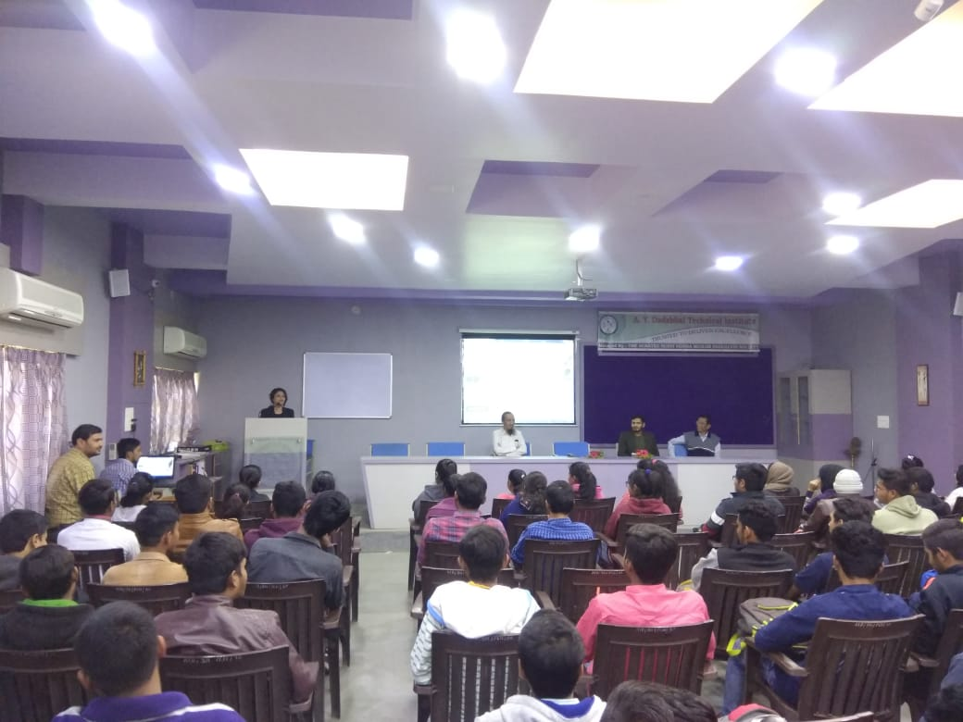 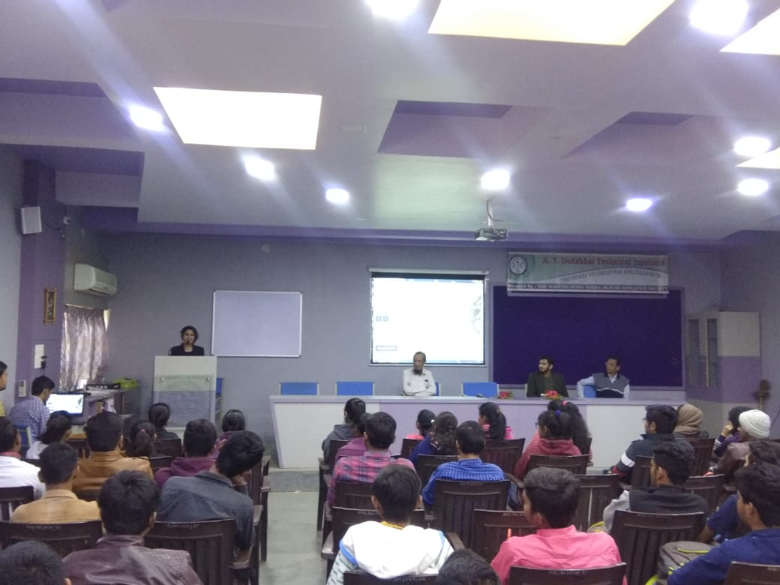

**Resource Person: Ms. Bhumika Dilkhush (CEO- IntStu Consultants, Surat)**

**Mr. Meet Kotadiya (Director- Ocxee.com, UK)**