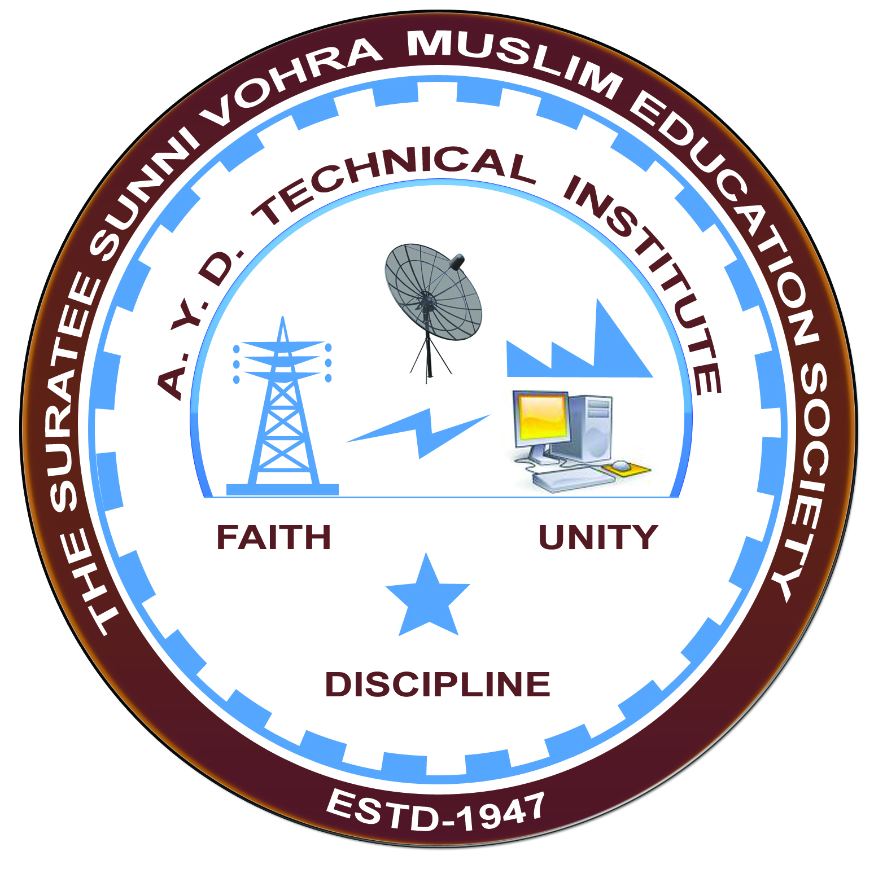

**Report on Expert Lecture**

**JOB OPPRTUNITY IN ELECTRICAL ENGINEERING**

**DELIVERED BY MR.IRBAZ I.SHAIKH**

**&**

**Arranged by**

**Electrical Engineering Department,**

**A.Y.DADABHAI TECHNICAL INSTITUTE, KOSAMBA**

**EXPERT LECTURE**

**Date:-** 12/10/2019

**Department:-** Electrical Engineering

**Sem:-** 1ST Semester

**Faculty:-** (1) Mr. R.J.SINGH

(2) MISS. M. R. VANSIYA

**No of Students: -**73

|  |  |  |
| --- | --- | --- |
| **Name Of Expert** | **Designation** | **Organization Of Expert** |
| MR.IRBAZ I.SHAIKH | ASST.SYSTEM ENGINEER | TATA CONSULTANCY SERVICES (T.C.S.) GANDHINAGAR |

**Topic of Expert Lecture:- JOB OPPRTUNITY IN ELECTRICAL ENGINEERING**

**Brief about Expert Lecture:-**

Our electrical engineering department of A. Y. Dadabhai Technical Institute, Kosamba Had organized expert lecture of **JOB OPPRTUNITY IN ELECTRICAL ENGINEERING** on the date of 12 OCT 2019.

MR.IRBAZ explains the global importance of electrical engineering. Then he explained job opportunity in private and government sector. He covers the following topics.

* Explain about government job applications and explains how to prepare for govt. job.
* List of government organization like GENCO, TRANSCO, DISCOM, ONGC, BHEL and their recruitment procedure.
* How to prepare for private sector job, their recruitment procedure.
* Opportunity to start up own business like panel design, electrical contractor, electrical equipment maintenance workshop, and electrical equipment design and manufacturing.

Finally Students discuss questions with experts.

**PHOTO GALLERY:**

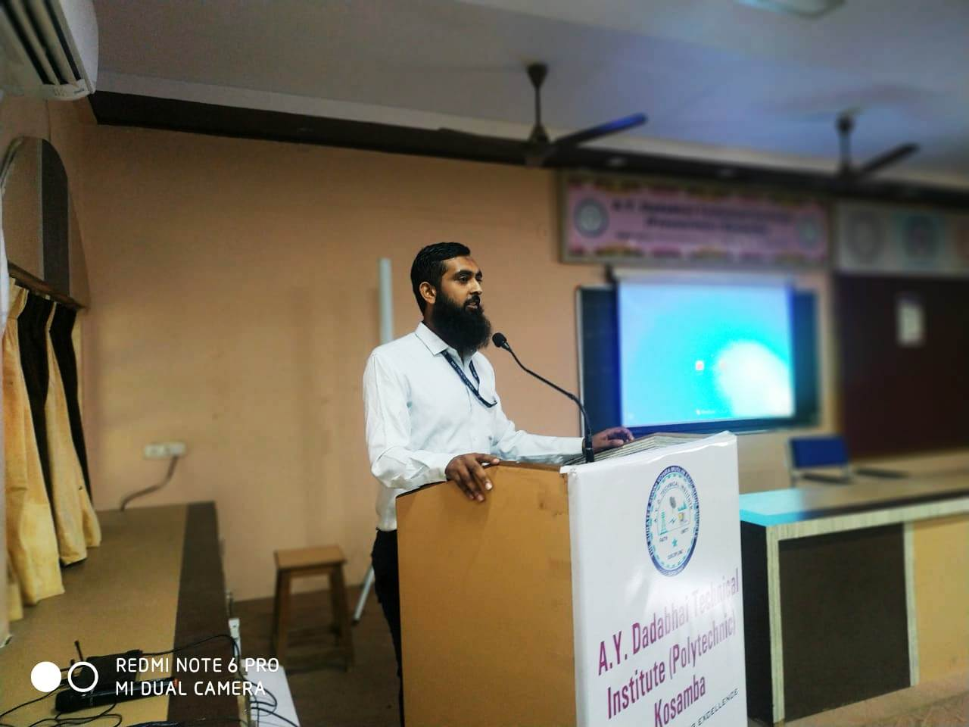

**EXPERT DELIVERING SPEECH**

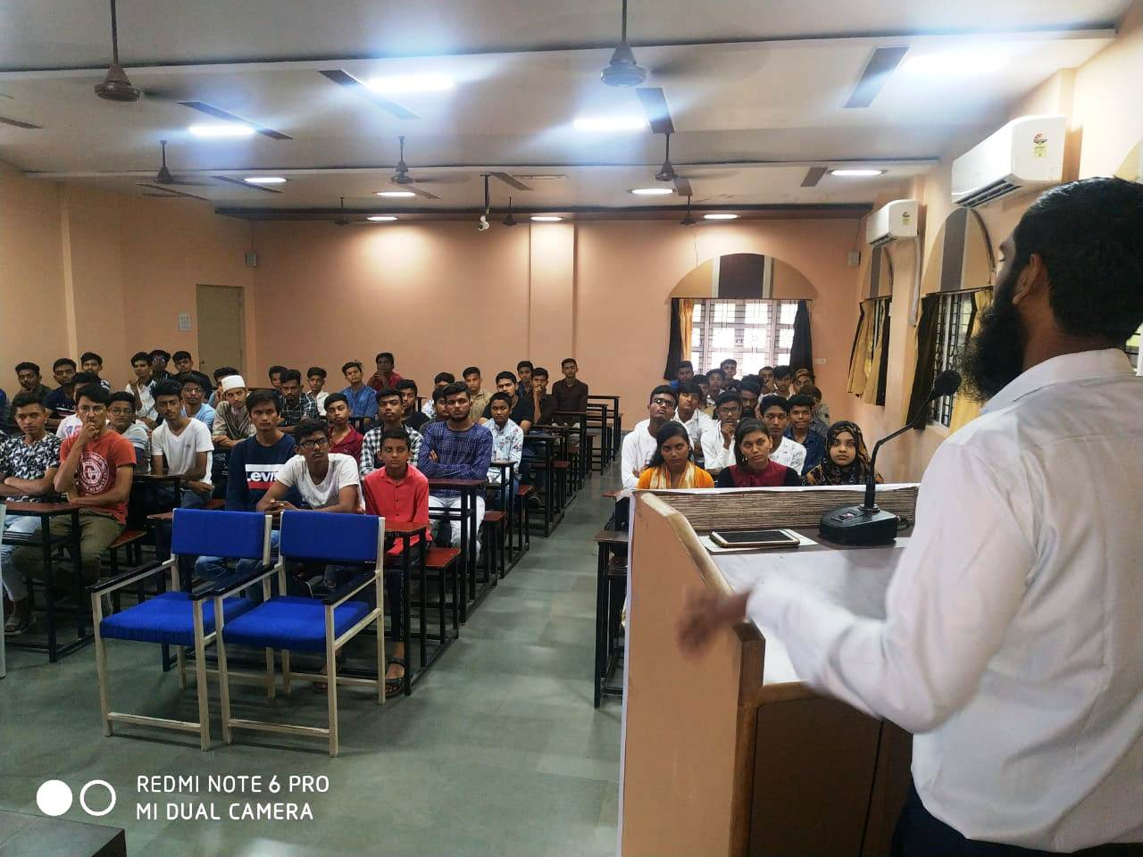

**STUDENTS PARTICIPATED**