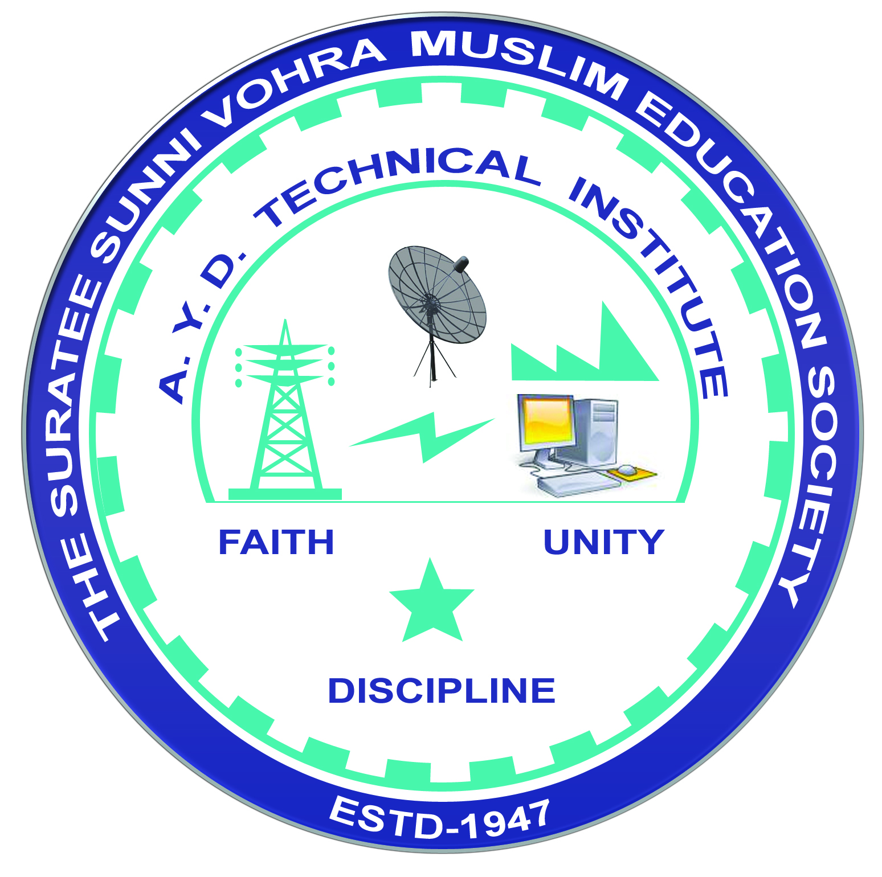 | A.Y. DADABHAI TECHNICAL INSTITUTE, KOSAMBA | 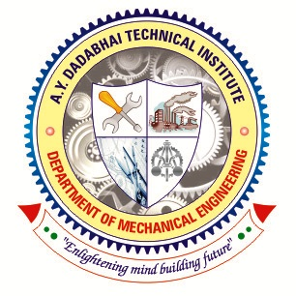

DEPARTMENT OF MECHANICAL ENGINEERING

One Day Educational Visit of Industry

Name of Industry:
Address:
Date of Visit:
No. of Students Visited:
No. of Faculty Visited:
Subject (Course) Related to Industry:
Contact person of Industry:
Contact No:
Get Approved by:
Product of Industry:
Name of departments visited in Industry:
Prepared brief report: Yes No

Attachment:
- List of students.
- List of faculties.
- Consent letter from parents.
- Faculty order letter.

