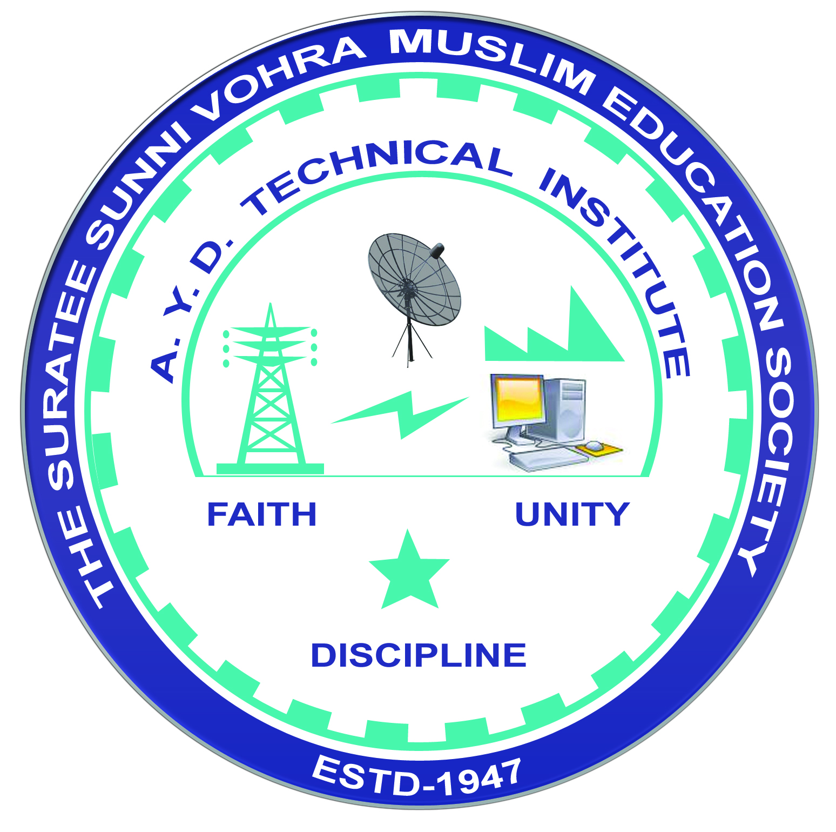 | A.Y. DADABHAI TECHNICAL INSTITUTE, KOSAMBA | 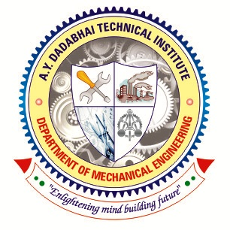

DEPARTMENT OF MECHANICAL ENGINEERING

Report

Name of Expert: Dr. Hitesh S. Jariwala
Designation: Asst. Professor and T & P Officer of Mechanical Engg. Dept.
Address: SNPIT & RC, Umrakh, Bardoli
Date of Lecture Conduct: 11-02-2023
Semester: 6th – 3rd Year
No. of Students: 61
Subject (Course) Related to Expert Lecture: - “How to crack Aptitude & Technical test for the Interview”
Topic Covered: (1) Aptitude & Technical Test.
Time: - 9.30 am to 10.45 am.
(2) How to crack Interviews.
Time: - 10.45 am to 12.15 pm.
Photographs:
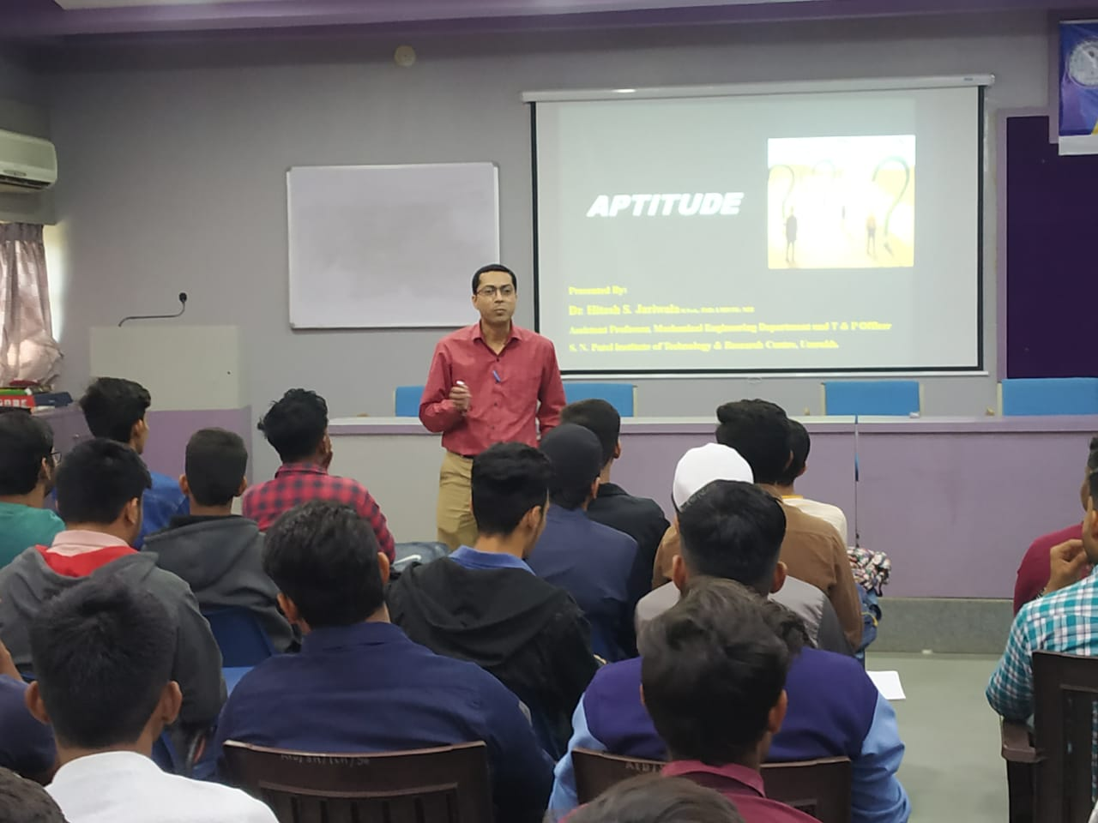 | 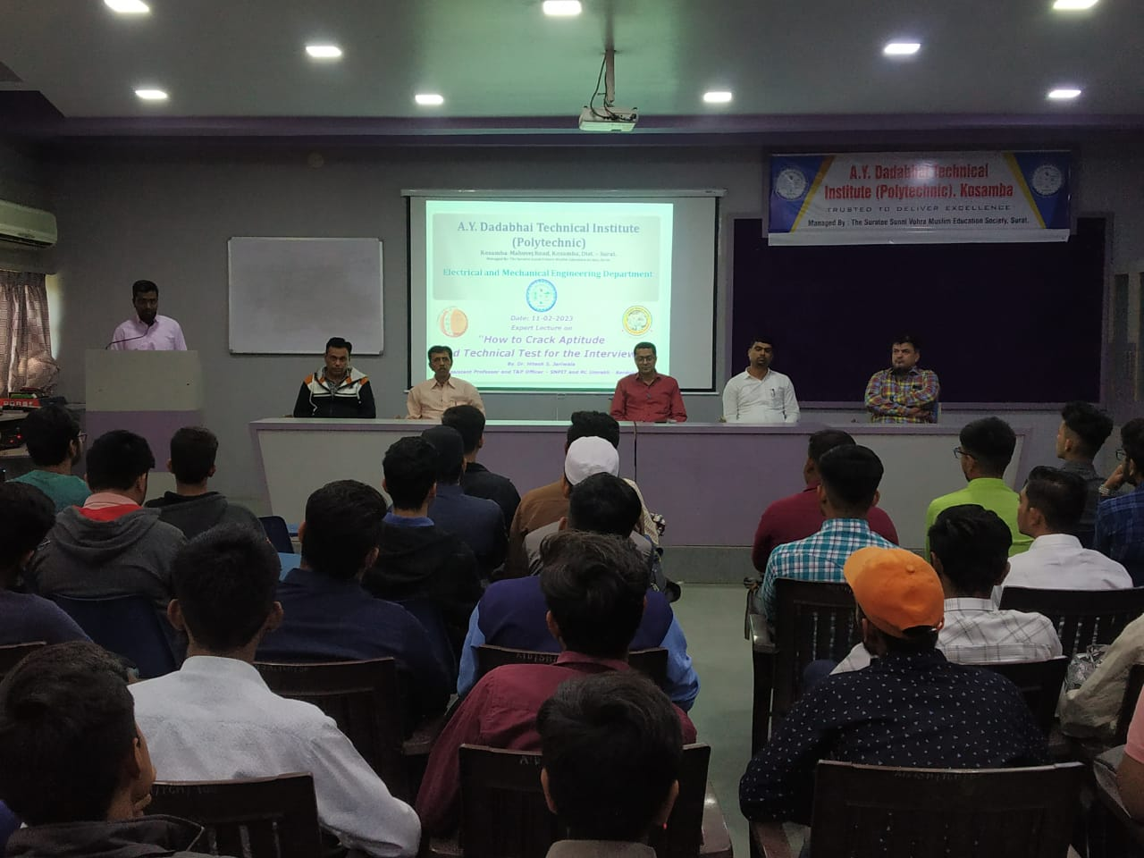
Dr. H.S. Jariwala talks with students “How to crack Aptitude & Technical test for the
Interview”

