**A Report**

**On**

**One Day Workshop on**

**“Energy Conservation Awareness”**

**A.Y.DADABHAI TECHNICAL INSTITUTE, KOSAMBA**

|  |
| --- |
| I:\logo_t&p.jpg |

**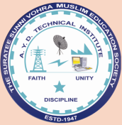**

***Held on31st July, 2018***

**BY**

****

**Gujarat Energy Development Agency**

**(A Government of Gujarat Organization)**

**Title: One day workshop on “Energy Conservation Awareness”**

**Date:** 31st JULY, 2018

**Time:** 09:00 AM to 5:00 PM

**Venue:** Seminar Hall, B-wing, AYDTI, Kosamba

**Workshop Coordinator:** Mr. M.S.DINATH

**Department:** Electrical and Mechanical Engineering

**Expert Speakers:**

1. **Mr. R.M.Panchal**

Proprietor, Global Energy Consultancy Services, Vadodara

Retired Chief Engineer, MGVCL, Vadodara

BEE Certified Energy Auditor

1. **Mr. D.N.Shah**

Executive Engineer, Kosamba (South Gujarat)

BEE Certified Energy Auditor

**Total Students Participants:** 70(50 Electrical+20 Mechanical)

**Total Faculty Participants:** 10

**ABOUT GEDA**

**1. Historical perspective**

GEDA (Gujarat Energy Development Agency), one of the premier organizations and a forerunner in India has been working in the field of renewable energy development and energy conservation. GEDA is shouldering the responsibility of  a state nodal agency (SNA) for the Ministry of New and Renewable Energy Sources and the state designated agency (SDA) for Bureau of Energy Efficiency (BEE).

GEDA has played a pioneering role in the development of a long-term renewable policy and implementing of sustainable energy programmes across the state. GEDA’s challenge has been to make the renewable energy and energy efficient technologies economically and commercially viable. GEDA was catalytic in the formation of the Commission of Additional Sources of Energy (CASE) in 1981, which later became the Department of Non-conventional Energy Sources (DNES) in 1982 and a full-fledged Ministry- MNES (Ministry of Non-conventional Energy Sources) in 90s, which is now the MNRE (Ministry of New and Renewable Energy).   The model was then replicated to establish similar state nodal agencies in other states throughout the country.

The renewable energy promotion and popularization programmes in the state have crossed the over 3 decades of untiring efforts and pioneered several sustainable initiatives; many of which are the country’s first. GEDA has virtually been the crucible, the melting pot of ideas to ‘check out’ renewable sources of energy as alternatives to conventional fuels. The convenient green-n-clean actions in these direction and milestones achieved have set the pace for Renewable Energy Development in India

* Assessment of energy needs,
* Technology assessment and demonstration
* Assessment of biomass resources
* Research in technology, product and market development through applied research, field trials and soft studies
* Localization of programmes and effective grassroots penetration by networking with NGO’s and other local institutions
* Developing a manufacturing base to aid commercialization of renewable energy technologies
* Strengthening commercial distribution channels to make NRSE products available to consumers as of- the- counter- devices
* Developing a network of users to gather vital feedback for effective programme/technology development
* Building a renewable energy resource centre and maintaining a state-of- the-art knowledge bank
* Information, promotion, training and education packaged to take energy ideas to the vast and varied base of energy consumers.
* Reaching out through the school energy education programme

In this scenario, it is certainly in our economic self-interest to employ renewable energy technologies.

**Brief Information:**

A.Y.Dadabhai Technical Institute (Polytechnic), Kosamba organized a one day GEDA sponsored workshop on “Energy Conservation Awareness” for final year students of Electrical& mechanical Engineering, on 31st JULY, 2018.

The workshop started with the prayer. Welcome address is given by Mr.M.H.DARSOT (Lecturer in Electrical Department) and inaugural address of this workshop given by the college Director Mr. M.A.SHEIKH.

Mr. R.M.Panchal, Mr. D.N.Shah delivered expert lecture on the following topics and guided the participants.

* Electrical Energy Scenario in Gujarat and India.
* Energy Sources Overview.
* Why Save Energy?
* Energy Conservation Means.
* Energy Conservation in Domestic Appliances.
* Electricity Tariff.
* Energy Audit
* Energy Conservation in Industries, Motors and Pumps.
* Role of GEDA in Energy Conservation.
* Energy Conservation through Renewable Energy Sources.

In the last session of the workshop the answers of the questions given by the experts, students expressed their review and gave commitment to save the energy.

After completion of workshop, feedback taken from the participants and finally all the participants received certificates.

Morning tea with refreshment, working lunch and afternoon tea provided to all the participants during the workshop.

All the participants enjoyed the workshop.

A.Y.Dadabhai Technical Institute is thankful to the Gujarat Energy Development Agency (GEDA), Gandhinagar for their sponsorship to arrange such type useful workshop and also thankful to the experts of the Global Energy Consultancy Services, Vadodara for providing a valuable knowledge to the participants.

**Event Photographs**

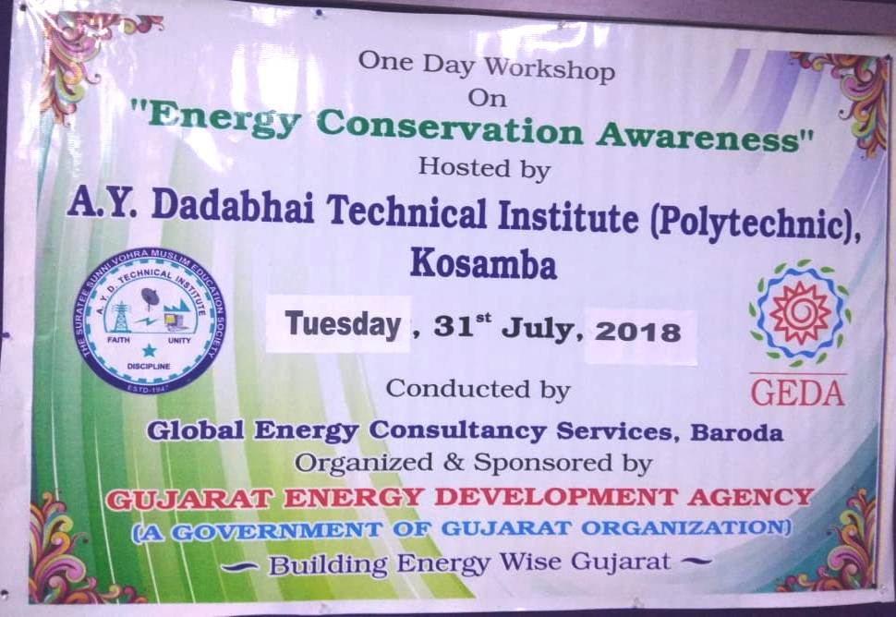 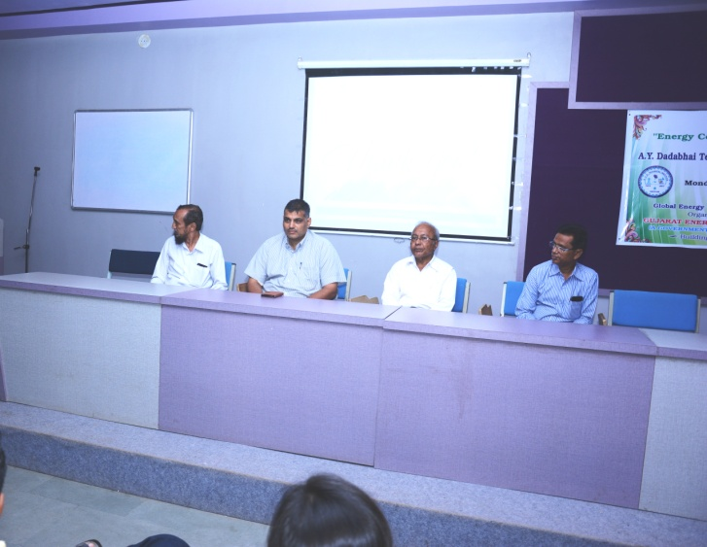

**Workshop Banner Delegates on the dais**

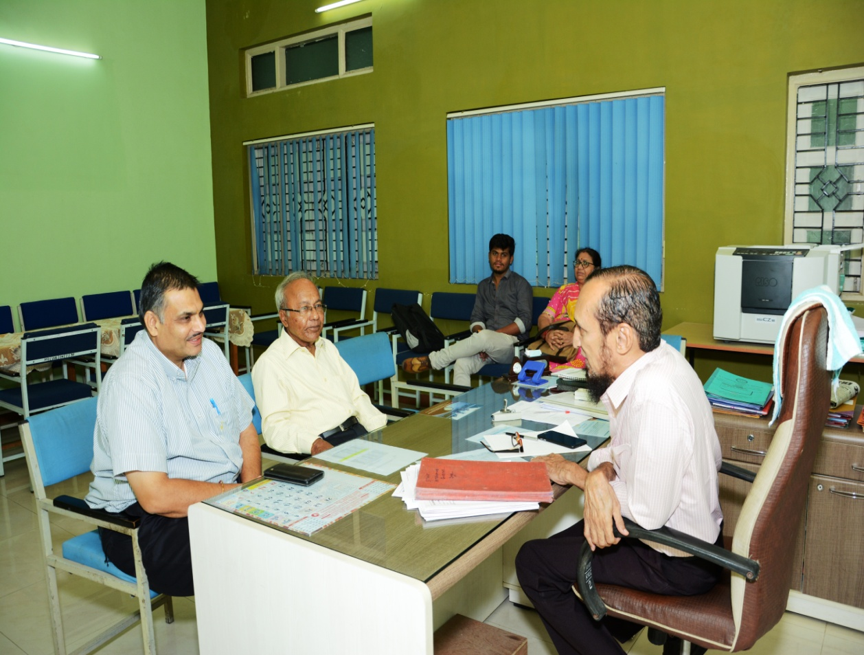

**GEDA EXPERT MEETS WITH DIRECTOR SIR**

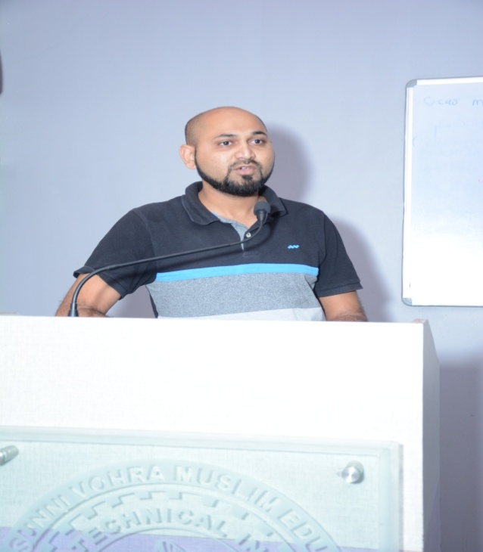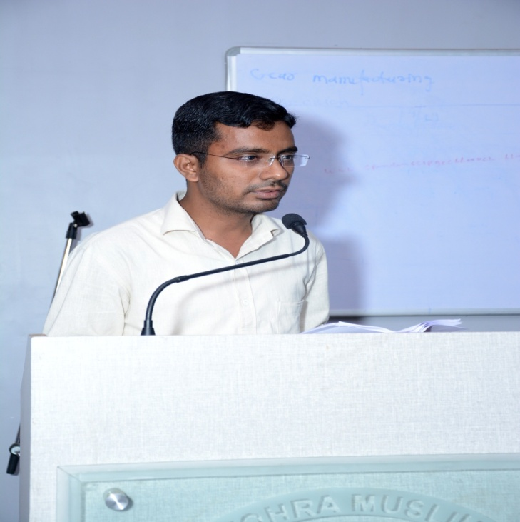

**WELCOME BY M.H.DARSOT INAUGRAL BY M.A.SHAIKH**

**(LECTURER ELECT.DEPT) (LECTURER ELECT.DEPT)**

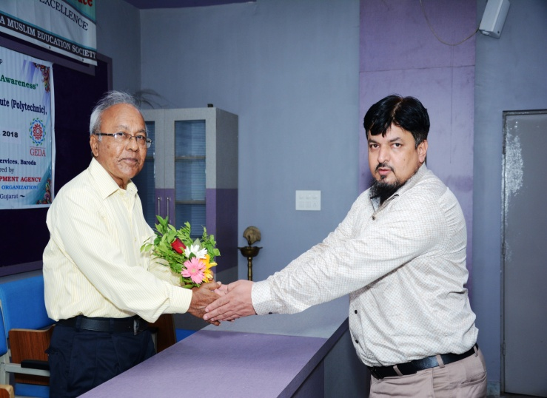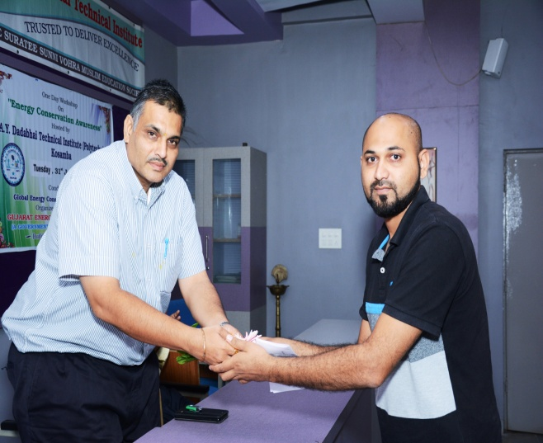

**FELICITATION OF GUEST**

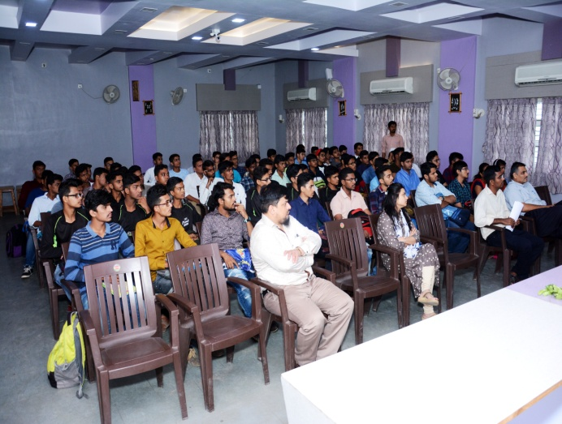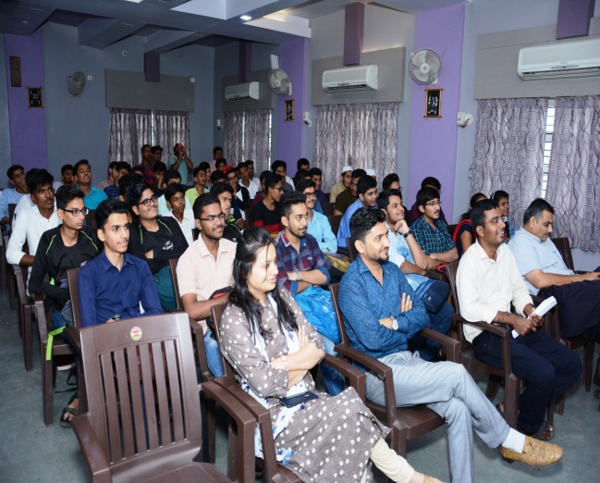

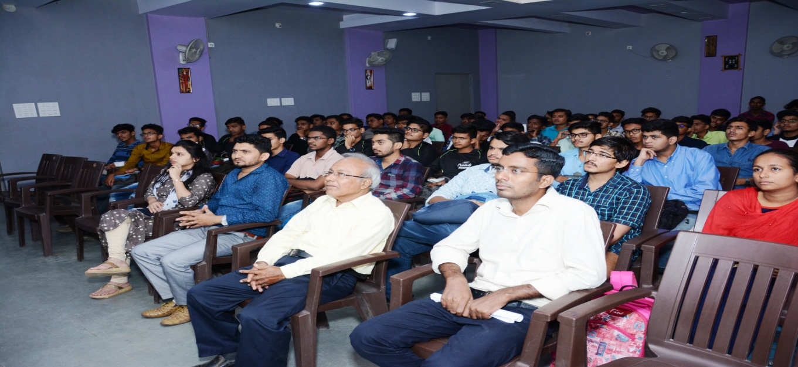

**PARTICIPANT OF QUIZ**

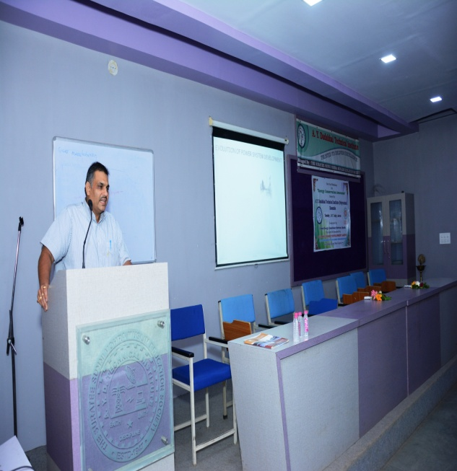 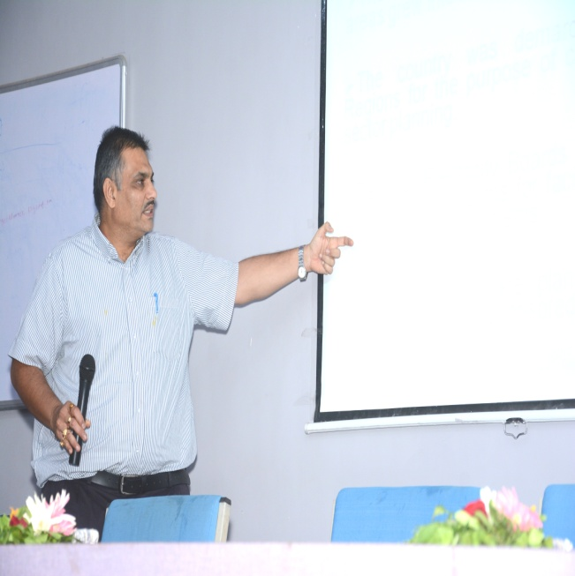

**Experts delivering their lecture (Mr. D.N.Shah sir)**

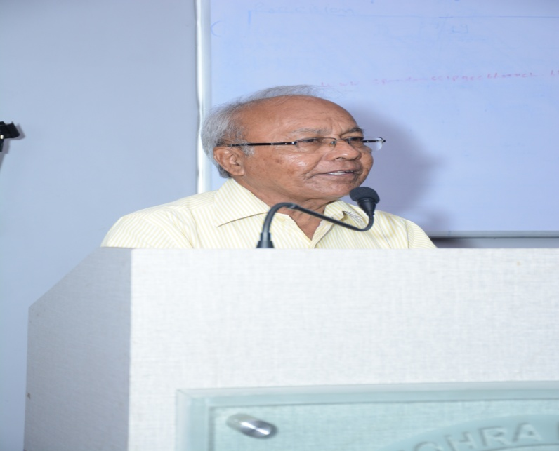 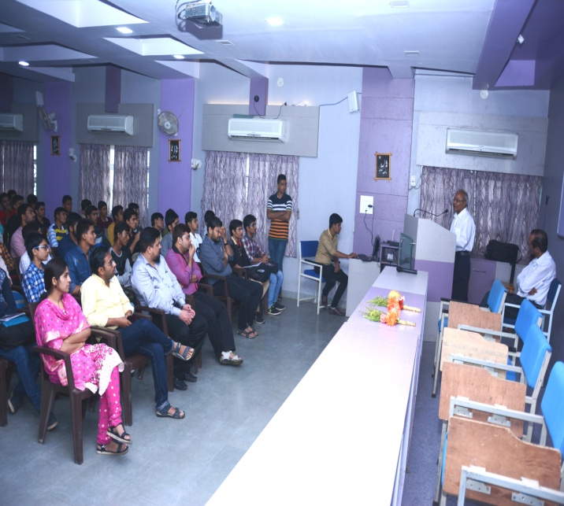

**Experts delivering their lecture (Mr. R.M.Panchal sir)**