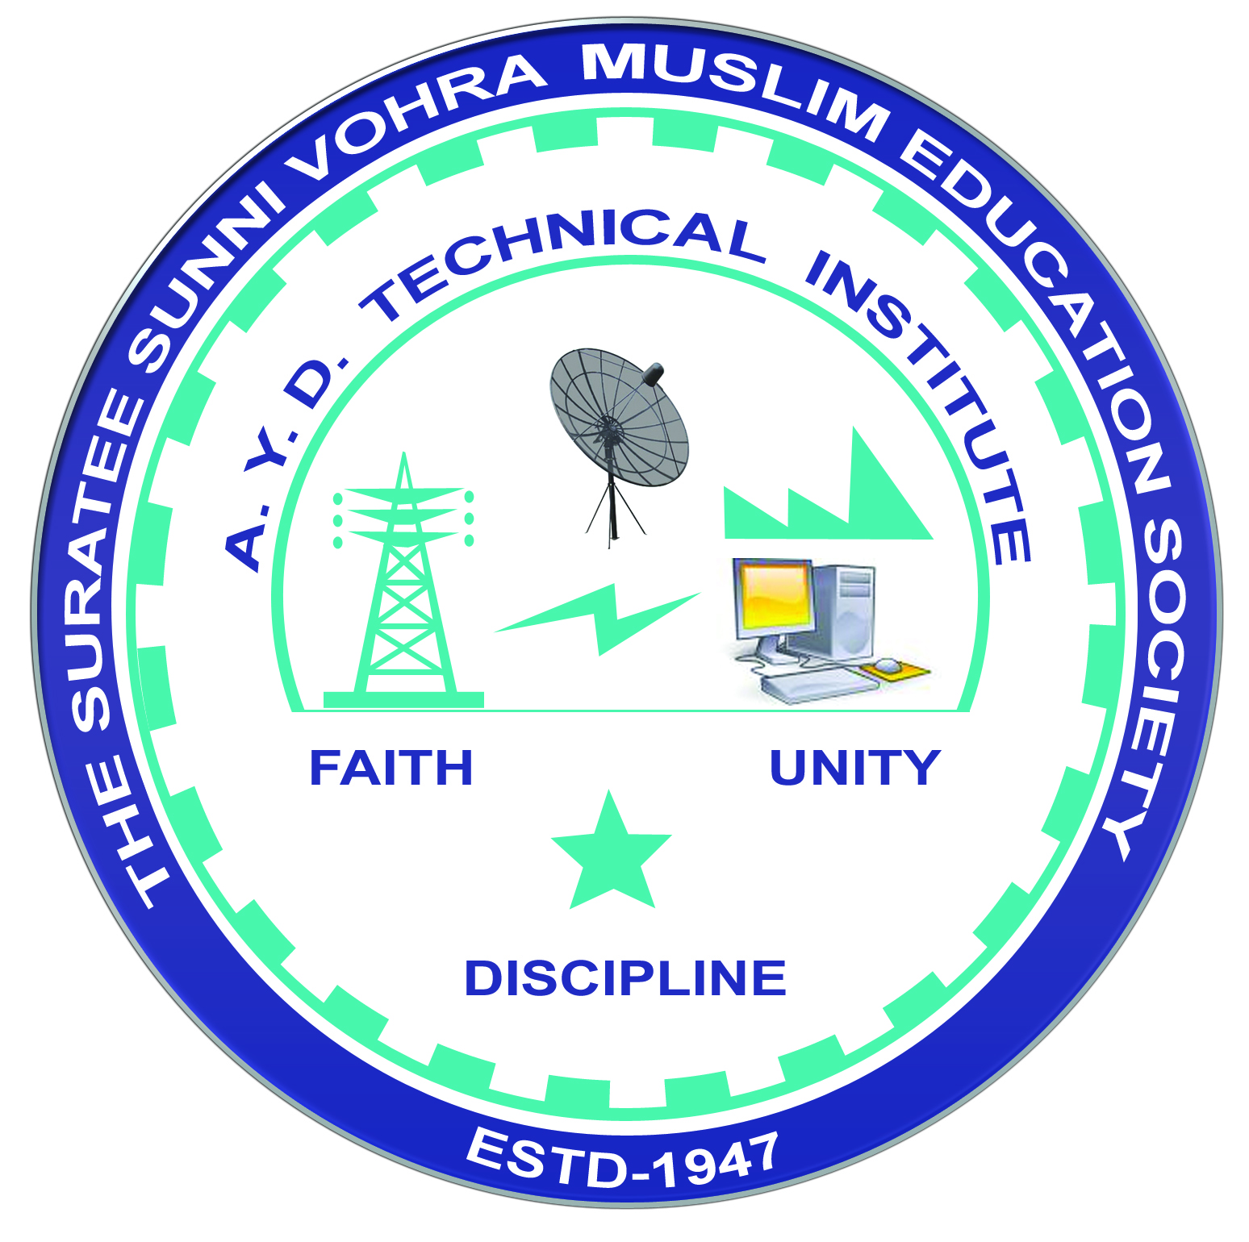 | A.Y. DADABHAI TECHNICAL INSTITUTE, KOSAMBA | 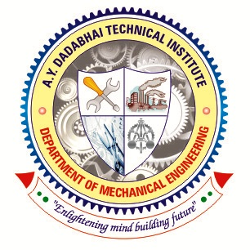

DEPARTMENT OF MECHANICAL ENGINEERING

Report

Name of Expert: Mr. Dinanath Akela
Designation: Energy Consultant
Address: Hajira Industries Group, Hajira, Surat
Date of Lecture Conduct: 08-04-2024
Semester: 6th – 3rd Year
No. of Students: 41
Subject (Course) Related to Expert Lecture: - Beyond Syllabus
Topic Covered: “New Digital Technology”.
Time:-10.00 am to 12.30 pm.
Photographs:

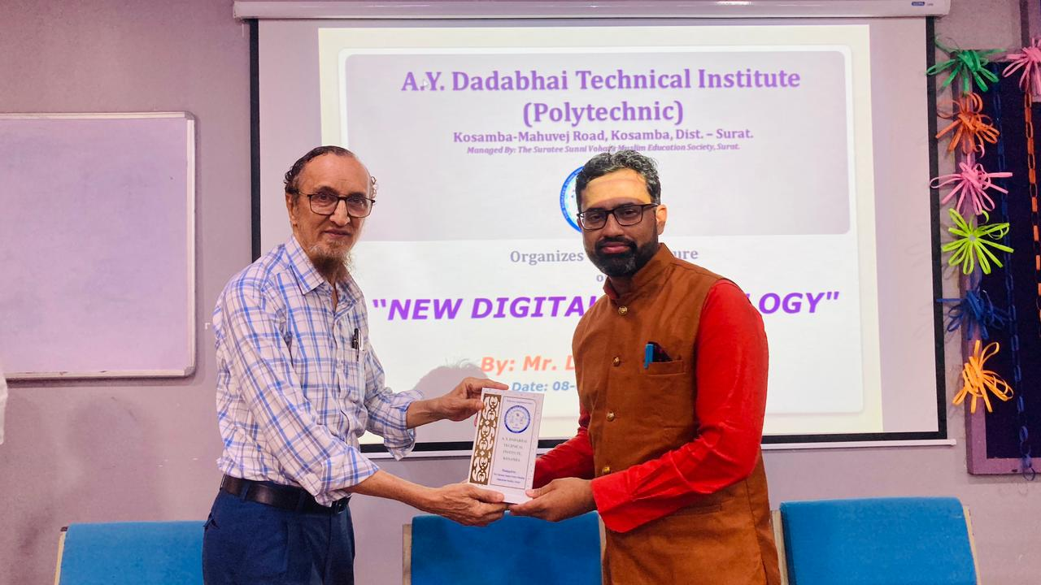 | 