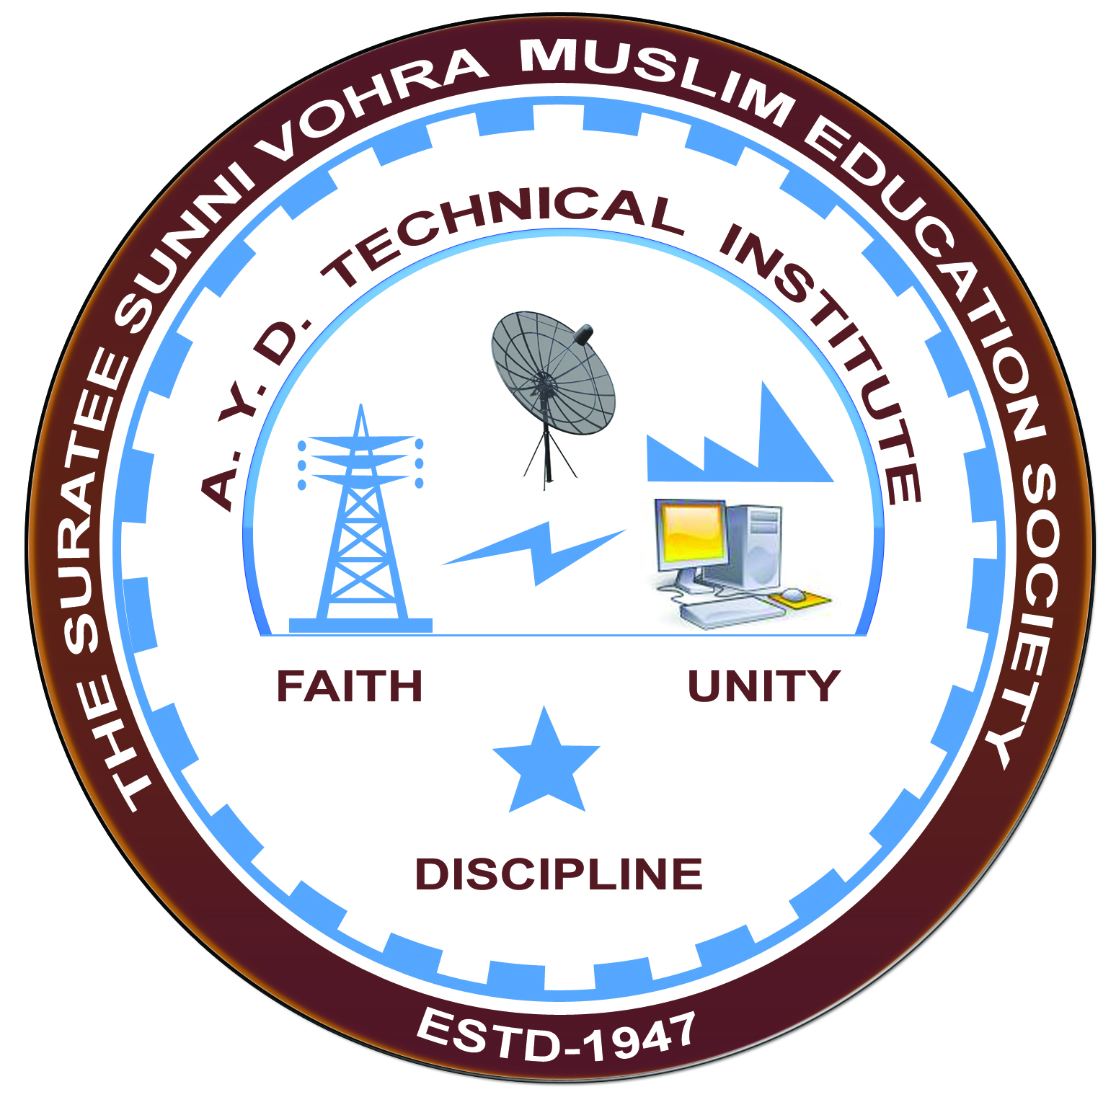

**ELECTRIC LOCOSHED VADODARA**

**Arranged by**

**Electrical Engineering Department,**

**A.Y.DADABHAI TECHNICAL INSTITUTE, KOSAMBA**

**VISIT REPORT**

**Date:-** 03/10/2019

**Department:-** Electrical Engineering

**Semester:-** 5th SEM

**Subject:-** Electrical Traction and Control

**No Of Students:-** 38

**Name Of Faculty:-**

1. Mr. M. S.DINATH (H.O.D.)
2. MR. M.A.SHEIKH (LECTURER)
3. MR.R.J.SINGH (LECTURER)
4. Mr. J. C. Parmar (Lab Assistant)

**Name Of Place/Company Visited:-** ELECTRIC LOCOSHED (VADODARA)

**About Company & Visit**

On the 3rd October 2019 our electrical Department has arranged an industrial visit for our 5TH SEM students. Total 38 students & four faculty members had visited ELECTRIC LOCOSHED Vadodara.

Students visited

* The traction model room,
* Different types of circuit breaker,
* Electric substation model,
* Locomotive model,
* Different types of insulators used in electric traction,
* Different types of temperature control,
* Auxiliary transformer,
* Different types of relay along with panel.

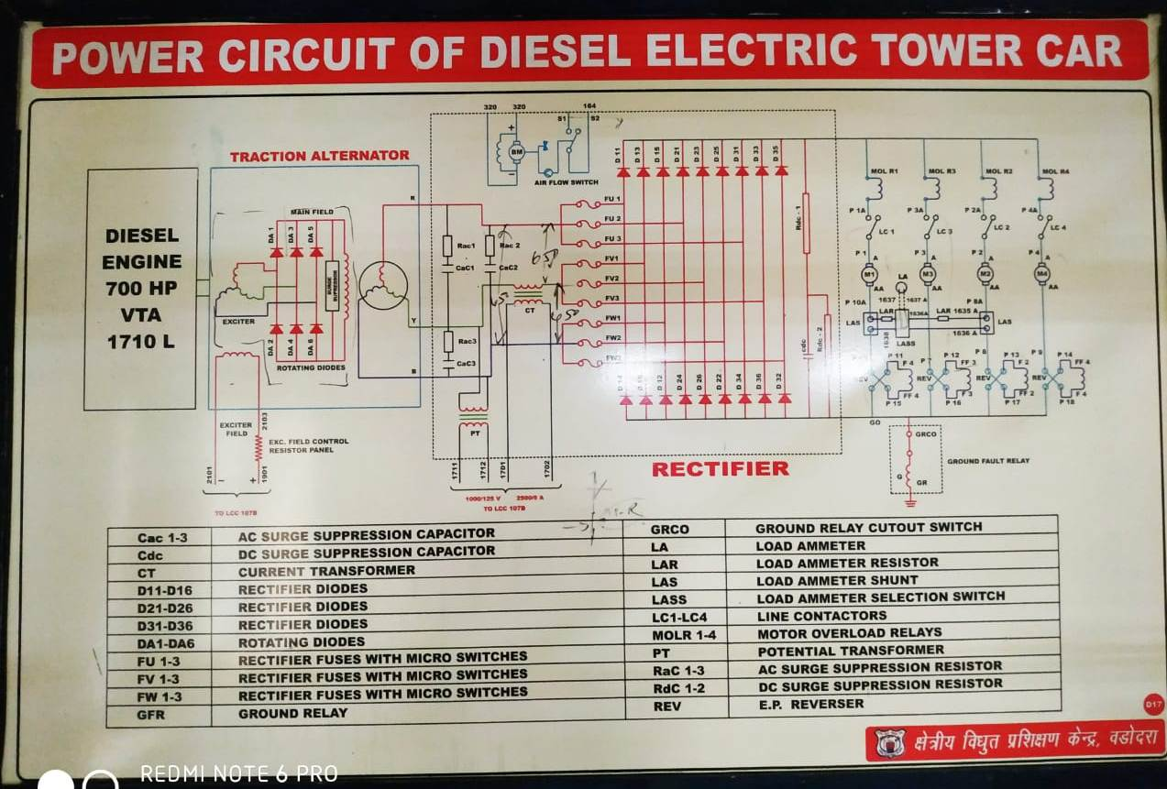

**POWER CIRCUIT OF ELECTRIC LOCOMOTIVE**

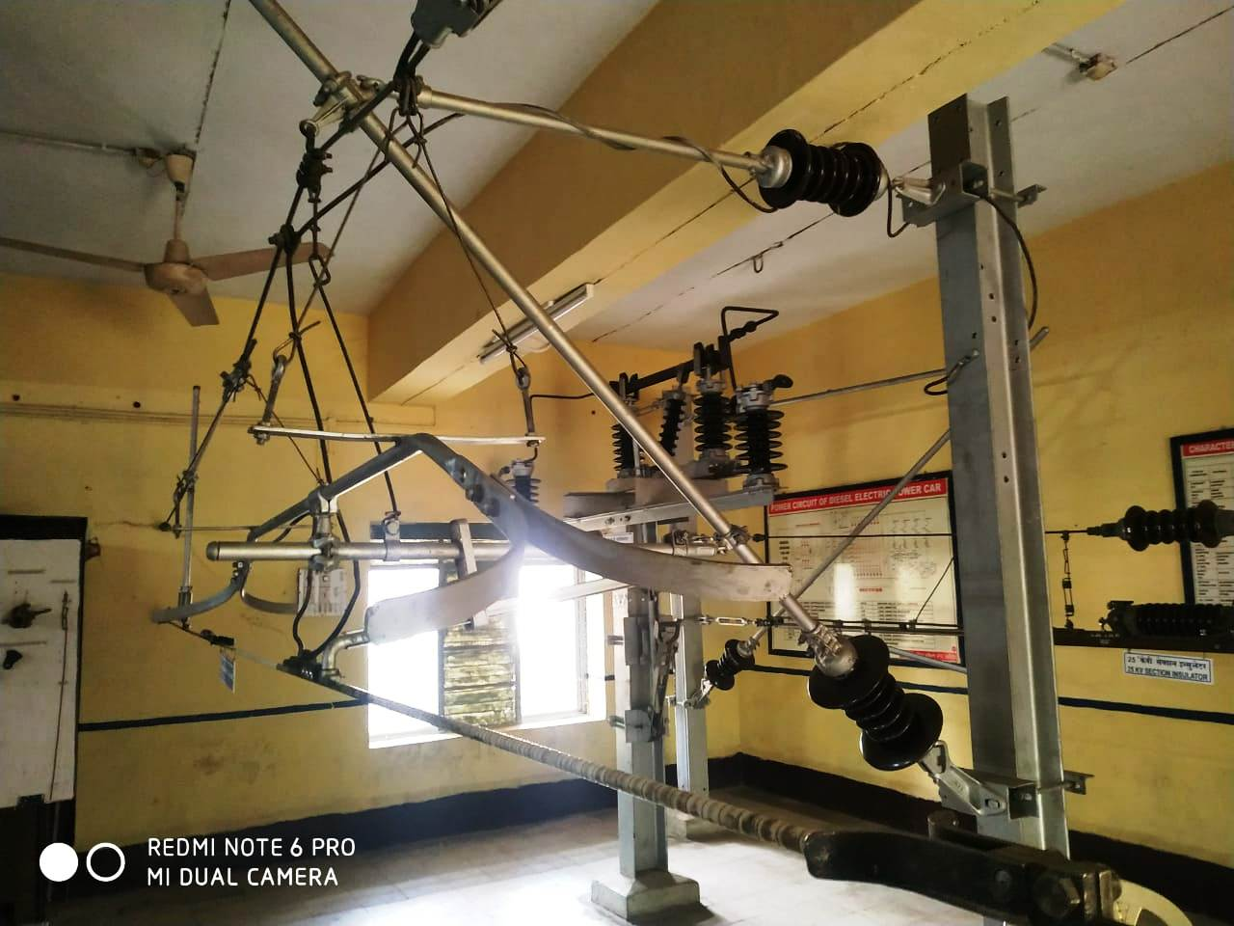

**SUBSTATION MODEL**

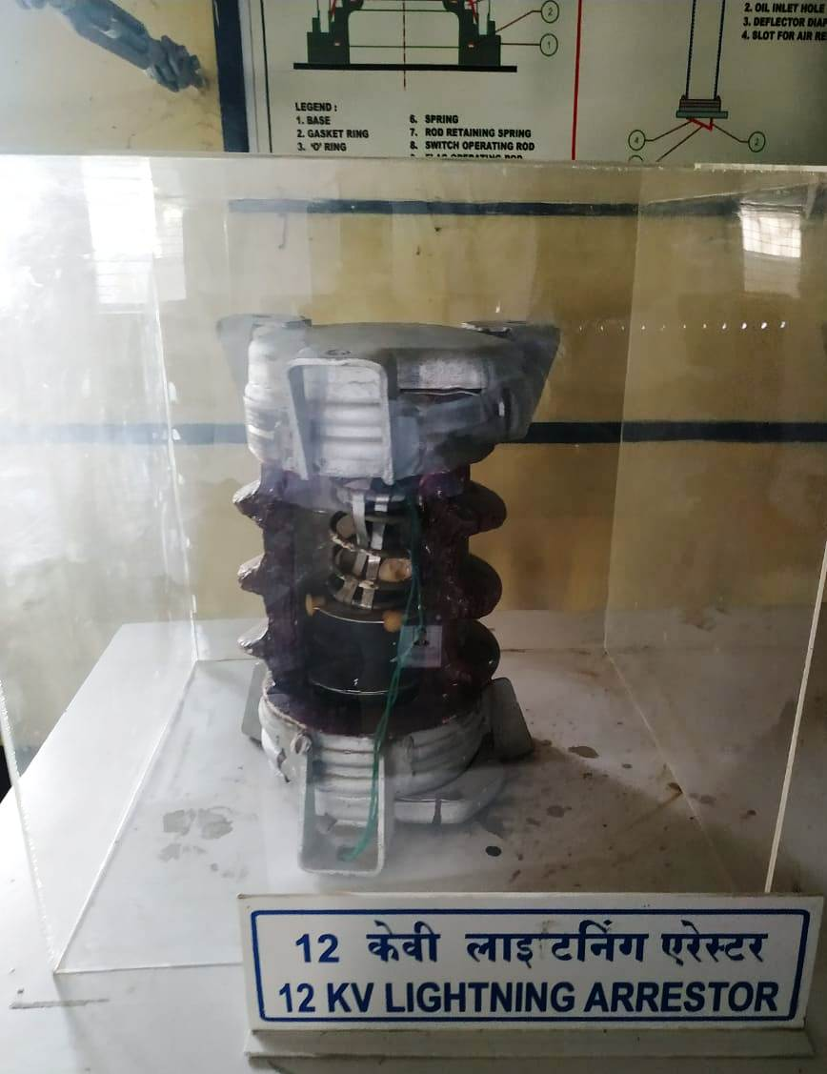

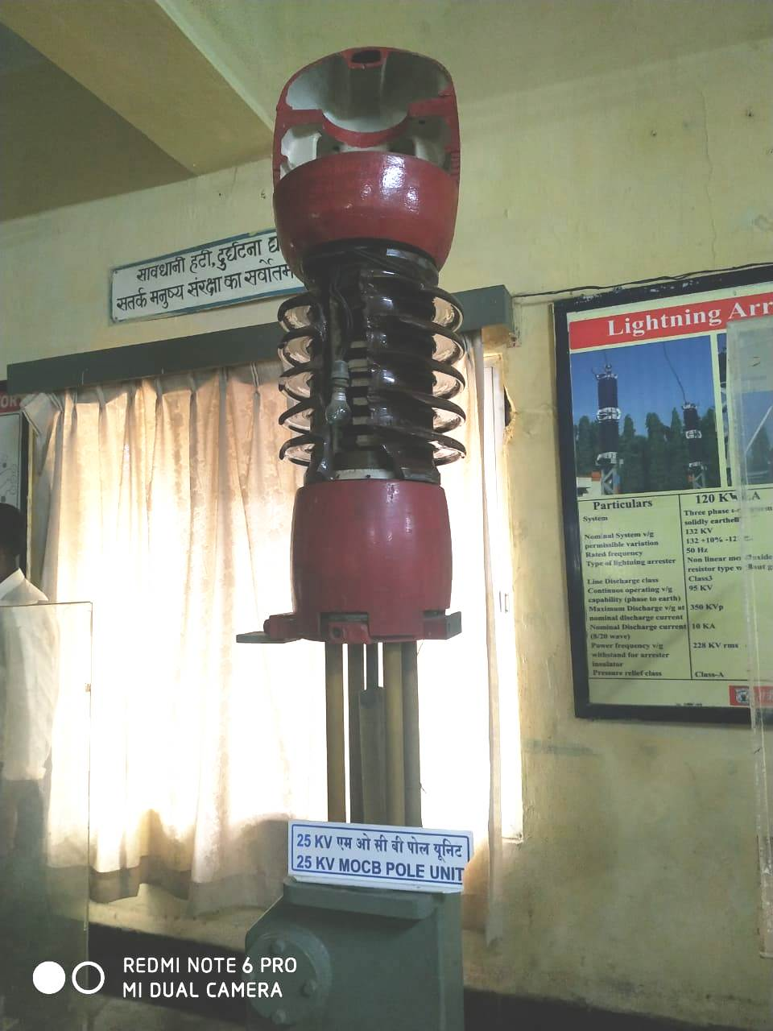

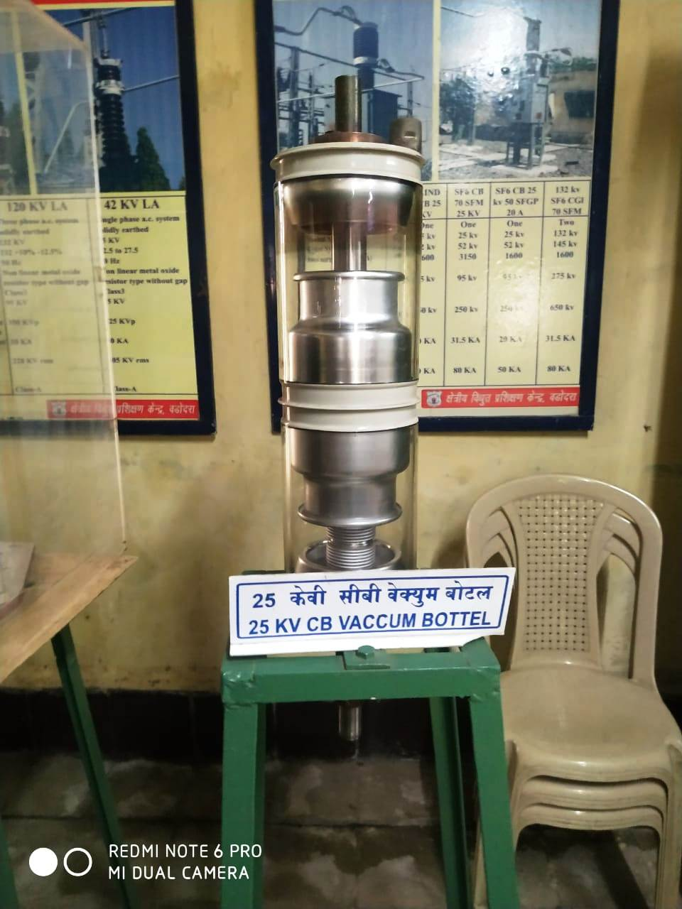

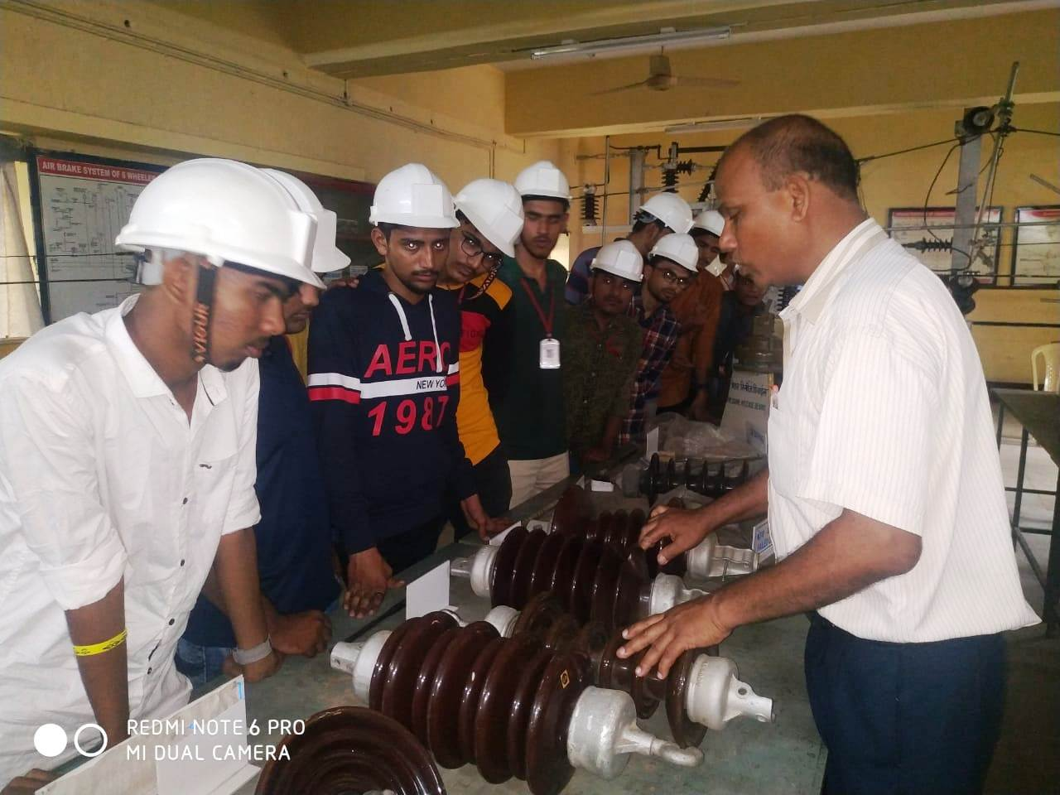

**INSTRUCTOR EXPLAINING TO STUDENTS**

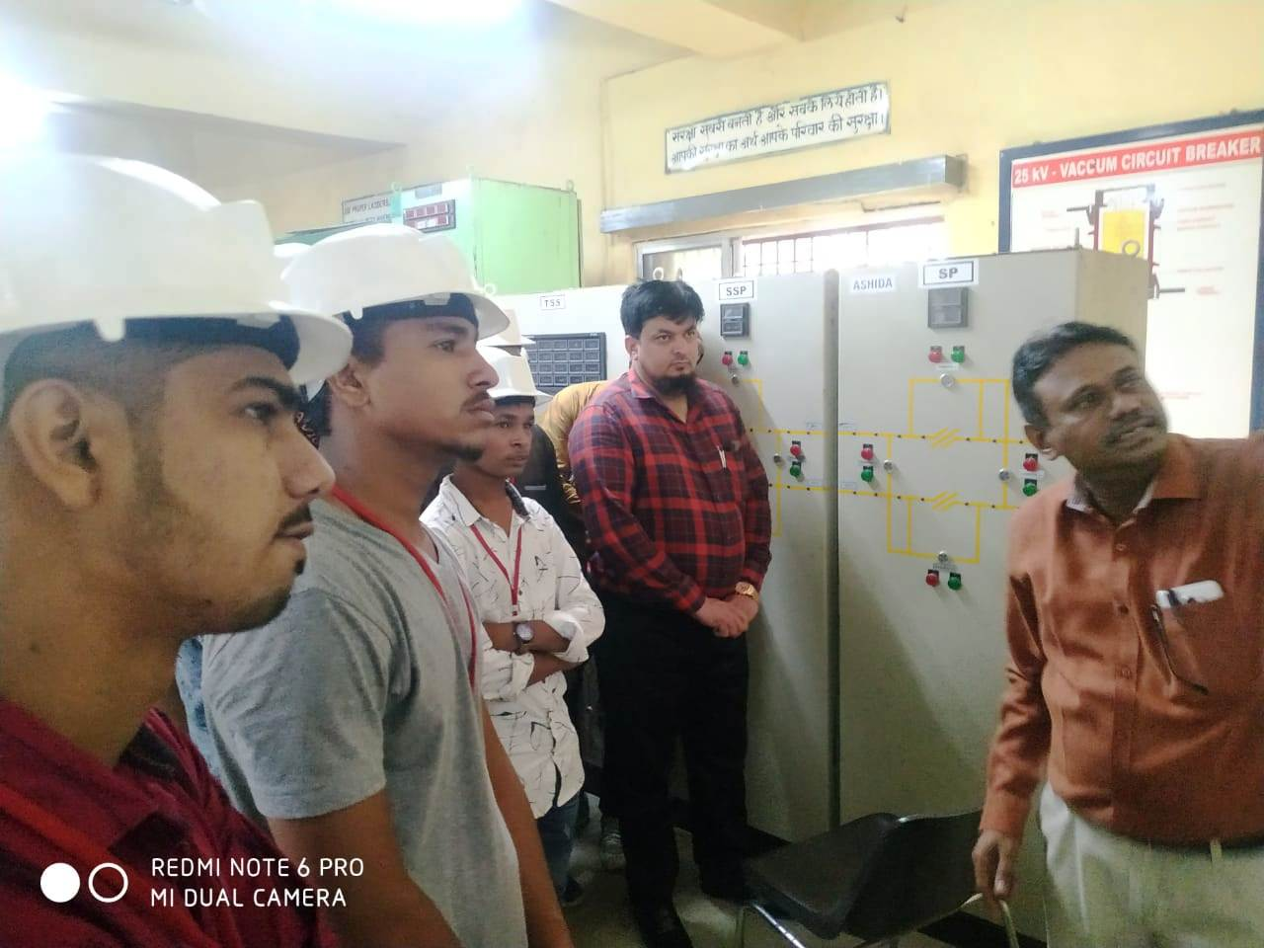

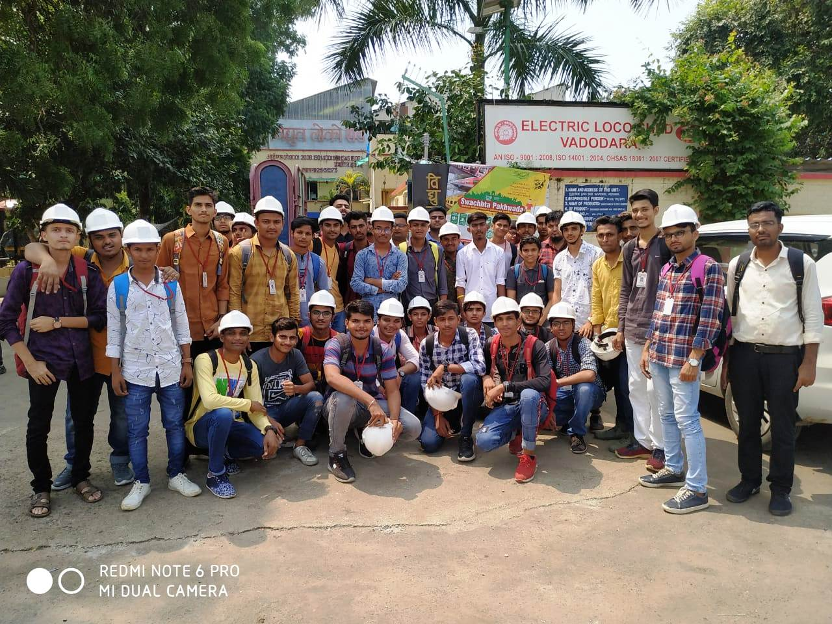

**GROUP PHOTO**