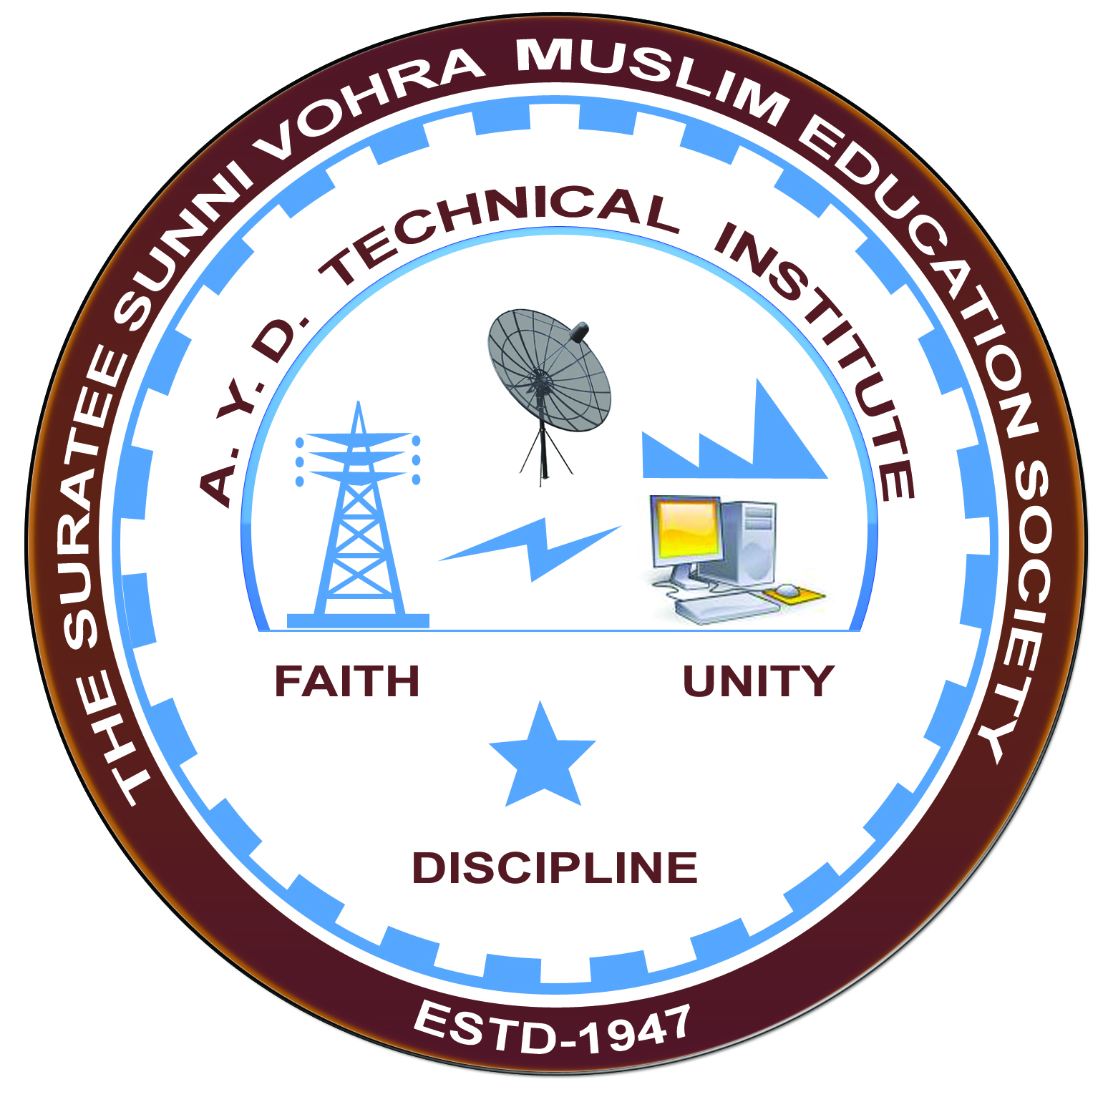

**Entrepreneurship Awareness**

**Arranged by**

**Electrical Engineering Department,**

**A. Y. DADABHAI TECHNICAL INSTITUTE, KOSAMBA**

**REPORT ON EXPERT LECTURE**

**Date:-** 24-01-2020

**Department:-** Electrical Engineering

**Sem:-** 6th

**Faculty: -** (1) Mr. M. A. Sheikh

(2) Mr. M. Y. Patel

(3) Mr. R. J. Singh

**No of Students: -** 36

|  |  |  |
| --- | --- | --- |
| **Name Of Expert** | **Designation** | **Organization Of Expert** |
| Mr. D. G. Kalathiya | TPO & ED cell Co-coordinator | A Y D Tech Institute. Kosamba |

**Topic Of Expert Lecture:-** Entrepreneurship Awareness

**Brief about Expert Lecture:-**

Our electrical engineering department of A. Y. Dadabhai Technical Institute, Kosamba Had organized expert lecture on **Entrepreneurship Awareness** system on the date of **24 January 2020.**

Entrepreneurship Awareness Program (EAP) under Entrepreneurship Development (ED) Cell. For about 110 final year students of diploma in Civil, Computer and Electrical Engineering.

**Program Photograph:-**

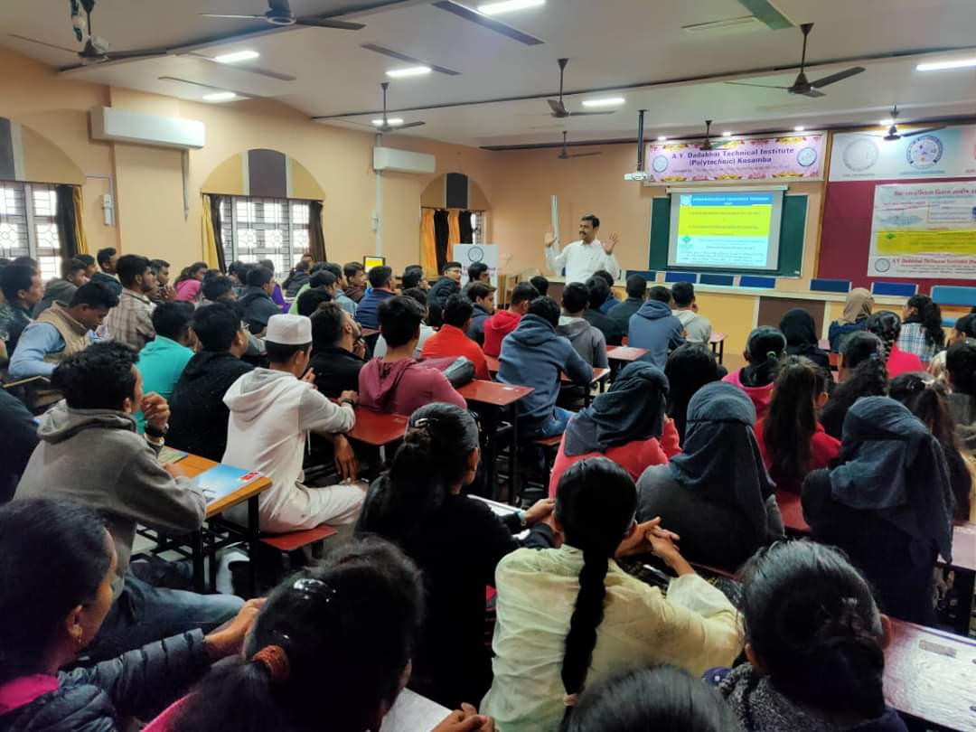

(Expert Delivering Lecture)

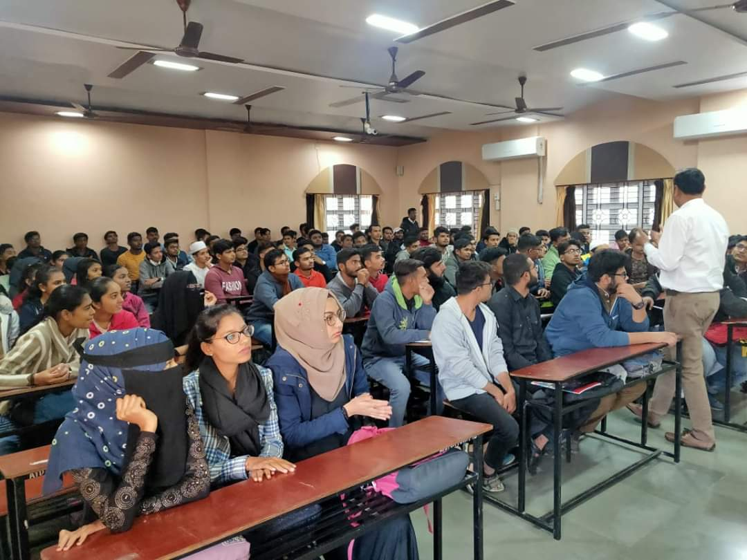

(Participations Of Students)

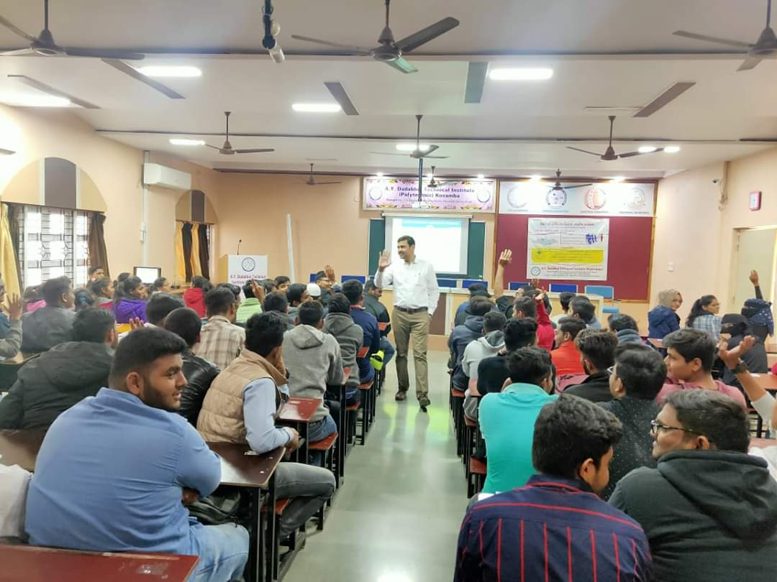

(Moment Of Lecture)