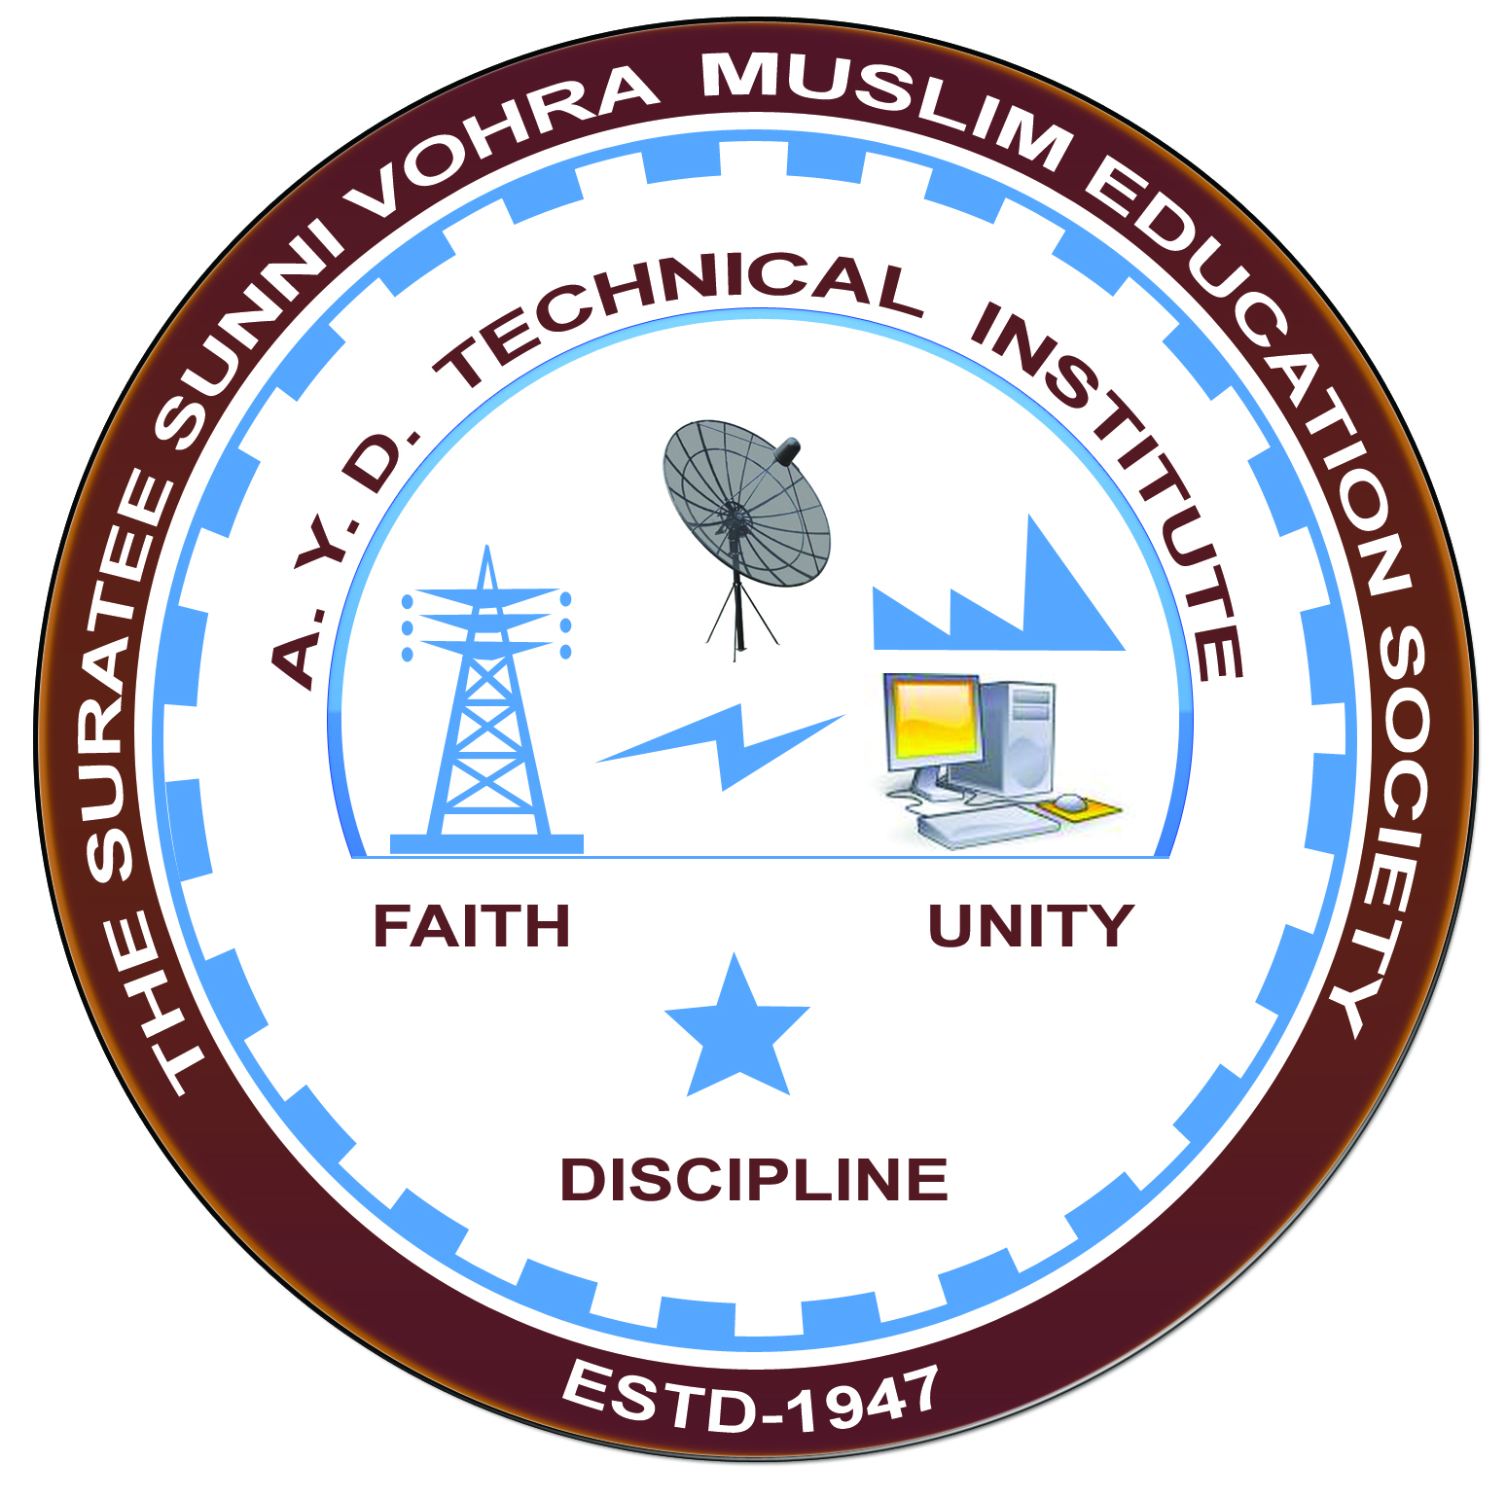

**Career selection after diploma & future of Electrical Vehicles**

**Arranged by**

**Electrical Engineering Department,**

**A.Y.DADABHAI TECHNICAL INSTITUTE, KOSAMBA**

**REPORT ON EXPERT LECTURE**

**Date:-** 9 MARCH 2022

**Department:-** Electrical Engineering

**Sem:-**6TH SEM

**Faculty:**2

(1) SNEHA MANIK

(2) M.R. VANSIYA

**No of Students: -**50

|  |  |  |
| --- | --- | --- |
| **Name Of Expert** | **Designation** | **Organization Of Expert** |
| DR N. R. PATEL | HEAD OF DEPARTMENT | Shree Swami Atmanand Saraswati Institute Of Technology, Surat |

**Topic Of Expert Lecture:-Career selection after diploma & future of Electrical Vehicles**

**Brief about Expert Lecture:-**

Our electrical engineering department of A. Y. Dadabhai Technical Institute, Kosamba Had organized expert lecture on**Career selection after diploma & future of Electrical Vehicles** on the date of**9 MARCH 2022**The session was very interactive and students participated enthusiastically in the beginning thespeaker gave introduction about various opportunities in electrical field as an diploma electrical engineer in private sector as well as in government sector and about future of electrical vehicle.

He also give students knowledge about further study and its scope in future.

As per the feedback received from the students it was very good experience, the lecture was so helpfulfor them for further career.

**PHOTO**

