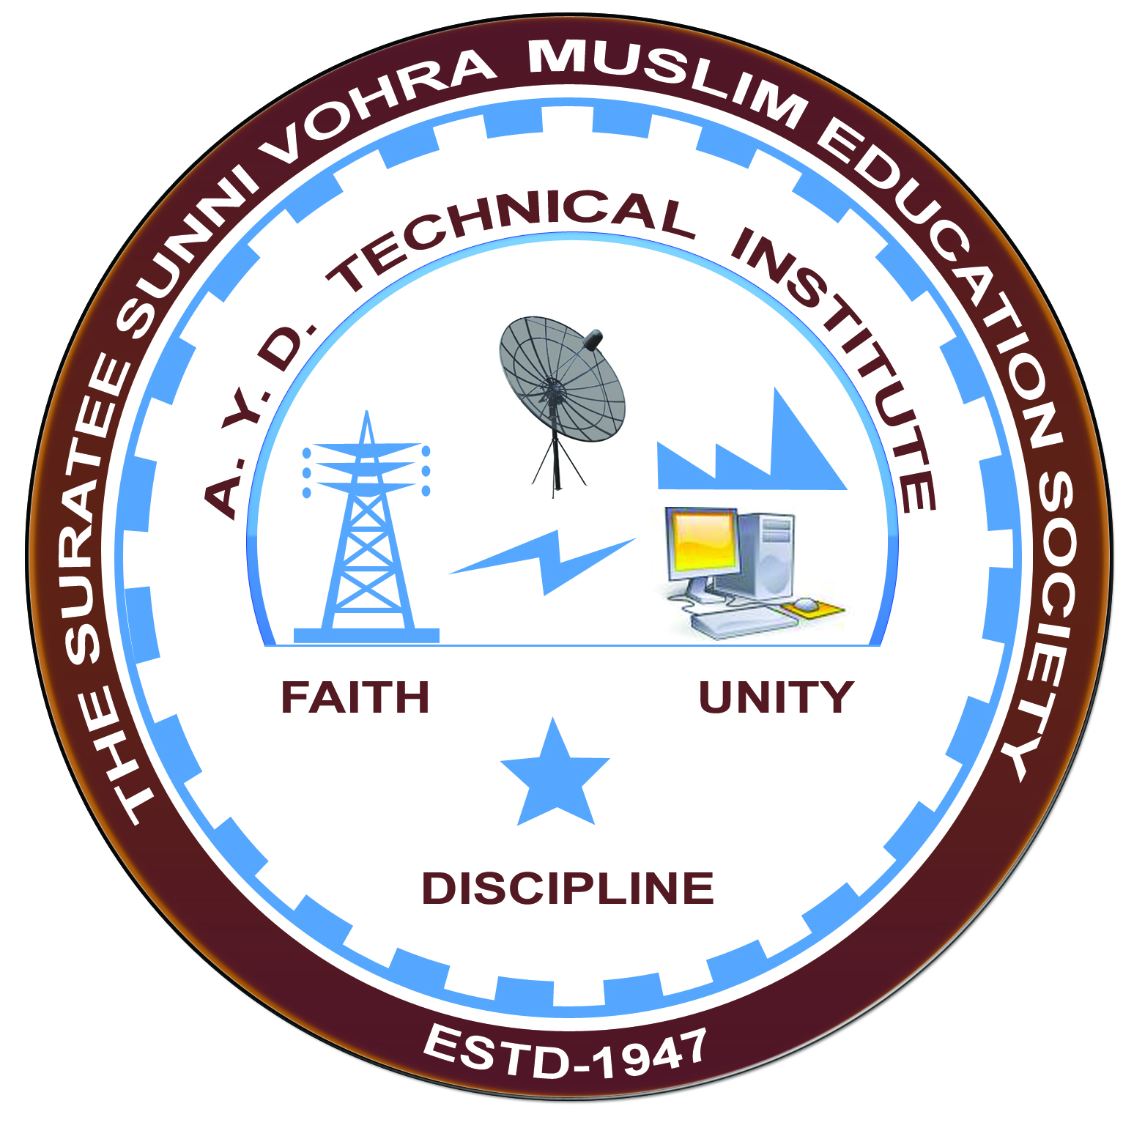

**“ELECTRIC TRACTION and CONTROL”**

**Arranged by**

**Electrical Engineering Department,**

**A.Y.DADABHAI TECHNICAL INSTITUTE, KOSAMBA**

**REPORT ON EXPERT LECTURE**

**DATE:-** 12TH SEPTEMBER 2022

**DEPARTMENT:-** Electrical Engineering

**SEM:-**5TH SEM

**FACULTY: -** (1) Mr M.S.DINATH

(2) Mr M.Y. PATEL

**NO OF STUDENTS: -** 43

|  |  |  |
| --- | --- | --- |
| **Name Of Expert** | **Designation** | **Organization Of Expert** |
| Mr. C.J. BHAIDASHNA | RETD SENIOR SECTION ENGINEER | WESTERN RAILWAY ( VALSAD LOCOSHED) |

**Topic Of Expert Lecture:- ELECTRIC TRACTION SYSTEM**

**Brief about Expert Lecture:-**

Our electrical engineering department of A. Y. Dadabhai Technical Institute, Kosamba Had organized expert lecture on **MODERN ELECTRIC TRACTION SYSTEM** on the date of12THSEPTEMBER2022.The session was very interactive and students participated enthusiastically.In the beginning the speaker gave introduction about various technical aspects and concepts of electric traction system and also explain operation and control of system. Further discussed about different parts of modern electric traction system.

As per the feedback received from the students it was very good learning experience, the lecture helped them in their understanding the concept of actual electric traction system operation and control and what improvement in modern traction system is in recent trends.

**PHOTO’S OF EXPERT LECTURE**

