ACADEMIC YEAR: - 2022



AN INDUSTRIAL VISIT REPORT ON

PANDVAI SUGAR FACTORY

By The Students of Mechanical Engineering Department

Date of Visit: - 9TH April 2022

We visited PANDVAI SUGAR FACTORY at 9:30 am to 1:00 pm.

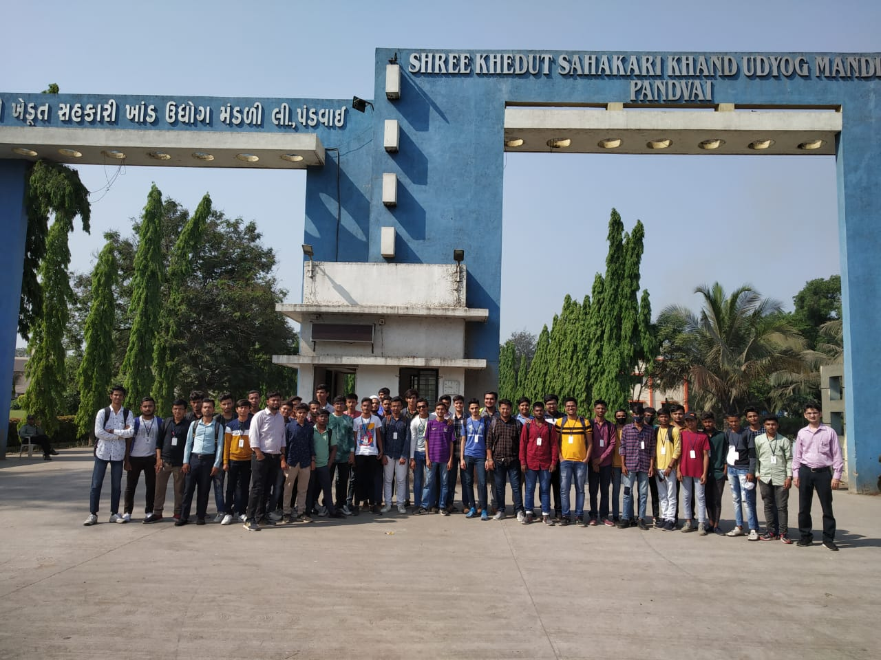

A.Y.DADABHAI TECHNICAL INSTITUTE, KOSAMBA (R.S)

Index

Contents

1. Overview 4

2. Need of Establishing Sugar Plant 5

3. Product List 5

4. Benefits to Shareholders 6

5. Sugar and Health 7

6. Machineries 8

7. Students Feedback 9

8. Photographs 10

On receiving the call permission from PANDVAI SUGAR FACTORY, PANDVAI, A.Y.Dadabhai Technical Institute, Kosamba Mechanical Engineering Department students with four faculty members (Mr. Ritesh Patel, Mr. Umang Desai, Mr. Mahesh Kataria, Mr. Mahendra Desai) went on an industrial visit to Pandvai sugar Factory on 9th April 2022. We all assembled at Pandvai Sugar Factory at 9.00 am. We reached the plant at 9:00 am. A factory engineer Mr. N.B. Patel received us at the entrance and gave a brief description related to production, different machineries used in plant. The visit came to an end at 1:00 pm. We left the premises at 1:30 pm. It was an informative, interesting and a successful visit. As students of Mechanical Engineering, We learned different machineries and their applications. We express our thanks to our department who permitted us to go on the visit, the faculty members who accompanied us and engineer of sugar plant who explained entire plant from establishment.

# Overview

Factory Name: Shree Khedut Sahakari Khand Udyog Mandli Ltd., Pandvai, Gujarat

Operational Status: Working

Plant Name: Kosamba

Code: 41101

Factory Nature: Co-Operative

Nearest Railway Station: Kosamba 5 Km

Contact

Mobile Number: 9925170009

Phone Number: (02646) 287313, 14,

Fax Number: (02646) 287388

Email: [pandvai.sugar@yahoo.co.in](mailto:pandvai.sugar@yahoo.co.in)

***Performance data***

|  |  |  |  |
| --- | --- | --- | --- |
|  | **2018-2019** | **2019-2020** | **2020-2021** |
| **Crushing Capacity (M.T.)** | 2500 | 2500 | 2500 |
| **Cane Crushed (Lakh M.T.)** | 7.10 | 6.47 | 6.32 |
| **Sugar Produced (Lakh/Qtl)** | 7.11 | 6.60 | 7.20 |
| **Sugar Recovery (%)** | 10.00 | 10.19 | 11.38 |
| **Molasses Produced (M.T.)** | 34800 | 30500 | 28100 |

**The sugar industry** in co-operative sector in many states has played a very vital role in development of rural areas and had so far rendered human services to the marginal farmers, landless laborers economically and socially weaker section of the society in the area of social welfare activities, medical services and education and with the same prime object this co-operative society was established in the year as back as in the year 1994 and got registered with Co-operation Dept. of Gujarat Government, intending to establish its sugar factory so that it could pay an important role in social and economic development of Hansot Taluka, the interior part of Bharuch District. The society has 32000 Nos. of shareholders.

**The** climatic condition in its command area is conducive for agriculture and particularly for sugarcane crop as an average rain-fall is above 60” to 70” per season and over and above, the canal net-work of Ukai Dam throughout the year provides perennial irrigation. Considering all above, Co-Operative leaders of this area formed this Co-Op. Society with a noble cause of setting up Co-Operative sugar factory, likewise in South Gujarat, so farmers can be benefited by cultivating sugarcane which will subsequently improve their socio economic condition. It will be a great blessing to all cane growers/farmers and also to quite good numbers of youth offering job them.   
  
 **Society** about the suitable size of the sugar factory to be set up considering all aspects such as finance involved, availability of sugarcane being the main raw material and its potential in future, term loan and interest burden, financial viability, climatic conditions, irrigation facility available in command area.

# Need of Establishing Sugar Plant

Agroclimatic condition in the proposed sugar factory zone is suitable for cultivation of sugarcane. The area of operation of the proposed sugar mill is located in the potential sugarcane belt of the state. Sugar recovery in the located area varies form 10.00 to 11.00 percent cane and there is further scope to increase the production of sugarcane.

* There is no sugar plant within 15 kms radius of plant.
* The command area is fully irrigated.
* Soil & climatic condition are very conducive for cane cultivation.
* Quality of cane is very good. High recovery up to 11.20% is expected from the area.
* Yield of cane is very good.
* The area is fully free from floods etc.
* The farmers are very keen to supply cane to mill.
* Presently the cane is being supplied to nearby sugar mills.
* Plant shall be suitably designed to reduce steam consumption power consumption and hence shall save extra bagasse.
* The Chairman & MD are very well versed with Sugarcane cultivation & working of the mill.

# Product List

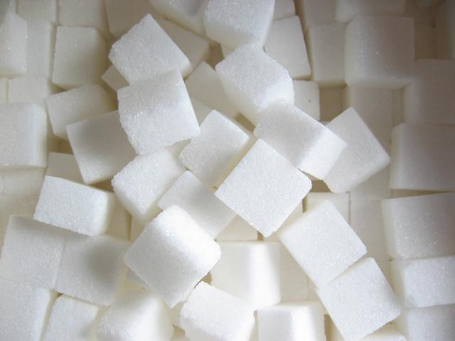**SUGAR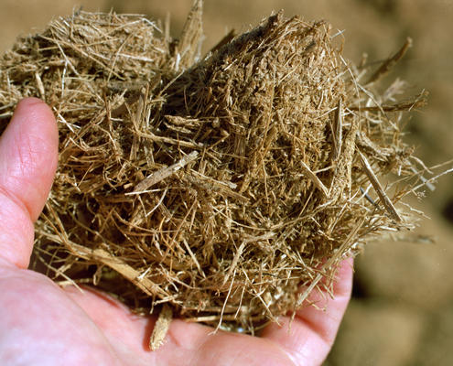BAGASSE**

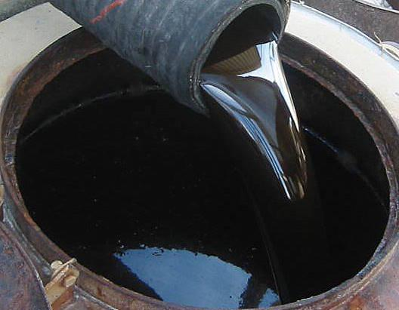**MOLASSES**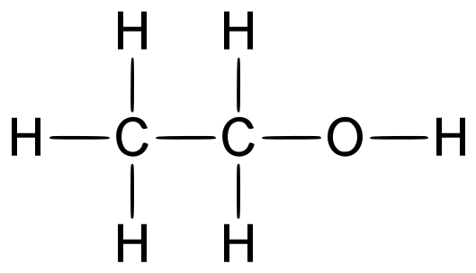*ETHANOL*

# Benefits to Shareholders

All Shareholders are covered under Insurance Every shareholder is provided with Bag of Sugar at subsidized rates as per their sugarcane coming for crushing.

* **Bio Compost Project**

Bi-products from sugar production namely press mud, boiler ash and bagasse are used for preparing press mud bio-compost and enriched PMBC and packed in 50 Kg. Bags. Factory gives subsidy @ Rs.100/- per M.T. of PMBC. Thus factory gives about Rs. 25 to 28 Lakhs subsidy every year to their cane growing members.

* **Soil Testing Laboratory**

Factory has established Soil & Micronutrient Testing Laboratory with the help of Rashtriya Krushi Vikas Yojana. In this Laboratory the samples of soil and water analyzed and giving report to cane growing members free of cost. About 5,000 samples are tested every year.

* **Research & Development Farm**

Factory has around 7 Acres of R & D farm. In this farm different promising sugarcane varieties are to be tested and prepare seeds and giving to the cane growing members.

* **Cane Development Programme**

For increasing the cane production per acre and for improving the sugar recovery, factory is running Cane Development Programme since last 15 years with the guidelines from Scientists of Navsari Agri. University. In this programme factory spent about Rs.45 to 50 Lakhs every year for cane development activities.

* **Bio-Control Laboratory**

Factory has owned Bio-control Laboratory. In this Laboratory we produce Tricho Card for biological control of sugarcane borer pests. Factory giving about 5,000 Tricho Card at free of cost to their cane growing members every year.

* **Drip Irrigation Method**

In the area where shortage of irrigation water for sugarcane crop for enhancing the establishment of Drip Irrigation System, factory giving subsidy @ Rs.5,000/- per Hectare. (Maximum Rs.10,000/- for two hectares) to their cane growing members.

# Sugar and Health

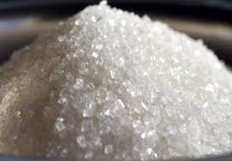

**Of-late, sustained** publicity campaign is being made by the producers of chemical sweeteners against sugar consumption by attributing to it various health problems. This has no scientific basis at all. Sugar is a perfectly healthy product as would be evident from the following:

* ***What is sugar?***

Sugars are a major form of carbohydrates and are found probably in all green plants they occur in significant amounts in most fruits and vegetables there are three main simple sugars sucrose, fructose, glucose, sucrose is in fact a combination of fructose and glucose and the body quickly breaks down into these separate substances

* ***The need for energy***

All energy stored in food is derived originally from the sun and it is made by green plant life. The sun's energy acts upon the green chemical "chlorophyll" in the leaves of plants to produce sugars and Starches from the carbon-dioxide in the atmosphere and the water from the roots by a process known as Photosynthesis .These carbohydrates (starches and sugar) acts as a plants food and energy supply. .The Energy need of human body is largely dependent on the carbohydrates that are derived from plants.

* ***A Balance Diet***

A balanced diet can (and should) come from a variety of different foods ,calculated to give the desired levels of carbohydrates ,proteins, fats, vitamins, and minerals .Nutritional scientists advocate that carbohydrates should provide at least 50% of over energy requirements .

* ***Sugars Role***

Starches provide the large part of our carbohydrate needs .The sugar which nature provides alongside the starches in our food supply have also a very special role to play in human metabolism for primitive man the sweet taste probably acted as a signal that the food was safe to eat .For modern man sugar is used to improve the palatability of many foods and can thereby encourage a more varied diet.

# Machineries

* **Crushing chain**

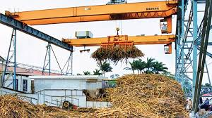

Crushing chain used for material handling from unloading section to crushing section then after boiler section. And finally take baggase to the storage section.

* **Crushing turbine**

In crushing turbine sugarcane crush with the help of 3 crushing roller. In this section juice is separated from sugarcane and then goes to Pan section.

* **Boiler section**

Babcock and Wilcox boiler is used in pandvai sugar. It is horizontal turbine. Used for 3MW power generation. This boiler is run with the use of baggase. No extra fuel is required in furnace.

* **Power section**

Power section used for power generation in this section 3mw power is generated with the help of power turbine. Control panel is also there used for power control in whole plant.

* **Pan section**

A sugar cane juice is heated in this section and then cleans the juice. And also sugar crystal is starting to produce after cooling. Molasses is also separated from this section. This molasses is transfer to ethanol plant to produce ethanol.

* **Bagging section**

After sugar production first of all sugar crystal is separated in grade wise. And automatic 50kg bag is packed in this section.

* **Other machinery**

1. Different types of pumps
2. Compressor
3. Vacuum pump
4. Water treatment plant
5. Condenser
6. Etc.

# Students Feedback

Educational visit to "PANDVAI SUGAR FACTORY” organized by Department of Mechanical Engineering was very informative. The guiding staff both college staff as well as plant head Mr. N.B.PATEL was very supportive to all students.

We hope that this visit will help us in our future practical life and bring a positive change in our thinking and practical behavior regarding education and specially engineering.

We, the students of Mechanical Engineering are extremely thankful to honorable staff members of Mechanical Engineering Department.

# Photographs

