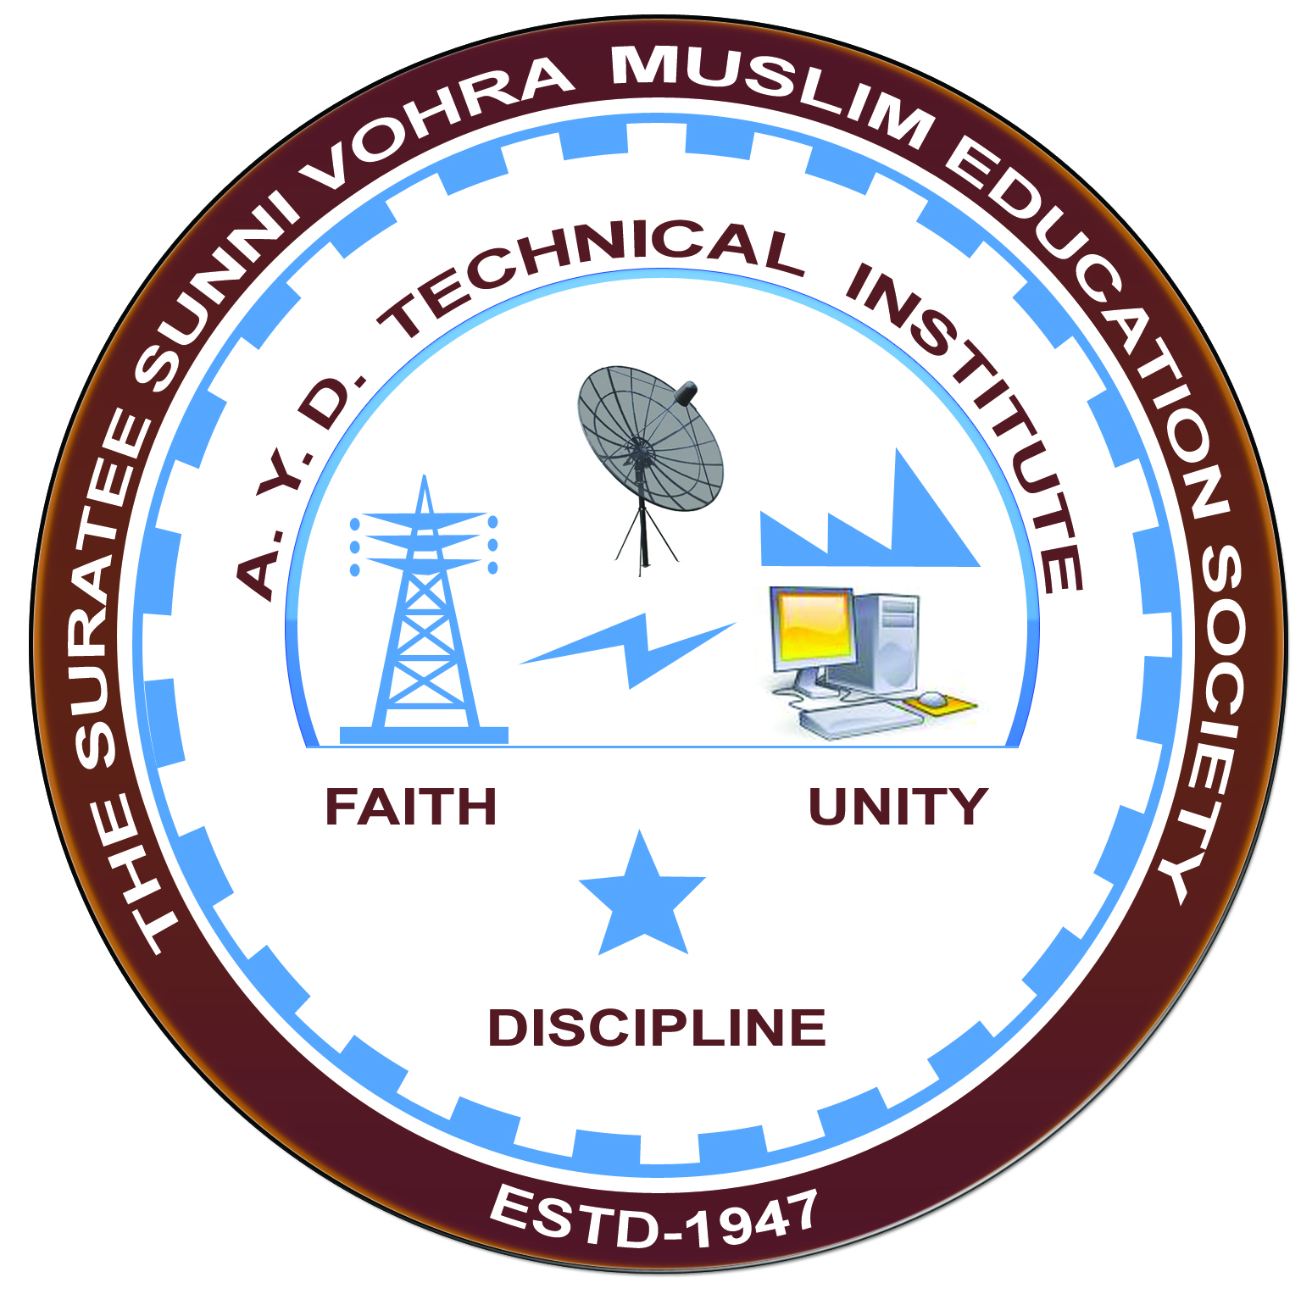

**DIGITAL INSTRUMENTATION AND AUTOMATION**

**Arranged by**

**Electrical Engineering Department,**

**A. Y. DADABHAI TECHNICAL INSTITUTE, KOSAMBA**

**REPORT ON EXPERT LECTURE**

**Date:-** 12-02-2020

**Department:-** Electrical Engineering

**Sem:-** 4th Semester

**Faculty: -** (1) MIss. S. V. More

(2) MIss. M. R. Vansiya

**No of Students: -** 53

|  |  |  |
| --- | --- | --- |
| **Name Of Expert** | **Designation** | **Organization Of Expert** |
| Mr. Bharatsinh Chawda | HEAD OF ELECTRICAL MAINTENANCE | J B Chemical & Pharmaceutical |

**Topic Of Expert Lecture:-** Digital Instrumentation and Automation.

**Brief about Expert Lecture:-**

Today on 12/02/2020, Wednesday Electrical Department of A Y Dadabhai Polytechnic, kosamba has arranged an expert lecture regarding the Digital Instrumentation and Automation. Mr. Bharatsinh Chawda sir with strong background of 25 years of experience and Head of technical side (Electrical) from a well known firm J B Chemical & Pharmaceutical has given an interesting session to our students and staff members.

**Program Photograph:-**

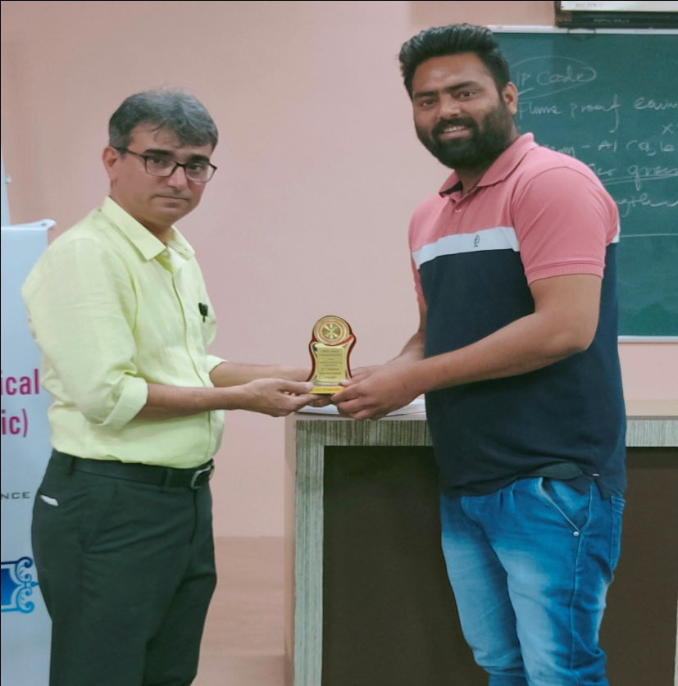

(Felicitation Of Expert)

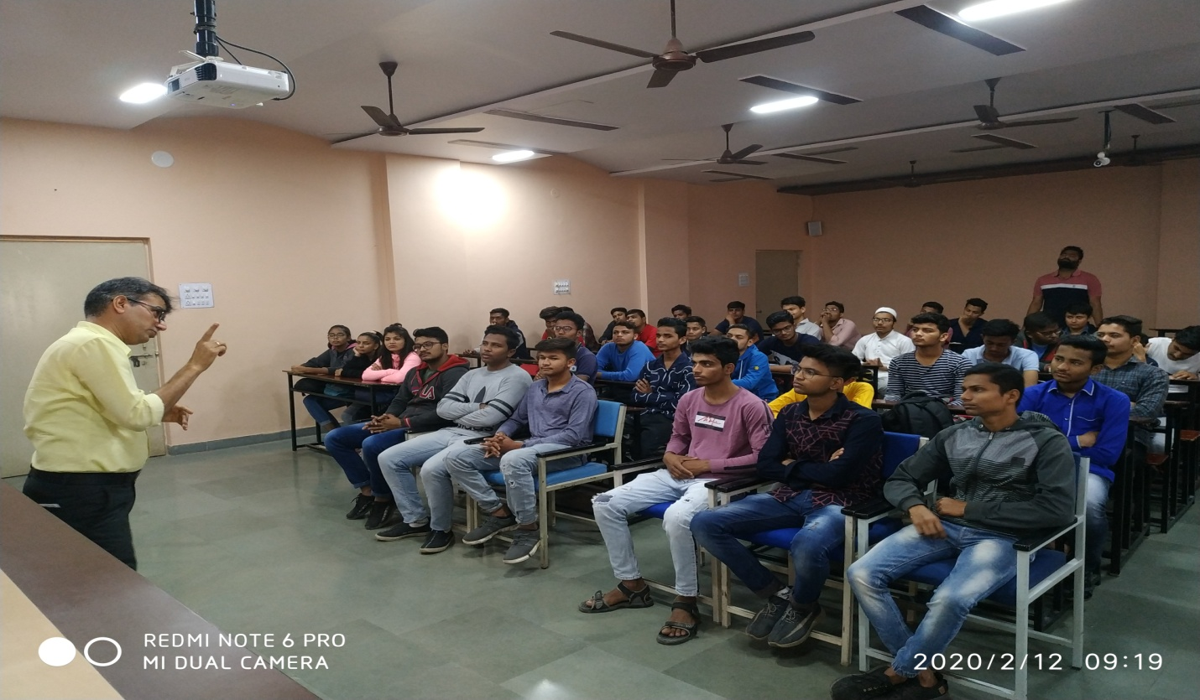

(Expert Delivering Lecture)

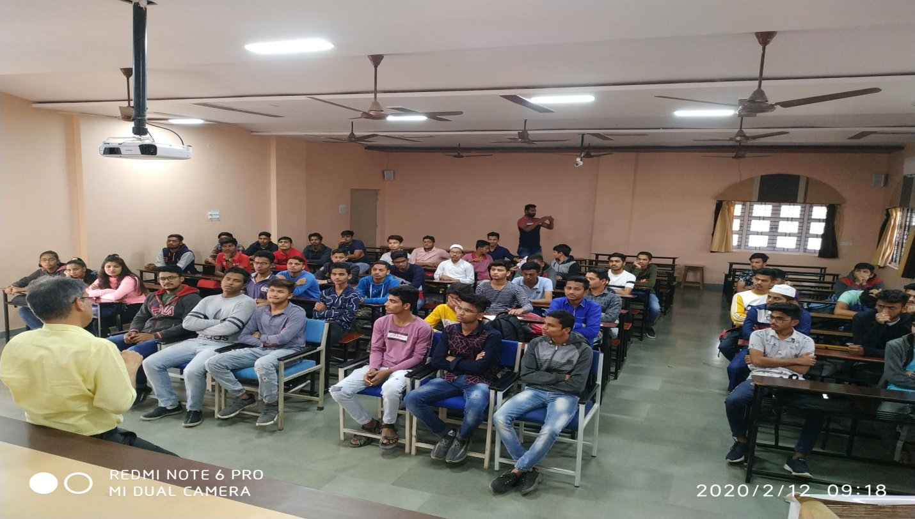

(Participations Of Students)

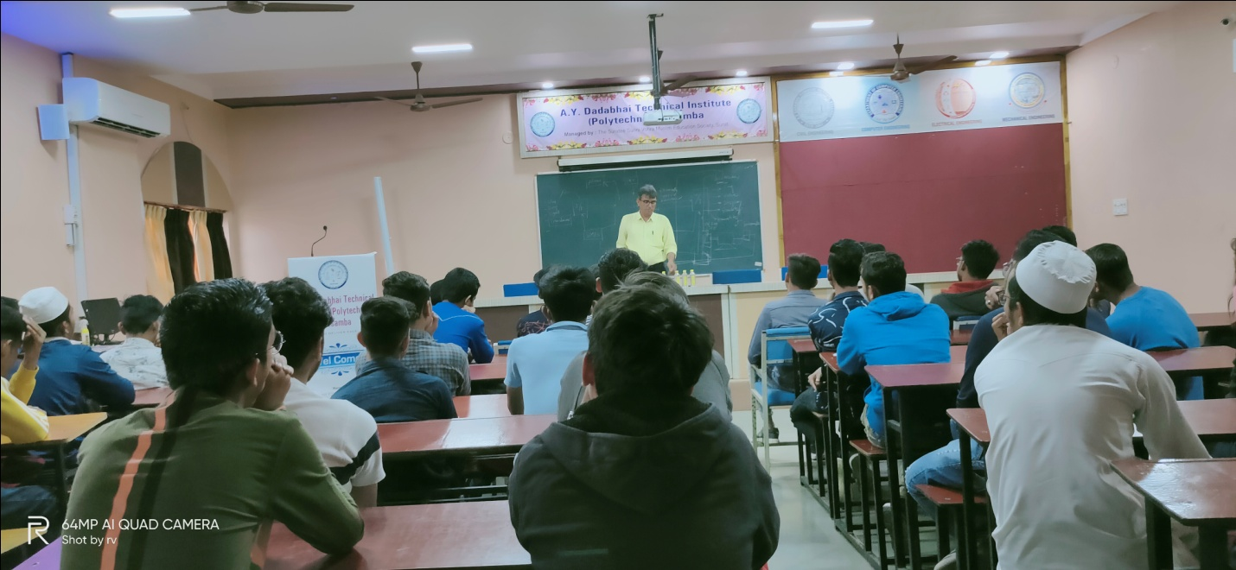

(Moment Of Lecture)