**Report on Campus Interview Held on 29/07/2024 by Ansa Deco Kosamba**

On the 29th of July, 2024, Ansa Deco Kosamba, a subsidiary company of P.G.P. Glass Kosamba, conducted a campus placement drive at our institute. The event was well-organized and saw active participation from both the mechanical and electrical engineering departments. A total of 15 students took part in this placement drive, aspiring to secure positions in the esteemed organization.

**Program Overview**

The program commenced with a warm welcome and an introductory speech by Mr. M.A. Sheikh, who set a positive tone for the day. Following this, key individuals who played significant roles in organizing and supporting the event were felicitated by Mr. M.M. Dalchawal, the Director of the institute. This gesture of appreciation highlighted the collaborative effort behind the successful execution of the placement drive.

|  |  |
| --- | --- |
|  |  |
|  |  |

**Company Presentation**

The highlight of the event was the insightful presentation by Mr. Firoz Shaikh, the H.R. Head of Ansa Deco Kosamba. He provided a comprehensive overview of the company, detailing its operations, achievements, and future prospects. Mr. Shaikh also discussed the company policies, which gave the students a clear understanding of the organizational culture and the expectations from potential employees. This session was instrumental in aligning the students' aspirations with the company's vision.

|  |  |
| --- | --- |
|  |  |

**Interview Process**

After the presentation, the students proceeded to the personal interview stage. The interviews were conducted by a panel comprising members from the H.R. and technical teams. This rigorous process was designed to assess the technical competencies, problem-solving abilities, and overall suitability of the candidates for various roles within the company.

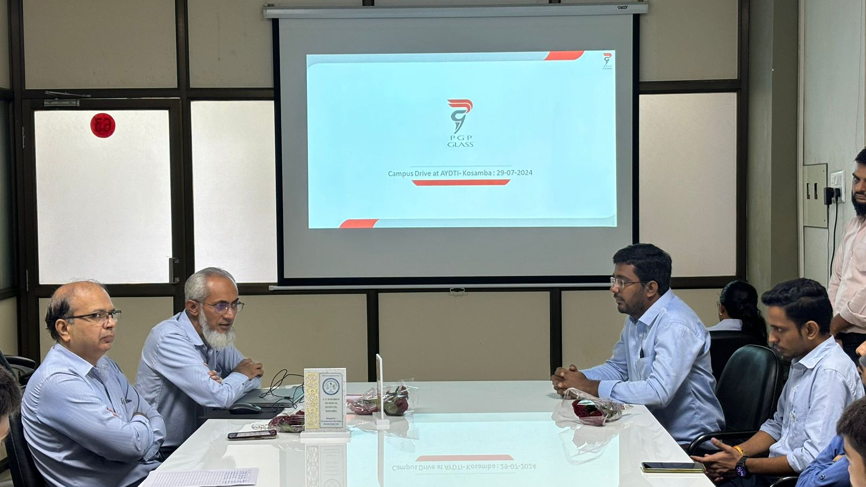

The campus placement drive by Ansa Deco Kosamba was a significant event for our institute, providing valuable opportunities for our students. It also reinforced the strong industry-academic collaboration that our institute strives to maintain.

We extend our heartfelt thanks to Ansa Deco Kosamba, especially to Mr. Firoz Shaikh and the interview panel, for their time and effort in making this event a success. We look forward to continued collaboration and more such opportunities in the future.

