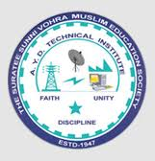 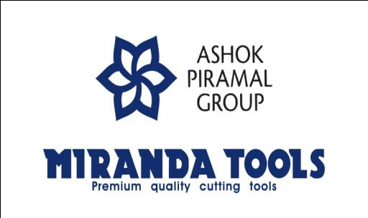

***A REPORT ON***

***CAMPUS INTERVIEW***

***At***

**A.Y.DADABHAI TECHNICAL INSTITUTE, KOSAMBA**

***On***

***13th October, 2021***

B**y**

**MIRANDA TOOLS, ANKLESHWER**

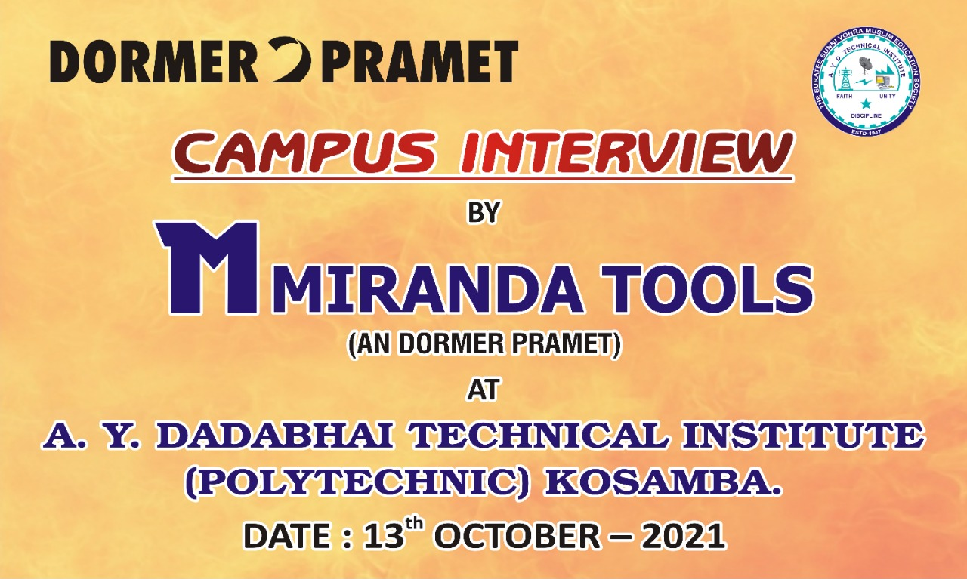

**ABOUT COMPANY**

Miranda Tools (a division of PMP Auto Components Private Limited) is a part of Ashok Piramal Group, A business conglomerate with business interest in Textiles, Real Estate, Auto Components, Renewable Energy and Sports.

Miranda Tools was established in 1945 and it was acquired by the Piramals in 1978. The company manufactures HSS Tools Bits, Drills, End mills, Reamers, HSS Saws and Metal Cutting Band saw Blades. It has its manufacturing unit & marketing office at Ankleshwar in the state of Gujarat in India. It is equipped with state of the art technology for producing precision cutting tools confirming to IS, BS, DIN, JIS & ISO standards.

Miranda Tools was established in 1945 and is a part of Ashok Piramal Group, A business conglomerate with business interest in Textiles, Real Estate, Auto Components, and Renewable Energy and Sports the company manufactures HSS Tools Bits, Drills, End mills, Reamers, HSS Saws and Metal Cutting Band saw Blades.

It is equipped with state of the art technology for producing precision cutting tools confirming to IS, BS, DIN, JIS & ISO standards. Miranda Tools was the first Indian company manufacturing high speed steel tools to have been awarded the ISO 9002:1994 certificate by BVQI in August 1994. The company is certified ISO 9001:2000 by BVQI since January 2003.

In 2005, Miranda Tools entered into a joint venture for manufacturing HSS Taps with M/s French Engineering Works Pty Ltd (FEW), South Africa. This has been instrumental in growing the footprint of our engineering products business globally. These Taps are manufactured confirming to IS, BS, DIN, JIS, & ISO standards.

The company has an extensive Sales & Marketing network comprising Depots/Branches/Resident Engineers & over 400 distributors spread all over India. Miranda Tools has a strong global thrust with almost half its sales being from exports to most developed countries. It supplies its products to its customers in USA, UK, Europe, Middle East, South East Asia, Scandinavian countries & Australasia.

**SUMMARY OF CAMPUS INTERVIEW**

We have organized campus interview for the pass out students of Mechanical Engineering Department on 13th October 2021 at conference room of A.Y. Dadabhai Technical Institute, Kosamba. All the Department heads along with director Mr. M. M. Dalchawal attended felicitation & introductory session. Total 16 students participated in this campus interview process.

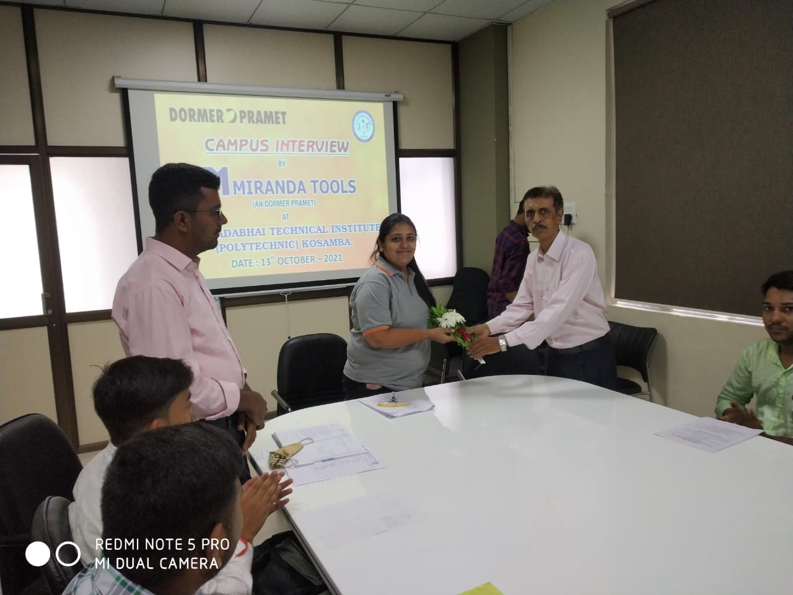 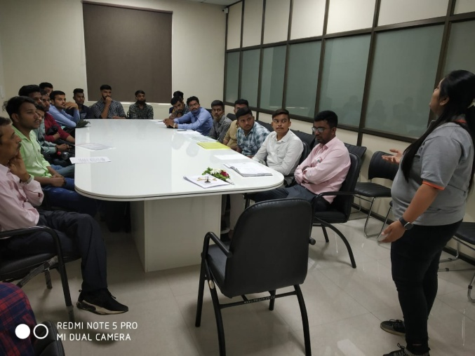

***Introduction & welcome of guest***

The function started with introduction & welcome of all guests. On behalf of institute, Head of Mechanical department, Mr. K.H. Patel welcomed distinguished representatives from Miranda Tools. He gave the brief introduction about the guest.

The company HR Manager Mrs. Nidhi Desai gave brief introduction about the company to the students & shown video about the process of manufacturing. He also discusses the recruitment process.

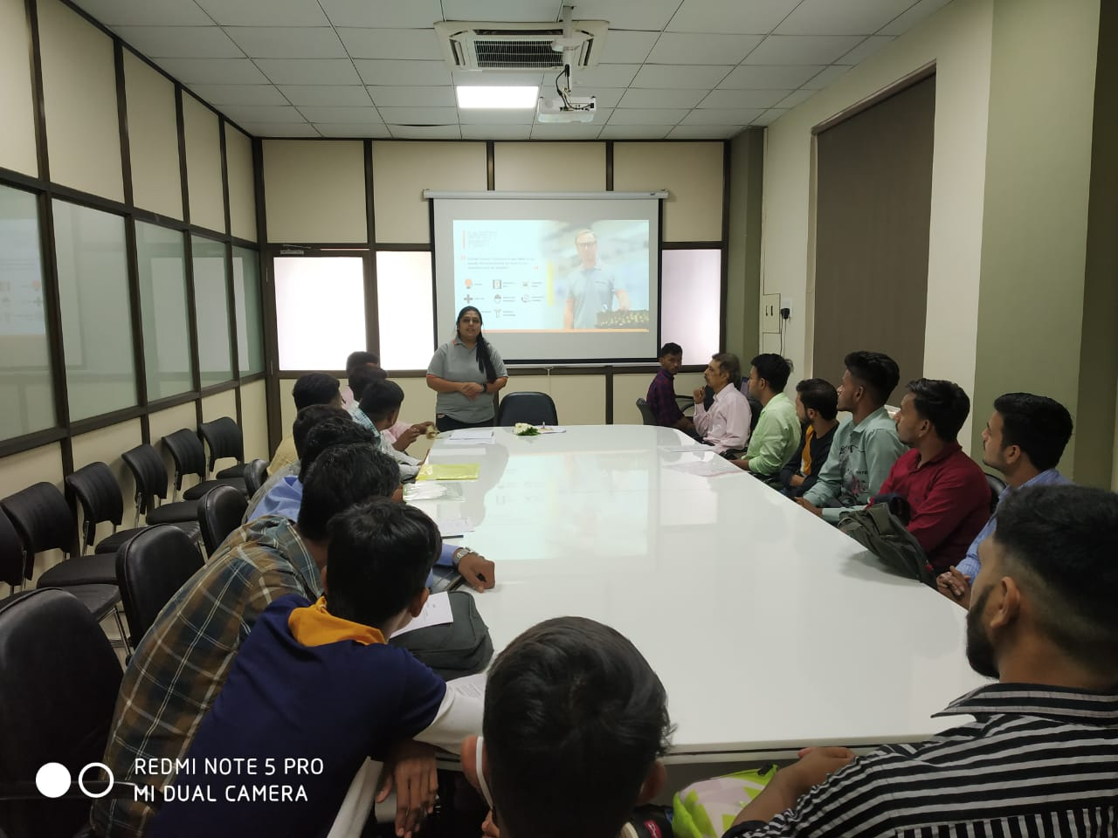 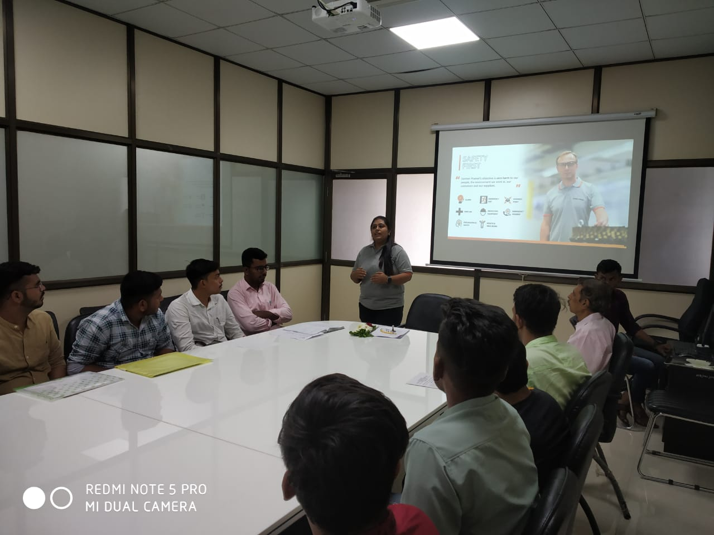

***Company Introduction by HR Manager, Mrs. Nidhi Desai***

After the introductory session, the process of personal interview of students by HR representatives of company was conducted. The process of selection started with **Written Test (Aptitude & Technical)**, in which **15** eligible students from Diploma Mechanical Engineering appeared.

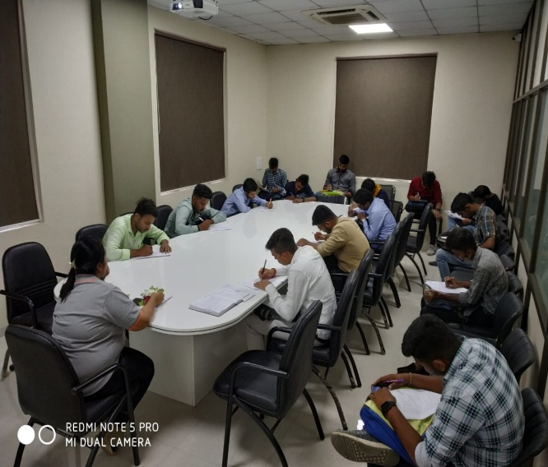 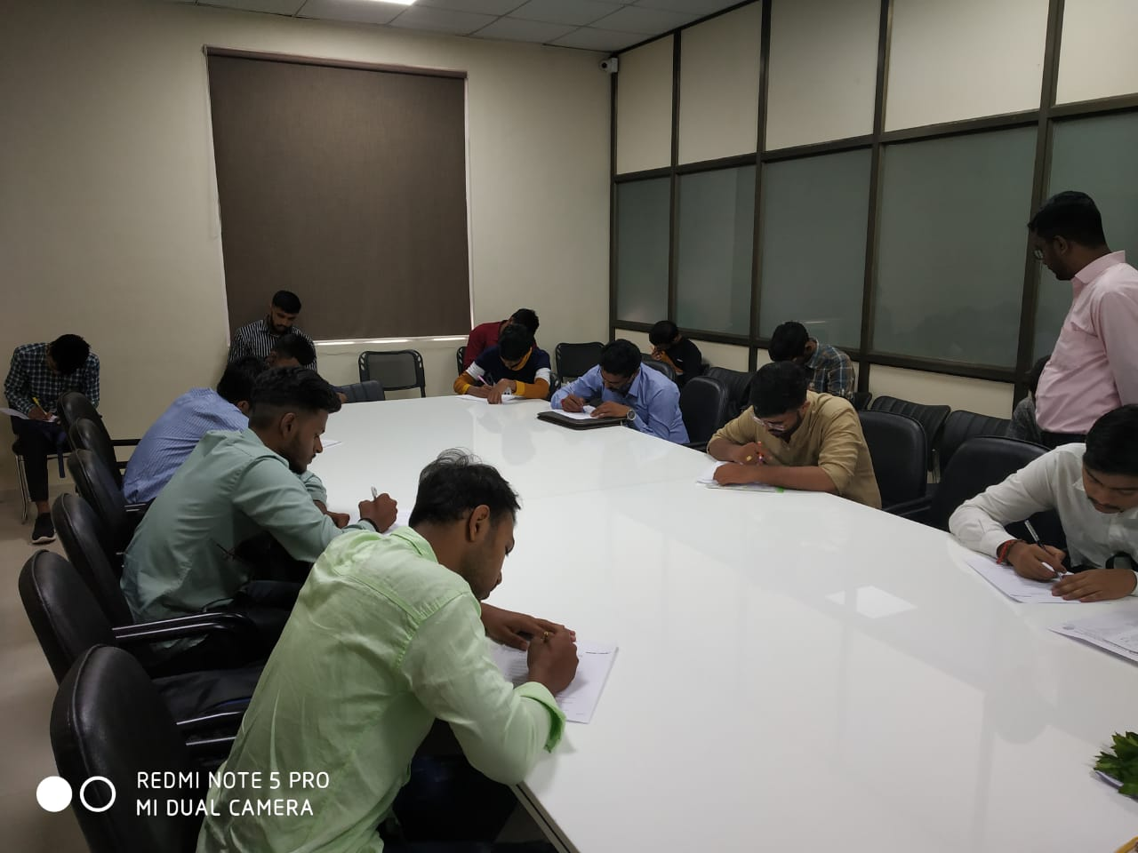

***Written Test***

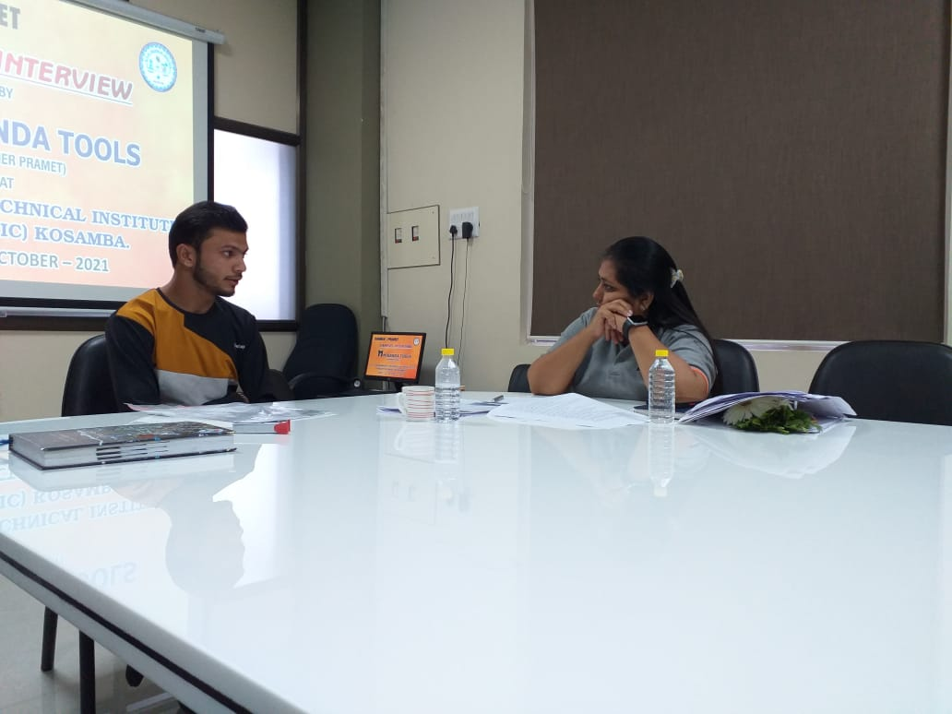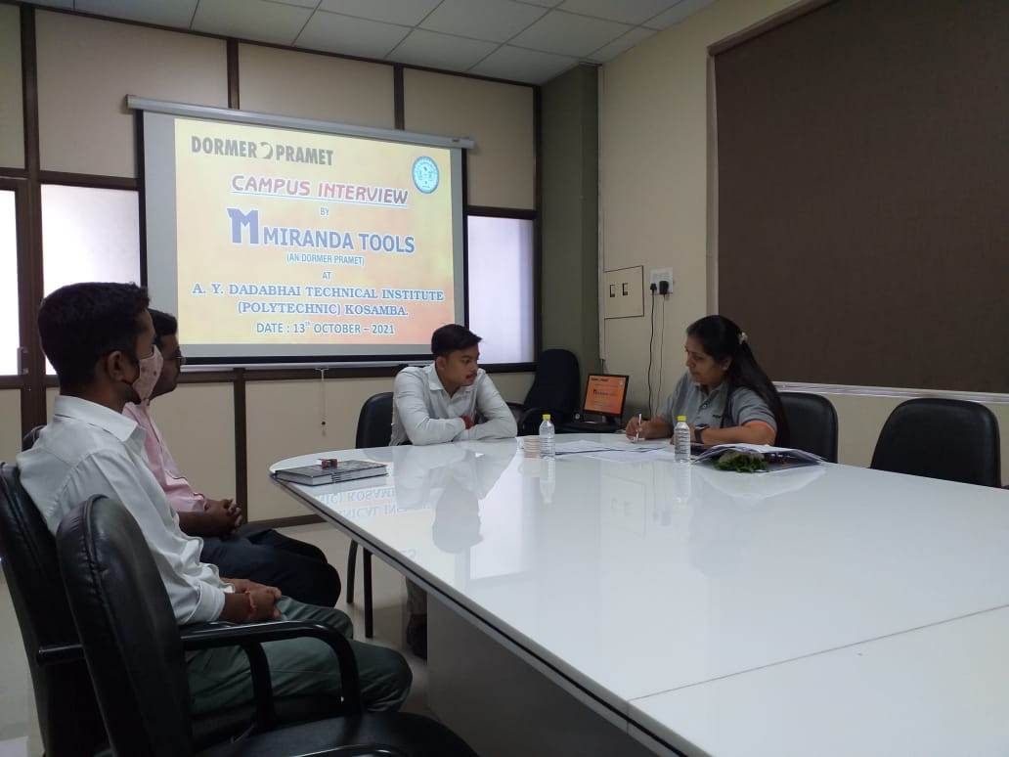 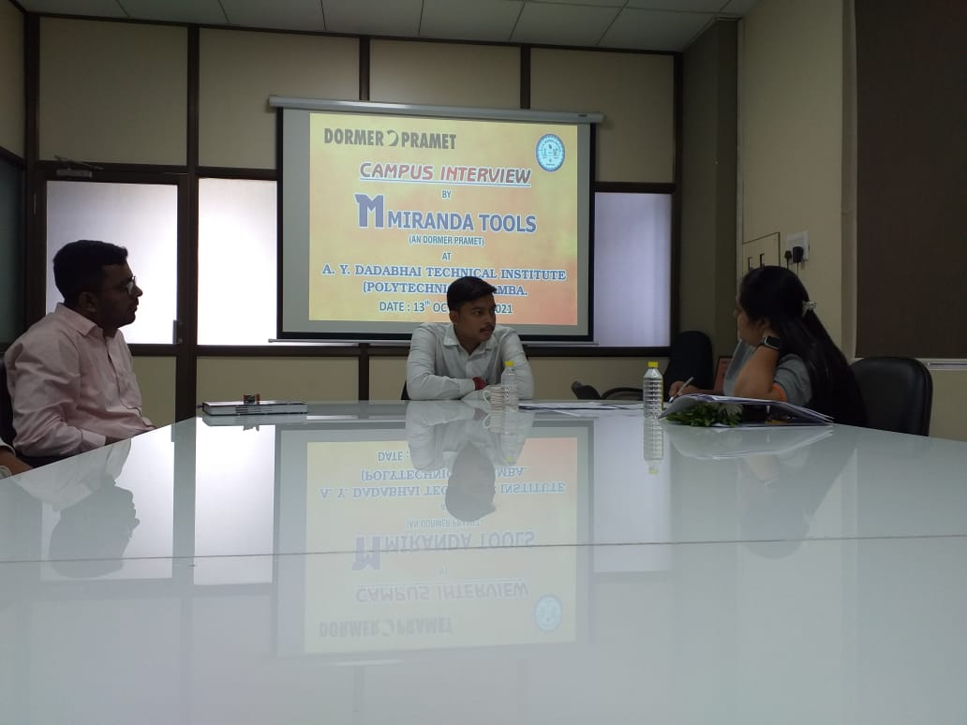 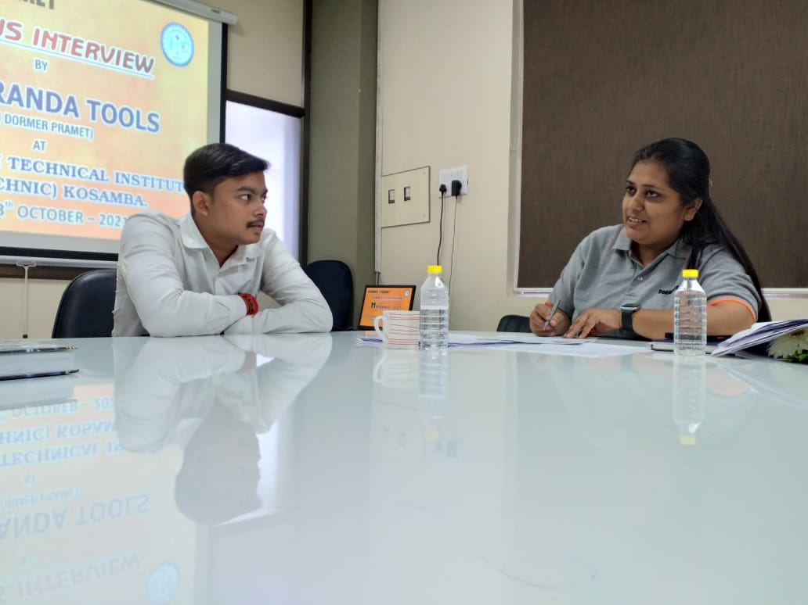

***Personal Interview***

After Personal Interview the guest are doing a discussion with hade of department, T&P officer and director. Then the final short listed students list is declared and it’s very pompous for us that all the **15** students were short listed for final **Personal Interview**.

Prepared by: Mr. Shaid Shaikh