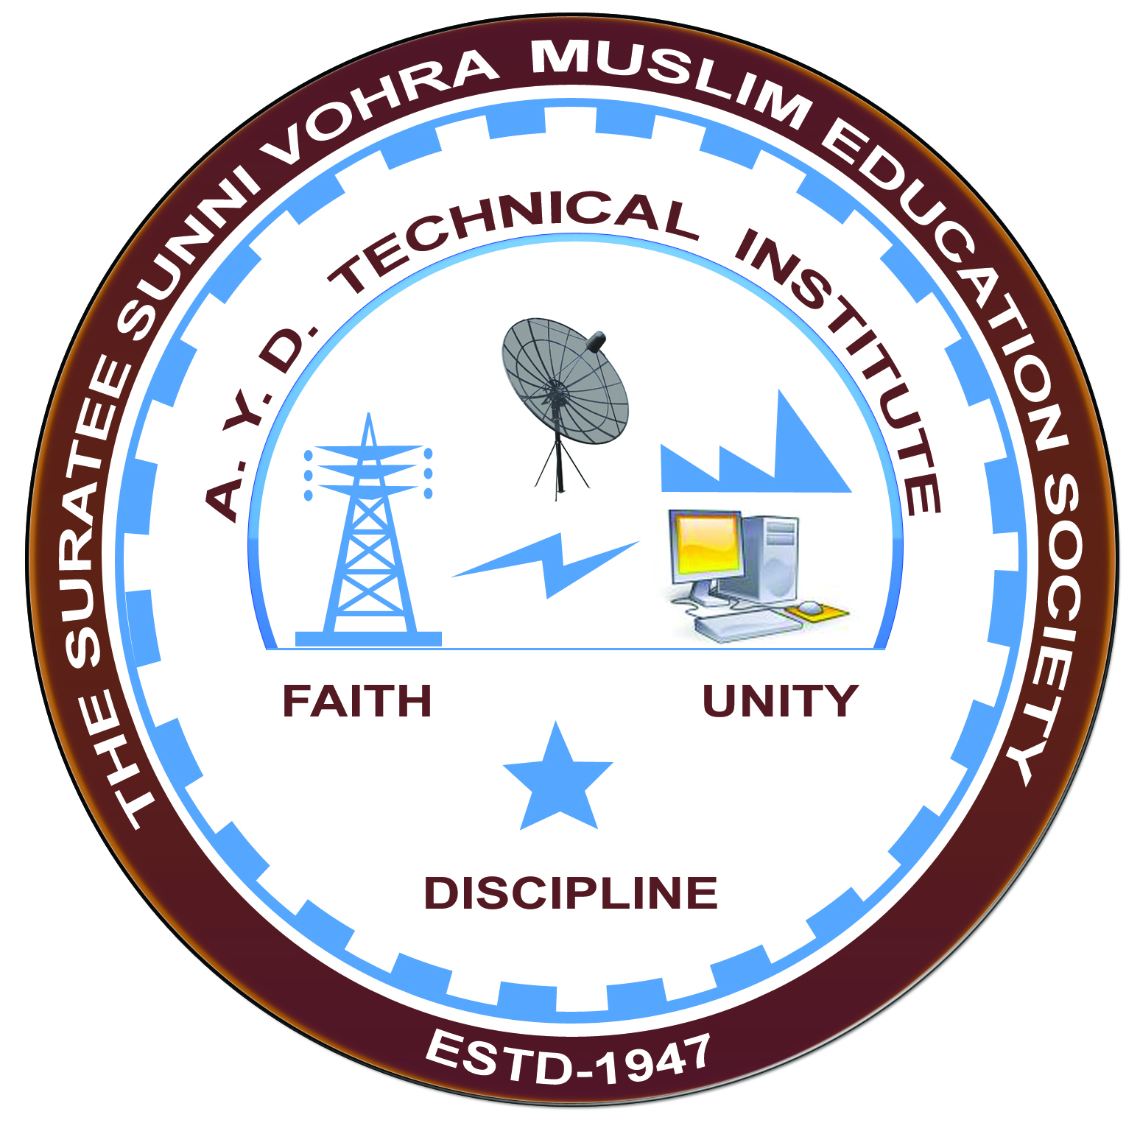

**Report on Expert Lecture**

**MICROPROCESSOR & CONTROL**

**DELIVERED BY MR.AVESH CHAMADIYA**

**&**

**Arranged by**

**Electrical Engineering Department,**

**A.Y.DADABHAI TECHNICAL INSTITUTE, KOSAMBA**

**EXPERT LECTURE**

**Date: -** 28/08/2019 and 29/08/2019 (TWO DAYS)

**Department:-** Electrical Engineering

**Sem:-** 5th Semester

**Faculty: -** (1) Miss. S. V. More

(2) Miss. M. R. Vansiya

**No Of Students: -** 40

|  |  |  |
| --- | --- | --- |
| **Name Of Expert** | **Designation** | **Organization Of Expert** |
| Mr. Avesh Chamadiya | Technical Assistant | Income tax Dept |

**Topic Of Expert Lecture:-** Microprocessor & Control

**Brief about Expert Lecture:-**

Our electrical engineering department of A. Y. Dadabhai Technical Institute, Kosamba Had organized expert lecture of Microprocessor on the date of 28 & 29 August 2019

Mr. Avesh Chamadiya started with basic of microprocessor. They Cover the following topics.

* 8085 Microprocessor Architecture & Block diagram
* Basic SCADA system
* 8051 Microcontroller
* Interfacing of microprocessor
* Basic programming.

Finally Students discuss their query & technical problems with experts.

**PHOTO GALLERY:**

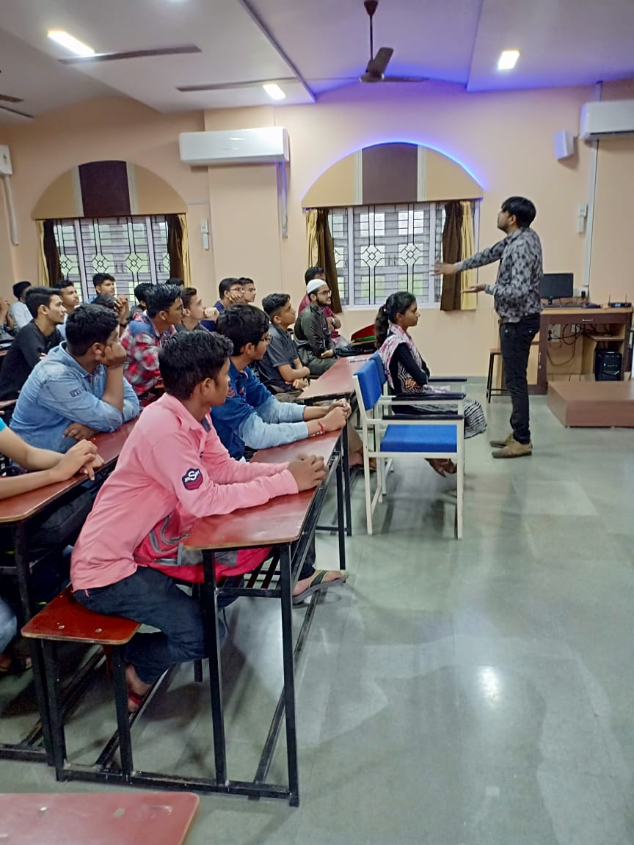

**MR.AVESH DELIVERING LECTURE**

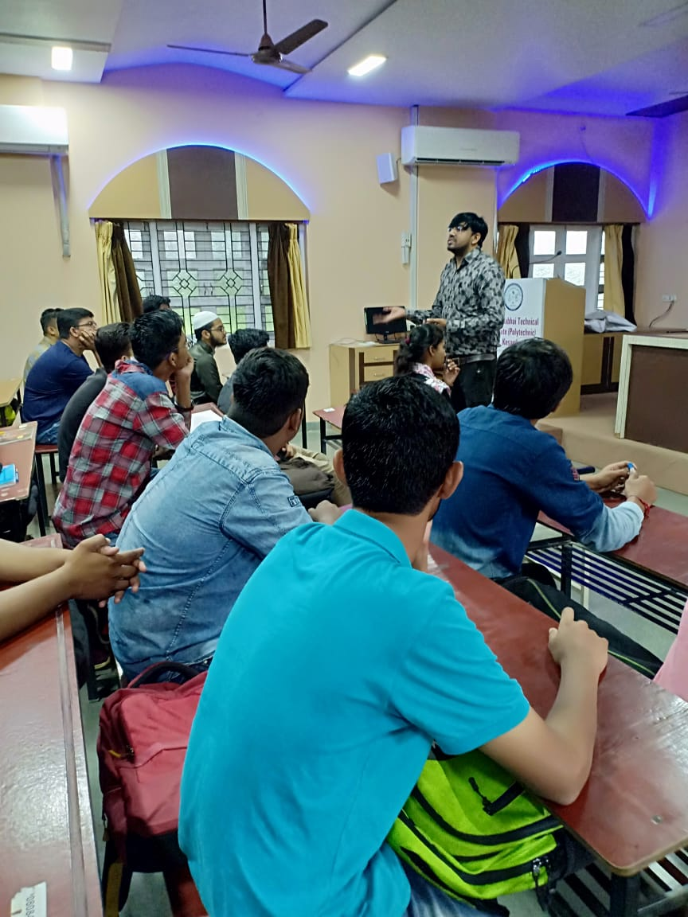

**STUDENTS PARTICIPATED**